The Little Years: Establishing Authority, Affection & Trust

Two priorities for Children’s Relationship with Their Parents:
Ephesians 6:1-3

Priority #1: Obedient Action in Response to a Parent’s God-given Authority
- Command: “Children, obey your parents in the Lord” (cf Col 3:20 “in all things”).

Obedience – listening with a view to submission

- Reason: “For this is right” (cf Col. 3:20 “For this is well-pleasing in His sight”).

Obedience is “right” in the sight of God

Disobedience is condemned by God:
Rom 1:30 mark of man’s moral depravity
2 Tim 3:2 disobedient children are a sign of the difficult “last days”
1 Tim 1:9 children who murder their parents contrary to God’s law

- Train your children that because of God’s command, the first time that you speak a command, they must obey.

- Avoid an early warning system or countdown method: “I’m gonna count to three! One, two, three…”

- Avoid repeating a command multiple times:
“Come to Mommy…Come to Mommy, I said come to Mommy NOW!!!

- Avoid giving a command followed by seeking your child’s approval “Let’s stop hitting your sibling, OK?” Replace “… OK?” with, “Do you hear or understand Mommy?”

“Obedience is doing what you are asked without challenge, delay or excuse”
Tedd Tripp in “Shepherding a Child’s Heart

Priority #2: Honoring Attitude in Response to a Parent’s God-given Authority
- Command: “Honor your father and mother (which is the first commandment with a promise).”

Honor – a loving, respect that holds a parent’s delegated authority in high regard.

Outward manifestations of this inward attitude.
- Eye contact with you and other adults/authority figures

- Respectful words choices and tone of voice

- Honoring facial expression/body language

- Attentive listening

- Soft hearted submission & compliance

- Tender relinquishing of their desires

- Reason “So that it may be well with you and that you may live long on the earth.”

Paul quotes Ex 20:12 7 Deut. 5:16 as a summary of the rewards and benefits and protection of obedience. This is not a law of longevity. Nor does it mean that all childhood sickness or death is the result of sin. Contrast Prov. 30:17!

Two priorities in a Parent’s Relationship with their Children
Ephesians 6:4

Priority #1: Avoid Sinful Provocation and Discouragement of Your Children
“Fathers, do not provoke your children to anger” (cf Col 3:21 “do not exasperate your children, so that they will not lose heart.”)
Provoke = Goading then into perpetual resentment

Ways Parents Can Provoke Their Kids
Taken from “The Christian Home” by Paul Shirley
This list has been compiled, edited, and expanded from similar lists found in The Faithful Parent by Martha Peace and Stuart Scott and The Heart of Anger by Lou Priolo.
- Prideful parenting – always right, never confesses sin, never admits mistakes
- Angry parenting – sinful speech, selfish, inconvenienced, modeling what you are not supposed to provoke
- Inconsistent parenting – kids never know when they will get in trouble or what they are going to get in trouble for
- Controlling parenting - constantly micromanaging every detail of life according to your preferences
- Weak parenting – allowing them to always get their way will create problems when they can’t get their way
- Overactive parenting – constantly making a bigger deal out of something than it really is
- Perfectionist parenting – demanding your kids make no mistakes, exhibiting no patience, getting angry over spilling a drink
- Competitive parenting – comparing kids to siblings, yourself, or cultural expectations
- Man-pleasing parenting – worried about what people will think
- Manipulative parenting - forcing your kids to comply through ungodly means and emotional ploys, mocking
- Distracted parenting – you are with your kids, but really at work or on the phone
- Presumptuous parenting – you always know everything before you even hear what happened or hear their perspective
- Hypercritical parenting – you demand your kids meet a standard that you refuse to pursue
- Joyless parenting – you are constantly despairing, there is no joy, no enjoyment of God’s blessings in your home
- Grudge-bearing parent - you won’t let go of something even after it has been dealt with and forgiveness has been granted
- Fearful parenting – everything will kill you or ruin your life, no trust in the Lord
- Critical parenting – only interaction with your kids is to criticize them, no positive reinforcement or relationship
- Promise-breaking parenting – always making and forgetting promises and commitments to your kids
- Worldly parenting – borrowing techniques from worldly wisdom, following advice from guests on Oprah
Priority #2 Pursue Tender Nurture of Your Children
“But bring them up in the discipline and instruction of the Lord.”

Bring them up - Literally means “to feed or nourish” cf Eph. 5:29
Metaphorically – “to care for,” develop with painstaking care, “to bring to maturity” Fathers NOTE: This is NOT strictly a feminine trait!

- Bring them up by Training
Training of all types by various means: instruction, rules, modeling, rewards.

- Proactive Teaching
- Waiting/Self-control
- Eating/manners
- Naps and bedtime
- Communication (speaking vs. screaming, polite words)
- Helping with chores
- Inside/outside behaviors (running vs. walking)
- Caring for others property
- Sharing & Self-control
- Preferring others (Prayer for other’s needs)
- Repeating an event following the rod

- Correction & Chastisement
- Reserved for disobedience, defiance, and dishonoring behavior
- Not for immaturity, confusion, irrationality
- Begin as soon as they are old enough to disobey

- Instruction
Admonish = to verbally place God’s truth into the mind

Tragic examples of failure to train children:
Eli 1 Sam 3:13
David 1 Kings 1:5-6

Encouraging examples of diligence to train children:
Lois & Eunice: 2 Tim 1:5; 3:14-15
Israel: Deut 6:4ff
Asaph Psalm 78:1-8
Godly Elders in the church 1 Tim. 3:4
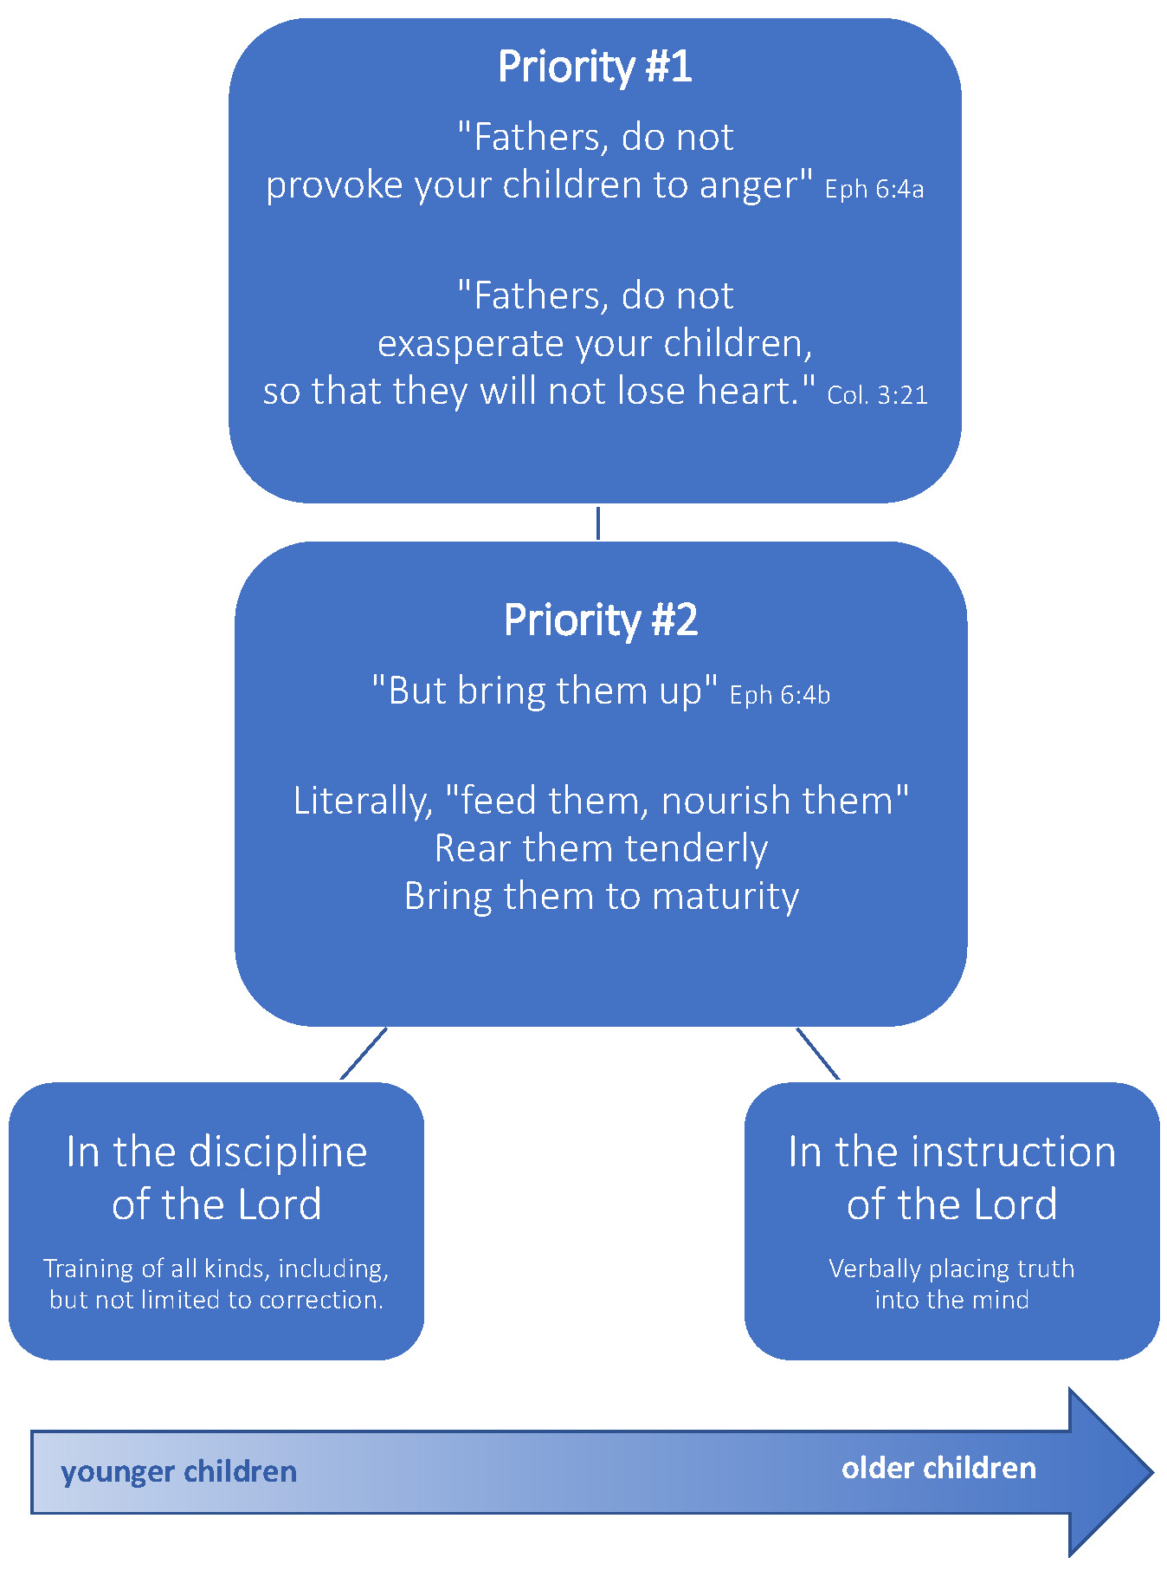
Proverbs on the Use of the Rod

The rod is necessary because of children’s sinful nature
“The rod is for the back of him who lacks understanding” 10:13

“In the mouth of fools is a rod for his back” 14:3

“Foolishness is bound up in the heart of a child; the rod of discipline will remove it far from him” 22:15

“A whip is for the horse, a bridle for the donkey, and a rod for the back of fools” 26:3

The rod teaches that sin leads to suffering!

The rod is necessary because of a parent’s sinful reluctance
“He who withholds his rod hates his son, but he who loves him disciplines diligently 13:24

“Do not hold back discipline from the child, although you strike him with the rod, He will not die. You shall strike him with the rod and rescue his soul from Sheol.” 23:13-14

The rod is necessary because of the consequences
“Disciplines your son while there is hope, and do not desire his death” 19:18

“The rod and reproof give wisdom, but a child who gets his own way brings shame to his mother.” 29:15

“Correct your son, and he will give you comfort; He will also delight your soul.” 29:17

Common Problems with the use of the Rod

Waiting too late for discipline Parental Anger/lack of love
Too much force Not enough force
Inconsistency Failing to include instruction
Child’s fear No confession/acknowledgement of sin
Release for parental frustration, rather than loving correction
Failing to represent God’s authority/offence in the process
Failing to show affection and reconcile afterwards

Suggestions When Using the Rod
From “Parenting for Life” Grace Community Church

The goal of biblical discipline is to correct, not merely to punish; to clear the conscience and be reconciled with God and others. These things are true of both chastisement and negative consequences.

“Let it (the rod) be reserved, at least in its more serious forms, for willfulness. It is medicine, not food; the remedy for the occasional diseases of the constitution, not the daily regimen for life and nourishment. And to convert medicine into daily food, gradually destroys it remedial qualities.” Charles Bridges, Proverbs p. 430
When a child willfully defies a parent, the parents are God’s instrument of correction so that the child knows his choice was wrong and against God’s will. However, God does not tell parents how to practically apply discipline in all cases. The following suggestions may be helpful as you learn to apply the principles of biblical discipline lovingly, effectively, and prayerfully in your home.
Calmly examine the nature of the offense in your own mind.
Was the offense rebellious? Defiant?
- Were clear directions given and obeyed without challenge, excuse, or delay?
- Was stubbornness demonstrated with pouting, grumbling, or sulking? Was the child saying “no” with his body language? Ask proper questions to determine what they intended to convey with their body language (Prov. 18:13). (Be careful not to confuse momentary disappointment or sorrow with defiance.)
- Was a disrespectful or dishonoring comment made?
- Was there a contrary spirit in general?
- Was lying involved?

If you are convinced that there was rebellion or defiance, most likely a spanking is required (Prov. 15:10a) unless there are other mitigating factors ( i.e. immaturity, grace). If a spanking isn’t necessary, substitute an appropriate negative consequence in this process.
Require the child to acknowledge his guilt and accept responsibility for his foolish choice.
- Ask him what choice he should have made.
- Ask him if what he did was right or wrong in God’s eyes.
- Call him to repentance and pray that God would bring true repentance to pass. He needs to understand he has offended God.
Administer the chastisement calmly and thoroughly.
- Don’t spank in such a way that would injure the child. Corporal punishment should be moderate, reasonable, and age-appropriate.
- The discipline needs to be thorough enough to cause reflection and sorrow that may bring change.
- Spank the proper area so safety is maintained.
- In general, children should as much as is possible be chastised privately. Be especially careful to avoid disciplining the child in a public setting.
- Remember, the goal is not punishment but correction so that he will repent, not repeat the offense (II Pet. 2:22; Prov. 26:11).

Follow the chastisement with instruction, teaching, training, and prayer (II Tim. 3:16,17).
- Discuss what to do the next time a similar situation occurs. What could he have done instead, and why?
- Remind your child that you desire to come along side and help him.
- This can be a special time of comfort and prayer, asking God to work in his heart.
- Instruct him to sincerely ask God and other appropriate people for forgiveness, and to affirm an offended brother or sister with affection, making an effort to restore the relationship (Luke 11:24-26; Eph. 4:22-24).

All that you do should be a demonstration of agape love.
- A gentle answer turns away wrath, but a harsh word stirs up strife Prov. 15:1.
- The anger of man will not accomplish God’s purposes (James. 1:20).
- Use words that help resolve and clarify the problem, avoiding words and tones that attack the person (Eph. 4:29).
- Do not mention the offense again, so as to use it against the child. If you must mention past offenses do so for their good (i.e. to help them deal with a sinful pattern).
- Look for an opportunity to encourage your child now that the issue is resolved.

Understand that though you may pray for and desire the correction to be complete with repentance and reconciliation, sometimes it won’t be. Be patient as God works in the heart of the child.
Unless their reaction is severe enough to warrant new correction, move on. Look for other opportunities to talk with your child apart from this specific conflict in order to understand the true condition of his heart (Prov. 4:23; 20:5). Pray for wisdom; God will provide it (Jms. 1:5).

Our responsibility before God is to administer correction under His authority, accurately reflecting the manner in which He chastises His beloved sons in love. Biblical correction can only be administered is a context of love; anything else is not biblical correction. It may be discipline, or it may have a correcting influence, but it is not biblical correction. It is not obedient to the command of God.

Bruce Ray from Withhold Not Correction

Recommended Resources

Parenting for Life
https://www.gracebooks.com/ISBN/303

Shepherding a Child’s Heart
Tedd Tripp
Shepherd Press

The Faithful Parent
Stuart Scott & Martha Peace
P&R Publishers

Withhold Not Correction
Bruce Ray
P&R Publishing

Disciplines of a Godly Family
Kent & Barbara Hughes
Crossway Publishing

Duties of Parents
J.C. Ryle

Hints for Parents
Gardiner Spring
Shepherd Press

