The Elementary Years:
Forming Character, Conscience & Responsibility
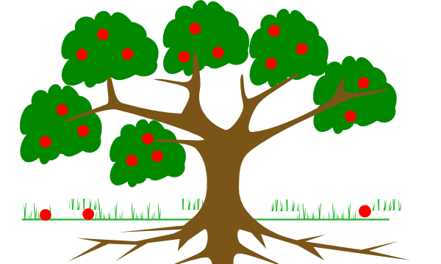
Fruit of Sinful Words & Deeds

Root of Sinful Anger
Self-exaltation/worship • Self-protection/preservation • Self-pity
Self-indulgence • Self-absorption • Self-trust/confidence
Self-atonement/justification
Root of Sinful Fear

Taproot of Pride

Soil of Unbelief

Lies about Sin
Lies Doubts
About God’s About God’s Word
Character

Minimizing Call your sin what the Bible calls it.

Denying “This is not a sin”

“There will be no judgment” Eph. 5:6 “because of these things the wrath of God comes upon the sons of disobedience” (cf Col. 3)

“There will be no discipline” Heb 12:4ff

“This pleasure is better that pleasing God.” or, “Happiness isn’t found in holiness.”
“The Spirit’s resources aren’t enough to fight this sin” or, “It won’t become a habit.”

Lies about Yourself
“I can handle this.”
“I only sin when provoked.”
“Forgetting your identity in Christ.”
“I am entitled or deserve…”

Ask yourself:
- What was I hoping to accomplish through the sin? (heart motive)
- What did I actually accomplish?
- How did my sin affect others?

Lies about the Lord
“He won’t judge” leads to highhanded rebellion
“He asks too much” leads to disobedience
“There’s nothing to fear” leads to presumption about forgiveness “He won’t help/care” leads to Fear/anxiety/worry

What attribute of God would I have to doubt to participate in this sin?
What promise of God would I have to doubt to participate in this sin?
What warning of God would I have to doubt to participate in this sin?

Examples
In each of the examples below, analyze the biblical scenarios of temptations & sin
- What was the visible temptation/sin in word and deed?

- What was the invisible temptation/sin in the heart? Pride, fear, or anger?

- What promise, command, or warning from God was questioned?

- What attribute of God’s character was doubted or ignored?

Genesis 3 Garden of Eden
Genesis 4 Cain’s murder of Abel
Genesis 20 Abraham, Sarah, and Abimelech
Genesis 39 Joseph and Potiphar’s Wife
Exodus 17:1-7 Israel’s quarrel with Moses
Numbers 20:8-13 Moses striking the rock
Deut. 1:19ff Israel’s fear of entering the Promised Land
Joshua 7:16ff; 1 Tim 6:6ff Materialism
1 Samuel 13:14; 18:6-9 Saul’s anger at David
1 Samuel 25:1ff David anger at Nabal
2 Samuel 11 David, Bathsheba, and Uriah
2 Samuel 12:7-15 Nathan’s confrontation of David’s sin with Bathsheba
Job 42:1-6 Job’s Repentance
Psalm 56 David’s temptation toward sinful fear
Proverbs 24 Laziness
Proverbs 5-7 Sexual immorality
Matthew 4 Christ’s Temptations
Matthew 6:25-34 Jesus words on sinful worry
Mark 4:35-41 Jesus calming the sea
John 3:22ff John the Baptist temptation toward jealousy/covetousness
Ephesians 5:1ff Sexual immorality
1Thessalonians 4:3-7 Sexual immorality
1 Peter 2:23 Christ’s sufferings

