WEEK TWO: October 12-18
Focus on fellowship and growing friendships
What this means…
- Less time on discussion, more time getting to know each other.
- Leaders and co-leaders alternate sharing brief testimony.
- Ending a little early so people can “just hangout.”
Note on sharing testimony:
- Sharing each other’s story is invaluable.
- Consider ending discussion 10-15 minutes early to have 1-2 people share their testimony.
- Leaders go first, then co-leaders, then other people in group when they’re ready.
“THE SLOW TURN”
After the first meeting, you can slowly begin to decrease time spent fellowshipping and increase time spent working through discussions and guides. This is the “slow turn.”
Potential structure for your SECOND meeting (note: less time spent on fellowship)
The first 10-15 minutes should be “built in buffer time” for people to arrive and socialize.
What this means…
- No one is “late” who shows up within this timeframe.
- Have food, drinks, and snacks. This helps people feel interact.
- Have light music playing in the background if possible.
The next 15-20 minutes should be lighthearted easy-going conversation to get to know each other.
What this means…
- Spend time getting to know each other, but not as much since you did that last week.
- If there’s anyone knew, be sure to welcome them and introduce them to the group.
ICEBREAKER/GETTING TO KNOW YOU:
- “High-Low-Buffalo”
  - High: What is the most encouraging thing that happened last week?
  - Low: What was the hardest part about last week?
  - Buffalo: What was the most surprising or unexpected thing last week?
The next 30-45 minutes spend time discussing the sermon. See discussion questions below.

LAST WEEK’S SERMON
Series: Book of Romans, Season 6: Dead to Sin, Alive to God
Title: “The Whole Christ” (Romans 6:1-13)
Summary: Goal of the sermon was to show how the gospel does not give people an excuse to sin. Instead, it sets us free from the power of sin to surrender their lives wholeheartedly to God.
Outline of Romans 1-8: Chapter 5 is all about the gospel of salvation by grace alone through faith. Chapters 6-7 is Paul addressing the issue of how the gospel does not mean that we can live however we want.
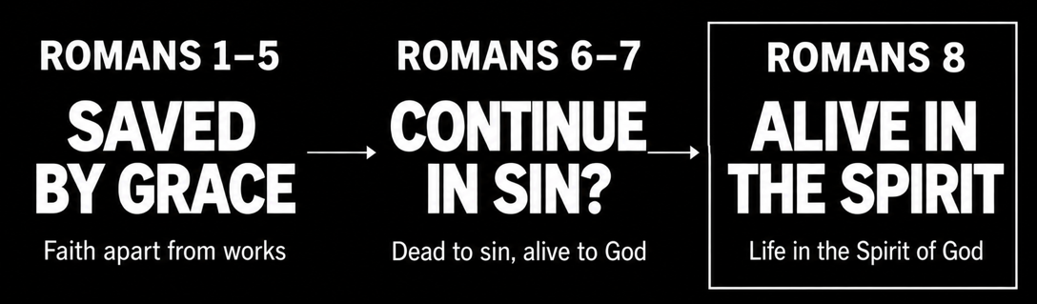
Questions For Discussion:
- The sermon began with a quote by Martyn Lloyd Jones: “There is no better test of whether a man is really preaching the gospel of salvation by grace than this, that people misunderstand him to mean that because you are saved by grace alone it does not matter at all what you do; you can go on sinning as much as you like. If our preaching of the gospel of salvation does not expose it to that misunderstanding, then it is not the gospel.”

QUESTION: Do you see why this issue would be raised? Can you identify with this concern? How come?

NOTES: This is one of the big problems people have with Christianity and the gospel: it sounds too easy (“Just believe in Jesus and you’ll go to heaven.”). It's not uncommon for people to use this as an excuse to give into sin (“God will forgive me, so I can do this.”).

You could ask people if they have ever been tempted to use this as an excuse?

- The reason people use this as an excuse to sin is because they misunderstand the profound relationship we have with Christ: we are united to the Whole Christ: Crucified and Risen. Read Romans 6:5-11 and ask the following question…

QUESTION: In what ways, does being united to the crucified and risen Christ help you grasp how horrible and nonsensical sin really is? Does this change anything for you in terms of how you see your relationship to sin?

NOTES: The example used in the sermon was the idea of no longer being a “spiritual bachelor.” There’s a profound union that takes place between believers and Christ. This means that whenever we sin, we are taking Christ into that sin. For a deep dive into this, check out 1 Corinthians 6:15-20. Basically, it says that all forms of sexual immorality taking Christ into the bedroom and bringing him into our immorality and lust. There is a vileness of sin that is felt when we understand how near Christ is to us.

- People sometimes have a hard time with the idea of being “enslaved to sin,” that’s clearly what Romans 6:6 says. Apart from union with Christ, we are all enslaved to something. What this means is that there is something we have made ultimate to our existence (the smallest person in the Russian Nesting Doll, see below). It can even be something good (e.g. money, sex, career, relationships, family, sports, self-image/beauty/thinness, etc.).

QUESTION: There are different ways to discern what that could be in our lives. Which of these could you identify with most, or what are examples that come to your minds of what this actually looks like?
- The anger test: what is it that if we can’t have something, we don’t just get upset, we go into a rage.
- The fear test: what is it that if something is threatened, we don’t just get nervous and anxious, but we are paralyzed with fear and we melt down.
- The sadness test: what is it that if we lose something we don’t just get sad and grieve, but we have no desire to live anymore.

NOTES: People don’t necessarily need to be specific with their own lives. It is more about Christians being equipped to identify areas of their lives that they might be tempted to be pulled back into. Encourage people to actually think these out and come up with examples to help people to enlighten one another.
RUSSIAN NESTING DOLLS: Here is the image I used in the sermon for illustrating union with Christ. Just for your reference.


- This topic of union with Christ can be a hard thing to grasp, and can feel impractical at times, but the last part of the passage gets practical (Romans 6:11-13). In fact, it is the first commands in the book of Romans. There are two simple habitual rhythms that Christians must continually do to see themselves become freer from sin: remember and surrender.

QUESTION: Whenever you sin and fall into sin again, you are to remind yourself of your identity as being dead to sin and alive to God. Then you are to surrender yourself completely and entirely back to God. How do you think continually practicing this will help you become freer from sin?

NOTES: There was the example of orphans or slaves believing more in their identity as a child or a freeman or woman. When a Christian sins, they don’t sin as a slave to sin, but as a free and liberated child of God… who willingly goes back to what they’ve been set free from. The key is to shorten the time between when you sin and when you practice this.

PRAYING TOGETHER
The last 15-20 minutes should focus on praying with and for one another.
Tips on praying together:
- Taking prayer requests can take up too much time. Consider asking people if there are any encouraging stores with their “ONE.” You can ask people: What are specific ways that we can pray for your one, or for someone who needs spiritual help or rescue from God?
- If you just ask for prayer requests, then prayer can quickly turn into “health concerns.” This is not bad, but there’s a tendency to make prayer only about that, rather than using as a War-time walkie-talkie to call on God for power to save and transform people’s lives.

CHECK OUT THIS QUOTE: “Prayer is a war-time walkie-talkie, not a domestic intercom for ringing up the butler to change the thermostat. It is a war-time walkie-talkie to call in firepower because the enemy is greater than we are. If you try to turn this into a domestic intercom to bring another pillow, it malfunctions, and you wonder why. It’s not made to be an intercom. It’s made to be a war-time walkie-talkie.” – John Piper
TRY TO END EARLY
The last 10-15 minutes should be unstructured hangout time. Let people leave early if they have to, or stay, chat, hangout, etc.

