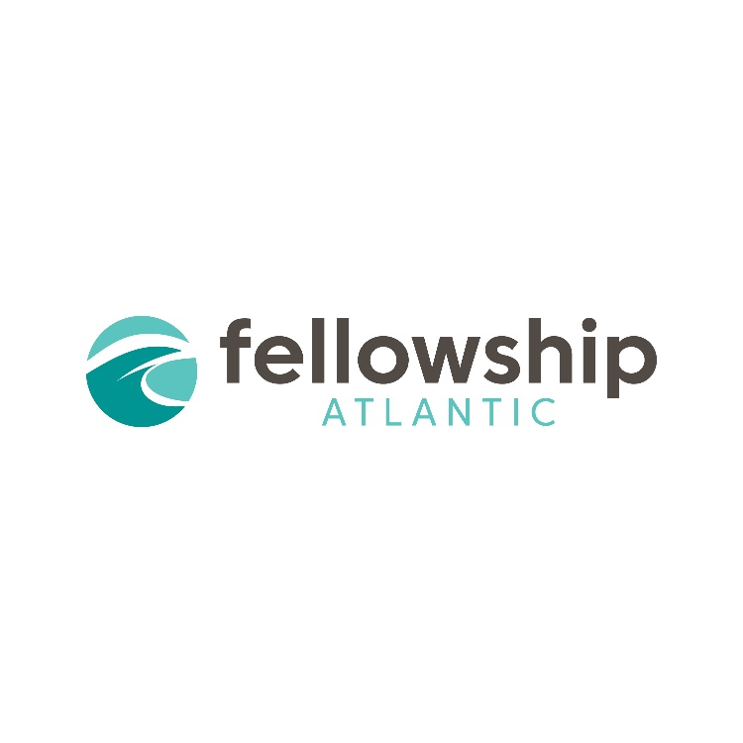
The Regional
May 9-11th, 2024

Hosted by Grace Baptist Church
50 Kirkdale Rd, Charlottetown, PEI

Thursday, May 9th

7pm - Church Recognition Council for Faith Bible Church (392 St. Peter’s Rd, Charlottetown, PEI)

Friday, May 10th

9am - Ordination Council for Luke Playford
12pm - Lunch
2pm - Affirmation of a Previous Ordination Councils for Jeff Eastwood, Jonathan McLeod and Paul Smylski
7pm - Plenary Session 1: “Gratitude for Effective Engagement: Philippians 1:3-4” with Andrew Swanson

Saturday, May 11th

10am - Tim Elmore commissioning
10:30am - Celebration stories
11am - Plenary Session 2: “Remembering Effective Engagement: Philippians 1:5” with Jeff Eastwood
12pm - Lunch
1pm - Breakout Session 1

“Raising Up Leaders from the Next Generation”- Brad Somers (Church Leadership/Planting; Children/Youth Ministry)

“How to Care for Your Volunteers”- Danny Barrett (Church Health, Ministry Directors, Music Leaders)

“Nine Systems Your Church Should Consider Implementing”- Dave Adams (Church Leadership; Pastors)

2pm - Break

2:30pm - Breakout Session 2

“Where Have All the Young People Gone? - Ministering During an Exodus”- Jeff Eastwood (Church Leadership/Planting; Children/Youth/Young Adult Ministry)

“Surveying the Landscape- A Biblical Response to Current Issues”- Steve Adams (Church Health; Ministry Leaders)

“An Expository Preaching Primer”- Neal Whitman (Church Leadership; Pastors)

3:30pm - Plenary Session 3: “Confidence in Effective Engagement: Philippians 1:6” with Tim Elmore
4:30pm - Closing, prayer, and dismissal

