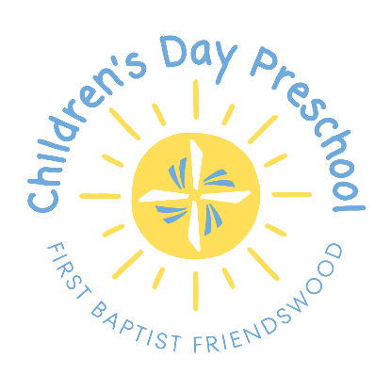

Letter of Intent
2026-2027

I would like to reserve a spot for my child for the upcoming school year. I understand that all application requirements (paperwork and fees) must be received before enrollment is complete.

Child’s Name: ______________________

Child’s Birthdate: ___________________

Please indicate how many days your child will attend by checking the appropriate box. It is highly recommended that three and four-year-olds attend 3 days per week.

 2-days-a-week 3-days-a-week
Requests*: ________________________________________________________

________________________________________________________
*Requests will be considered but not guaranteed.

Parent’s Name: ________________________________________________________

Parent’s Email: ________________________________________________________

Parent’s Signature: ____________________________________________________

Parent’s Phone: _______________________________________________________

