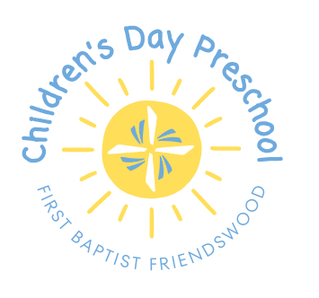
Parents,
It’s hard to believe, but it is time to start planning for the next school year! Closed registration will begin on Tuesday, January 13th. During closed registration, only current Children’s Day families and members of First Baptist Friendswood will be able to register. Registration will be open to the public on January 27th. When classes are full, we will place students on a wait list. Below are listings of the paperwork required for registration:
Paperwork needed for all students | Date to be tuned in
Letter of Intent | Upon registration
Admission Information Form | Upon registration
Operational Discipline and Guidance Form | Upon registration
Health Requirements with Physicians Statement that child is healthy to attend school | Before the end of school if up to date or before the start of school
Immunization record | Before the end of school if up to date or before the start of school

Paperwork only needed if applicable | Who needs it | Date to be turned in
Vision and Hearing screening | All 4-year-olds | Before the start of school
Allergy Action Plan | Students who have a life- threatening allergy | Before the start of school
Court Documents | If there is a custody order pertaining to your child | Before the start of school

Fees for the 26-27 school year:
These fees are due at registration to hold your spot for the school year.
*Sibling discount $15 for 2nd sibling; $10 for 3rd sibling.

Days | Registration Fee | Curriculum/Resource | May 27 Tuition | Total for one child
2 | 90 | 170 | 250 | 510
3 | 90 | 195 | 305 | 590

