**Climate Change (Part 2)**

**Greenhouse gas theory**

1. Man-made gases changing Earth’s temperature

2. Predicts increase in frequency of record-breaking temperatures

**Greenhouse gas theory & observations**

1. Opposite is happening—decrease in record-breaking temperatures

2. Explanation: urbanization and natural variability

*- “I’ve actually done this same analysis for the 682 [U.S. Historical Climatology Network] stations with at least 105 years of record since 1895. It is clear that the occurrence of both record high and record lows has declined since 1895, thanks to many records set from the 1920s to 1954. The AP … is spinning the story by only noting that record lows are fewer than highs now—but the real story is that in the U.S., both extremes are falling. This is consistent with the decline in number of days greater than 100 [degrees] Fahrenheit (or 105 Fahrenheit or 95 Fahrenheit, etc.). The differential decline in record temps is inconsistent with [greenhouse gas] theory, which predicts an increase in record highs.” Climatologist John Christy (University of Alabama-Huntsville)*

3. Not just man-made causes

*- “Without assessing the role of increased urbanization and other land-use changes … changes in atmospheric aerosols overhead, microclimate around observing site, changes in heights of observations, and concurrent trends in surface air humidity, it is not robust to attribute any changes in extreme temperatures to just human-added atmospheric CO2… We have published on each of these subjects but work remains mostly ignored.” Climatologist Roger Pielke Sr. (Cooperative Institute for Research in Environmental Sciences, Colorado University)*

[https://www.dailysignal.com/2019/03/19/media-touts-clear-sign-of-human-caused-climate- change-here-are-the-facts](https://www.dailysignal.com/2019/03/19/media-touts-clear-sign-of-human-caused-climate-%20change-here-are-the-facts)

**Observations**

1. Vegetation--Earth is greening/increasing (NASA)

*- Up to 50%; less than 4% is browning (loss of vegetation)*

*- Due to modest warming and increased CO2; UN reports record farm crops*

2. Hurricanes (Intergovernmental Panel on Climate Change—IPCC)

*- No measurable increase in hurricanes*

*- Slight 1% increase in intensity*

## 3. Animal extinction

## (**International Union for Conservation of Nature—**Red List of Threatened Species)

*- 2 extinctions per year; projection was 30,000*

<https://www.dailysignal.com/2020/03/20/fact-or-fiction-climate-change-explained>

4. US wildfires down from 406, 614 (2005-2009) to 315, 953 (2015-2019): National

Interagency Coordination Center

5. No discernible global trends for hurricanes, winter storms, floods, tornadoes, or thunderstorms; trends

in heat waves, heavy precipitation, and some kinds of drought (IPCC)

**Temperature variability (1.3° F) and carbon dioxide concentration**

## Figure 1

<https://answersingenesis.org/environmental-science/climate-change/what-scientists-ignore-about-climate-change/>

**Solar activity**

1. As sunspot cycle length decreases, temperature increases

2. Brighter sun leads to more radiation & less cloud cover <http://www.soest.hawaii.edu/mguidry>

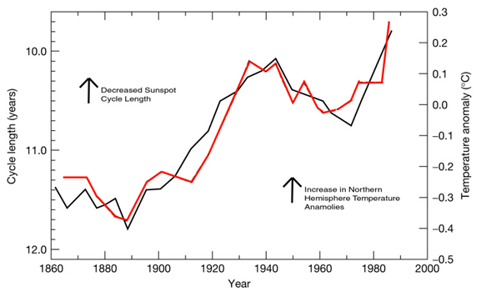

**5-minute video by Dr. Richard Lindzen, Atmospheric Sciences, MIT**

<https://www.prageru.com/video/climate-change-what-do-scientists-say>