**UN Summit of the Future**

<https://www.glennbeck.com/radio/united-nations-framework-world-government>

**Our Common Agenda**

Developed after 2020

**3 agreements from Our Common Agenda**

1. Pact for the Future

2. Declaration of Future Generations

3. Global Digital Compact

**Purpose for agreements**

1. All passed to implement after America’s 2024 election

2. Empower and expand UN & globalist Great Reset

**Pact for the Future**

1. Emergency Platform—power given to UN Secretary General in case of emergency

2. Specifics tabled to be detailed later

**Declaration of Future Generations**

1. Reduce inequality & fight climate change

2. Vague and idealistic

**Global Digital Compact**

1. Increase global governance of artificial intelligence

2. Funding for private/public partnerships for social justice goals

3. Control internet to manage misinformation/disinformation

4. Help social media companies to silence dissenting voices

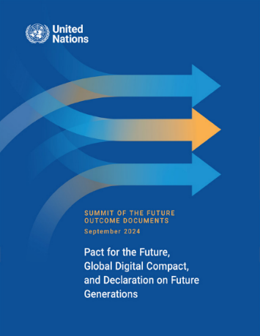

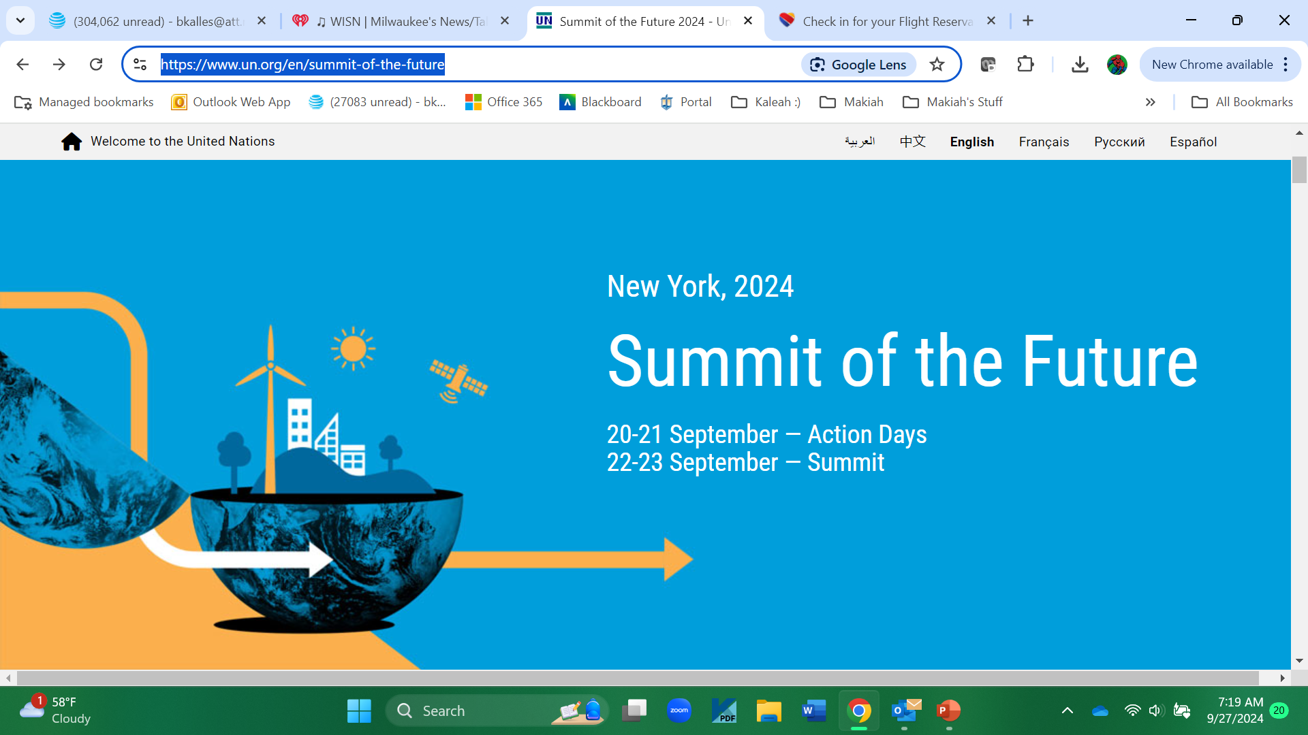

<https://www.un.org/en/summit-of-the-future>

<https://www.dailysignal.com/2024/09/17/given-its-past-oppose-the-united-nations-pact-for-the-future/>