GRACE LUTHERAN CHAPEL
Grace Chapel exists to make and keep disciples for Jesus Christ.

The Nativity of Our Lord - Christmas Day
December 25, 2025 – 9:30 a.m.

Welcome to Grace Lutheran Chapel and to our worship with Holy Communion. As Lutheran Christians we believe and confess that Christ’s Body and Blood are present in the bread and wine of Holy Communion. This meal benefits those who acknowledge and confess their sin and trust in Christ alone for their salvation. Where Christ’s true body and blood are present, so also is the forgiveness of sins and eternal life. Baptized and instructed Christians who share in this belief are welcome to this meal of our Lord’s grace and forgiveness.

WELCOME/GREETING

OPENING HYMN “O Come, All Ye Faithful,” No. 379
1 O come, all ye faithful, Joyful and triumphant!
O come ye, O come ye to Bethlehem;
Come and behold Him Born the king of angels: Refrain

Refrain: O come, let us adore Him, O come, let us adore Him,
O come, let us adore Him, Christ the Lord!

2 Highest, most holy, Light of Light eternal,
Born of a virgin, a mortal He comes;
Son of the Father Now in flesh appearing! Refrain

3 Sing, choirs of angels, Sing in exultation,
Sing, all ye citizens of heaven above!
Glory to God In the highest: Refrain

4 Yea, Lord, we greet Thee, Born this happy morning;
Jesus, to Thee be glory giv’n!
Word of the Father Now in flesh appearing! Refrain

INVOCATION
In the name of the Father and of the Son and of the Holy Spirit.
Amen.

CONFESSION AND ABSOLUTION
Our help is in the name of the Lord,
who made heaven and earth.

If You, O Lord, kept a record of sins, O Lord, who could stand?
But with You there is forgiveness; therefore You are feared.

Since we are gathered this Christmas morning to hear God’s Word, to marvel at the mystery of the Word becoming flesh, and to receive Him as He comes to us in His body and blood, let us first consider our unworthiness before God and confess before Him and one another that we have sinned in thought, word, and deed. We cannot free ourselves from our sinful condition; only God’s Son, Jesus Christ, has set us free from our fears and failures, our sin and death, and He enables us to live forever as God’s children. Let us then take refuge in the infinite mercy of our God and, seeking His grace for the sake of Christ, say: God, be merciful to me, a sinner.
Almighty God, have mercy upon us, forgive us our sins, and lead us to everlasting life. Amen.

Almighty God in His mercy has given His Son, born into this world on Christmas, to live, suffer, die, and rise again for you. For Jesus’ sake, your heavenly Father forgives you all your sins. As your pastor, it is my privilege to announce this message of grace unto you and, as Christ has commanded, I forgive you all your sins in the name of the Father and of the Son and of the Holy Spirit.
Amen.

PSALM Psalm 98 (spoken responsively)
The Lord has made known His salvation;
He has revealed His righteousness in the sight of the nations.

Oh sing to the Lord a new song, for He has done marvelous things!
His right hand and His holy arm have worked salvation for Him.

The Lord has made known His salvation;
He has revealed His righteousness in the sight of the nations.

He has remembered His steadfast love and faithfulness to the house of Israel.
All the ends of the earth have seen the salvation of our God.

Make a joyful noise to the Lord, all the earth;
break forth into joyous song and sing praises!
The Lord has made known His salvation;
He has revealed His righteousness in the sight of the nations.

Sing praises to the Lord with the lyre,
with the lyre and the sound of melody!

With trumpets and the sound of the horn
make a joyful noise before the King, the Lord!

Let the sea roar, and all that fills it;
the world and those who dwell in it!

Let the rivers clap their hands; let the hills sing for joy together before the Lord, for He comes to judge the earth.
He will judge the world with righteousness, and the peoples with equity.
The Lord has made known His salvation;
He has revealed His righteousness in the sight of the nations.
Glory be to the Father and to the Son and to the Holy Spirit;
as it was in the beginning, is now, and will be forever. Amen.

HYMN OF PRAISE “Angels We Have Heard on High,” No. 368
1 Angels we have heard on high, Sweetly singing o’er the plains,
And the mountains in reply, Echoing their joyous strains. Refrain

Refrain: Gloria in excelsis Deo. Gloria in excelsis Deo.

2 Shepherds, why this jubilee? Why your joyous strains prolong?
What the gladsome tidings be Which inspire your heav’nly song? Refrain

3 Come to Bethlehem and see Him whose birth the angels sing;
Come, adore on bended knee Christ the Lord, the newborn King. Refrain

SALUTATION
The Lord be with you.
And also with you.

PRAYER OF THE DAY
Let us pray. Almighty God, grant that the birth of Your only-begotten Son in the flesh may set us free from our fears and from the bondage of our sin that we may rejoice in Your salvation; through Jesus Christ, Your Son, our Lord, who lives and reigns with You and the Holy Spirit, one God, now and forever.
Amen.

OLD TESTAMENT READING Isaiah 52:7–10
How beautiful upon the mountains are the feet of him who brings good news, who publishes peace, who brings good news of happiness, who publishes salvation, who says to Zion, “Your God reigns.” ⁸ The voice of your watchmen—they lift up their voice; together they sing for joy; for eye to eye they see the return of the Lord to Zion. ⁹ Break forth together into singing, you waste places of Jerusalem, for the Lord has comforted his people; he has redeemed Jerusalem. ¹⁰ The Lord has bared his holy arm before the eyes of all the nations, and all the ends of the earth shall see the salvation of our God.

This is the Word of the Lord.
Thanks be to God.

ANTHEM “How Quietly” - Choir

EPISTLE Hebrews 1:1-6 (7-12)
Long ago, at many times and in many ways, God spoke to our fathers by the prophets, ² but in these last days he has spoken to us by his Son, whom he appointed the heir of all things, through whom also he created the world. ³ He is the radiance of the glory of God and the exact imprint of his nature, and he upholds the universe by the word of his power. After making purification for sins, he sat down at the right hand of the Majesty on high, ⁴ having become as much superior to angels as the name he has inherited is more excellent than theirs.
⁵ For to which of the angels did God ever say, “You are my Son, today I have begotten you”? Or again, “I will be to him a father, and he shall be to me a son”? ⁶ And again, when he brings the firstborn into the world, he says, “Let all God's angels worship him.”
⁷ Of the angels he says, “He makes his angels winds, and his ministers a flame of fire.” ⁸ But of the Son he says, “Your throne, O God, is forever and ever, the scepter of uprightness is the scepter of your kingdom. ⁹ You have loved righteousness and hated wickedness; therefore God, your God, has anointed you with the oil of gladness beyond your companions.”
¹⁰ And, “You, Lord, laid the foundation of the earth in the beginning, and the heavens are the work of your hands; ¹¹ they will perish, but you remain; they will all wear out like a garment,
¹² like a robe you will roll them up, like a garment they will be changed. But you are the same, and your years will have no end.”

This is the Word of the Lord.
Thanks be to God.

HOLY GOSPEL John 1:1-14 (15-18)
The Holy Gospel according to St. John, the first chapter.
Glory to You, O Lord.
In the beginning was the Word, and the Word was with God, and the Word was God. ² He was in the beginning with God. ³ All things were made through him, and without him was not any thing made that was made. ⁴ In him was life, and the life was the light of men. ⁵ The light shines in the darkness, and the darkness has not overcome it.
⁶ There was a man sent from God, whose name was John. ⁷ He came as a witness, to bear witness about the light, that all might believe through him. ⁸ He was not the light, but came to bear witness about the light.
⁹ The true light, which gives light to everyone, was coming into the world. ¹⁰ He was in the world, and the world was made through him, yet the world did not know him. ¹¹ He came to his own, and his own people did not receive him. ¹² But to all who did receive him, who believed in his name, he gave the right to become children of God, ¹³ who were born, not of blood nor of the will of the flesh nor of the will of man, but of God.
¹⁴ And the Word became flesh and dwelt among us, and we have seen his glory, glory as of the only Son from the Father, full of grace and truth. ¹⁵ (John bore witness about him, and cried out, “This was he of whom I said, ‘He who comes after me ranks before me, because he was before me.’”) ¹⁶ For from his fullness we have all received, grace upon grace. ¹⁷ For the law was given through Moses; grace and truth came through Jesus Christ. ¹⁸ No one has ever seen God; the only God, who is at the Father's side, he has made him known.

This is the Gospel of the Lord. Praise to You, O Christ.

NICENE CREED
I believe in one God, the Father Almighty, maker of heaven and earth and of all things visible and invisible.
And in one Lord Jesus Christ, the only-begotten Son of God, begotten of his Father before all worlds, God of God, Light of Light, very God of very God, begotten, not made, being of one substance with the Father, by whom all things were made; who for us men and for our salvation came down from heaven and was incarnate by the Holy Spirit of the virgin Mary and was made man; and was crucified also for us under Pontius Pilate. He suffered and was buried. And the third day he rose again according to the Scriptures and ascended into heaven and sits at the right hand of the Father. And he will come again with glory to judge both the living and the dead, whose kingdom will have no end.
And I believe in the Holy Spirit, the Lord and giver of life, who proceeds from the Father and the Son, who with the Father and the Son together is worshiped and glorified, who spoke by the prophets. And I believe in one holy Christian and apostolic Church, I acknowledge one Baptism for the remission of sins, and I look for the resurrection of the dead and the life of the world to come. Amen.

OFFERING and ANTHEM -- “Deo Gracias” - Choir
(Bringing tithes and financial gifts to the Lord is an important act of worship for our members. These offerings help to accomplish ministry both here at Grace and around the world. Guests may regard the offering of tithes as optional. God is pleased with your offering today of praise and prayer.
So that we may have a record of your attendance, fellowship pads are located in each pew near the center aisle. Please enter the appropriate information and pass it on to those sitting next to you. VISITORS - please note your address and phone number.)

SERMON “God Makes Himself Known” – John 1:1-18

SERMON HYMN “Hark! The Herald Angels Sing,” No. 380
1 Hark! The herald angels sing,
“Glory to the newborn King;
Peace on earth and mercy mild,
God and sinners reconciled!”
Joyful, all ye nations, rise,
Join the triumph of the skies;
With the_angelic host proclaim,
“Christ is born in Bethlehem!” Refrain

Refrain: Hark! The herald angels sing, “Glory to the newborn King!”

2 Christ, by highest heav’n adored,
Christ, the everlasting Lord,
Late in time behold Him come,
Offspring of a virgin’s womb.
Veiled in flesh the Godhead see,
Hail the_incarnate Deity!
Pleased as Man with man to dwell,
Jesus, our Immanuel! Refrain

3 Hail, the heav’n-born Prince of Peace!
Hail, the Sun of Righteousness!
Light and life to all He brings,
Ris’n with healing in His wings.
Mild He lays His glory by,
Born that man no more may die,
Born to raise the sons of earth,
Born to give them second birth. Refrain

PRAYER OF THE CHURCH
Let us pray for the whole people of God in Christ Jesus and for all people according to their needs.

Wonderful Counselor, You govern all things with wisdom, righteousness, and truth. Grant to Your creation the joy of Your presence, that we may see You at work in our midst. Guide the nations of the earth to Your Son, that all would know Your salvation. Wherever the good news of great joy is announced this day, grant that lives are changed forever by the power of Your Holy Spirit. Let us pray to the Lord:
We rejoice that You have come unto us to draw us unto You.

Mighty God, Your power knows no limits. You reign over all things and yet, in Christ, You stoop down to save us. Give to us, Your Church, the power to declare Your mighty deeds throughout the world. Inspire us to fulfill our earthly callings so that, through our lives of joyful service, all would know of Your grace and mercy. Let us pray to the Lord:
We rejoice that You have come unto us to draw us unto You.

Everlasting Father, You embrace us and make us Your children through faith in Your only-begotten Son. Bless all those who, in any form of sickness or infirmity, need Your tender care. Heal the sick, bind up the brokenhearted, and grant Your saving power to all who rest in You. Let us pray to the Lord:
We rejoice that You have come unto us to draw us unto You.

Prince of Peace, You give to us what the world can never give. Drive out all fears and doubts. Deliver us from all enemies, seen and unseen. Grant us solace in Him whose blood has set us free that we would be Your people forever. Open our ears to the message of the angels: “Fear not! For unto you is born this day in the city of David a Savior, who is Christ the Lord!” Let us pray to the Lord:
We rejoice that You have come unto us to draw us unto You.

Fearing, loving, and trusting in You above all things, we entrust all of these prayers to Your mercy, O Lord, for the sake of Him whose birth we celebrate this day: Jesus Christ, our Lord.
Amen.

PREFACE
The Lord be with you.
And also with you.

Lift up your hearts.
We lift them to the Lord.

Let us give thanks to the Lord our God.
It is right to give Him thanks and praise.

PROPER PREFACE
It is truly good, right, and salutary that we should at all times and in all places give thanks to You, holy Lord, almighty Father, everlasting God, for the countless blessings You have given to us and all creation. This day we rejoice with the heavenly host as they proclaim the glad tidings of great joy, knowing that the Word has become flesh and made His dwelling among us. Your holy Child, who entered our world that first Christmas, comes unto us again this day in His body and blood as we are drawn unto Your holy presence. Therefore with angels and archangels and with all the company of heaven we laud and magnify Your glorious name, evermore praising You and saying:

SANCTUS, pg. 161
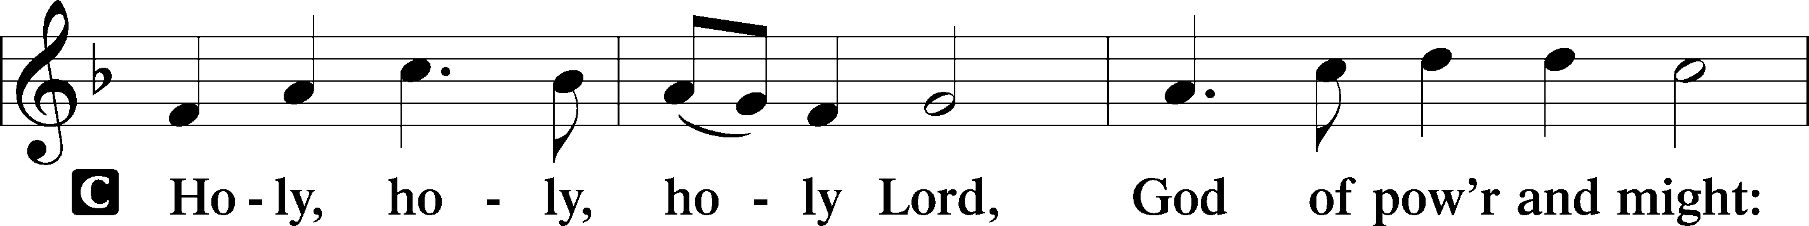
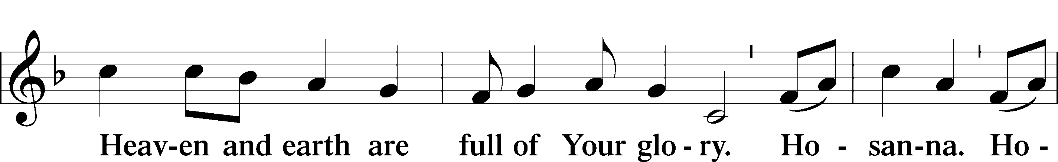
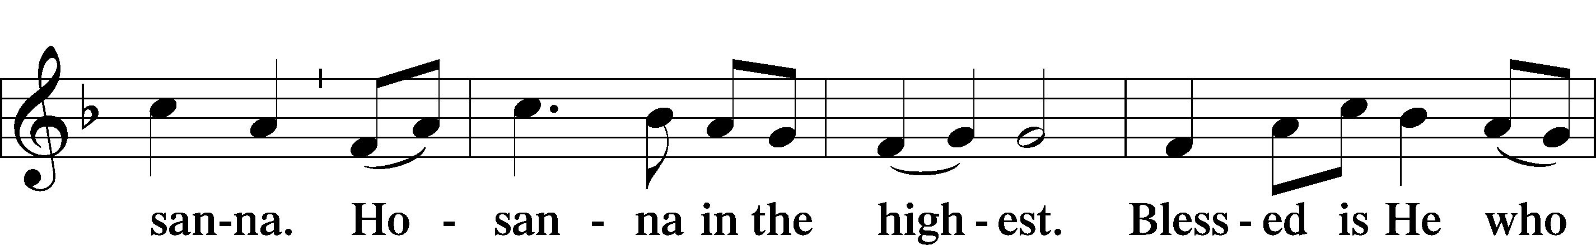
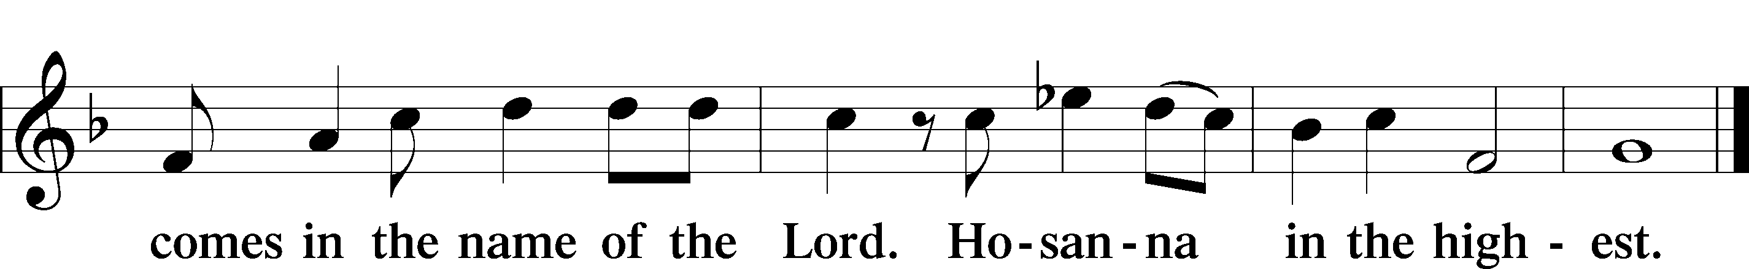

PRAYER OF THANKSGIVING
Blessed are You, O mighty God, King of all creation, for You have had mercy on us and given Your only-begotten Son that whoever believes in Him should not perish but have eternal life.
You have come unto us in the babe of Bethlehem, who grew up to live the holy life we cannot live so that, by His death and resurrection, we are granted forgiveness, full and free, and drawn unto You for all eternity.
All glory and honor belong to You, O Lord, as You fill us with Your presence in this sacred Meal that we may forever rejoice in Your salvation.
Hear us as we pray in Your Son’s name and in the words He has taught us:
LORD’S PRAYER
Our Father, who art in heaven, hallowed be thy name, thy kingdom come, thy will be done on earth as it is in heaven. Give us this day our daily bread; and forgive us our trespasses, as we forgive those who trespass against us; and lead us not into temptation, but deliver us from evil. For thine is the kingdom and the power and the glory forever and ever. Amen.

THE WORDS OF OUR LORD
Our Lord Jesus Christ, on the night when He was betrayed, took bread, and when He had given thanks, He broke it and gave it to the disciples and said: “Take, eat; this is My body, which is given for you. This do in remembrance of Me.”
In the same way also He took the cup after supper, and when He had given thanks, He gave it to them, saying: “Drink of it, all of you; this cup is the new testament in My blood, which is shed for you for the forgiveness of sins. This do, as often as you drink it, in remembrance of Me.”

PAX DOMINI
The peace of the Lord be with you always.
Amen.

AGNUS DEI, pg. 163
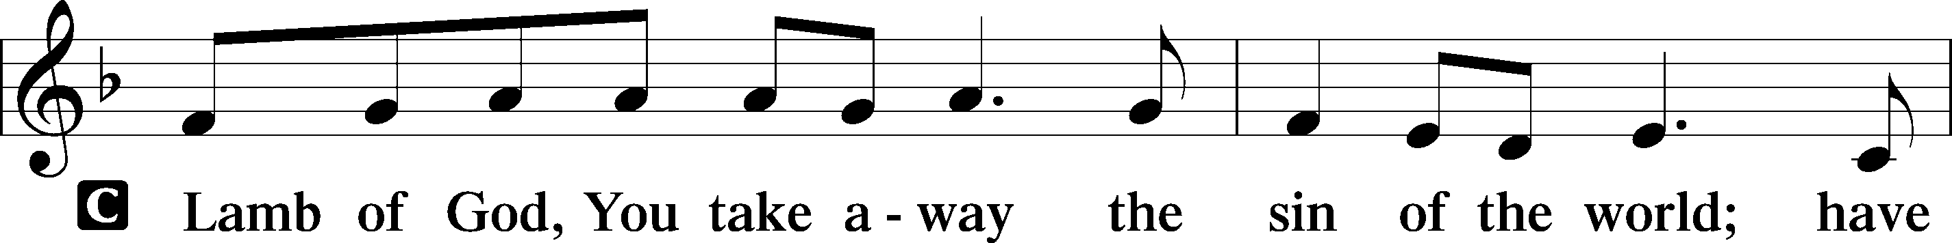
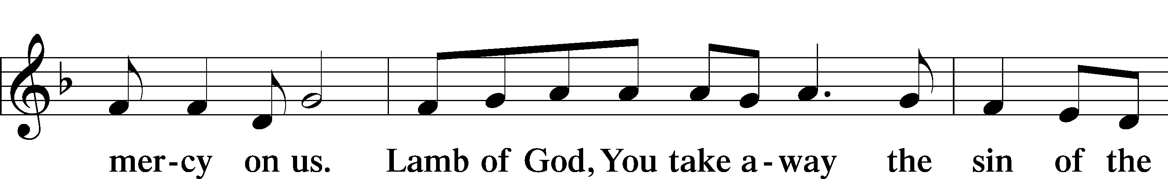
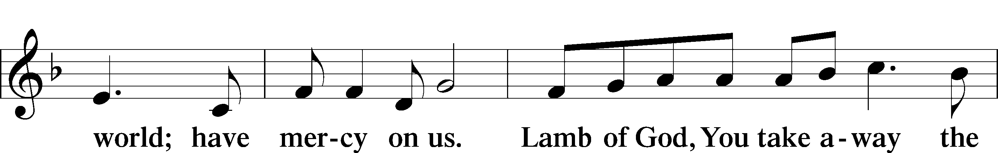
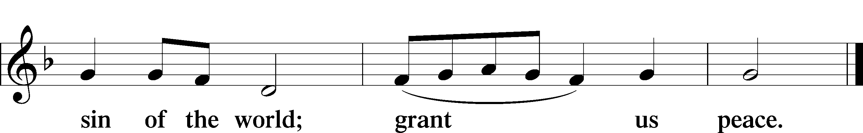

DISTRIBUTION - (Ushers will invite you to come forward to the Lord’s Table to receive Christ within the bread and wine of Holy Communion. If you are able, please kneel at the rail beginning at the center. Extend your hand to receive the bread. You may receive the wine, either by individual or common cup. Non-alcoholic wine is available in the center of each tray. Those not baptized or instructed in the Biblical teaching of Holy Communion may come forward to receive a blessing. Simply cross your arms across your chest to receive a blessing. “Come, for all has been made ready!” Luke 14:17)

DISTRIBUTION HYMNS:
“Angels from the Realms of Glory,” No. 367
1 Angels from the realms of glory, Wing your flight o’er all the earth;
Ye who sang creation’s story, Now proclaim Messiah’s birth. Refrain

Refrain: Come and worship, come and worship;
Worship Christ, the newborn King.

2 Shepherds in the field abiding, Watching o’er your flocks by night,
God with us is now residing, Yonder shines the Infant Light. Refrain

3 Sages, leave your contemplations, Brighter visions beam afar;
Seek the great Desire of nations, Ye have seen His natal star. Refrain

4 Saints before the altar bending, Watching long in hope and fear,
Suddenly the Lord, descending, In His temple shall appear. Refrain

D 5 All creation, join in praising God the Father, Spirit, Son,
Evermore your voices raising To the_eternal Three in One. Refrain

“Gentle Mary Laid Her Child,” No. 374
1 Gentle Mary laid her child Lowly in a manger;
There He lay, the Undefiled, To the world a stranger.
Such a babe in such a place, Can He be the Savior?
Ask the saved of all the race Who have found His favor.

2 Angels sang about His birth, Wise Men sought and found Him;
Heaven’s star shone brightly forth Glory all around Him.
Shepherds saw the wondrous sight, Heard the angels singing;
All the plains were lit that night, All the hills were ringing.

3 Gentle Mary laid her child Lowly in a manger;
He is still the Undefiled But no more a stranger.
Son of God of humble birth, Beautiful the story;
Praise His name in all the earth; Hail the King of glory!

“Of the Father’s Love Begotten,” No. 384
1 Of the Father’s love begotten Ere the worlds began to be,
He is Alpha and Omega, He the source, the ending He,
Of the things that are, that have been,
And that future years shall see
Evermore and evermore.

2 Oh, that birth forever blessèd, When the virgin, full of grace,
By the Holy Ghost conceiving, Bore the Savior of our race,
And the babe, the world’s Redeemer,
First revealed His sacred face
Evermore and evermore.

3 This is He whom seers in old time Chanted of with one accord,
Whom the voices of the prophets Promised in their faithful word.
Now He shines, the long-expected;
Let creation praise its Lord
Evermore and evermore.

4 O ye heights of heav’n, adore Him; Angel hosts, His praises sing.
Pow’rs, dominions, bow before Him And extol our God and King.
Let no tongue on earth be silent,
Ev’ry voice in concert ring
Evermore and evermore.

D 5 Christ, to Thee, with God the Father, And, O Holy Ghost, to Thee
Hymn and chant and high thanksgiving And unending praises be,
Honor, glory, and dominion,
And eternal victory
Evermore and evermore. Amen.

POST-COMMUNION THANKSGIVING
Let us pray. We give thanks to You, almighty God, that You have refreshed us through this salutary gift, and we implore You that of Your mercy You would strengthen us through the same in faith toward You and in fervent love toward one another. Set us free from all our fears that we rejoice in the salvation You have freely given us; through Jesus Christ, Your Son, our Lord, who lives and reigns with You and the Holy Spirit, one God, now and forever.
Amen.

BENEDICTION
Unto us
a child is born!

Unto us
a son is given!

And the government shall be upon His shoulder.
And His name shall be called Wonderful Counselor, Mighty God, Everlasting Father, Prince of Peace.

The Lord bless you and keep you.
The Lord make His face shine on you and be gracious to you.
The Lord look upon you with favor and give you peace.
Amen.

CLOSING HYMN “Go Tell It on the Mountain,” No. 388
Refrain: Go tell it on the mountain, Over the hills and ev’rywhere;
Go tell it on the mountain That Jesus Christ is born!

1 While shepherds kept their watching O’er silent flocks by night,
Behold, throughout the heavens There shone a holy light. Refrain

2 The shepherds feared and trembled When lo, above the earth
Rang out the angel chorus That hailed our Savior’s birth. Refrain

3 Down in a lonely manger The humble Christ was born;
And God sent us salvation That blessèd Christmas morn. Refrain

POSTLUDE
Grace is for all!

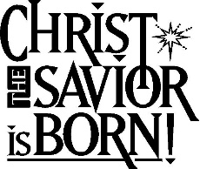
Participants
Preacher . . . . . . . . . . . . . . . . . . . . . . . . . . . . . . . . . Rev. Eric Stacy
Celebrant. . . . . . . . . . . . . . . . . . . . . . . . . . . . . . . . Rev. Nate Ruback
Communion Assistant. . . . . . . . . . . . . . . . . . . . . Mr. Bob Kirschner
Organist. . . . . . . . . . . . . . . . . . . . . . . . . . . . . . . . . Rev. John Greene

