GRACE LUTHERAN CHAPEL (LC-MS)
St. Louis, MO 63137
Church Office: 314-868-3232 School Office: 314-867-6564
e-mail: churchoffice@gracechapelstl.org FAX: 314-868-2485
websites: www.gracechapelstl.org www.graceschoolstl.org

First Sunday after Christmas – December 28, 2025

GRACE NOTES

SERVING TODAY -
Preacher and Liturgist: Pastor Eric Stacy
Organist: Mrs. Lisa Fackler

USHERING THIS SUNDAY –
(9:30 AM) – Youth Team
USHERING NEXT SUNDAY (January 4)
(8:00 AM) – Mr. Mike Roth (10:30 AM) – Mr. Gary Stein

2026 CONTRIBUTION ENVELOPES are available for pick up in the narthex.

THE NEW QUARTERLY EDITION OF THE PORTALS OF PRAYER (January-March) is now available in the narthex. Copies are available to all. We do ask that you make a donation towards the cost of these magazines. Envelopes for your donation are available on the small oak shelf with the Portals of Prayer. Your donation of $17.25 for the large print or $9.50 for the small, pocket size will cover the annual cost of these booklets. A donation of any amount would be appreciated.

“LUTHERAN WITNESS” RENEWALS and new subscriptions are needed by Sunday, February 1, 2026. Please use the envelope in your 2026 contribution packet. Your donation of $20.65 will cover the cost of the annual subscription.

LHSN ANNUAL BAND AND CHOIR TOUR – If you would be interested in supporting the February 13-16, 2026, tour to Milwaukee, Wisconsin, please stop by the church bulletin board and scan the QR code to see how you can give. Approximately 27 students plan to go – an all-time high in recent years! Your support would be greatly appreciated.

GIVING OPTIONS – Check out the Grace Chapel website, www.gracechapelstl.org, for electronic giving options. You can now give via PayPal (for one-time donations) or the Simply Giving program through Vanco Services. To set up recurring, electronic donations through Simply Giving, contact the church office at
314-868-3232 or email churchoffice@gracechapelstl.org. These donations can be debited directly from either a checking or savings account.

DONATIONS FOR THE FOOD BANK at St. Peter’s Lutheran Church in Spanish Lake can be placed in the box in the narthex. Looking for canned goods and other non-perishable items. Monetary donations can be made by check payable to Chapel of the Cross and marked for food bank. Any donations will help. Thank you.

YOU’RE INVITED to join the members of Our Redeemer Lutheran, 9135 Shelley, Overland 63114, on Sunday, December 21, at 3:00 PM as instrumental, vocal, and handbell choirs lead the musical service “Come, Lord Jesus.” A free-will offering will support Our Redeemer’s Music Ministry.

LISTEN TO KFUO.ORG - Through January 6, KFUO Radio will celebrate the Christmas season with special programming, including sacred music, Scripture readings, and greetings from missionaries and chaplains of The Lutheran Church—Missouri Synod. Listen online at kfuo.org or on your Amazon Alexa device.

THE CONCORDIA SEMINARY LAY BIBLE INSTITUTE presents “The Unambitious Ambition: Leading Quiet Lives of Hope” Saturday, February 5, 2026, FROM 10:00 AM – 3:00 PM in Sieck Hall 202 on the Seminary Campus. Program is led by Dr. Ryan Tinetti. Registration is $25.00; $43.00 with lunch. Registration deadline is January 26, 2026. Contact 314-505-7286 or ce@csl.edu.



Calendar for Week of December 28, 2025

Sunday, December 28
One Service at 9:30 AM – Worship
(Sunday School and Bible Class will NOT meet.)

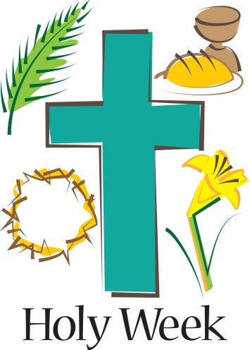
Monday, December 29

Tuesday, December 30

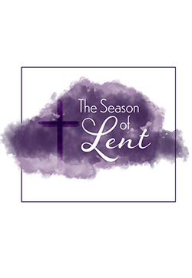
Wednesday, December 31- New Year’s Eve
5:00 PM – Worship with Holy Communion

Thursday, January 1, 2026 – New Year’s Day

Friday, January 2
Church office closed.

Saturday, January 3
4:00 PM – Worship with Holy Communion

Sunday, January 4
8:00 AM – Worship with Holy Communion (Live streamed – info on website)
9:15 AM -- Sunday School preschool - 6th grade (Memorial Hall)
Youth/Young Adults – Pastor Eric Stacy and Mr. Kevin Williams (Youth Room)
Adult Bible Class – Pastor Nate Ruback (Fellowship Hall)
10:30 AM – “Living Praise” Worship with Holy Communion (Live streamed – info on website)

SEMINARY FOOD BANK REMINDER! We continue to collect non-perishable food items and paper products for the Concordia Seminary Food Bank. Our main collection is on the last Sunday of the month, but donations can be placed in the big blue box in Fellowship Hall at any time! Cash donations are also accepted – make check payable to Grace Lutheran Chapel and give to the church office.

DON’T FORGET Boy Scout Troop 551 is collecting aluminum cans and scrap metal. Cans can be placed in the snack bar area or larger bags can be put in the old oil tank next to the garage on the northwest corner of the parking lot. Call Mike Yarbrough at 314-393-8392 if you have any large scrap metal items you’d like to donate.

Use Your Tax Dollars to Support Lutheran Education Taxpayers to the state of Missouri—both individuals and businesses—have the unique opportunity to direct up to 50% of their state taxes to Lutheran Education. The tax credit program, MOScholars, allows the Missouri District to convert tax dollars into scholarships for qualifying students attending LCMS schools throughout the state. Reserving these tax credits is easy and can be completed online in a matter of minutes. Head to https://mo.lcms.org/moscholars/ to learn more about MOScholars and get the process started. Questions can be directed to Leah Sieveking at 314-590-6211 or leah.sieveking@mo.lcms.org. Thank you for your participation in MOScholars through the Missouri District!

