**My Dear Family of Faith,**

It is with great emotion and gratitude that I address you now. In the name of our Lord and Savior, Jesus Christ, I send you greetings and blessings. Your continued collaboration and support have been a fundamental pillar in our ministry in Costa Rica, and it is an honor to share with you the latest updates and reflections that have filled us with hope and renewed our commitment to the Lord's work.

The two words that come to mind in this newsletter are prayer and faith, which come to mind as I think of you, dear brother and sister in Christ.

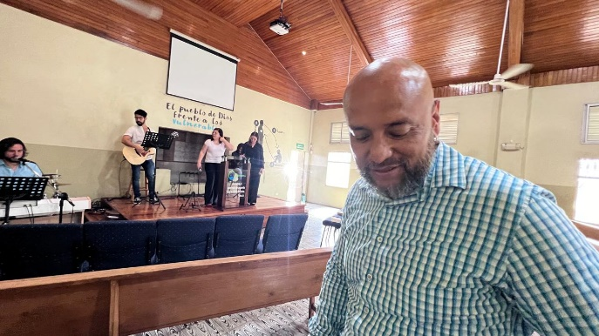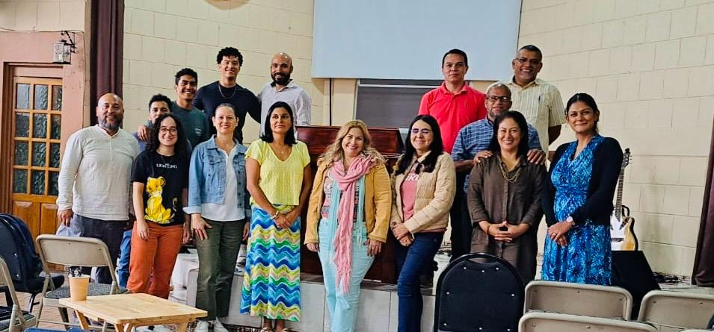Ministry has been a blessing. I am focused on faithfully helping the students. I am encouraging them and assisting them in their Christian education. At first, I came to believe that not being from Costa Rica would make it difficult for me to be accepted, and for them to take my ongoing encouragement and assistance would be hindered because I was not Costa Rican. I thank God that the result was the complete opposite. I have been embraced completely, and my counsel has been accepted. It comes down to the fact that it is not about what nation I am from, but because we share Christ. Our citizenship is in heaven, and based on that fact, I am accepted in Christ. For that I am thankful and joyful. Thank you for your prayers in ministry; I know God answers prayers, and God made this possible. Knowing that we are in your prayers is encouraging and uplifting.

Amid our daily activities, we remember that prayer is the foundation of our ministry. We cling to the promise that all things work together for the good of those who love God, and in that assurance, we find comfort and hope. As the Gospels teach us, prayer is the mainstay of our relationship with God, and we find strength and direction to move forward.

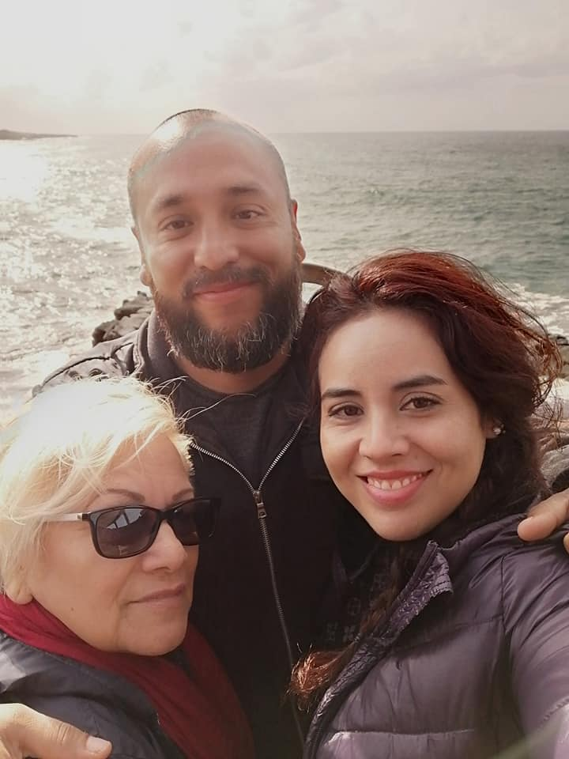Your prayers are a balm for our souls, and at this current time, particularly, I want to ask you to raise your prayers for my mom. She has been diagnosed with cancer and has started her fight against thyroid cancer and two tumors found on her pancreas that are yet to be diagnosed. They are first going to treat what has been confirmed as cancerous, her thyroid. We know that the power of prayer is excellent, and we trust that together we can sustain it during this difficult time.

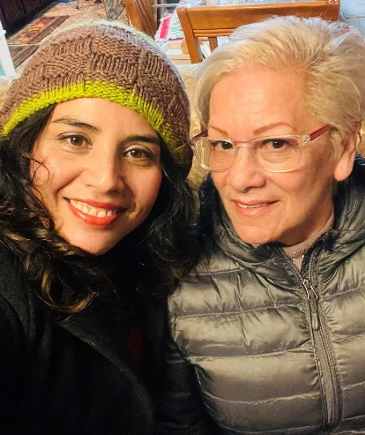The news of such a devastating illness confronts me and invites me to reflect on what it means to be in Christ when faced with strong emotions. Uncertainty, fear, and anguish can invade my heart, but amid darkness it is essential to hold on to true hope and true faith that God has given, and which is found only in Christ. Even though my mom faces a difficult battle, she is not alone on this path. God reminds us, “Do not fear, for I am with you; Do not anxiously look about you, for I am your God. I will strengthen you; surely, I will help you; surely, I will uphold you with My righteous right hand.” (Isaiah 41:10)

These words remind us that God is our refuge and strength amid adversity and that we can trust in His power to sustain us. This is also a reminder that faith does not eliminate suffering but sustains us in the midst of it. We trust that God is present in every moment of this battle, guiding the hands of doctors, comforting grieving hearts, and providing hope amid adversity. Let us keep the flame of hope and faith alive, knowing that in the union of our prayers and our love we find comfort and strength to move forward.

Over the past few months, we have witnessed God's faithfulness every step of the way. Despite the challenges we have faced, His hand has been always guiding and providing for us. Your prayers have been an inexhaustible source of strength and comfort for us, especially in the most challenging times. The successful renewal of our permit in Costa Rica has been one of the most outstanding achievements recently, and we are now living in a new location in Santa Ana, which is in the metropolitan area of the state capitol, where we will continue our work with dedication. Your prayers and support have been 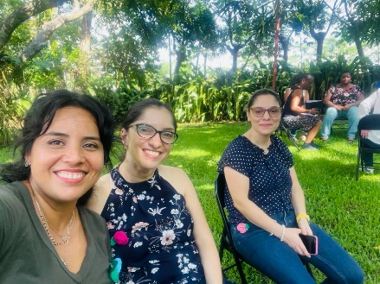instrumental in meeting our needs; seeing God use you all for His glory is beautiful.

I wish to share reflections on the importance of faith and trust in God's sovereignty amid trials and tribulations. In difficult times, it is critical to hold on to our faith and remember that God controls everything. Faith is the foundation of our relationship with God. It is believing in what we do not see, trusting in His perfect plan even when we do not fully understand. As Scripture teaches us, “Wow, faith is the assurance of things hoped for, the conviction of things not seen.” Amid adversity, our faith is strengthened by remembering God's promises and trusting His faithfulness. Confidence in God's sovereignty is knowing He has a perfect plan for each of us. Although we sometimes do not understand why certain situations happen, we can rest in the fact that God works all things for our good. As Romans 8:28 says, “And we know that [a]God causes all things to work together for good to those who love God, to those who are called according to His purpose.” In the midst of trials and tribulations, it is natural for doubts and fears to arise in our hearts. However, it is in those moments that we must hold on even tighter to our faith and trust that God has a greater purpose behind every situation.

In conclusion, let us always remember that Jesus is close to those who suffer. Amidst our afflictions, we can trust in the all-powerful love of God, who always sustains us believers. Our faith not only strengthens ourselves, but it is also a powerful witness to those around us. Dear family of faith, let us always keep our faith and trust in God’s sovereignty. May our lives reflect the hope and peace of an intimate relationship with our Lord. Let us continue to pray for one another, sustaining each other in love and faith.

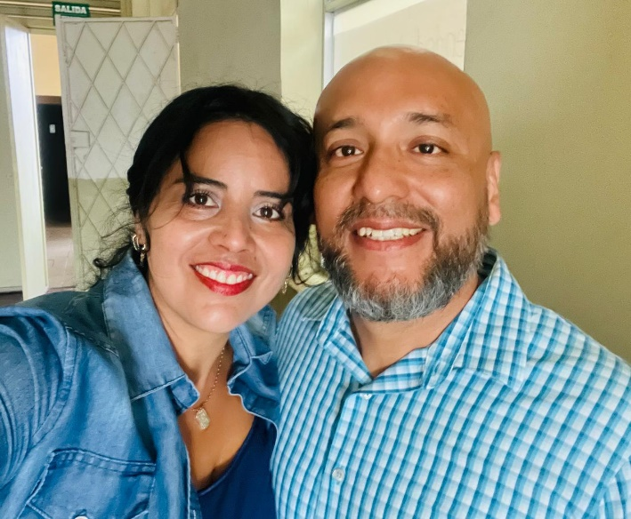

With love and gratitude in Christ,

Pastor Fernando Rocha