**Lesson 1: Firm in the Gospel** *Colossians 1:1–14*

**Hook**

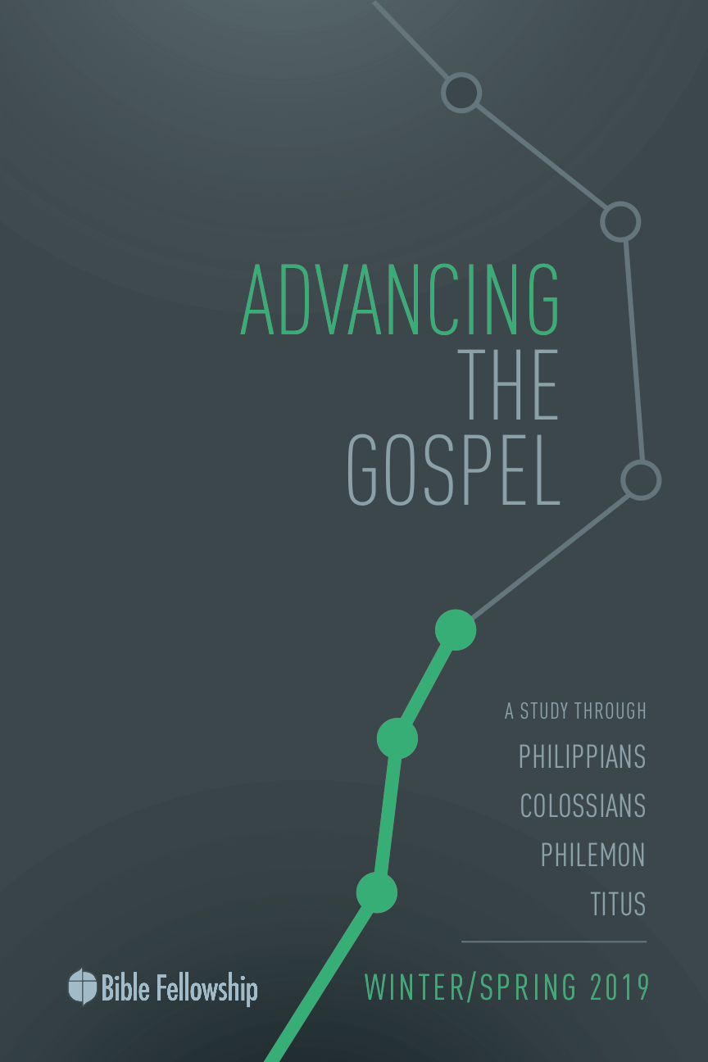

**Main Point: We advance the Gospel when we believe the Gospel and bear fruit.**

As Christians, we should be thankful for much. Paul does a wonderful job modeling what it looks like for the Christian to rejoice over what Christ has done in his own life as well as Christ’s work in other believers. It’s no small thing when God moves someone from death to life. Paul understands this.

Using Paul’s example, pass out blank notecards or stationery to everyone present in your group. Give them five minutes to write a personal note of gratitude to someone in their life who has either played an important role in their own salvation, or someone whom they themselves have had the joy of leading to Christ. Have the class members turn to Colossians 1 and model their note of thanksgiving after Paul’s words of thanksgiving for the Christians at Colossae.

***Why is giving thanks to God for your own salvation important?***

***Why is it important to continually rejoice over the salvation of others in your life?***

***What are practical steps to help in conveying gratitude more often for the work Christ is doing in others?***

**Lesson 1: Firm in the Gospel** *Colossians 1:1–14*

**Book**

**Main Point: We advance the Gospel when we believe the Gospel and bear fruit.**

**Text Summary:**  Paul goes at length to give thanks for the Colossians’ faith in Christ. His introduction to this letter starts with thanksgiving and transitions into prayer. While Paul rejoices in the faith of the Colossians, his prayer is that they would continue in the faith, and that their lives would bear fruit in the world through the power of the Spirit. He prays for continuation in the very things he rejoices over. Paul closes these verses with a reminder of the rescue of God in Christ for those who believe.

**Philippians 1:1–8 [Read]**

**Sub-Point 1:** Rejoice when others believe the truth of the Gospel.

***How does Paul describe the believers at Colossae?***

In verses 3–8, Paul wants to show the Colossians how he is thanking God for them and for their faith in Christ. Paul lays out the reasons for his rejoicing. In verses 3–4, Paul is elated that these dear believers have come to know the truth of the Gospel and put their faith in Christ. N. T. Wright mentions that in verse 4, Paul explains this faith “is in Christ—it’s not only personal commitment, but belief that certain things are true.”[1] Meaning, Paul uses this phrase to show that he is thankful they believe the truth surrounding Christ and His mission to offer forgiveness for sin through His sacrificial death on the Cross. Paul identifies the Colossians’ faith, hope and love in verses 4–5. He commends their faith in Christ, their love for one another, and the hope that awaits them now as sons and daughters of God.

***Knowing that belief in the Gospel message means belief that certain things are true, what are those important aspects of the Gospel that one must believe?***

For Paul, the fruit of the Gospel can be seen in the very faith of these believers at Colossae. Wright comments, “God is doing through the gospel what he always intended to do. He is sowing good seed in the world and preparing to reap a harvest of human lives recreated to reflect his glory.”[2] The Gospel advances as believers put their hope and trust in Christ and the Spirit, and then they are commissioned as lights in the world to bring others to saving knowledge of God in Christ.

Paul finds it necessary and valuable that the Colossians understand the Gospel in verse 6. “The word here translated “understood” indicates that the response sought an intelligent thinking through and recognition of that truth. Paul was in no doubt about the Colossians’ state of heart, but he knew that Christian emotion must be undergirded with a clear-headed grasp of truth.”[3] He rejoices that the Gospel reached these believers, and that they understand the truth of Christ. Paul understands that the Gospel at this point in history has not reached the ends of the earth. His language is more symbolic of who the Gospel is for. One source even mentioned Paul’s motto being “the whole Gospel for the whole world.”

***What does it mean for the Gospel to bear fruit in the world and in individuals’ lives?***

The Colossians have a picture of Gospel multiplication and advancement in the example of Epaphras (vv. 7–8). Epaphras is an example of Gospel faithfulness, as well as a key role in the Colossians seeing how the Gospel moves forward. Just as Epaphras brought the Gospel to the Colossians, so too must the Colossians take the Gospel forward and into the lives of others.

***What does it mean that Epaphras was a “faithful minister” on behalf of the Colossians? (v. 7)***

**Colossians 1:9–12 [Read]**

**Sub-Point 2:** Pray for others to faithfully bear the fruit of the Gospel.

Now that Paul has laid out why he is thankful for the Colossians, he moves on to pray that the work of the Gospel would continue in their lives. Verses 9–12 are a direct parallel to his verses of thanksgiving found earlier in the chapter. Paul’s point is this: “even as the gospel is fruitful, those who have embraced the good news should bear spiritual fruit.”[4] Paul is praying they would continue the course they’ve begun in the Gospel.[5] The chart below shows Paul’s use of parallel structure in his thanksgiving and his prayer for the Colossians.[6]

*“since the day you heard”* ***v. 6*** *“since the day we heard”* ***v. 9***

*“thank”* ***v. 3*** *“giving…thanks”* ***v. 12***

*“always”* ***v. 3*** *“not stopped”* ***v. 9***

*“when we pray for you”* ***v. 3*** *“praying for you”* ***v. 9***

*“understood”* ***v. 6*** *“knowledge”* ***vv. 9–10***

*“bearing fruit and growing”* ***v. 6*** *“bearing fruit … growing”* ***v. 10***

Paul shows the Colossians that the power and work of the Gospel doesn’t stop with them; it keeps going. Paul prays they would be filled with knowledge of the will of God in verse 9. Believers can get hung up on the mystery of God’s will. Yet in verse 9, Paul isn’t using this phrase as modern-day Christians understand it. Moo writes, “What Paul has in mind is not some particular or special direction for one’s life (as we often use the phrase, ‘God’s will’), but a deep and abiding understanding of the revelation of Christ and all that he means for the universe (vv. 15–20) and for the Colossians (vv. 21–23).”[7] This knowledge, given by God himself, should fill the Christian and produce Gospel fruit in them and around them. The Christian cannot muster this work on his own; it comes through God’s power at work in His Church.

***What does it look like for the Gospel to continue to work in individual lives after coming to faith in Christ?***

Paul uses knowledge again in verse 10. Paul wants the Christians to live rightly, but also think rightly about God and His work in Christ. One commentator explains, “A worthy walk is not only characterized by fruit-bearing for God; it is also typified by knowledge of God.”[8] Bruce explains this further, “This knowledge is no merely intellectual exercise, no theosophical *gnōsis* such as was affected by the teachers who threatened to lead the Colossian church astray.… True knowledge … is that knowledge which, as the OT wisdom writers affirmed, started with a proper attitude toward God. Right knowledge leads to right behavior.”[9] Paul says it is this knowledge that will empower them to live in a manner worthy of the Lord. This echoes Philippians 1:27, that the church would live in a manner worthy of the Gospel.

***How does knowing truth about God influence the way one lives? Why does knowledge come before behavior?***

As the Christian believes the Gospel, he will bear fruit. As John 15 explains, those who abide in the vine will produce life-giving fruit. Because they understood the Gospel and have come to faith, their lives now should give evidence to the Gospel’s work. Moo says, “Paul’s use of the verb meaning ‘walk’ picks up a common Jewish and Biblical idiom, according to which a person’s lifestyle is pictured as a road that one travels along.”[10] Christians walk along the road of the Gospel.

The Christian life is one characterized by patience and endurance, Paul says. But more importantly, it is a life empowered by the strength of God at work in the believer. This is the psalmist’s cry, “Grant your strength to your servant” (Psalm 86:16). Paul desires that these Christians at Colossae would not only bear spiritual fruit but do so with joy and thankfulness. Paul keeps in mind that it is God that qualifies them and empowers them.

***Why can Christians practice patience endurance with joy? (v. 11)***

**Colossians 1:13–14 [Read]**

**Sub-Point 3:** Remind others of the hope of the Gospel.

Paul closes out these verses with a reminder of the hope that believers have in Christ. Paul uses these verses concerning what God has done in Christ to show exactly how it is that God qualifies believers. Again, it is worth restating for Paul that it is God who empowers, rescues, and redeems His sons and daughters. This echoes other writings of Paul (Romans 3, 5; Ephesians 2).

***How has Christ secured redemption for believers?***

Because believers are now citizens of a new kingdom (Philippians 3), they live and work in light of their new home. God has delivered Christians through His Son, Christ, and now Christians produce fruit by the power of His Spirit for the advancement of God’s Good News. But it will not be without a fight. The “domain of darkness” language in verse 13 “is found elsewhere in Paul (Romans 13:12; Ephesians 5:8; Philippians 2:15; 1 Thessalonians 5:5) and is not uncommon in the NT.… Although Colossians contends that Christ is superior to and more powerful than any other and all else, it nevertheless acknowledges the sinister power of lesser authorities that Christ, and through him Christians, must overcome and conquer.”[11]

***What does it mean that believers have been transferred from the domain of darkness into the kingdom of God’s Son?***

Yet even in the midst of struggle, Christians must remember for themselves and remind others that Christ is, in fact, more powerful than the earthly forces at work, and that God has graciously rescued His children from sin and death by the blood of his Son, Jesus (v. 14). This news is the truth that Christians believe, the power behind Christian fruit, and the hope enabling Christian endurance.

**Lesson 1: Firm in the Gospel** *Colossians 1:1–14*

**Took**

**Main Point: We advance the Gospel when we believe the Gospel and bear fruit.**

Paul modeled well how Christians should rejoice and pray for one another. With sin at work in the world, Christians need God’s power daily to walk in a manner worthy of the Gospel. After experiencing the power of God in salvation, believers need the power of God to produce kingdom fruit for the sake of further Gospel advancement. In this way, the Christian life continues on in the very truth they believed in for redemption.

**Challenges**

Use Paul’s structure of prayer for the Colossians in verses 9–14 to pray for fellow believers in your life this week. Pray with Paul that:

1. Believers would know the Lord’s will: I pray that the Lord would fill you with a knowledge of His will for your life, for His Church, and for the world. Pray that it wouldn’t be your will, but His, in every decision and every key turning point. May the Lord grant this to you.

2. The Lord would give wisdom: This isn’t wisdom that comes from the world or life experience, but rather wisdom that comes from His Spirit. Pray that the Lord would give you His mind and His counsel. James says we must ask for this, and so I am asking this for you.

3. The Lord would give understanding: I pray that you would have a deep, spiritual understanding of reality. Knowing that sin is at work, knowing our own limitations, I pray the Lord grant you an understanding of the gospel and how that changes the flow of our thoughts and comprehension of all things.

4. Believers would walk in holiness: I pray the Spirit would give you power to fight sin, to show Christlike love and compassion, to pursue dependence on the Spirit and to abide in the True Vine so that you, in turn, would live a life of obedience, according to 1 John 5.

5. Your life would be pleasing: I pray you would embrace Christ in your place and that your life, through Christ, would be a sweet aroma to the Father.

6. Your life would bear fruit: I pray that the Spirit would work in you in such a way to bear spiritual fruit in God’s kingdom, showing signs of the restoration that is to come; that you would not quench the Spirit’s power and movement in your daily life so that evidences of God at work in the world and His people would be all around you.

7. You would continue knowing God: I pray you would increase in your knowledge of who God is. I pray this would be a moment-by-moment reality. Whatever comes, whatever God brings, I pray each circumstance would bring you deeper into knowing God’s heart and His character.

8. Believers would live by His power: I pray that you would be strengthened by His power, not your own; that you would know your inability to make things happen and trust that His power, the same power that raised Christ from the grave, is at work in you and available to you in its fullness.

9. You would endure: I pray you would keep going; that you wouldn’t be discouraged today. I pray the Lord would give you a sweet strength to keep pushing even when things get hard. It is the Lord who continues to strengthen us and keep us from stumbling. As you seek to endure, simply lean on Him and into Him.

10. You would be patient: I pray that you would know that the Lord is working and that He knows every small detail of what’s happening. Trust Him. Trust is what allows you to be patient. You will only be patient to the extent that you trust God is actually in control.

11. You would have joy: I pray that you would know where true joy comes from; that it would be a joy to you that you are on a journey with Christ. Let Him keep you from the temporary woes that fight to steal your joy and cause your spirit to descend into despair and discouragement.

12. You would be grateful: I pray that you would always thank God for what He’s done in you, for you, and through you. Thank Him that He’s brought you into His family, and that He has done what is necessary to call you a son or daughter. I pray that you would constantly dwell on the gladness of the Gospel.

1. N. T. Wright, *Tyndale New Testament Commentary: Colossians and Philemon.* [Downers Grove, IL: InterVarsity Press, 1986], p. 54.
2. Ibid., 58.
3. Ibid.
4. Longman & Garland, *The Expositor’s Bible Commentary: Ephesians – Philemon*, 284.
5. Douglas J. Moo, *The Pillar New Testament Commentary: The Letters to the Colossians and to Philemon*. [Grand Rapids, MI: Eerdmans, 2008], p. 92.
6. Moo, *The Pillar New Testament Commentary: Colossians and Philemon,* 92.
7. Ibid., 93.
8. Longman & Garland, *The Expositor’s Bible Commentary: Ephesians – Philemon*, 284.
9. F. F. Bruce, *The New International Commentary on the New Testament: The Epistles to the Colossians, to Philemon, and to the Ephesians.* [Grand Rapids, MI: Eerdmans, 1984], p. 46.
10. Moo, *The Pillar New Testament Commentary: Colossians and Philemon,* 95.
11. Longman & Garland, *The Expositor’s Bible Commentary: Ephesians – Philemon*, 285.