**Lesson 2: Spiritual Wisdom** *Colossians 1:15–23*

**Hook**

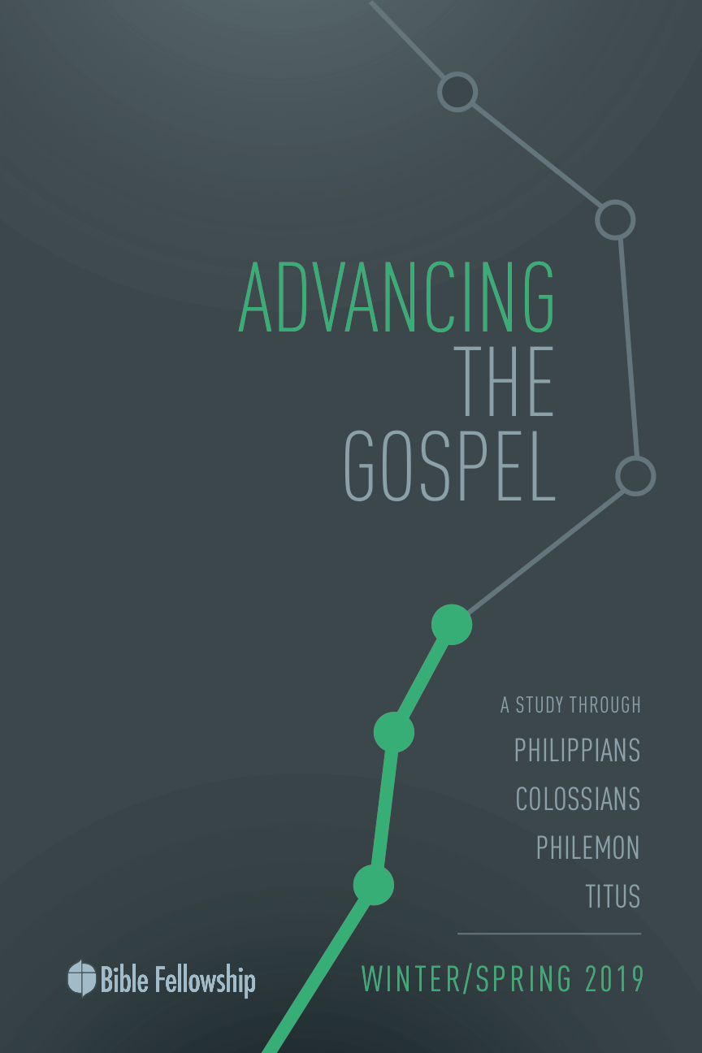

**Main Point: We advance the Gospel in Christ’s power and for Christ’s glory.**

It’s easy to marvel at the lives of celebrities. Whether actors or athletes, they’re always in the spotlight, beckoning our hearts to desire a life and status such as theirs. Not only does societal marketing pressure us to want to be like these cultural icons, but we feel the urge and longing to be associated with people of such status. Just to be at the table with them, in the car with them, a contact in their phone. We look at their lives and think, “How nice it would be if only _________.” Money. Fame. Connections. Societal rank.

Use 3”x5” notecards and pass one out to each member of your group. For this activity, have them write down three celebrities (actor/actress, musician, athlete, fashion icon, author) they would love to meet. Get them to think through the lens of “How crazy would it be if I could spend time/meet _______.” Under each name, have them write a small explanation of why they chose that specific figure.

***What makes celebrities seem so interesting?***

***Why does culture give celebrities such perceived power?***

***Share one or two of the people on your card and the explanations for why you chose them.***

Paul’s aim in this particular passage of Colossians is to show the royalty, worth, authority and in a sense, fame, of Christ. There is none like Him. He has no equal. He has power over all things— and all things, all of creation, answers to Christ alone. He is the true celebrity. He is the true culture-maker. He is the true life-giver. And all who know Him are included in God’s royal, eternal family. That’s the true joy of association.

**Lesson 2: Spiritual Wisdom** *Colossians 1:15–23*

**Book**

**Main Point: We advance the Gospel in Christ’s power and for Christ’s glory.**

**Text Summary:** In the preceding verses, Paul explained the deliverance accomplished by the work of Christ and the redemption offered in Christ. This “He” from verses 13–14 is now identified and qualified. Paul spends these eight verses in the middle of chapter 1 to describe the beauty, divinity and supremacy of Christ. One commentator explained that while Philippians 2:1–11 boasted of Christ’s humanity, Colossians 1:15–23 boasts of Christ’s divinity. Paul uses these verses to describe in depth why Christ is supreme and deserving of all worship and allegiance.

**Colossians 1:15–17 [Read]**

**Sub-Point 1:** Find purpose in Christ’s supremacy.

***According to the first 2 verses, what was the source of all creation?***

***What is the purpose of creation?***

These verses in Colossians 1 are central not only to Paul’s individual letter to the Colossians, but to the entire body of Scripture. Jesus is above all. Jesus is before all. Jesus, in all things, is supreme. And the man Jesus, who lived and walked the earth for 33 years, was more than fully human, He was fully divine. Jesus Christ, the Messiah, is the Good News. He is the Gospel. And Paul wants his readers to know the true nature of the man Jesus; to understand the full nature of God in Christ.

In verse 15, Paul describes Jesus as the image of the invisible God. Paul does this to “show his conviction that the beloved Son is the likeness, representation, reflection, and manifestation of God.”[1] Jesus made the invisible visible. And He did this in such a way to bring further glory to God, not take away from it. Jesus wasn’t a crafted image. He wasn’t a formed idol. For people to place their hope in Christ wasn’t a wrong thing. Paul was helping a Jewish understanding of idol worship. “Like all other Jews, Paul thought God to be invisible, and viewed graven images as idolatrous. After his encounter with the risen Christ en route to Damascus, Paul began to view Jesus as ‘the dwelling place of the divine wisdom, the immanent presence of the transcendent God, the visible image of the invisible God.’”[2]

***Why is it significant that Paul explains Jesus as the image of the invisible God?***

Paul also uses an interesting phrase in verse 15. Paul writes that Jesus is the “firstborn of all creation.” What Paul is not doing here is saying that Jesus was a created being. A popular 3rd century heresy concerning Christ’s divinity and oneness with God was the belief that there was a time before Christ existed. This heretical teaching, taught by Arius, used this verse as evidence. However, the Greek word used here is *prōtótokos* (“firstborn,” GK 4758). Scholars explain Paul’s usage here by stating: “while often used in the literal sense of the first to come from the womb, here it takes on a metaphorical significance based on the ancient attribution of preeminence to the first to be born.[3] Furthermore, “The LXX usually employs the word in reference to birth order. Among the Israelites, firstborn sons possessed privileges not afforded to other progeny. This fact gave rise to a metaphorical use of *prōtótokos* to express status and primacy … he was before all creation in time and is above all creation in rank.”[4]

Christ deserves the ultimate status. Nothing in creation compares to Him. He has no rival. He has no equal. One scholar states, in connection with verse 16, that Christ is the key to creation.[5] Creation flowed from Christ and is sustained by Him. This is how we find purpose in Christ’s supremacy: we were created for Him. There is a beautiful connection here with creation and, what will be mentioned later, redemption, and how they find their origin in Christ. Bruce comments, “The one through whom the divine work of redemption has been accomplished is the one through whom the divine act of creation took place in the beginning. His mediatorial relation to the created universe provides a setting to the gospel of salvation which helps his people to appreciate that gospel the more.”[6]

Paul uses key phrases in verse 16 to show the complete and total reign of Christ over the universe. Knowing this, believers find hope and purpose that they were made for Christ and are sustained by Christ. Concerning verse 17, Moo writes, “What holds the universe together is not an idea or a virtue, but a person: the resurrected Christ.”[7]

Jesus isn’t distant or apathetic. No, what He created He continues to maintain. He’s not absent. Moreover, as He maintains the created order, He is the purpose of it all. He is the aim and agency of all creation.[8]

***How does Paul describe Jesus in such a way that shows His complete authority over the universe?***

**Colossians 1:18–20 [Read]**

**Sub-Point 2:** Find life in Christ’s victory.

Paul continues with Christ’s supremacy and authority, but he adds something in these next verses that transitions to something deeper. Paul started with creation, now he moves on to the Church, the body of believers, God’s family, and the hope of the kingdom to come. He starts with creation and now moves to *new creation*.

Paul uses *kephalé* (“head,” GK 3051) in verse 18 and “seems to connote both origin and authority … verse 18a is contending that Christ is both the source of and the Lord over the church.”[9] This idea stacks on the idea Paul put forth earlier: Christ is the life in creation, Christ is the life in the Church. He is both the source of creation and God’s family. Moo notes, “The *ekklēsia* (“church”) is no longer, as is typical in the NT usage of the word elsewhere, the local gathering of believers. It is a worldwide entity, embracing all who acknowledge Christ as Lord.”[10] This concept finds its origin in the ancient world; the idea that the head was the governing member of one’s body. The head controlled and provided. This is Paul’s description of Christ’s role.

***How is Christ’s role in the Church similar to the way a human head relates to the rest of the body?***

Paul goes against the false teaching of the day. Instead of “ultimate spiritual experience [having] to be found in places in addition to Christ, Paul holds up Christ as the one who is the true and only source of life for the body.”[11] Paul qualifies Christ as the source of life even further in verse 18 when he writes that Christ is the beginning, the firstborn from the dead. Here again Paul builds on the idea of Christ as the source of creation, except here Paul shows that Christ is the source of new creation. His Resurrection marks the beginning, the start of the process that will culminate in His future return.

His Resurrection shows the path forward; the ultimate aim for all those in Christ. He has supremacy over all because of who He is and what He has done. Christ is, as verse 19 states, the fullness of God. One commentator explains it well by writing, “Why should God’s Son have first place in all things? It is not only because of his resurrection (v.18), or incarnation (v.19), but it is also because of his crucifixion (v. 20).”[12]

***How does Christ’s life, death, and Resurrection qualify Him for receiving first place in all things? Use other Scripture if possible.***

Death could not hold down the Messiah. Because of this, believers now have life in Him. It was pleasing for God to dwell among humanity in Christ, just as it was pleasing for God to work through Christ to save humanity by way of His death (vv. 19–20). This victory, achieved by Christ’s rising from the grave, gives life to those who accept it in faith, as well as start their own process of future resurrection; entering into life as God intended.

***In what ways does Christ’s Resurrection start the process of total resurrection and restoration for the world?***

**Colossians 1:21–23 [Read]**

**Sub-Point 3:** Find belonging in Christ’s kingdom.

Paul encourages the Colossians first by rejoicing in their salvation, but then exhorts them to keep walking in the faith. Notice in verse 21, Paul identifies their status with God before Christ (alienated). They were hostile, Paul says, in their mind, which produced a life of evil deeds. Paul teaches a great lesson concerning the nature of our hearts and minds before Christ. The Colossians engaged in evil deeds because they were hostile in mind. It wasn’t that they were hostile in mind because of their evil deeds. John Owen said it well when he said the seed of every sin is located in every human heart.

***How does Christ bring us from alienation to belonging?***

But instead of alienation, humanity has the opportunity to belong in God’s kingdom. Christ came to save humanity from its rebellious hearts. Paul shows in verse 22 just how God did this: through Jesus. “The reconciliatory means was Christ’s fleshly body, the reconciliatory goal was the Colossians’ right standing before God.”[13] And because of all that God has done, Paul urges the Colossians to stay rooted in the Gospel in verse 23. For Paul, assurance and perseverance were two sides of the same coin. One commentator says it this way: “Assurance of salvation and perseverance in salvation go hand in hand … spiritual fidelity and eternal security were [close] partners for Paul.”[14]

Stay focused on the hope that Christ offers: new creation, new life. Moreover, rejoice in the belonging that believers find in the family of God. Rejoice in the alienation and rebellion that Christ defeated in the heart of every Christ-follower.

***What does it mean to be stable and steadfast in one’s faith? (v. 23)***

**Lesson 2: Spiritual Wisdom** *Colossians 1:15–23*

**Took**

**Main Point: We advance the Gospel in Christ’s power and for Christ’s glory.**

We live in a constantly changing culture. Many times, our tendency might be to get caught up in all that shifts and lose focus on the One that remains the same yesterday, today and forever. Paul’s robust description of Christ gives the Christian hope and assurance amid the ups and downs of this world. No matter what happens, Christ is over all things even when it doesn’t look like it. Christ’s place in the universe gives the Christian daily direction, knowing that whatever gets done, it’s all for Christ and His kingdom. We were made by Him and for Him. And despite our sinful hearts and desires to rebel against God, Christ, by the power of His Spirit, sustains us and brings us into the fold of God.

**Challenges**

**Keep your eyes focused on Him.** No matter what your life looks like from day to day, fight to keep your eyes focused on Jesus and rest in His control. Don’t believe the hopelessness that this world may send your way. Plant yourself on the truth that Christ holds everything together and His Resurrection is assurance that God will have the final word.

**Keep your hope on what’s to come.** Fight to hope in the coming kingdom. Despite the death and decay we see here and now, choose to hope in what is to come. Hope in the day that Christ will return and make all wrongs right and wipe death away for good. Fight to place your hope in what is to come, not what currently is.

**Keep your heart rooted in the Gospel.** In the hard times and even in the good times, keep your heart planted in the Gospel. Remain steadfast and stable in God. Don’t let your heart be swayed by this world. Continue to believe that Jesus is better, that Jesus is enough, and that Jesus is worthy.

1. Tremper Longman III & David E. Garland. *The Expositor’s Bible Commentary: Ephesians – Philemon.* [Grand Rapids, MI: Zondervan, 2006], p. 289.
2. Ibid.
3. Douglas J. Moo, *The Pillar New Testament Commentary: The Letters to the Colossians and to Philemon*. [Grand Rapids, MI: Eerdmans, 2008], p. 119.
4. Longman & Garland, *The Expositor’s Bible Commentary: Ephesians – Philemon*, 290.
5. F. F. Bruce, *The New International Commentary on the New Testament: The Epistles to the Colossians, to Philemon, and to the Ephesians.* [Grand Rapids, MI: Eerdmans, 1984], p. 61.
6. Bruce, *The Epistles to the Colossians, to Philemon, and to the Ephesians,* 62–63.
7. Moo, *The Pillar New Testament Commentary: Colossians and Philemon,* 125–126.
8. Longman & Garland, *The Expositor’s Bible Commentary: Ephesians – Philemon*, 290.
9. Ibid., 291.
10. Moo, *The Pillar New Testament Commentary: Colossians and Philemon,* 128.
11. Ibid.
12. Longman & Garland, *The Expositor’s Bible Commentary: Ephesians – Philemon*, 293.
13. Ibid., 297.
14. Ibid.