**Lesson 3: Him We Proclaim** *Colossians 1:24–2:5*

**Hook**

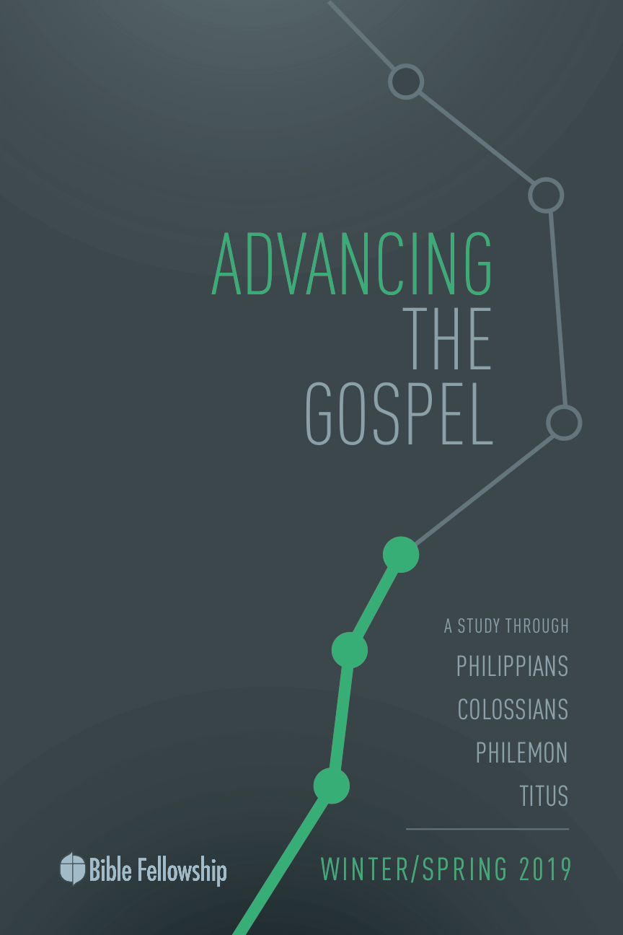

**Main Point: We advance the Gospel when we proclaim good news offered in Christ.**

Suffering isn’t easy. If we aren’t careful, we will slip into believing that living the good life means our lives are free from hardship or trial of any kind. More importantly, we will think the good life means our lives are 100-percent about us and we will remain inwardly focused. When we read the Bible, however, we read a different story. The Bible says that the good life—the life lived for the glory of God and the hope of resurrection—is about suffering for the sake of Christ as we live for Him and serve others. This is what it means to walk in the path that Jesus laid out before us by way of His incarnation, Crucifixion and Resurrection. By suffering, Jesus served. And in serving, Jesus suffered.

In turn, have your group members share a time in their life that was particularly difficult. It could have something to do with work, family, finances or health. Have them share how they thought and felt during the process. If they are out of that season, allow them to share what they learned about themselves and about God. As another touchpoint, allow them to share how they believe their suffering can now be used to serve others. Secondly, have them share a season of life that was difficult because of the hardship brought about by serving someone else. Serving others and bearing their burdens can take a toll on us. Paul explains this well in his letters as he serves these churches. In the same questions from the previous share time, ask them what they learned about God from serving others and sharing in the burdens of others.

***How do you process God’s love during times of suffering?***

***What makes bearing the burdens of others difficult?***

***How does sharing the burdens of others follow in the example of Christ?***

***What are practical steps to take during times of hardship in order to keep your mind focused on biblical truth and the reality of the hope we have in Christ?***

**Lesson 3: Him We Proclaim** *Colossians 1:24–2:5*

**Book**

**Main Point: We advance the Gospel when we proclaim good news offered in Christ.**

**Text Summary:**  Paul reminds the Colossians that believers will suffer for the sake of Christ and believers are to proclaim Christ to a lost world. This is how the Gospel moves forward. Paul makes it clear that this Gospel is for the entire world, not just for a select few. The Gospel goes forward only by the power of God at work in His people.

**Colossians 1:24–25 [Read]**

**Sub-Point 1:** Look to Christ during seasons of trial and hardship.

***How is it that Paul can rejoice in his suffering?***

Paul writes to the Colossians that suffering accompanies the Christian life because it is suffering that bought redemption for the Christian life. But in suffering there is rejoicing. Paul rejoices in his suffering for the sake of the Colossians (verse 24) because Paul understands that suffering is part of the Christian life. To add to this, Paul can rejoice because it is in suffering that one follows in the footsteps of Jesus.

There is much debate surrounding Paul’s language in verse 24. What does Paul mean when he says he is filling up what is lacking in Christ’s afflictions? Was the suffering of Jesus not enough? Did Jesus not accomplish fully what needed to be done to save sinners? Paul absolutely believed that Christ’s sacrifice was enough. In fact, Colossians is clear that Paul did not look at Jesus’ work on the Cross as inadequate (See 1:14, 20; 2:13–15).[1] Wright comments, “[Paul] is not adding to the achievement of Calvary.”[2] Paul is putting into practice what Jesus modeled in His suffering. This is how believers participate in the sufferings of Christ.

***For whom does Paul say he is suffering?***

***Where else in Paul’s letter has he discussed the relationship of Christ and the Church?***

In verse 25, Paul confirms that God called him to serve Christ’s body and pour out his life for the sake of the Church. Though Paul’s—nor the believer’s—sufferings have no redemptive benefit, they are always on behalf of the Church and the forwarding of the Gospel.[3] The idea that Paul’s suffering fills what is lacking connects to ancient Jewish literature. Such literature “speaks of ‘messianic woes,’ tribulations to be endured by God’s people in the last days immediately before the coming of the Messiah.”[4] This means that after Christ’s Resurrection, more suffering was to be experienced by God’s people as they await Christ’s return. Moo continues, “What is lacking, then … are the tribulations that are inevitable and necessary as God’s kingdom faces the opposition of the dominion of darkness.”[5]

This suffering is so that the on-looking world comes to see and know the Gospel, as Paul mentions in verse 25. The idea is that not only the Gospel would be preached, but that it would take root and bear fruit in the lives of Christians. Bruce explains, “The word of God is fulfilled in this sense when it is freely proclaimed in the world and accepted in faith.”[6] Paul wants the Gospel proclaimed *so that* others would accept the Gospel in faith. Moo adds, “God’s word is not ‘filled’ when it’s preached only, but when its preaching accomplishes the purpose God has for it: when it’s heard and produces growth and fruit in the lives of those who respond.”[7]

***What are other places in Scripture that mention the hearing of the Gospel taking root and bearing fruit in believers’ lives?***

The call to advance the Gospel will include suffering and trials; this is true. But Paul wants to redirect the focus away from the suffering and on to the hope of the Gospel and the joy in serving Christ. The glorious reward of people coming to a full understanding of God’s rescue is so much greater than any risk involved in taking the Gospel to the world. As the Church serves Christ, the Church suffers for Christ.

**Colossians 1:26–27 [Read]**

**Sub-Point 2:** Rejoice that the hope of the Gospel is for everyone.

***What mystery is Paul talking about in these verses?***

Verses 26–27 confirm the reason for which Paul was called by God in Acts 9: to bring the message of the Gospel to the Gentiles. Paul uses the word *mystery* to describe this news. Paul writes that this mystery has been kept hidden for ages, but it is now revealed in Jesus. Paul says this has been God’s plan all along. Yes, Jesus was born into a Jewish family. But His mission was to break down the dividing wall of cultures and nationalities to show that through Him, anyone could become a member in the family of God. God knew that one day He would send a Redeemer. But the identity of this Redeemer was hidden until Jesus was born into this world.

Now, the Gentiles are in Christ, and Christ is in them. God’s family now includes more than just the Jews. Longman and Garland write, “Paul sought to convey to the Gentiles that they did not need to remain spiritual ‘foreigners and aliens;’ instead, alongside Israel, they could be ‘fellow citizens with God’s people and members of God’s household.’”[8] The glory and hope of God crosses all societal, cultural and racial boundaries. Paul stresses in Colossians that Christ came to redeem all people, regardless of ancestral heritage. Christ is their hope, the Redeemer made known. Paul explains that the riches of God are great among the Gentiles. They don’t just get a small piece of God. They get all of Him. Paul writes in Ephesians 3:6 that the Gentiles are now fellow heirs. Gentiles and Jews are now on level ground. This is huge news!

***What does Paul mean when he says that “the hope of glory is Christ in you”? (v. 27)***

***Why is the news that the Gospel is being offered to the Gentiles such a big deal? Use Scripture here if possible.***

**Colossians 1:28–2:5 [Read]**

**Sub-Point 3:** Look to Christ for all maturity and knowledge and wisdom.

***According to verse 28, whom is Paul concerned about?***

It’s all about Jesus for Paul. In verse 28, Paul is repetitious with his use of “everyone.” Paul is making a clear point: “There is no part of Christian teaching that is to be reserved for a spiritual elite. All the truth of God is for all the people of God.”[9] Paul builds on the mystery he just explained in verses 26–27; the reality that God’s hope is for the world, not just for Israel.

There has been much discussion on Paul’s use of *teleios* (“perfect,” “mature”) in verse 28. Paul isn’t saying it is his job to attain perfection for Christians or that perfection is possible before Christ’s ultimate return. In fact, “the word *teleois* doesn’t signal sinless perfection as much as Christian maturation.”[10] The *Expositor’s Commentary* continues, “Paul wanted the apostolic privilege and pleasure of presenting to Christ mature believers, not spiritual babes.”[11] This is the joy of true discipleship: planting the Word in the life of another and watching God grow them into spiritual maturity.

Paul knows how easy it is for Christians to be enticed by the surrounding culture. For this reason, he stresses the importance of warning other believers and teaching them well. He wants the Colossians to know how to live and stay true to their calling. In line with Paul’s aim throughout his letters, he desires the people of God to continue living out what they believe. If they’ve come to believe the Gospel, then they must follow that belief and live out the truths and calling of the Gospel.

***How does Paul find the strength to accomplish his calling? Why is this truth vital for Christians to understand and put into practice?***

Paul is clear that Christ is at work in him. The words Paul uses “‘energy’ and ‘works’ come from the same Greek root (*energeia/energeō*) which often refers in the NT to the power of God (Galatians 2:8; Ephesians 1:11, 19–20; 3:7, 20; Philippians 2:13; 3:21; Colossians 2:12).”[12] Paul’s point in verse 29: He would be useless and ineffective if it weren’t for the power of God working through him. The *Expositor’s Commentary* explains this well by saying, “Paul did not expect Christ to do everything for him, but he also knew that he could do nothing apart from Christ.”[13]

In the first five verses of chapter 2, Paul’s aim is simple: seek to know and love Christ above all things, for Christ is all you need. Christ is not, as N. T. Wright explains, “just a clue or a key to [God’s wisdom].”[14] Though Paul is not with them, as he writes in verse 5, he wants them to treasure Christ above everything. Wright continues, “Everything we might want to ask about God and his purposes can and must now be answered – this is the force of the verse – with reference to the crucified and risen Jesus, the Messiah.”[15] That’s Paul’s thrust in verses 2–3.

***For Paul, what is the answer against arguments that come against the faith of Christians?***

**Lesson 3: Him We Proclaim** *Colossians 1:24–2:5*

**Took**

**Main Point: We advance the Gospel when we proclaim the Good News offered in Christ.**

Paul gives a biblical framework for thinking about the Christian life. First, he says there will be afflictions. The Christian life is not free from trial. Second, the Christian life is a life of service unto others. And thirdly, all this is done through the power of Christ working in each individual Christian. This means that the Gospel advances as we suffer while serving through the power of God in us.

**Challenges**

**Rejoice in your suffering**. Paul is clear that suffering does two things. It unites us to Christ and it unites us to His body. We can rejoice in our suffering knowing it is bringing us closer intimacy with Christ and that it is being used for the glory of Christ and the Gospel’s advancement.

**Don’t waste your suffering.** Paul says in his second letter to the Corinthians that God uses our suffering in order that we might comfort others going through times of great trial. Paul didn’t waste his afflictions, knowing they were seasons of Gospel multiplication. Use your times of trial to bring others closer to the Gospel and into a deeper understanding of Jesus.

**Seek Christ in everything.** In all things, know that Christ’s Spirit inside you is giving you the strength to press on. Because of His power at work in you, seek Him above all else. Know that in Him the fullness of God’s power, wisdom and knowledge can be found.

1. Tremper Longman III & David E. Garland. *The Expositor’s Bible Commentary: Ephesians – Philemon.* [Grand Rapids, MI: Zondervan, 2006], p. 300.
2. N. T. Wright, *Tyndale New Testament Commentary: Colossians and Philemon.* [Downers Grove, IL: InterVarsity Press, 1986], p. 92.
3. Douglas J. Moo, *The Pillar New Testament Commentary: The Letters to the Colossians and to Philemon*. [Grand Rapids, MI: Eerdmans, 2008], p. 152.
4. Ibid., 151.
5. Ibid., 152.
6. F. F. Bruce, *The New International Commentary on the New Testament: The Epistles to the Colossians, to Philemon, and to the Ephesians.* [Grand Rapids, MI: Eerdmans, 1984], p. 84.
7. Moo, *The Pillar New Testament Commentary: Colossians and Philemon,* 155.
8. Ibid.
9. Bruce, *The Epistles to the Colossians, to Philemon, and to the Ephesians,* 87.
10. Longman & Garland, *The Expositor’s Bible Commentary: Ephesians – Philemon*, 303.
11. Ibid.
12. Ibid., 163.
13. Longman & Garland, *The Expositor’s Bible Commentary: Ephesians – Philemon*, 303.
14. Wright, *Tyndale New Testament Commentary: Colossians and Philemon,* 99.
15. Ibid.