**Lesson 4: Rooted in Victory** *Colossians 2:6–15*

**Hook**

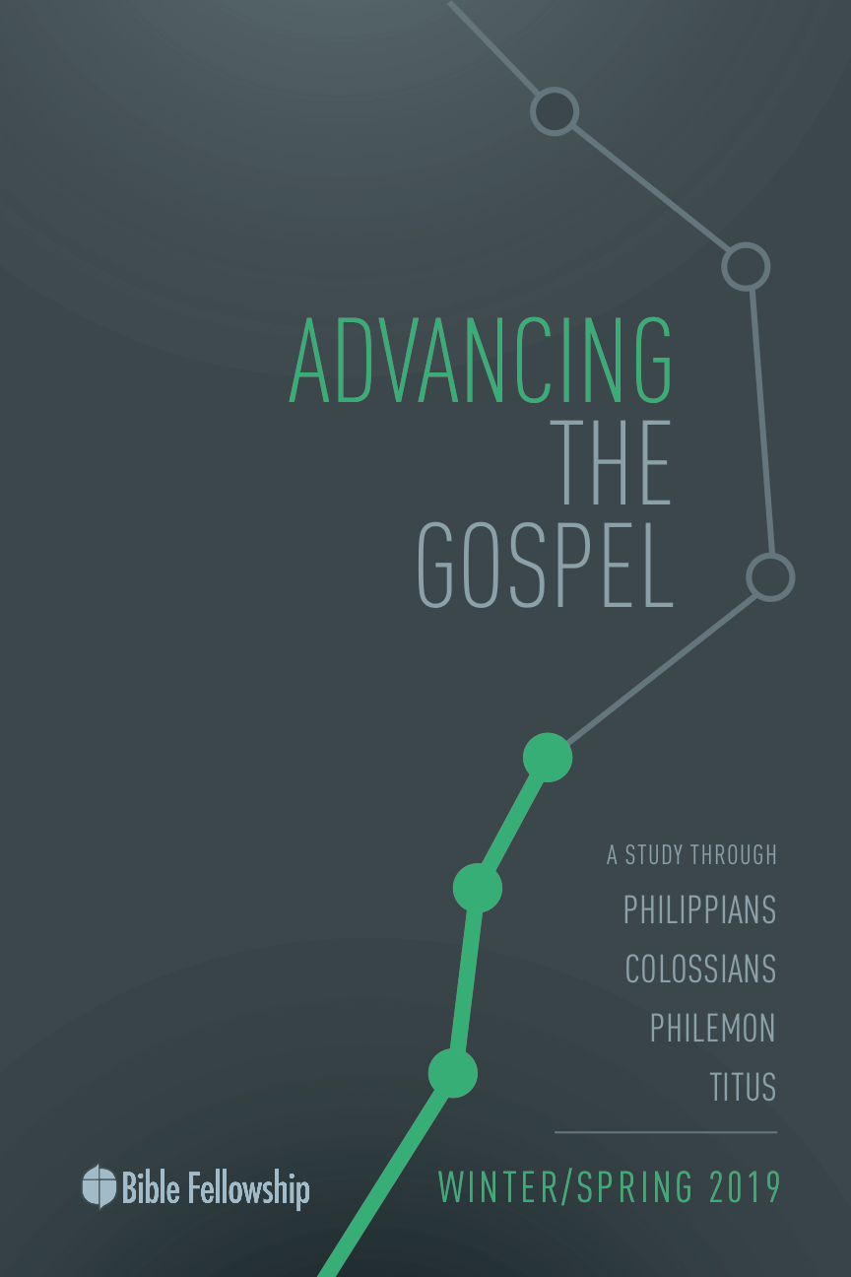

**Main Point: We advance the Gospel as we root our faith in Christ’s victory.**

Coming to faith in Christ is the most important experience of our lives. The moment we surrender our lives to the lordship of Christ should not be minimized. Throughout his letters, Paul conveys his rejoicing and gratitude for the faith of fellow believers. It is no small event when someone moves from death to life. There is rejoicing that takes place in heaven, and there should be rejoicing that takes place here on earth when we witness the confession of someone’s putting his or her trust in Jesus.

This week we will discuss a passage in Colossians where Paul exhorts believers to continue in the faith with thankfulness for all that Christ has done. For your group time, divide your class into groups of three and have each one share with his or her group about how they came to faith. Encourage the listeners to really listen to each testimony and ask the Lord to give them hearts of gratitude for the stories of their brothers and sisters in Christ. Encourage each group to have a time of prayer where they express their praise and gratitude to the Lord.

***Why is everyone’s testimony of their journey with Christ a reason to be thankful?***

***How can the Church practice more tangible displays of gratitude for believers not only coming to faith but remaining rooted in the faith after years of being a Christian?***

***What are aspects of life that may cause us to swerve to the right or to the left in our journeys with Christ?***

**Lesson 4: Rooted in Victory** *Colossians 2:6–15*

**Book**

**Main Point: We advance the Gospel as we root our faith in Christ’s victory.**

**Text Summary:** This passage is central to the message of Colossians. Paul urges Christians to remain rooted in Christ. Despite the variety of religious opportunities of the culture, Christ is supreme. The fullness of God dwells in Christ alone; one need not look anywhere else. Paul encourages Christians to remember all that God has accomplished for them through Christ and that He is before time and is worthy of all worship.

**Colossians 2:6–7 [Read]**

**Sub-Point 1:** Stay true to your life in Christ.

***How did the Colossian believers know what it meant to be rooted and built up in the faith, according to verse 7?***

Paul connects the flow of this passage with the context of the previous verses with his use of “therefore.” Knowing that salvation from God is available to all through Christ, Paul wants his readers to give their entire lives for sake of the Gospel. Don’t come to God half-heartedly and every now and then. Now that the Colossians have come to Christ, Paul wants them to stay the course.

As indicated by the present active verb *perpateō* (“walk” or “live,” GK 4344), the Colossians are to live every day for Christ. He says in verse 6, “as you received Christ Jesus the Lord, so walk in him.” Paul wants the Colossians to keep going. Like the man described in Jeremiah 17 who puts his trust in the Lord, the Colossians are to “root” themselves in Christ, bearing fruit in season and out of season. This is the way to spiritual multiplication. Christ-followers remain healthy, vibrant sources of God’s mercy of grace as they root themselves in the Gospel and build their lives on a foundation that is eternal.

***Why is using agricultural imagery helpful when understanding what Paul is calling the Colossians to?***

Paul wants the Colossians to know that “Faith in Christ would give them a stability which nothing could subvert.”[1] When Paul writes “built up” in verse 7, he “shifts from agriculture to architecture”[2] to show that after the Gospel seed produces fruit, there is still work (construction) to be done by God in the lives of believers. It is a lifelong process. Moo explains, “Let Christ — and no other! For he is Lord — establish your values, guide your thinking, direct your conduct.”[3]

This is Paul’s message. The Christian life consumes everything in a person. Continue with what you professed, Paul tells them. Dependence on God and faith in the Gospel don’t stop after one first believes. Paul closes verse 7 by explaining that the Christian life is a life of gratitude. The *Expositor’s Commentary* explains, “Thankfulness should not trickle from the fellowship as water does from a leaky faucet; rather it should be full to overflowing as with an overfilled container.”[4] The Christian must be thankful for what God has done, for “true gratitude for God’s grace is an important ‘offensive’ measure against the false teaching.”[5] Just as the Christian hears and responds to the message of Christ, Paul says, the Christian must remain committed to message of Christ and thankful for the message of Christ.

***In what ways does faith in Christ give stability that nothing else in this world can give?***

***Using other Scripture references, why is continuing in the faith an important aspect to true Christian confession?***

**Colossians 2:8–10 [Read]**

**Sub-Point 2:** Stand firm on your knowledge of Christ.

Paul wants the Colossians to see that all they need and could ever desire can be found in Jesus. He wants this to give them confidence as they stand against an ever-enticing culture. The word used in verse 8 for “take captive” is a “rare word, which occurs only here in the NT” and “likely means ‘to carry off as booty or plunder.’”[6] Paul doesn’t want the Colossians to be carried off by the human traditions of their day, according to verse 8. He doesn’t want the world to steal away the hearts of the Colossians. False teachers are attempting to lure them away with vain philosophy. His use of “philosophy” means “love of wisdom” and the phrase conveys a philosophy and way of life that “promises much and gives nothing.”[7] This is what Paul means when he writes “empty deceit” in verse 8.

***In what ways does this world attempt to take hearts captive?***

This wisdom is not from God, but rather is manmade.[8] Paul’s point isn’t to condemn philosophy as an area of study and practice. Rather, Paul “condemns philosophy that seduces believers from the simplicity of their faith in Christ.”[9] This wasn’t a step toward spiritual maturity; it was one of regression. Accepting empty beliefs that delivered nothing was the opposite of what Paul charged the Colossians with. He was calling them to something greater. He knew committing to Christ gave them everything.

Paul wanted the Colossians to mature in their faith in Christ, not go backward. Paul’s aim is to show that Christians mature as their commitment to Christ and faith in Him deepens.

***Practically speaking, what does it look like for Christians to deepen their faith in Christ?***

In the latter part of verse 8, there is some debate on what Paul intends by writing “elemental spirits of the world,” however the point is clear that Paul “viewed these elements grounded in principles that were in connection with powers diametrically opposed to the Colossians’ new life in Christ.”[10] Paul wants the Colossians to remember that Christ reigns supreme over the created order. He reminds them clearly of this in verse 9. There is nothing outside of Christ the Colossians need. Moreover, because of what Christ accomplished, the fullness of God now dwells in believers.

The *Expositors Commentary* explains this well: “If the whole fullness of God dwells in Christ, it is wholly unnecessary for the Christians in Colossae to supplement their spiritual lives with anything or anyone else.”[11] In Christ, Christians find wholeness. Paul reiterates that Christ is enough, plain and simple. They mustn’t treat their spiritual lives like a buffet. More importantly, there is nothing that compares to Christ the Lord. Keep trusting Christ. Keep believing Christ. And keep putting your hope in all that Christ’s supremacy over all creation means for the life of the Christian.

***Why is having a robust knowledge of Christ and who He is helpful for the Christian in the midst of an alluring culture?***

**Colossians 2:11–15 [Read]**

**Sub-Point 3:** Rest in the grace given by Christ.

Paul transitions to give his readers rest and hope by way of reminder. It is through this Christ that they have been rescued. In verse 11, Paul does something interesting by connecting the Jewish tradition of circumcision to what happens in the heart of new Christians. This practice was a physical display that marked all who were included into God’s people. Paul viewed this as “an unnecessary wedge between Jews and Gentiles.”[12] Paul’s focus in these verses is to show the new sign of inclusion into God’s family: the transformation of the heart.

***Where did God first give the command of circumcision in the Old Testament?***

***Why did he give this particular command?***

Even though Paul will describe a new “form” of circumcision, Bruce explains, “Even in the OT the symbolical character of the outward sign of circumcision was emphasized: what God really desired was not the external sign for its own sake, but the circumcision of the heart (Deut. 10:16; 30:6; Jer. 4:4), an inward purification, which to Paul was the true circumcision.”[13] This message wasn’t just for Gentiles, it was for Jews as well. God wants children who would worship Him in spirit and in truth, with their whole hearts.

Verse 11 has attracted much scholarly debate surrounding the phrase “circumcision of Christ.” However, Moo explains a slight inclination to the view that “circumcision of Christ” “is a metaphor for the conquering of the power of sin that takes place when a person comes to Christ.”[14] This is in line with Paul’s teaching, found in Colossians 3:5, that believers are to put to death their earthly members. This circumcision, as Paul explains, is not done with human hands, but performed “on us by Christ, who removes not a piece of physical ‘flesh,’ but the enveloping, enervating power of our ‘fleshly’ nature or propensity.”[15] What was once a physical sign of divine inclusion is now one of the heart and the letting go of an allegiance to this world and sinful desire. This circumcision is a cleansing of the inner man, made possible by Christ’s death and Resurrection.

In verse 12, Paul brings in the realities signified in Christian baptism. One source explains, “In some respects, what circumcision was for the Jew, baptism was for the Christian … baptism signifies inclusion into God’s people.”[16] In baptism, the Christian identifies with Christ’s death, burial, and Resurrection. Just as God raised Christ from the dead, Christ raises believers from their spiritual deadness. While circumcision literally means “cut around,” humanity was cut off from God. This is Paul’s focus in verse 13. Without the putting off of our sinful flesh, humanity is without hope and lifeless. But God brings His children back to life through the sacrifice of Christ.

***To what extent has sin affected God’s creation? Use Scripture here.***

***Why is Christ’s sacrifice necessary to redeem humanity and cancel the power and debt of sin?***

Paul reminds the Colossians in verses 14–15 how it is that Christ brings humanity back to life: by canceling the debt that humanity owed from Adam’s sin in Genesis 3. Instead of trusting God and following God as Lord and Creator, humanity rebelled and chose themselves as their own kings. This has been the nature of humanity since Adam and Eve’s disobedience in the Garden. But because of Jesus’ taking the punishment for this disobedience and idolatry, God now grants us life. Jesus canceled the power of sin in the hearts of God’s people, as well as canceling the sentence of death that came as a result of disobedience toward God the Father.

Concerning the record of debt mentioned in verse 14, Christ took what humanity owed and paid it with His life on Calvary. Christ lived the life humanity was supposed to live and died the death humanity should have died. This is the message of the Gospel. In verse 15, Paul shows exactly what Christ did to the forces and human traditions of this world. Though the earthly forces and evil powers believed they achieved victory by hanging Jesus on the Cross and placing Him in the tomb, “All the while, Colossians contends, other forces were at work.”[17] Jesus turned tragedy, Paul explains, into triumph.

***What does it mean that Christ nailed our record of debt to the Cross?***

***How does Paul say God disarmed the rulers and authorities of this world in verse 15?***

**Lesson 4: Rooted in Victory** *Colossians 2:6–15*

**Took**

**Main Point: We advance the Gospel as we root our faith in Christ’s victory.**

Paul encouraged the Colossians to abound in thanksgiving. Practicing a heart of thankfulness is one of the greatest ways to remind ourselves of all that Christ has done. Isaiah 61 says that for the faint spirit, the spirit of heaviness, we put on a garment of praise. It’s hard for the Enemy to attack us when we are in active praise and thankfulness to God. Paul encouraged the believers in Colossae to stay rooted and established while staying thankful. Gratitude and praise are vital elements to growing in maturity in Christ.

**Challenges**

**Root yourself in God’s Word.** There is no greater weapon against this world and our sinful hearts than the truth of God’s Word. This is the way we stay rooted in Him: intake His Word daily. When everything else seems to give way and the world seems too great to bear, stay close to God’s Word and let it give you strength, confidence and blessed assurance.

**Remind yourself of God’s forgiveness.** Don’t forget the beauty of grace and mercy found at Calvary. Remind yourself daily of the forgiveness that God grants you in His Son. When the world tells you it’s about your effort, your accolades, your goodness, your morals, and your competency, stand on the truth that God sees you as He sees Christ. Remind yourself that it’s not about you; it’s about Him. It’s not about what you’ve done; it’s about what Christ has accomplished in your place.

**Respond in thanksgiving.** In all things, respond with thanksgiving. Paul says to abound in thanksgiving. Let gratitude spring forth from your heart and from your mouth. Let your words be those of Psalm 126:3: The Lord has done great things for us; we are glad.

1. F. F. Bruce, *The New International Commentary on the New Testament: The Epistles to the Colossians, to Philemon, and to the Ephesians.* [Grand Rapids, MI: Eerdmans, 1984], p. 94.
2. Tremper Longman III & David E. Garland. *The Expositor’s Bible Commentary: Ephesians – Philemon.* [Grand Rapids, MI: Zondervan, 2006], p. 309.
3. Moo, *The Pillar New Testament Commentary: Colossians and Philemon,* 179.
4. Longman & Garland, *The Expositor’s Bible Commentary: Ephesians – Philemon*, 310.
5. Moo, *The Pillar New Testament Commentary: Colossians and Philemon,* 183.
6. Longman & Garland, *The Expositor’s Bible Commentary: Ephesians – Philemon*, 311.
7. N. T. Wright, *Tyndale New Testament Commentary: Colossians and Philemon.* [Downers Grove, IL: InterVarsity Press, 1986], p. 105.
8. Longman & Garland, *The Expositor’s Bible Commentary: Ephesians – Philemon*, 312.
9. Bruce, *The Epistles to the Colossians, to Philemon, and to the Ephesians,* 98.
10. Longman & Garland, *The Expositor’s Bible Commentary: Ephesians – Philemon*, 312.
11. Ibid.
12. Ibid., 313.
13. Bruce, *The Epistles to the Colossians, to Philemon, and to the Ephesians,* 103.
14. Moo, *The Pillar New Testament Commentary: Colossians and Philemon,* 200.
15. Ibid., 198.
16. Longman & Garland, *The Expositor’s Bible Commentary: Ephesians – Philemon*, 314.
17. Longman & Garland, *The Expositor’s Bible Commentary: Ephesians – Philemon*, 315.