**Lesson 5: Freedom from Ritual** *Colossians 2:16–3:4*

**Hook**

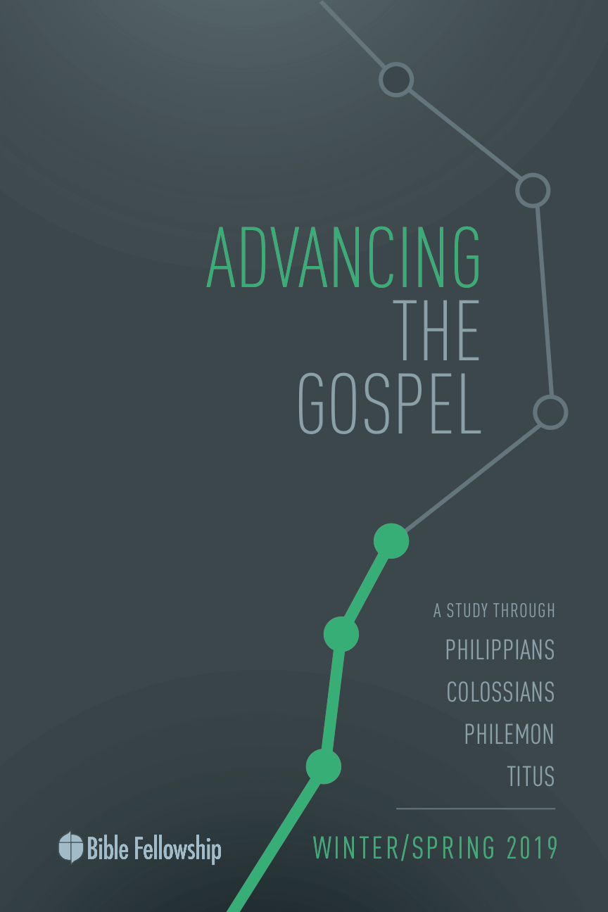

**Main Point: We advance the Gospel as we trust Christ for our spiritual growth.**

Finding value and purpose outside the Gospel is a daily fight. It’s easy to get caught up in thinking that our value to the Lord is Christ-plus-something else. Maybe it’s a ministry accomplishment. Maybe it’s how often we pray or read the Bible. Or maybe it’s finding worth in serving others. While none of these examples are wrong, and actually are, in fact, fruit of the Gospel at work in our hearts, finding our salvation in completing tasks or following commands isn’t the nature of the freedom we have in Christ. We are pleasing to God the Father solely because of what Christ has done. And when we trust Christ and put our faith in His work on our behalf, we are freed from the pressure of performance. The Gospel is Jesus-plus-nothing.

Have class members openly share particular aspects of the Christian life that are easy to attach worth to. Again, maybe it’s how often you serve in the nursery at church. Maybe it’s how many days each week you read your Bible. Because we have died with Christ and are raised with Him into new life, He has freed us from the bondage of works-based salvation. Paul writes in Galatians 5 that Christ has set us free!

***What makes it difficult to rest in Jesus’ work for you?***

***Why do we fall into the trap of thinking our salvation is “Jesus + something else”?***

***What are practical ways to remind yourself of the truth of the Gospel each day?***

**Lesson 5: Freedom from Ritual** *Colossians 2:16–3:4*

**Book**

**Main Point: We advance the Gospel as we trust Christ for our spiritual growth.**

**Text Summary:**  Once again, Paul uses as the foundation for his present argument his main point from the previous section of verses. Because believers have died and been raised with Christ, because Christ is above all earthly power and authority, believers don’t have to submit themselves to the rules and religious commands of the world. Christ is their life now, as well as their master. Paul encourages the Colossians not to listen to the false teachers of their day concerning how they should live their lives. Look to Christ and find rest in His work on the Cross, not in empty manmade religious practices.

**Colossians 2:16–17 [Read]**

**Sub-Point 1:** Trust that God has done everything necessary to save you in Christ.

Paul begins another section of this letter with the word *therefore*. Paul’s intention here is to remind the Colossians of what they gained through Christ: new life and spiritual freedom. Christ has done the work of complete salvation. Stemming back to chapter 1, there is nothing lacking in Christ’s work of redemption. In the same vein, there’s nothing more to perform after trusting Christ’s work on Calvary. Christ and His work on behalf of rebellious sinners is the heart of the Gospel. Because Christ is all one needs for spiritual fullness and acceptance by God, don’t let false teachers convince you there’s more to believe outside the Gospel. Christ is centerpiece of the Gospel, not tireless work to make yourself look better and feel better.

***What religious laws might the false teachers have in mind surrounding food and drink? Use Scripture here.***

These false teachers wanted the Colossians to believe that abstaining from certain foods and drink was necessary for spiritual maturity, as well as observing certain festivals and rituals. But all of these practices will one day fade away.

Concerning the abstention from food and drink, Bruce explains, “Paul lays down the principle of Christian liberty in all such matters, in the spirit of his master who, by one comprehensive pronouncement, ‘declared all foods clean (Mark 7:19).’”[1] The practice of observing ritual holidays and staying away from food and drink has parallels to Judaism. But perfection under the law was what Christ came to accomplish for the very men and women who are unable to keep such records. Christ is the Christian’s hope!

***What does it mean that Christians have liberty in Christ?***

Spiritual maturity means deepening one’s dependence on Christ and trusting in Christ’s sacrifice; not finding one’s salvation in one’s own works *added to* Christ’s work. It doesn’t make sense to trust Christ for new life this world can’t offer while also feeling the need to supplement that life with worldly religious practices. If Christ was already victorious, why are Christians still working so hard to win what has been accomplished?

In verse 17, Paul says these practices are mere shadows of what is to come, but the substance, the true reality, is Christ. These false teachers sought religious experiences, spiritual visions, by swearing off certain physical pleasures. They thought the more they rid themselves of their desires and things of this world, they would experience a deeper spiritual encounter with the Divine. But this is a shadow, Paul says. These empty experiences are just that: empty. Christ brings the substance. Christ brings true spiritual experience. Everything these false teachers chased in their religious works is found in Christ. He is the fullness of God, as Paul already has mentioned.

No worldly practice can bring one closer to God and into deeper intimacy with Him. This is why Paul says, “Remember? You have died and been raised with Christ!” Christ is the only pathway to achieving what these false teachers seek. Because of this, Paul says, “Don’t listen to what these people say. Believe me.” Paul says, “Rest in Christ’s work on the Cross and don’t pay any attention to the lies of these false teachers.”

***What does Paul mean when he says that Christ is the substance to religious experience?***

**Colossians 2:18–19 [Read]**

**Sub-Point 2:** Trust that everything needed for spiritual growth comes from Christ.

***What does it mean that these false teachers sought to disqualify the status of the Colossian Christians?***

Just as Paul warned against being taken captive, he now parallels his warning with the admonition, “Let no one disqualify you.” Moo contends that the false teachers were not just criticizing the Colossians’ beliefs, but also convincing them of God’s judgment on their lack of self-denial.[2] As an overarching description of these false teachers, Paul says they are too concerned with the present world rather than the coming kingdom. Paul encourages the Colossians that what Christ has qualified and secured cannot be undone.

These teachers put too much weight on severe self-discipline and abstention from physical pleasures. The goal here seems to be that by denying their desires, they sought spiritual visions, so much so that they worshipped angels. The traditional understanding of verse 18 is that the false teachers practiced angel worship, looking to angels for physical protection.[3] Angels do not provide the believer with anything that Christ doesn’t already freely give. They’re asking angels for protection from evil forces that Christ has already defeated. This is senseless, Paul says!

***What previous verse in chapter 2 speaks to Christ’s victory over rulers and authorities?***

These visions produced spiritual arrogance. But these visions were in vain. The phrase “puffed up” “translates a verb that occurs elsewhere in the NT only in 1 Corinthians. Its basic meaning, ‘blow up, inflate,’ suits beautifully to express the idea of arrogance.”[4] Paul warns against getting caught up with sensual experiences. That’s not how the Colossians learned Christ and experienced His power. It’s not about getting caught up in the moment; it’s about being one with Christ.

***Why is arrogance out of place for the Christian? Use Scripture.***

In verse 19, Paul directs their attention back to Christ, who is supreme above all. Paul shows that spiritual health comes when one is attached to Christ, receiving life and provision. The church is kept alive and moves forward on the power of Christ, its head, not by the workings of earthly means. Just as the body doesn’t work together when it’s disconnected from the head, so, too, the Christian doesn’t function rightly when he or she is disconnected from Christ. Paul wanted the Colossians to remember Christ’s supremacy, but also His sufficiency. Spiritual growth and strength come from God alone.

***How does God accomplish spiritual growth in the life of the Christian?***

***Why is humility and dependence on God necessary for such growth?***

**Colossians 2:20–3:4 [Read]**

**Sub-Point 3:** Trust that God is strong enough to defeat the sin in your life.

In this last section, Paul begins with a question. If you have, in fact, died with Christ, why are you still attached to this world? If Christ has brought you freedom, why are you still living in bondage? The reality of Galatians 2:20 is in full force here: Believers have been crucified with Christ and they no longer live, but Christ lives in them. Paul takes an exaggeratory tone in verse 21, creating a caricature of the extreme lifestyle and behavior the false teachers are proposing. Paul mocks how these teachers view the physical world in verse 21. Paul “justifies his position by 1: The rules have to do with matters of this world, 2: The rules reflect human and not divine retaking; and 3: The rules cannot bring spiritual transformation.”[5]

***How do religious acts convey spiritual maturity?***

***Why does Paul warn against trusting outward displays of religious commitment?***

God’s power, not our own works, is what we need to conquer sin in our lives. That’s Paul’s point. There is too much weight put on issues that do nothing for actual spiritual freedom and growth. That’s his aim in verse 23. These restrictions and regulations don’t produce holiness. They don’t produce Christlikeness. Bruce explains, “The imposition of prohibitions from without can do nothing to create or develop new life within.”[6] Said another way, these rules and restrictions are mere “window dressing.”[7]

Not one of these stipulations does anything in stopping sin at work in every heart. Without inward transformation, performing outward spiritual acts is simply a religious facade. That’s Paul’s reminder in 3:1–4: Remember your life in Christ. Your life rests in Christ and it’s the things of God that will bring true spiritual renewal. It’s inward transformation that brings outward change, not the other way around. Concerning verses 20–23, Moo concludes, “Their claim to offer a wise and comprehensive system of spiritual growth is nothing but a sham.”[8] Paul wants the Colossians to understand that God has qualified them in Christ and there’s nothing this world can condemn them with. Jesus has won their victory and they can find peace in that. God’s Spirit is at work in them and for them.

***What does it mean to seek the things that are above (Colossians 3:1)?***

***How is the Christian’s life hidden with Christ? How does this reality sum up the misrepresentations of the false teachers in Colossae?***

**Lesson 5: Freedom from Ritual** *Colossians 2:16–3:4*

**Took**

**Main Point: We advance the Gospel as we trust Christ for our spiritual growth.**

Paul encouraged the Christians in Colossae to trust Christ for their spiritual growth and maturity. Not only that, he warned them about finding their identity in anything other than Christ. Our identity as God’s children is rooted in the work of Jesus, not on any work we can do for God. This lie creeps into our daily beliefs and affects how we think God looks at us. Moreover, it affects how we think the Christian life is to be lived. We must look at our Christian journeys through the lens of rest, not work. Christ has secured everything we need for this life and the one to come. Whenever we think the Christian life is about how we look or what we’re doing, let us remember that we have died with Christ and, most importantly, been raised with Him. This is our hope. This is our path to spiritual growth.

**Challenges**

**Walk forward in your true identity**. Remember that you have been raised with Christ. Remember that God sees Christ in you and is pleased with you. Don’t wake up thinking your identity is in what you do for God. Rest in the peace that comes from understanding your identity is in what God has done for you.

**Pray for God’s power to work in you.** Ask God to bring spiritual fruit to bear in your life. Ask Him to do in you what you cannot do for yourself. Ask Him to help you defeat certain sins and pursue godliness. Find hope in that if you are humble and dependent on Him, He will work mightily in your life.

**Think about eternal things.** Don’t get caught up in the things of this world that will fade away. Jobs. Money. Status. Possessions. Direct your mind to things that will last throughout eternity. Discipleship. Service to others. Gospel proclamation. Generosity. When we find joy in the things that will last, we won’t be driven to despair when the things that won’t last are stripped away.

1. F. F. Bruce, *The New International Commentary on the New Testament: The Epistles to the Colossians, to Philemon, and to the Ephesians.* [Grand Rapids, MI: Eerdmans, 1984], p. 114.
2. Douglas J. Moo, *The Pillar New Testament Commentary: The Letters to the Colossians and to Philemon*. [Grand Rapids, MI: Eerdmans, 2008], p. 218.
3. Ibid., 226–227.
4. Ibid., 224.
5. Moo, *The Pillar New Testament Commentary: Colossians and Philemon,* 236.
6. Bruce, *The Epistles to the Colossians, to Philemon, and to the Ephesians,* 126.
7. Longman & Garland, *The Expositor’s Bible Commentary: Ephesians – Philemon*, 321.
8. Moo, *The Pillar New Testament Commentary: Colossians and Philemon,* 240.