**Lesson 6: A New Wardrobe** *Colossians 3:5–17*

**Hook**

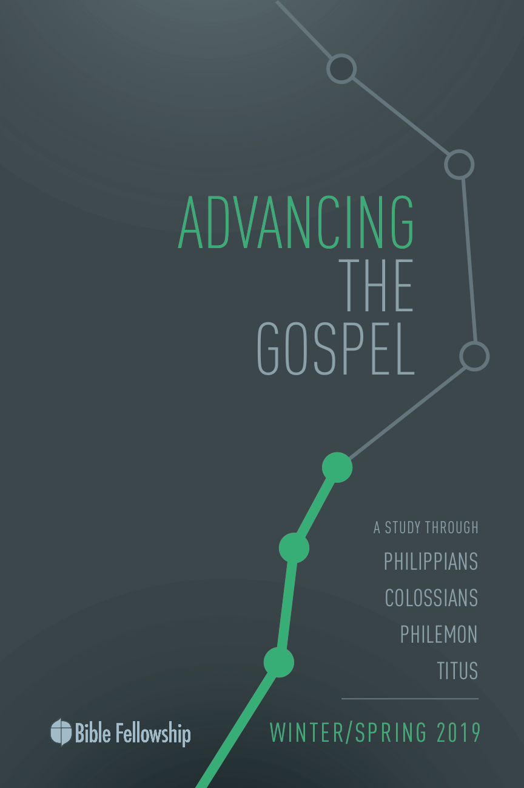

**Main Point: We advance the Gospel as we embrace our new life in Christ.**

Sometimes it’s hard to see the ways God is at work in our personal lives. With our various struggles, temptations, trials and stress, we fail to see any spiritual fruit. The longer this goes on, the Enemy may attack us and tempt us to question whether we belong to Christ or not. The voice of condemnation is the Enemy’s best trick against weak spirits, watching a beloved child of God question their identity as a son or daughter and believe their mistakes are too big for God to forgive. The Enemy wants us to live in despair, thinking Christ isn’t in us, and we are a lost cause.

In light of Paul’s encouragement regarding godly corporate behavior in verses 16–17 in chapter 3, use a few minutes at the start of group time to go around the room and encourage one another. Use these moments to affirm ways in which others have seen God’s Spirit at work in the lives of other group members. What an encouraging time for believers to be affirmed that God is in fact at work in their lives and that others see Christ in the way they are living.

***Why is encouragement such a valuable weapon against the schemes of the Enemy?***

***What are practical ways to encourage other believers more regularly for how you see God at work in their lives?***

***Describe a time when someone’s encouragement toward you came at just the right time and greatly affected you.***

**Lesson 6: A New Wardrobe** *Colossians 3:5–17*

**Book**

**Main Point: We advance the Gospel as we embrace our new life in Christ.**

**Text Summary:** Paul has spent a great deal of time emphasizing theological truths descriptive of the Christian life. He’s discussed in detail what it means for the believers to be found in Christ. Now, Paul addresses the way their lives should look as a result of their new identity in Christ. Paul describes the process of embracing the believer’s way of life as putting on new clothes. Being one of God’s children is more than a way of thinking and believing, it’s a way of living!

**Colossians 3:5–11 [Read]**

**Sub-Point 1:** Leave behind the life you lived before coming to Christ.

***What does Paul say believers must do with the worldliness that is in them?***

Paul’s written a lot to the Colossians concerning their theology. He laid out in depth the beauty of the Gospel message and all that the Gospel does for their lives as children of God. Believers are forgiven of sin. All people, including non-Jews, are included into God’s family because of Christ. Christ is central and supreme to creation and total earthly and spiritual redemption. Now, Paul wants to address the Colossians on what their lives look like practically because of these truths.

In the first set of verses, 5–11, Paul lists out behaviors that must not characterize believers anymore. In verse 5, the list includes sexual immorality, impurity, passion, evil desire and covetousness. Within the present culture for the Colossians, “there was a very tolerant attitude surrounding sexual activity outside marriage.”[1] These first four descriptions are sexual in nature. The last descriptor, “covetousness,” is simply wanting what you don’t have. This is considered the most dangerous by some, Bruce explains, “because it can assume so many forms.”[2] This person, this “old man,” desires pleasure more than God. The need to gain more and more, fulfill every desire, is idolatry, Paul says.

It’s idolatry, placing other things before God, that got creation into the predicament of sin in the first place. Because of this, God’s judgment is coming (v. 6). As Paul has already covered in chapter 1, Christ is supreme above all else. He is first place. God has no rival. But the Colossians know Christ and recognize their salvation in Him. Putting things above Christ was the old way of doing things, Paul says in verse 7.

***Where else in Paul’s letters does he describe the old way of living?***

***How does a believer fight the urge to covet? What accountability tools might help in this process?***

The list of behaviors in verse 5 included sins that destroyed the personal purity of believers. Paul moves to a different list in verse 8, exhorting the Colossians to put off these habits just as one would take discard old clothes. The list in verses 8–9 deals with specifically interpersonal sins, sinful habits of relating to others. The believer should never seek to harm another one of God’s children, whether in word or in deed. While sexual impurity destroys and fragments the heart of the believer, destructive words and behavior toward another fragments the community of faith. Christ came to unify God’s people, which is why it is characteristic of the old self to divide the Church. Just as old clothes don’t fit anymore, so, too, the old way of life doesn’t fit on the Christian.

Through the Spirit of Christ at work in the body, believers are renewed and restored to the image of true creation. This isn’t the first Adam, but rather the Second Adam; the one through whom righteousness came. The parallel to verse 10 is Genesis 1:27. Christ is the image of the new man, Adam is the image of the old. Within this body of new believers, Christ is the unifying factor that is above all other physical descriptions that divided before: race, nationality, language, family origin. In this way, Bruce explains, “the gospel made its deepest impression on the pagan world.”[3] It was amazing to see the people brought together through the means of the Gospel. This kind of unity doesn’t make sense to the world. But this is what the new life seeks to achieve: true unity. Keep in mind, “social differences aren’t eradicated, but they become less relevant … the focus of the church is not on its dissimilarities but on Christ who is all and is in all.”[4]

***How is Christ the model for new creation?***

***What imagery comes to mind when you hear the phrase “put on the new self”? What implications does that idea have?***

***Have you ever witnessed the unifying work of Christ among a diverse group of believers? What impression did it leave on you?***

**Colossians 3:12–15 [Read]**

**Sub-Point 2:** Walk forward in the new life Christ gives you.

Paul now transitions in verse 12 to describe the “clothes” which the Colossians must put on, now that they have discarded their old way of life. Notice in verse 12 that Paul uses the phrase “chosen ones.” This is a reminder that the Gentiles are included in God’s redemptive plan and that they, too, have God’s Spirit inside them, at work to achieve spiritual renewal. Just as the previous lists fostered division within the community of faith, Paul’s list in verses 12–15 seeks to promote unity and cohesion within Christ’s body. Paul’s descriptors in verse 12 describe the way of Jesus. Jesus was compassionate, kind, gentle, meek and, most importantly, humble. Moo makes mention, “These attributes aren’t associated with the false teaching previously dealt with. They are general Christian characteristics that mark them as the children of God.”[5] The point Paul makes is simple: Christians are to act like Christ toward one another.

***What does it mean that God’s people are chosen, holy and beloved? How is this possible?***

***Of the list in verse 12, which characteristic would you like to display/grow in through the coming year?***

In the same way that Christ came to put things back together and bring God’s children together from afar, so, too, must Christians seek to bring one another together and offer grace and acceptance and love to those they come into contact with. Yes, sin will still occur. But that’s why Paul says they must continue to forgive (v. 13). They must not remember the grand forgiveness they have received in Christ. This forgiveness empowers them as they relate to other human beings that are in a state of progress as well. Yes, salvation has come, but the renewal begun by the Spirit has not produced sinless men and women. There will still be opportunities to show Christ to one another.[6]

In verse 14, Paul says to put on love, which binds everything together. This love is the love that Christ prayed for in John 17:26. Christ asked the Father that the love between the Father and Son would be the same love that resided in the hearts of God’s children. This is unifying love. This is divine love. This is kingdom love. This love that Paul mentions in verse 14 is connected in verse 15 with the peace of Christ. Paul tells the Colossians that he wants the peace that Christ brings to be the ruler over their hearts and actions. Bruce writes, “If the members are subject to Christ, the peace which he imparts must regulate their relations with one another.”[7] Paul says, “Allow the peace of Christ to act as umpire, judge, or arbiter [*brabeuō*, GK 1093] in [your] hearts.”[8] Paul closes verse 15 with a call to be thankful, a central theme in his letter. Believers must live with an ever-present sense of gratitude for all that Christ has done for them. When they do this, they will operate with great joy and grace with one another.

***Why is forgiveness such a strong characteristic of the new life believers share?***

***Why is forgiving others so significant in the Christian life? What mindset/tools help you to forgive others?***

***Have you experienced forgiveness from other believers? How did that experience impact your spiritual growth?***

***What are a few things that you’re thankful in the Lord for in this season of life?***

**Colossians 3:16–17 [Read]**

**Sub-Point 3:** Enjoy new relationships with fellow believers.

Paul ends this section with a call to corporate encouragement and godly faithfulness. It’s within the corporate community of faith where this way of life—the new self—empowered and renewed by God, happens and is built up. Wright explains, “God intends Christian behavior to be reinforced and upheld by the friendship, company, teaching, counseling and loving criticism of other Christians.”[9] The call to follow Christ isn’t one of isolation. The Gospel, Paul says in verse 16, should influence the way you teach, speak, and sing. There is some debate surrounding the exact nature of interpreting verse 16, but Paul’s point is this: There is a strong connection between the church’s teaching and its singing.[10] The way we teach one another and the way we sing with one another matters. The church’s teaching, as well as the church’s singing, confesses great truth about Christ that is needed to continue walking in the Spirit. Christians must be reminded of the Gospel at all times.

But Paul doesn’t just stay within the gathering of the church – he explains worship as a way of life. Paul tells the Colossians in verse 17 that Christ must be a part of everything they do. Having Christ infused to everything one says and does is the path to understanding what it means to be truly human. This is the life of the new man.

***What does it mean for the church’s teaching and singing to have a strong connection? How is gratitude involved in each of these?***

***Who in your life best models the idea of doing everything, in word or deed, in the name of the Lord Jesus? How has his or her example changed the way you live your life?***

***Would you describe the words of the Scripture as “dwell(ing) in you richly”? How does a believer begin to move toward that lifestyle?***

***How does your personal time in the Scriptures impact your day? What do you notice about yourself when you miss that time? What tools do you utilize to encourage a strong daily time in the Bible?***

**Lesson 6: A New Wardrobe** *Colossians 3:5–17*

**Took**

**Main Point: We advance the Gospel as we embrace our new life in Christ.**

Take some time to think about your daily life and your relationships. Think about your thoughts and your actions. Are you living in the joy and power that is the new life in Christ? Or are you still living in your old clothes? It’s a good practice to evaluate our lives and look for weak points where the Enemy could get a foothold. Find encouragement today that Christ has redeemed you, and you are now His family. Take heart that the Spirit is at work in you, bringing you further along in your process of becoming like Christ. Experience hope that God can and will work in you to make you more and more like Himself, but you must first be humble and willing to ask for His help.

**Challenges**

**Evaluate your responses.** It’s easy to fly off the handle here and there. It’s easy to get involved in a conversation where gossip is central. But these things aren’t characteristic of new life in Christ. Examine your speech and your interaction with other believers, and ask that your response to others would be characteristic of your new clothes in Christ, not your old set.

**Enjoy godly counsel.** Paul says that we must teach one another and admonish one another. Is there someone in your life to whom you go for regular godly counsel? If not, seek out someone to be that in your life and begin to enjoy the fruit of God speaking to you through another brother or sister in the faith.

**Encourage one another.** Always find time to encourage other believers. This is the way the Church battles anger, malice, lies and gossip. Use your speech to give grace to others and encourage them in their walk with Christ. Let the words you say show signs of God’s new creation, not the old.

1. Tremper Longman III & David E. Garland. *The Expositor’s Bible Commentary: Ephesians – Philemon.* [Grand Rapids, MI: Zondervan, 2006], p. 326.
2. F. F. Bruce, *The New International Commentary on the New Testament: The Epistles to the Colossians, to Philemon, and to the Ephesians.* [Grand Rapids, MI: Eerdmans, 1984], p. 144.
3. Bruce, *The Epistles to the Colossians, to Philemon, and to the Ephesians,* 150.
4. Longman & Garland, *The Expositor’s Bible Commentary: Ephesians – Philemon*, 330.
5. Douglas J. Moo, *The Pillar New Testament Commentary: The Letters to the Colossians and to Philemon*. [Grand Rapids, MI: Eerdmans, 2008], p. 274.
6. Longman & Garland, *The Expositor’s Bible Commentary: Ephesians – Philemon*, 332.
7. Bruce, *The Epistles to the Colossians, to Philemon, and to the Ephesians,* 157.
8. Longman & Garland, *The Expositor’s Bible Commentary: Ephesians – Philemon*, 333.
9. N. T. Wright, *Tyndale New Testament Commentary: Colossians and Philemon.* [Downers Grove, IL: InterVarsity Press, 1986], p. 134.
10. Longman & Garland, *The Expositor’s Bible Commentary: Ephesians – Philemon*, 334.