**Lesson 7: Family Matters** *Colossians 3:18–4:1*

**Hook**

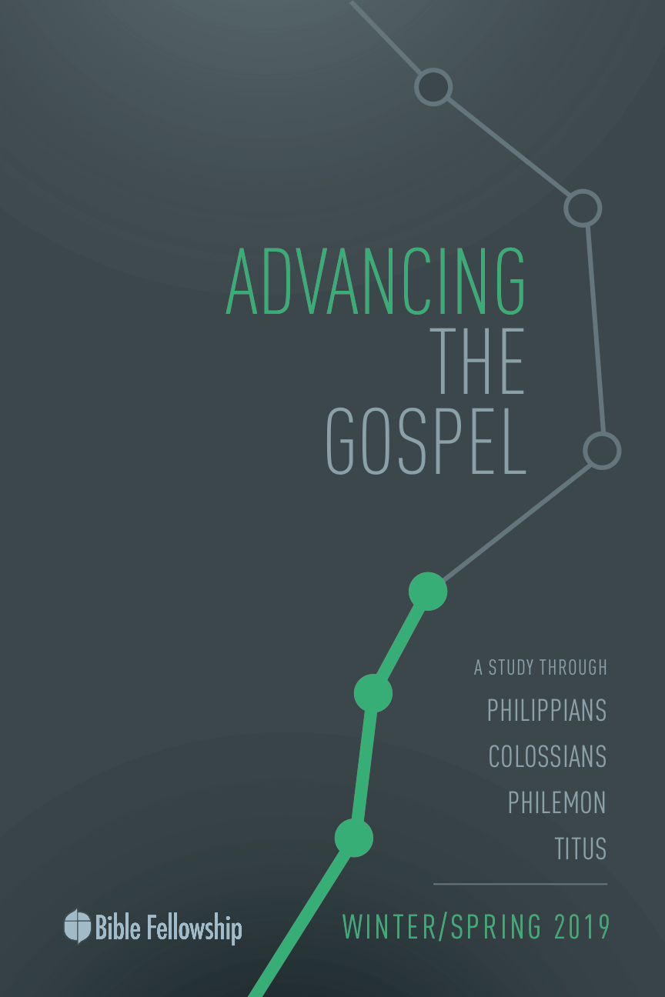

**Main Point: We advance the Gospel as we surrender our lives to Christ.**

In August of 2018, LifeWay Christian Resources celebrated the 10th anniversary of the latest Baptist hymnal. This was a painstaking process, beginning with more than 3,000 potential hymns to include and whittling down to only 674 songs.[1]

The familiar hymn *I Surrender All* is song number 433 in that hymnal. The first verse and chorus follow:

“All to Jesus I surrender

All to Him I freely give

I will ever love and trust Him

In His presence daily live

I surrender all

I surrender all

All to Thee my blessed Savior

I surrender all”

Surrender demands obedience, and that isn’t easy. We want our own way. We want to do things on our timetable and in the manner we want them done. We want to be in authority. Obedience, by nature, shows that we aren’t the ones in control. If we aren’t in step with the Spirit and what the Lord says about new life in Christ, we can tend to think obedience is a sign of weakness and that we don’t need to obey anyone else but ourselves. But this isn’t the path for those in Christ. Christians understand that God is in control and that God Himself humbly submitted to the Father in order to bring salvation and redemption to mankind.

Use the opening minutes of group time to share circumstances where obedience has been difficult (maybe at your job, in your family, at church, with your friends) and circumstances where obedience has been a joy and willful service to someone else.

***Describe a time in your life in which you were fully surrendered to Christ. What did you learn in that season?***

***What makes obedience difficult?***

***How do we demonstrate Christ when we obey with joy?***

***What does it mean to trust God in the midst of our obedience, even when we don’t want to obey?***

**Lesson 7: Family Matters** *Colossians 3:18–4:1*

**Book**

**Main Point: We advance the Gospel as we surrender our lives to Christ.**

**Text Summary:** Paul transitions from laying out how Christians must act toward one another in the church as new humanity to how believers act within their family relationships. Paul calls each household member to serve others in the house well, knowing that everyone serves Christ as his or her true master.

**Colossians 3:18–21 [Read]**

**Sub-Point 1:** The Christian family loves and serves one another.

***How have you typically understood submission as it’s used in verse 18?***

***Why is it important that husbands are called to love their wives in verse 19?***

Paul has spent his focus on the theological truths for the community of faith. In chapter 3, he began to lay out how the Christian’s theology affects his or her interpersonal interactions. In the close of chapter 3, Paul moves his focus to the family and how the “new man” lives within family borders. This is Paul’s transition from spiritual family to physical family.

Paul starts in verse 18 writing to the wives. This same call for wives appears elsewhere in the NT in Ephesians 5:22; Titus 2:5; 1 Peter 3:1; and 1 Corinthians 7:2–5. This call for wives has come under great scrutiny. Is Paul saying that women are weaker than men? Is Paul saying that women must listen to men in every situation? A clear understanding of this verse and how it reflects one’s relationship to the Lord is very important. Moreover, each relationship listed by Paul grounds itself in the understanding that everyone is to be a servant of Christ.

The verb used here in verse 18 for submit is *hypotassō*, which, when separated is “order” (tassō) and “under” (hypo). When found in the Greek translation of the Old Testament, this word can refer to one submitting to God. This role of the wife is one of willingness and is done voluntarily. The picture that Paul paints of the inner workings of the marital relationship is not limited to his day, as made clear by his writing concerning the order of creation (1 Timothy 2:13) and the order within the Godhead (1 Corinthians 11:3).[2] The relationship between husband and wife is ordained by God and instituted from the time of creation.

Paul includes the phrase “as is fitting to the Lord” because what Paul is not commanding here is blind obedience; obedience that would be counter to God’s commands. Wright raises an excellent point here by stating, “When the relation between man and woman, husband and wife, is viewed in the context expressed by these words “in the Lord,” the essential dignity of women in general and of wives in particular is placed on a firm foundation.”[3] One of the key attributes of these commands is how all obedience falls under the greater obedience to the Lord. It kept all rule and authority in check as it was operated under the rule of Christ in all things.

***How does knowing that submission is done as unto the Lord give wives a more solid foundation than if it were simply for the husband’s benefit?***

One cannot take verse 18 apart from verse 19. The wife’s submission to the husband is directly connected with the husband’s call to love the wife and not be harsh with her. While Paul was keeping the structure of the family in line with the cultural norm, meaning that it was led by the male figure, what he was doing was creating a family reality that treated the spouses very differently and looked at each of their roles as a service unto the Lord, not for power or authority’s sake. This was the new reality God had in mind: love for one another fueled by God’s love for His creation. Yes, wives are called to submit to their husbands, but in calling the husbands to love their wives in this way, the husbands are submitting their own desires and wishes under their love for their wives and their needs.[4]

The word used for love in verse 19 is *agapaō*, which is the Christian word for the kind of sacrificial love that reflects Christ Himself.[5] Here’s where Paul’s household table takes a different turn. Douglas Moo explains that no other code in the ancient world commands husbands to love their wives.[6] Paul shows that if love is not what leads these behaviors, then the leadership will turn harsh, domineering and selfish. One must keep in mind Paul’s list of the new man qualities from the previous section. Those characteristics are still applied to the new man relationships.

***What are characteristics of Christlike love? Use Scripture here.***

***How does that practically work itself out in marriage? What does that type of love look like?***

Paul moves to discuss the relationship between fathers and children in verses 20–21. As always, Paul’s aim is for the Gospel to be made known through these relationships. The parents are to love their children and care for their children in such a way that the children are reminded of Christ. The obedience of children to their parents pleases the Lord because this relationship keenly reflects the relationship of God’s children with Him.

Just as it was with wives, children are to obey their parents when it is fitting and pleasing to the Lord, not when their parents command them to act in a way that is displeasing or dishonoring to the Lord. A key aspect to the father’s role is leading his children well in the Lord. The Greek word translated “discouraged” in verse 21 is the verb *athymeō* and it means “without passion” (GK 126). What’s Paul saying? Once again, he brings the authority of the father and husband under the umbrella of God’s design. Bruce explains that the father’s discipline should not be such that it causes the children to “lose heart and come to think that it is useless trying to please their parents.”[7] The father’s authority should never render the children without passion and desire. The point is that parents must encourage and equip, not tear down and sideline. The obedience and authority that Paul puts forth in these verses is symbiotic in nature: obedience is willing because the authority is loving.

***How does a father discipline his children without causing them to lose heart?***

***In what ways did your father exhibit Christlike love?***

**Colossians 3:22–25 [Read]**

**Sub-Point 2:** The Christian worker works for Christ.

***How is work different when done with a sincere heart and unto the Lord?***

***How many times in these few verses does Paul draw the servant’s attention to the Lord’s authority?***

The next relationship Paul tackles is one between the master of the house and the household worker. The institution of slavery is in direct tension with the writings of the NT and the value that in God’s created order there is equality of value between all His children (1 Timothy 1:10; Revelation 18:11–13). Describing Paul’s instructions to slaves, the ESV study Bible comments: “As in any other city or village in the Roman world, there would have been many slaves at Colossae; Paul treats them with dignity and appeals to them directly to honor Christ in their hearts, work, and behavior.”[8]

Several key aspects of this passage show Paul’s countercultural view on the issue of slavery. First, Paul addresses the slaves in verse 22. Moreover, Paul includes a reference to Christ in each of the verses concerning the bondservant’s obedience and work in 22–24. Paul considers these slaves as fellow believers and brothers and sisters in Christ. But Paul’s aim in exhorting them is to keep their minds focused on the Lord and the reward He has prepared for them.

Paul isn’t ignoring the reality of their harsh conditions. What he is doing is getting them to see that now in Christ, they are serving Him, and He sees their worth and value and He has prepared something for them for eternity. There was little if any hope that slaves would receive any inheritance this side of eternity. But Paul says they will be richly rewarded in God’s kingdom. This way of thinking most certainly didn’t change their circumstances, but “this heavenly orientation [could] transform one’s attitudes and actions.”[9]

***Why is it necessary to understand Paul’s context in writing this verse? How does that help with the tension presented here, in regard to slavery and servanthood?***

Paul knew he couldn’t change an entire societal system. But he could help and benefit the way these servants looked at their current situations. He was concerned with the motivation behind their work and their working well as unto Christ. It was easy to slack off and only do the bare minimum for masters who were cruel and unkind. But to switch that mindset and know that slaves were actually working as unto Christ, who was generous, kind, loving and tender, changed their outlook altogether. Keeping Christ in mind and the suffering He went through could alter one’s perspective. It’s from the Lord that true value comes; not from this earth and worldly positions of authority. Though your earthly master may not ever reward your work, the Christian must work for his/her heavenly master, who promises great, eternal reward.

***How does the reminder of the Christian’s eternal reward affect how Christians serve on this side of eternity?***

**Colossians 4:1 [Read]**

**Sub-Point 3:** All Christians are servants of Christ.

***Why is it important for earthly masters to know they serve Christ?***

Verse 1 in chapter 4 demonstrates Paul’s countercultural instructions. He challenges earthly masters to be fair and just in their dealings with their servants, because the masters themselves are servants as well. But more importantly, charging the masters to be fair and just was countercultural because Paul didn’t give them the authority to treat their workers however they wanted. Paul didn’t give them a pass to abuse their authority. And, as mentioned previously, this gives status to the servants as humans deserving of fair treatment. Paul wants the masters to keep in mind the treatment all should have received from God. Humanity deserved punishment and separation from God. Instead, Christ took the punishment humanity deserved and as a result, welcomes them as sons and daughters of God.

***Why does the Gospel message transform how Christians treat others? Where in the New Testament did Jesus teach on such things?***

No matter the amount of authority one has, Paul says, no one is removed from living underneath the authority of the true master.[10] Paul gives an exhortation here that just as Christ has shown mercy and grace to all, so, too, must earthly masters show the same care and concern for those under their authority. This is where Christian beliefs translate into Christian practices. Humility is key for the Christian in a role of authority. Keeping Christ in mind and the reality that all work for the Lord, the master of each house knows he/she, too, is called to faithful service and that position and authority mean nothing compared to the grace given in Christ. This is how the reality of the new man should instill humility in everyone covered by Christ’s sacrifice.

**Lesson 7: Family Matters** *Colossians 3:18–4:1*

**Took**

**Main Point: We advance the Gospel as we surrender our lives to Christ.**

One of the greatest motivators to serve Christ with our whole heart is to reflect on what Christ has done for us. It’s all too easy for us to buck against authority, especially authority that we think comes against our rights and privileges. But what about Jesus? God Himself came to earth and put on human flesh. As Paul writes in Philippians, Jesus didn’t hold tightly to His divinity or His equality with God. Said another way, Jesus didn’t clinch with a tight fist His royal status. Instead, He gave it all up in order to serve humanity and give God’s children the chance to be united with Him again. In situations where God calls us to be obedient, even when we don’t want to, when we don’t feel like it, or when someone isn’t treating us with the respect we think we deserve, let us look to Christ and His example, who obeyed joyfully and entrusted His well-being to God, the Father.

**Challenges**

**Pray for patience as you serve.** Serving Christ is one thing. Serving a sinful boss is another. This week, as you serve others in various contexts, pray the Lord would give you patience to serve well and serve as Christ did.

**Pray for strength as you obey.** Paul mentioned in chapter 2 that he toiled for the Gospel with God’s strength inside him. As you work and submit to others this week, pray for strength to obey in difficult circumstances, even when it might not make sense to you. Trust that God is over all things and allow His Spirit to work in you to serve others faithfully in your Christlike obedience.

**Pray for those in authority over you.** Praying for those in authority over you is a powerful motivator for obedience because you’re praying for those in leadership. Knowing that God is at work and that you’re praying for the lives of those leaders allows you to trust Christ with their character, behavior and influence. Let this be a great opportunity to trust God through prayer.

1. http://www.bpnews.net/51386/baptist-hymnal-celebrates-10year-anniversary
2. Norman L. Geisler, [“Colossians,”](https://ref.ly/logosres/bkc?ref=Bible.Col3.18&off=89&ctx=and+was+not+limited+~to+Paul%E2%80%99s+day%2c+as+is) in *The Bible Knowledge Commentary: An Exposition of the Scriptures*, ed. J. F. Walvoord and R. B. Zuck, vol. 2 (Wheaton, IL: Victor Books, 1985), 683.
3. F. F. Bruce, *The New International Commentary on the New Testament: The Epistles to the Colossians, to Philemon, and to the Ephesians.* [Grand Rapids, MI: Eerdmans, 1984], p. 164.
4. Moo, *The Pillar New Testament Commentary: Colossians and Philemon,* 301.
5. Ibid., 303.
6. Ibid., 302.
7. Bruce, *The Epistles to the Colossians, to Philemon, and to the Ephesians,* 165.
8. Crossway Bibles, [*The ESV Study Bible*](https://ref.ly/logosres/esvsb?ref=BibleESV.Col3.22-25&off=578&ctx=cf.+Rev.+18:11%E2%80%9313).+~As+in+any+other+city) (Wheaton, IL: Crossway Bibles, 2008), 2299.
9. Tremper Longman III & David E. Garland. *The Expositor’s Bible Commentary: Ephesians – Philemon.* [Grand Rapids, MI: Zondervan, 2006], p. 342.
10. N. T. Wright, *Tyndale New Testament Commentary: Colossians and Philemon.* [Downers Grove, IL: InterVarsity Press, 1986], p. 154.