**Lesson 2:** *1 Peter 1:13–2:3*

**Hook**

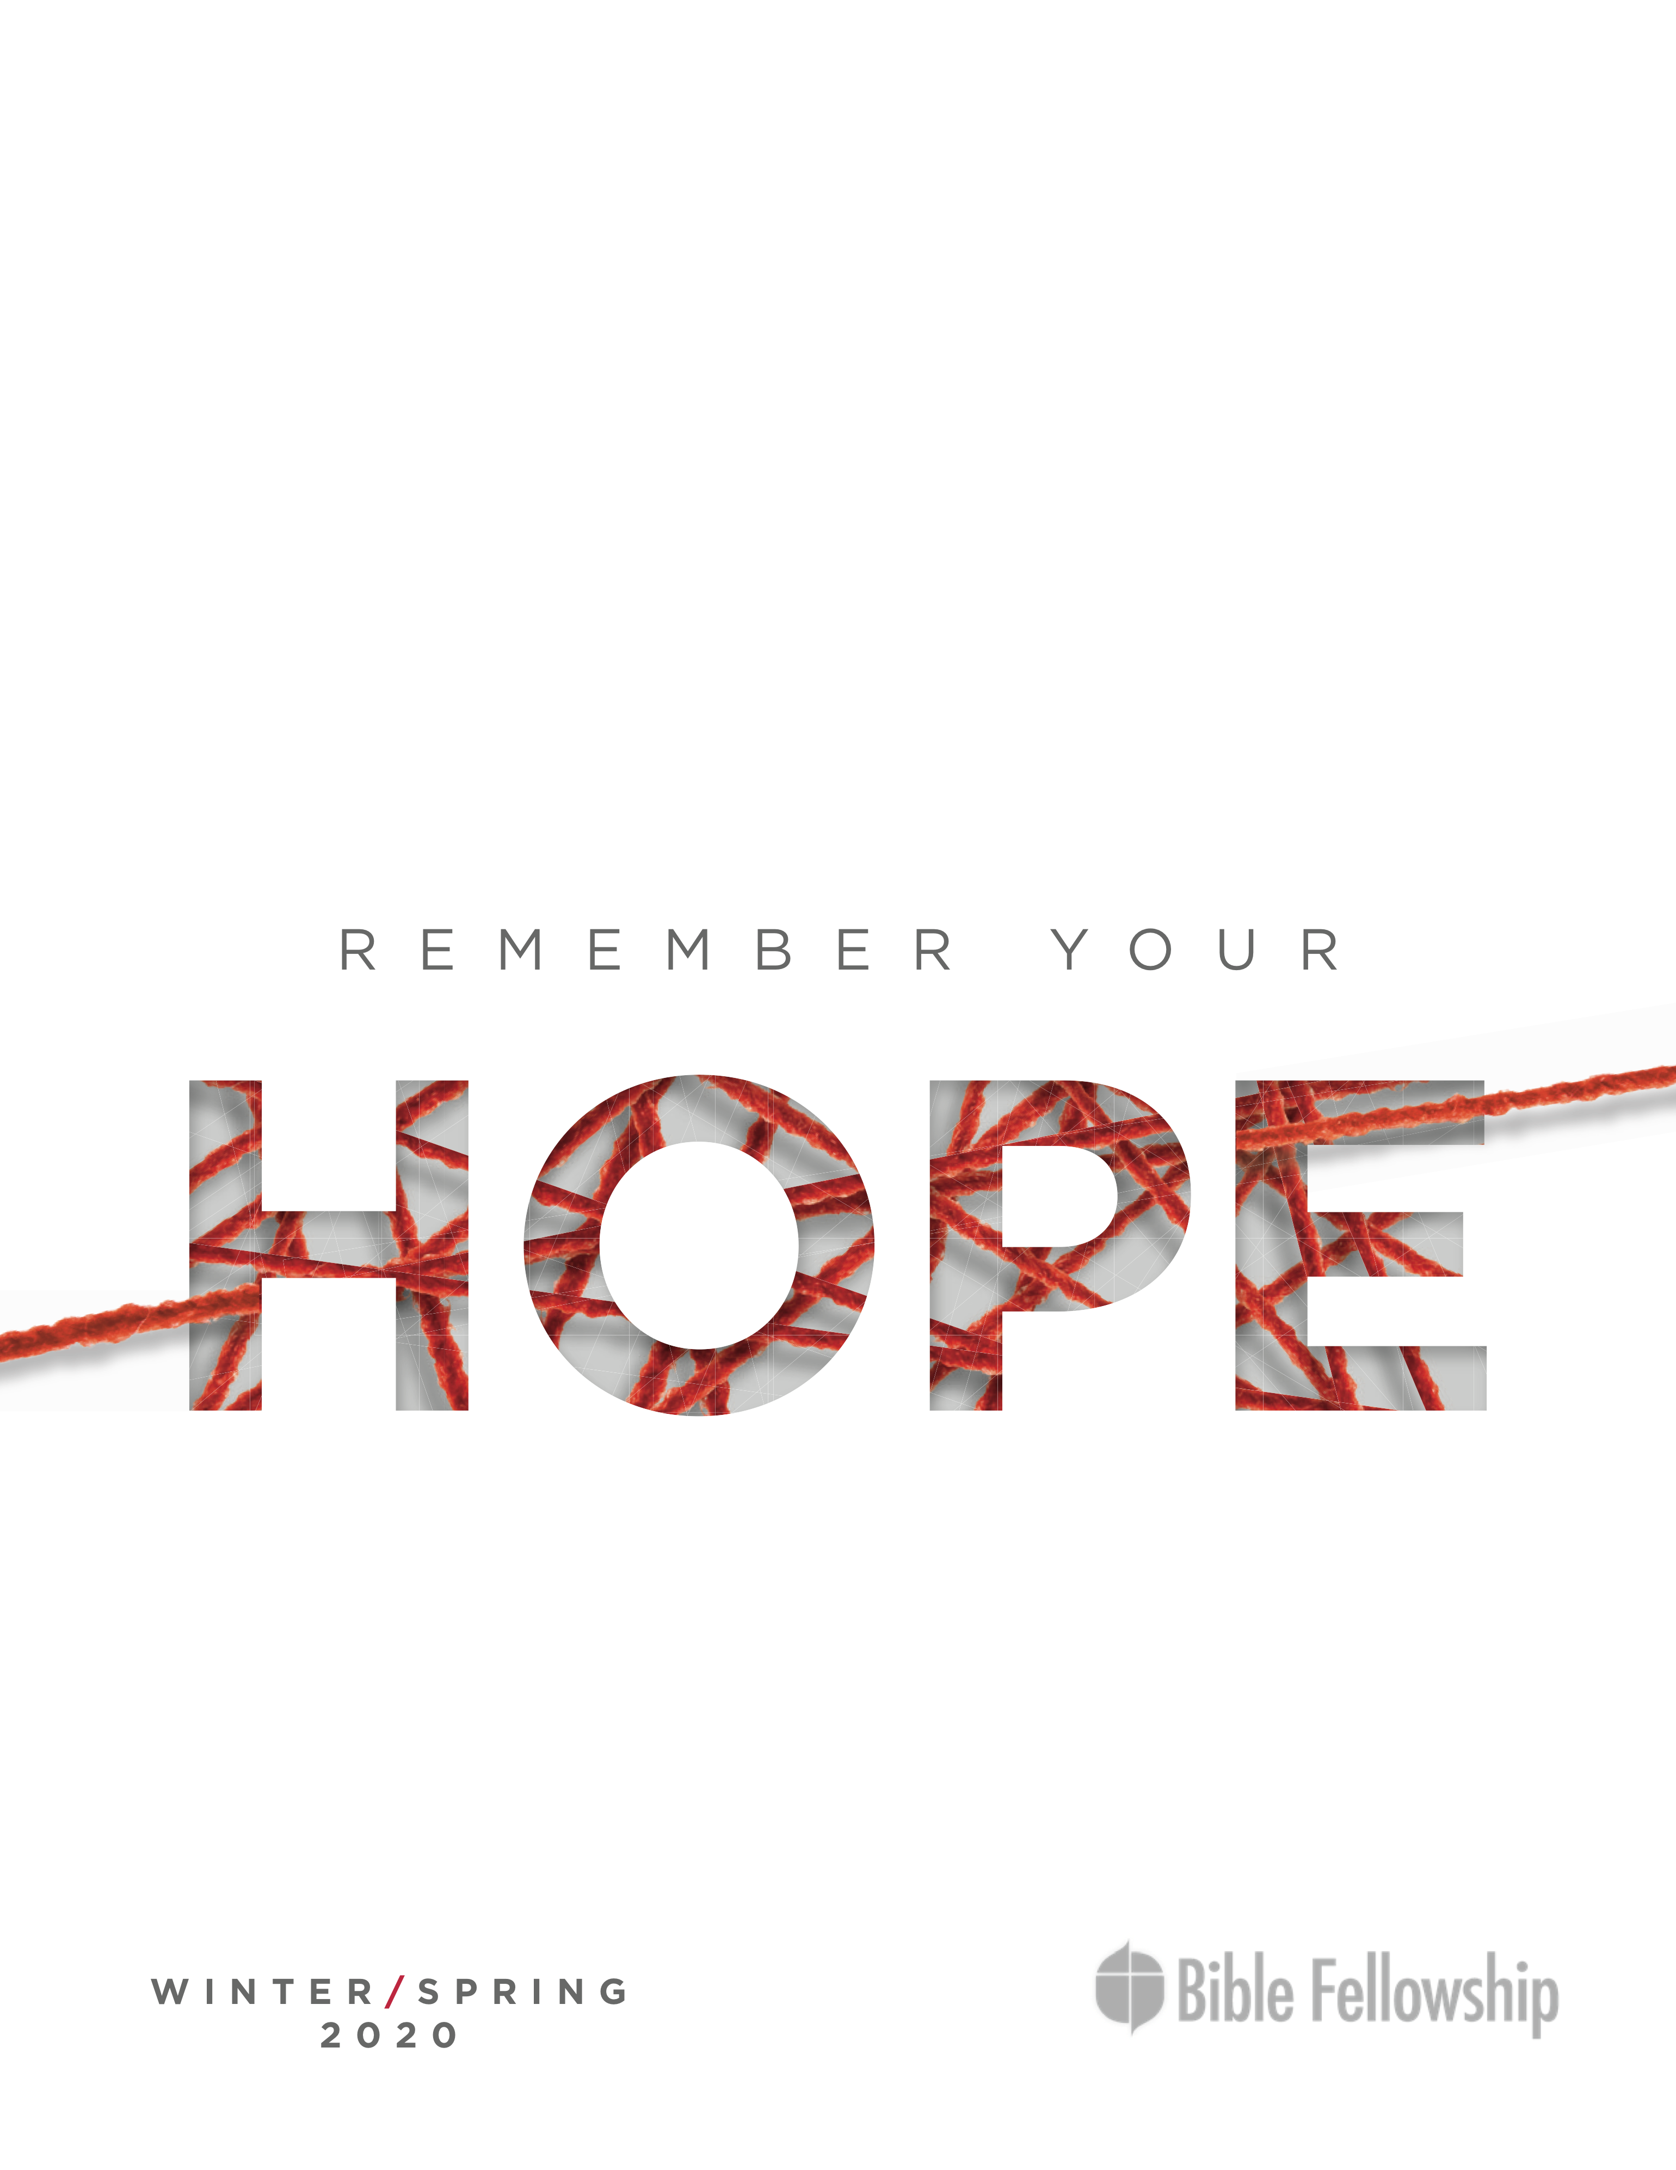

**Main Point: Because our hope is in heaven, we are to live holy lives, set apart for Christ, as citizens of heaven living on earth.**

On May 19, 2018, nearly 30 million Americans tuned in at 7:15 a.m. (EST) to the royal wedding of Prince Harry and Meghan Markle.[1] That number rivals the series finale episodes of *Everybody Loves Raymond* (32.9 million viewers) and *Dallas* (33.3 million).[2] Being a member of the royal family carries with it a degree of prominence and reverence. Recognizing the significance of the privileged positions they’ve inherited, the royal family abides by some unwritten rules; these include:

* No selfies
* No autographs
* No social media
* No dark nail polish
* No traveling without mourning clothes
* Bow/curtsey when entering the presence of the queen
* No miniskirts[3]

**Q: Why might it be significant for the British royal family to uphold particular etiquette?**

**Q: Have you ever been given a significant position (whether in your professional or personal life) that caused you to adjust your behavior in efforts to honor it? What behaviors did you change? Was this a natural adjustment?**

**Transition:** Last week we discussed the inheritance that is waiting for God’s children. Today we examine how this incredible truth should affect the way we conduct our lives.

**Book**

**Main Point: Because our hope is in heaven, we are to live holy lives, set apart for Christ, as citizens of heaven living on earth.**

**Text Summary:**  Peter describes what it means to live with an eternal perspective, with your hope in heaven. He gives four instructions for how to live in response to God’s grace: (1) set your hope fully on the grace ahead, (2) be holy in your whole way of life, (3) love one another earnestly, and (4) crave pure spiritual milk.

**1 Peter 1:13–21 [Read]**

**Talking Point 1:** We are called to set our hope fully on grace and to be holy in our whole way of life.

**Q: What is the connection between setting your hope fully on the grace of heaven and living holy lives here on earth?**

**Q: Why is it important that we live holy lives? How are we able to do that?**

**Q: How does Peter compare them to their Old Testament ancestors?**

The “therefore” that begins verse 13 connects this section with the one we studied last week. We have an incredible inheritance waiting for us in heaven, *therefore*, we can set our hope fully on that glorious future (v. 13). But the same “therefore” also introduces this new section. *Because* we have this incredible inheritance waiting for us in heaven, we are children of God (v. 14). *Therefore*, we are to live like He would, reflecting His character to the world. Like father, like son. The imperatives of Christian living, then, are not a way to try to earn your way to heaven. They are a “therefore,” a response to what God has *already* promised us, what God has *already* done for us. Our salvation and future inheritance are pure grace.[4]

In this section (1:13–2:3), Peter gives his readers four imperatives for how to live the Christian life in light of the Gospel:

* set your hope fully on the grace ahead (1:13)
* be holy in your whole way of life (1:15)
* love one another earnestly (1:22)
* crave pure spiritual milk (2:2)

Each of these commands is connected to an Old Testament passage, emphasizing the superiority of the new covenant over the old covenant, because the Gospel is the fulfillment of the old covenant.

***1. Set Your Hope Fully on the Grace Ahead (1:13):*** The biblical idea of hope is not a kind of wishful thinking, such as, “I hope I get to go to Disney World someday.” It’s an *expectant* *anticipation*, as if you have already purchased the tickets, booked the flight, and taken off from work; you’re just waiting for the day to come. That metaphor isn’t perfect, though, because something could always go wrong, of course. The flight could get canceled, Disney World could burn down before you go. But we can trust 100 percent in God’s promise of salvation. We have a confident expectation that we will receive grace and mercy, not condemnation, at the day of judgment because of Christ (Romans 8:1). So we can put our hope *fully* in our future inheritance in heaven.

We can be confident in our future hope because it is based in something that has already happened, the sacrifice of Christ (1:18–19). In describing Christ as a “lamb without blemish” and focusing on “His precious blood” (v. 19), Peter is calling to mind the Passover lamb of the Exodus and showing us how the new covenant is superior to the old. Israel was ransomed from slavery in Egypt, but we have been ransomed from slavery to sin. The Passover lamb saved Israel from death one time, but the blood of Christ saves believers from all sin and death forever (Exodus 11–12). We were ransomed by the imperishable precious blood of Christ (1 Peter 1:19). As the writer of Hebrews says, the blood of Christ secured for us an eternal redemption (Hebrews 9:12). Verses 20–21 tie these first two imperatives together in saying that though Jesus has existed forever with God, before creation began (1 Peter 1:20; John 1:2), He became flesh at just the right time *both* to die for us *and* to give us an example of how to live (1 Peter 1:20–21). His death gives us hope and His life gives us the example.

The Greek that is translated as “preparing your minds for action” more literally means “girding up the loins of your mind” (v. 13), which is a Hebrew idiom that describes tucking up a long robe into a belt so you can run or fight more easily. Again, this language reminds us of Passover. In the Exodus, God commanded the people to eat their last meal, the Passover, with their sandals on, their staffs in their hands, and their loins girded so they would be ready to run (Exodus 12:11). Jesus also used it in His teaching about being ready for the master to return (Luke 12:35–36).[5] Combined with the second participle, to be “sober-minded,” it means that we prepare for our future hope by resolving to live in light of this future hope now. We aren’t supposed to just sit around and wait for this future hope but live it out in our day-to-day lives in the here and now. This is what it means to live with an eternal perspective, to keep our mind focused on the future inheritance in such a way that it affects how we live today. The next three imperatives give us more detail about exactly *how* to do that.

***2. Be Holy in Your Whole Way of Life (1:15):*** There is a clear Old Testament connection here, as Peter quotes a phrase that was repeated throughout the book of Leviticus. “You shall be holy as I am holy” (Leviticus 11:44, et. al.). As Israel’s holiness was based on their relationship to a holy God, so it is with believers. When God called His people out of Egypt and gave them His Law, He said that when they followed His Law, the other nations would look at them and say what an incredible God they must have to have such righteous laws (Deuteronomy 4:5–8). They were called to be holy—set apart—from the rest of the world in the way they lived. Their obedience to God’s Law would reflect His character to the world around them. It would show how good and just and loving God was. In the same way, when we live holy lives, we reflect God’s character to the world. As Christians, we are representatives of His kingdom, so our lives affect God’s reputation, for better or for worse. By our actions, we either bring honor or shame to God’s name, His reputation in the world. When we follow God’s law, we show the world how good and kind and loving God is. When people see our good works, they will give glory to God our Father (Matthew 5:16).

Peter describes a life of holy living grounded in their relationship to God as their Father (1 Peter 1:14–17). We are part of His family; we live by His rules (v. 17). That’s what it means to “fear God” as our Father—to honor and respect Him not just with our words, but with the way we live. That is what sets us apart from the world. Holy living doesn’t mean we do everything perfectly all the time, it means we strive to live by God’s law rather than by what the world says is right. We are set apart for Him, a people of His own possession (2:9). If we call on God as Father to save us in the day of judgment, we should also live in a way that honors Him as Father in our daily lives (1:17). If we call upon Jesus as Savior, we must also honor Him as Lord.

Peter emphasizes that the new birth into God’s family (1:3) means our lives will look differently than they did before (1:14) in our *whole* way of life, in *all* our conduct (1:15). The change is not just spiritual. It’s a *new birth*, not just switching from one religion to another, that instead of offering sacrifices to Roman gods, now they should offer them to Jesus instead. It means everything in their lives should change. We are called to live differently, not just practice religion differently. [6]

As Paul wrote in Romans, we should no longer be conformed to the ideas, thoughts and patterns of this world, but should “be transformed by the renewal of your mind, that by testing you may discern what is the will of God, what is good and acceptable and perfect” (Romans 12:2). In the same way, Peter focuses on preparing our *minds* for action, being sober-*minded* (1 Peter 1:13). Our lives should look differently than they did before because our *minds* have been transformed. We see the world differently. Holy living doesn’t mean following a list of rules; it means our entire worldview is changed. Holy conduct starts from the inside. It’s a changed heart, not behavior modification.

That command in Romans 12 is passive—*be transformed* by the Holy Spirit. It is the Spirit who changes our hearts and minds and makes us a new creation. It is not something we do for ourselves, but by walking with the Spirit, something He does in us. Though not perfect, true Christians *will* live lives of holiness because the Holy Spirit dwells in them and works in them to bear fruit. Each day, each month, each year, they will grow more and more holy through the work of the Holy Spirit.[7]

**Q: In what ways does your life look differently than it looked before you became a Christian? What parts of your life are you still holding back from the lordship of Christ?**

**Q: Describe what it means to have a Christian worldview versus a secular humanist worldview. How does that change the way we live?**

**Q: How does setting your hope fully on the future inheritance prepare you to live a holy life?**

**Q: What is the difference between trying harder to follow a list of rules and having a changed heart?**

**1 Peter 1:22–25 [Read]**

**Talking Point 2:** We are called to love one another earnestly.

**Q: Why is love the greatest commandment? How is love the summation of God’s law?**

**Q: Why does loving others reflect holy living?**

***3. Love One Another Earnestly (1:22):*** Peter bases this next imperative on being “born again” through something “imperishable” (v. 23). The repeating of the same kind of language used in the last section firmly plants our behavior and lifestyle in the Gospel. We don’t just love other people because God said so. We love other people because we have been loved by God (1 John 4:19). Extravagantly, fully, humbly loved in the greatest way possible—He gave His life for us (John 15:13). We love other people because we have been born again by the Holy Spirit (John 3). Not just because it’s the right thing to do, but because God has changed our hearts. He has put His Spirit in our hearts, so He has given us His love for people.

Peter roots our love for others in “the living and abiding word of God” (1 Peter 1:23). The Bible can be described as a love story. In Hosea, Ezekiel, and other prophets, God described His relationship with Israel with the metaphor of a love story, an adulterous wife and the husband who continues to love and pursue her, no matter what. Though it contains instructions, the Bible is less an instruction manual than a story—the story of God’s relationship with mankind over the course of human history. How their relationship started good, how it was broken by sin, and how God gave His own life to fix it. It’s a story of God’s love for us. Consider the way God describes Himself over and over in the Bible. “The Lord, the Lord, a God merciful and gracious, slow to anger and abounding in steadfast love and faithfulness.” (Exodus 34:6; et. al.). Our God is a God of love.

Peter quotes Isaiah 40, the same chapter in which we find the prophecy about a voice crying in the wilderness “prepare the way of the Lord” (Isaiah 40:3). A chapter that declares the good news of a coming king who will rule with might but tend his flock like a shepherd (40:10–11). A chapter that describes the day of the Lord, when the glory of the Lord shall be revealed (40:5). It also says a voice will cry out that our flesh will wither like the grass, but the word of our God will stand forever (40:6–8). Peter again points to this future promise of eternal life as the basis for why we are to live in holiness and love.

At the Last Supper, Jesus gave His disciples many final instructions, but really one final, major command. Many more liturgical denominations call the celebration of this night “Maundy Thursday,” from the Latin word for “mandate” or command, because this is the night Jesus gave them this “new” commandment to “love one another: just as I have loved you, you also are to love one another. By this all people will know that you are my disciples, if you have love for one another” (John 13:34–35). Peter reiterates Jesus’ command to love one another. Peter uses the word “earnestly”—intently, fervently, completely—and “from a pure heart,” meaning without any ulterior motive.[8] Real, pure, true love. Not a love that seeks to get, but one that gives. The same kind of self-sacrificing love Jesus had for them. Jesus gave them this command just after He got down on His knees and washed their feet like a common servant. The kind of love He was commanding was a self-sacrificing love that puts others’ needs ahead of your own (Philippians 2:1–4).

Love is a defining attribute of being a Christian. Those who really love God will love His people (1 John 4:20). We can do all the “religious stuff” in the world, but if we don’t have love, it means nothing (1 Corinthians 13:1–3). Real love is a defining attribute of a holy life, a love that is different from the world’s, because this kind of love can only come from God. When people see us loving each other with the selfless, generous, fervent, no-ulterior-motive love of Jesus, they will see something different in us and in our communities. Just as people were attracted to the selfless love and unity they saw in the first church at Pentecost, they will be attracted to that kind of love in us (Acts 2:42–47).

**Q: Describe what it would mean to be loved with no ulterior motive. How is that different from the “love” we see in the world?**

**Q: What things about your life need to change in order to love others fervently and with a pure heart?**

**Q: How can our church show God’s love to our greater community?**

**1 Peter 2:1–3 [Read]**

**Talking Point 3:** We are called to long for pure spiritual milk.

**Q: What is the “pure spiritual milk”? How does this verse compare to other passages where believers are told to move on from spiritual milk to solid food?**

***4. Long for the Pure Spiritual Milk (2:2):*** In 1 Corinthians, Paul uses milk as a contrast with solid food to tell the Corinthians that they should be beyond the elementary teachings and into deeper things (1 Corinthians 3:1–3). Peter doesn’t draw that kind of contrast here, but instead uses “spiritual milk” as a symbol for spiritual nourishment, as it was commonly used in Judaism at the time. The Greek word for “pure” (*adolos*) is a negative of the word translated “deceit” (*dolos*) in the previous verse. In this “spiritual milk” there is no watering down, no deceit, no falsehood. It is all truth.[9] Peter isn’t so much calling them babies in the faith as he is telling them how they can grow —by putting away all untruth and focusing on the Truth.

*Logos,* the Greek root for the word “spiritual” here, is the same word used for God’s *Word*, so some translations render it “the pure milk of the word” (NASB, NKJV, CSB, ISV), meaning they should long for the pure teaching of Scripture. This reiterates what Peter said in the previous section, that the Word of God will last forever. He alludes to Psalm 34:8, “taste and see that the Lord is good,” encouraging them that a taste is not enough. If they have tasted that the Lord is good, they should long to grow deeper in their relationship with Him. Those of us who have the Holy Spirit within us should crave God’s Word the way babies crave their mother’s milk.

**Q: Describe a time when you really craved the Word of God, when you longed to grow spiritually. What made you crave it?**

**Q: What do you think holds Christians back from diving deep into God’s Word and/or pursuing spiritual maturity?**

**Q: What spiritual disciplines you would like to try to grow in your faith?**

**Took**

**Main Point: Because our hope is in heaven, we are to live holy lives, set apart for Christ, as citizens of heaven living on earth.**

Peter was writing to Christians who were being persecuted for their faith. He sought to encourage them to cling to the hope of their glorious future inheritance. One of the greatest promises of heaven is an intimate relationship with God Himself, dwelling in His presence with no barrier between us. Peter tells them they can have a taste of that intimacy on earth. The more they grow in sanctification, the more they will experience the presence of God even now. They can abide in Christ, in His Spirit, each and every day when they (1) focus their hope on heaven, (2) live holy lives of obedience, (3) love each other earnestly, and (4) seek spiritual growth.

*Teacher, challenge your group to write down the following on a sheet of paper. Ask them to prayerfully complete the statements and live them out this week.*

* *I will focus my hope on heaven by:*
* *I will choose to become obedient in this area:*
* *I will demonstrate the love of Jesus to:*
* *I will devote more time to the spiritual discipline of:*

**CHALLENGES**

**THINK: *How can I love other people more earnestly and purely?*** Are there any people in my life I am loving with ulterior motives? How can I serve people humbly the way Jesus did? Whom is God calling me to reach out to in love? How can I love other believers in my church and small group better?

**PRAY: *For wisdom and power to live a holy life*.** Ask the Holy Spirit to move in your heart, to change you from the inside out, to show you areas of your life that need to be transformed by Him.

**ACT: *Pursue spiritual growth*.** Choose one thing you can do this week to pursue a deeper walk with Jesus. Maybe it’s praying a little bit longer or in a different way. Maybe it’s adding a spiritual discipline, like fasting or simplicity, to your life. Maybe it’s digging deeper into God’s Word. Choose one thing and then implement it this week and see how God works in your life.

1. https://www.cnbc.com/2018/05/21/ratings-for-prince-harry-and-meghan-markle-royal-wedding.html
2. https://www.cheatsheet.com/entertainment/the-most-watched-tv-series-finales-of-all-time.html/
3. https://www.eonline.com/news/938211/16-royal-rules-meghan-markle-has-to-follow-now-that-she-s-a-duchess
4. Edmund P. Clowney, *The Message of 1 Peter, The Bible Speaks Today Series* (Downers Grove, IL: InterVarsity Press, 1988, 61.
5. Robert H. Gundry, “’Verba Christi’ in 1 Peter: Their Implications Concerning the Authorship of 1 Peter and the Authenticity of the Gospel Tradition” *New Testament Studies* (1966), 336–50.
6. Karen H. Jobes, *1 Peter, Baker Exegetical Commentary on the New Testament* (Grand Rapids, MI: Baker Academic, 2005), 113–4.
7. R.C. Sproul, “Love Earnestly,” *Tabletalk* - <https://www.ligonier.org/learn/devotionals/love-earnestly/>
8. Peter H. Davids, *The First Epistle of Peter, The New International Commentary on the New Testament* (Grand Rapids, MI: Wm. B. Eerdmans Publishing Co, 1990), 77.
9. Karen H. Jobes, *1 Peter, Baker Exegetical Commentary on the New Testament* (Grand Rapids, MI: Baker Academic, 2005), 82.