**Week 1: Thanksgiving and Prayer** *Philippians 1:1-11*

**Hook**

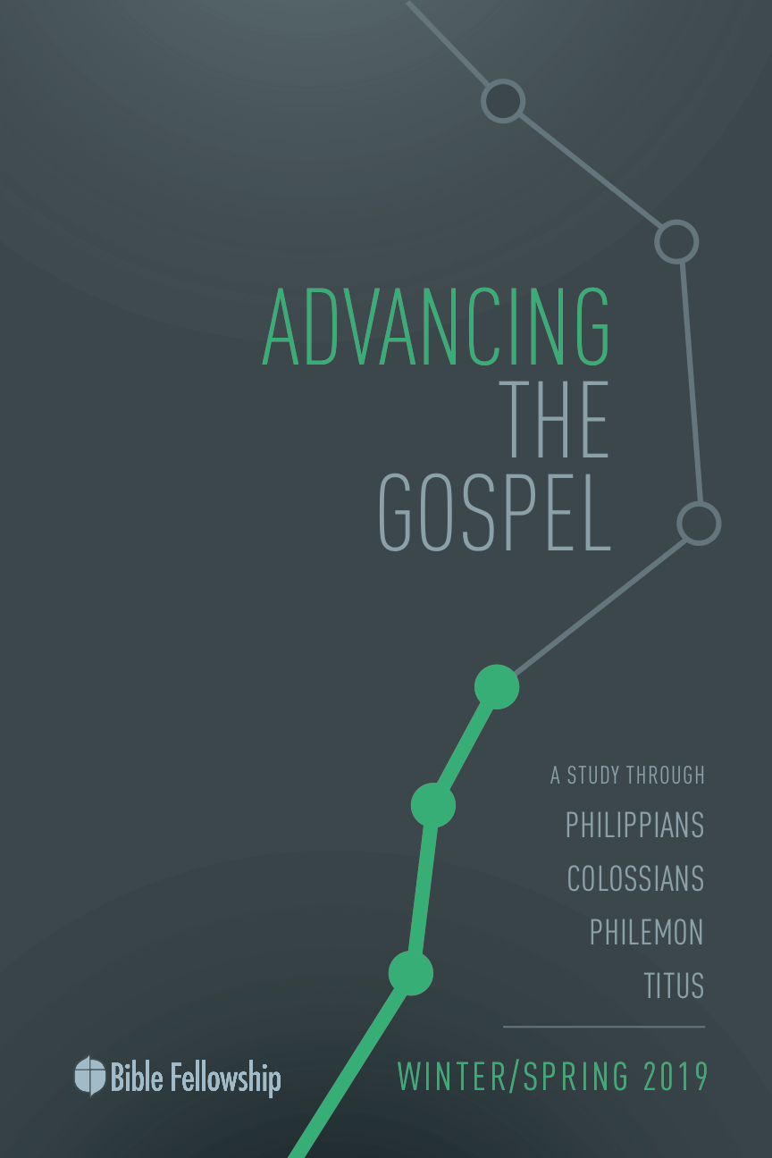

**Main Point: We advance the Gospel together by loving each other, giving thanks for each other, and praying for each other.**

Gospel ministry is not a one-man-show. In our culture, we have the tendency to think we don’t need anyone else. But this hurts our ability to both grow and be effective. This exercise will help us see in a concrete way why we need each other in the body of Christ.

Separate everyone into pairs. Have each pair choose between the two of them who is better at drawing (this helps eliminate the objection to the activity that the problem was really that they aren’t good at drawing). The “artists” turn their chair backward so they can’t see the front of the room. Then share an image from the front of the room, something relatively simple and familiar. The partner who can see the board has to describe the picture to the artist without saying what it is. The artist must draw what the partner describes without looking at the original picture. Allow them to work in their groups for a few minutes. Then, call them back together to discuss their results and the process.

***Questions***:

***How did it turn out? Does your picture look anything like the original?***

***What was the most difficult or frustrating part?***

***Why can teamwork be difficult? When is teamwork most necessary?***

***If you practiced with the same team, do you think you could get better?***

***How would your approach to this task change if you knew someone’s life depended on your effectiveness?***

***Do you think our teamwork within the church matters? Why?***

If we see church as just a place to socialize or even just to grow in our own personal faith, then teamwork might not really matter that much. But if we see the Church as a place to work together toward a goal or a mission, then teamwork can make or break us.

**Week 1, Philippians 1:1-11**

**Book**

**Main Point: We advance the Gospel together by loving each other, giving thanks for each other, and praying for each other.**

**Text Summary:**  Paul opens his letter to the Philippian saints with an effervescent joy and gratitude for their partnership and fellow work in advancing the Gospel. He expresses an impassioned declaration of his appreciation and love for them and his desire for them to grow spiritually. As a great example for us today, we learn about the relationship of prayer, thanksgiving, affection, partnership, and spiritual growth in the advancement of the Gospel.

**Philippians 1:1-2 [Read]**

This opening is a typical format for an ancient letter – author, recipients, greetings:

Author: Note that Paul includes himself and Timothy and calls themselves servants of Christ Jesus. “Servant” is an intentional choice to emphasize their humility. Paul will spend the next several verses calling the Philippians his partners in the Gospel. He starts here with the point that he and Timothy, though they are leaders in the church, are only servants of Christ. The body of Christ is one body with many members. Though we have different roles, there is no hierarchy of position. Only Christ is the head, the rest of us are all equal members of the body.

We should remember Timothy throughout this letter also. Timothy and Silas were working with Paul when they planted the church at Philippi. Timothy was of mixed heritage – Jewish mother, Greek father, so his familiarity with both cultures made him an ideal protégé of Paul. Timothy was young, but a mature follower of Jesus (1 Timothy 4:12), and he became one of Paul’s troubleshooters for problems in his churches (1 Corinthians 4:17; 1 Thessalonians 3:2). He is included as an author of Philippians because Paul is sending him with the letter to Philippi to report Paul’s status in Rome and bring back news about the Philippian church to Paul (Phil 2:19).

Recipients: As he did with the other two letters to churches in the Prison Letters (Ephesians and Colossians), Paul addresses them as “saints in Christ Jesus” who are at Philippi. This shows us how Paul viewed the people of God – people justified and holy before God through faith in Jesus. It can also be a word of encouragement to the believers – we are saints, let’s act like them.

Greetings: Paul’s greeting combines the typical Greek greeting (*charis* – “grace”) and the common Jewish greeting (*shalom* – “peace”).

***What does this tell us about Paul? His readers? The Gospel?***

Paul’s mission was to be God’s spokesman to the Gentiles. He was Jewish and the Gospel was rooted in the Jewish faith, but he was typically writing to Greeks. In his writings and in Acts, he shows us how he was passionate about the truth that the body of Christ was both Jew and Gentile, together, equally (Galatians 3:28).

Background on Philippi: Paul’s relationship with the Philippians began when he, with Timothy and Silas, first preached the Gospel there during his second missionary journey, likely between 49 and 52 A.D. Through their ministry, the first church on the European continent was planted (Acts 16:6-40). So it has been about eight to 10 years since their church was planted.

In terms of the Greco-Roman world, the city of Philippi was quite prominent, named *Colonia Iulia Augusta Philippensis* by Caesar Augustus himself. Although located on the Greek Peninsula, it had the benefits of being considered an official Roman city, rather than just a colony. Its citizens had full Roman citizenship and legal benefits after a battle was won there against the assassins of Julius Caesar in 42 BC. So, at the time of the writing of Philippians, Philippi had been a prestigious Roman city for more than a hundred years. It was also quite wealthy due to its location on the primary trade route between the East and West, called the *Via Egnatia*. This is where they had met the successful business woman, Lydia (Acts 16:14).[1]

**Philippians 1:3-5 [Read]**

**Sub-Point 1:** The Philippians are partners.

Look at Paul’s emphasis on the greatness of his appreciation of them – *I thank my God in* ***all*** *my remembrance…* ***always*** *in* ***every*** *payer…* (vv. 3-4)

***Why is he so thankful for them? (v. 5)***

Paul calls them partners. He isn’t some holier-than-thou bishop in an ivory tower sending down proclamations and judgments to them. They are his *partners* in the Gospel. This will be key for understanding the rest of the book and Paul’s heart for his churches.

***What do these verses say about the way Paul prays, how often he prays, and what he sees as the purpose for prayer?***

Paul didn’t see his prayer life as a list of requests to God as if God were Santa Claus. He saw it as a vibrant relationship with God. His prayers are filled with *thankfulness* and *joy*, particularly for those who have been such partners for him in the faith. As we said in the series introduction, this letter is one of Paul’s Prison Epistles. Paul wrote this letter during his first imprisonment in Rome. And yet, his opening to the Philippians is all thanksgiving and joy. Because of the Philippians’ persistent and faithful support, not only for him but for the advancement of the Gospel. For him, this is an evidence of the genuineness of their faith. They are not just going through the religious motions.

**Philippians 1:6-11 [Read]**

**Sub-Point 2:** The Philippians are righteous.

***What does Paul mean here when he talks about “beginning a good work” and “bringing it to completion”? (v. 6)***

Because of the Philippians’ commitment to the Gospel and the fruit he has seen in their lives, Paul is confident to declare their inclusion with Christ on the last day. The phrase “the day of Christ” is a common one in Paul’s letters, though he sometimes calls it “that day” or “the day of the Lord” instead.[2] It referred back to the Old Testament “Day of the Lord” preached so often by the prophets. The “day of the Lord” was the judgment day, which was a day of judgment for the wicked, but is also a day of vindication for the righteous. So, true believers are not to fear the day of judgment, but welcome it.

In the Old Testament, the prophets preached that the problem was that some people who thought they were of “the righteous” were really of “the wicked.” So they thought they were safe, but they really should be afraid. The prophets called them to repent and turn back to God. Here, Paul is telling the Philippians the opposite – he is confident they have nothing to fear. They are of “the righteous” because of their authentic faith in Christ. True righteousness does not come from our works or our religion or our heritage; it comes from Christ (Philippians 3:9; Romans 3:22).

God will continue to work on them – *“that their love may abound more and more with all knowledge and discernment”* (v. 9) – but they should be confident in their righteousness. They will stand “pure and blameless” on the day of Christ (v. 10). This is why Paul can address them as saints in his formal greeting (v. 1). Though God is still working on them, by their faith in Christ alone, they are sanctified. They are made holy.

**Sub-Point 3:** Paul’s partnership with the Philippians results in love, thanksgiving and prayer.

***Love:***

Look at the way Paul talks about this church:

* He thanks God for them every time he remembers them, in every prayer, with joy (v. 4).
* He holds them in his heart (v. 7).
* He yearns for them with the affection of Christ (v. 8).
* He prays for their love to abound more and more (v. 9).

These are the words of a spiritual father who loves his people dearly and only wants God’s best for them. Paul’s relationship with the church at Philippi was not casual. It was intimate and loving. The Greek word for “affection” in verse 8 is always used for very intense emotions. It was based on its common use for the intestines, so figuratively, it meant loving someone from the very deepest part of you.[3] Paul specifically uses this word with *“in Christ”* – this intense love in Christ. His love for them came from their mutual love for Christ.

Though we all love our friends and family, there is a deep love that cannot be had except with other people who love Jesus. The mutual love of Jesus and a shared life-mission bond you in a way that you aren’t bonded even with your biological family. That’s why we so often call it “my church family.” Jesus even said that Himself (Matthew 12:50). Anyone who “does the will of My Father,” anyone who shares in God’s mission to advance the Gospel – is Jesus’ family, is a fellow worker with Paul, is loved with the affection of Christ.

***Do you have any dear friends in Christ whom you love this way? How does this kind of relationship differ from secular friendships that you have?***

***Have you ever been shown support, either physically or spiritually, by fellow Christians? How did that make you feel?***

***What are some ways you can start supporting other believers around you? How can you reach out to people at Henderson Hills who may not feel connected to the family?***

***Why would proper love for fellow believers – our coworkers in the mission – be important for advancing the Gospel?***

***Thanksgiving:***

Paul thanks God for the Philippians in all his remembrance of them (v. 3). Every time he remembers them, he thanks God for them. Paul says they not only worked to advance the Gospel, they were *“partakers with me of grace … in my imprisonment”* (v. 7). This meant they prayed persistently for him and sent him letters and sacrificial gifts while he was in prison. Paul’s type of arrest was a house arrest, where he had to pay his own rent and for his own food and other expenses (Acts 28:30). Several churches sent him financial support during this time.[4]

Paul didn’t just write a thank you note to the Philippians, he also thanked God for them in prayer. Thanksgiving is a big part of any healthy prayer life. When we practice thanking God for the good gifts He has given us, it opens our eyes to see His gifts more and more, in every aspect of our lives. Even the things that don’t look like gifts at first – like Paul’s imprisonment. Because Paul lived a life focused on Christ’s mission and filled with gratitude, he was able to see how his imprisonment was actually a good thing, an act of grace (v. 7). It gave him the chance to preach to the Roman guards and many in Rome who visited him and it emboldened others to share the Gospel back in their own cities.

***In your prayer life, do you thank God for other believers who have supported you and encouraged you in your faith? If you did, what kind of difference do you think it would make in their lives? What difference would it make in your prayer life?***

***Why is it hard to be grateful sometimes?***

***How can we cultivate gratitude in our lives?***

Cultivating gratitude takes practice. If we start thanking God every day, we will see more things to be thankful for. Paul said he thanked God for the Philippians *every time he thought about them*. Imagine how much more we will see the good things in our lives if we stop to thank God every time we think about them.

***How might prayerful gratitude affect our personal lives?***

***How might prayerful gratitude affect our church?***

***Prayer:***

Beyond thanking God for them, Paul said he also prayed for the Philippian church. What kinds of things did he pray for them? (v. 9)

* That their love would abound more and more
* That they would grow in knowledge and discernment
* That they would be able to approve what is excellent
* That they would grow in sanctification

There is not a single thing in there about looking for a new job or their decision to move or a conflict in their family. Paul prayed that they would be sanctified, that they would be more and more like Jesus. The rest of those things are important and God cares about them; after all, He knows every hair on our head. However, God works all things for our *good*, not for our comfort (Romans 8:28). And sometimes, we need a fire to refine us (1 Peter 1:7).

Paul prays for the Philippian Christians to grow in love and wisdom and knowledge. To become more like Jesus. This should be our prayer for ourselves and for everyone we love.

***Why is sanctification important for advancing the Gospel?***

***How have others helped you in your spiritual growth and sanctification?***

***Have you ever prayed for someone else’s spiritual growth? Not just their physical needs, but for God to work in their lives to make them more like Jesus? If you did, what kind of difference do you think it would make in their lives? What difference would it make in your prayer life?***

**Week 1, Philippians 1:1-11**

**Took**

**Main Point: We advance the Gospel together by loving each other, giving thanks for each other, and praying for each other.**

We learned at the beginning of the lesson that we need each other to accomplish God’s mission. Even the apostle Paul knew he needed others. And even though he was crazy busy working toward his mission, he took the time to show them love, to thank God for them, and to pray for them.

Hand out blank index cards to people in the class. They will use both sides. On the front, have them write “LOVE 🡪 THANKS” at the top. On the back, have them write “LOVE 🡪 PRAYER” at the top.

Under LOVE 🡪 THANKS: Make a list of people you love with that special kind of Jesus-bond. People who have invested in your spiritual life, encouraged you, helped you to grow, etc. Commit today to praying for those people *every morning*, thanking God for them and all they have done for you in your spiritual life. (Ideally, by doing this step in the morning, you will see more things to be thankful for throughout the day).

Under LOVE 🡪 PRAYER: Make another list of people you want to pray for. Keeping in mind you are praying not for temporal details of their lives, but for them to grow in their spiritual lives. They may or may not include some of the same people whose names you wrote on the other side of the card. Commit today to praying for those people *every night*. If it feels awkward, if you don’t know what to say, just start by praying Paul’s prayer for the Philippians (vv. 9-11).

You can put this index card wherever is helpful for you. Consider tucking it into your bathroom mirror, because you’re in there in the morning and at night. You can flip the card back and forth depending on which side you are praying for. You could also keep it in your Bible, in your purse, in your car, on your dresser… wherever you think you will see it every day, to remind yourself to pray for these people in the morning and at night.

Note: Even though this is an individual activity, we still recommend taking a few minutes to do it in class before you go.

1. Peter Thomas O’Brien, *The Epistle to the Philippians: A Commentary on the Greek Text*, The New International Greek Testament Commentary (Grand Rapids: Eerdmans, 1991), 4.
2. 1 Thessalonians 5:4; 1 Corinthians 3:13; Romans 13:12; 2 Thessalonians 1:10; 1 Corinthians 5:5; 1 Thessalonians 5:2; 2 Thessalonians 2:12; 1 Corinthians 1:8; 2 Corinthians 1:14
3. Strong's #4698
4. Craig S. Keener, *The Bible Background Commentary: New Testament* (IVP, 2014).