**Week 10: Abundance in Giving** *Philippians 4:10-23*

**Hook**

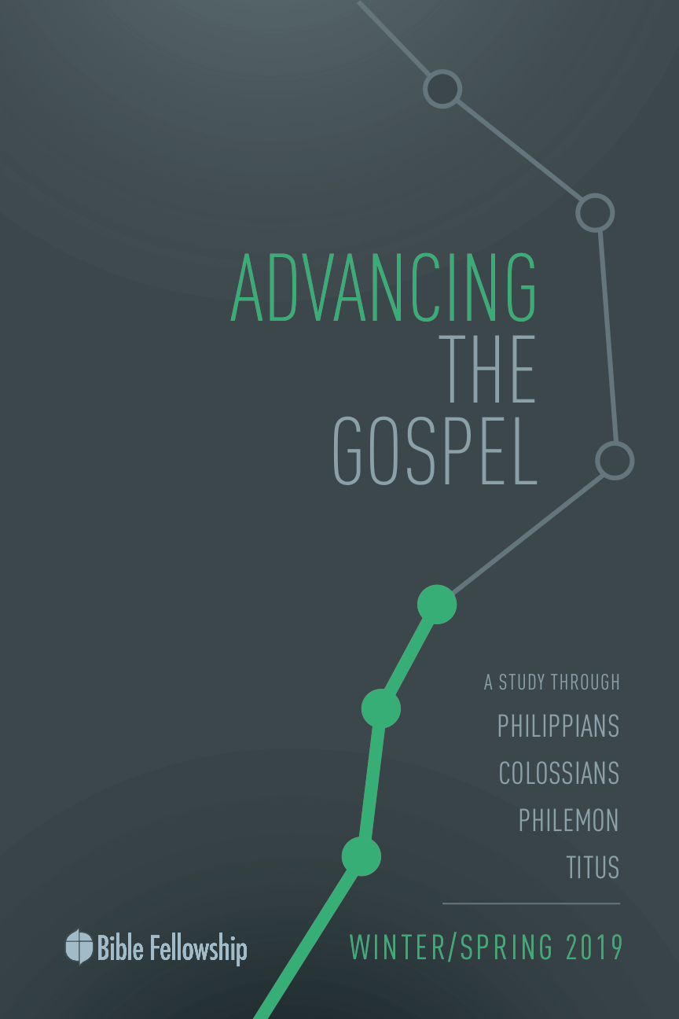

**Main Point: We advance the Gospel when we trust Christ to meet our needs.**

Generosity and service to one another is an important aspect to the Christian life. By serving others, we display the character and love of Jesus. In fact, this is how Jesus said the world will know His disciples, by the way they love one another. Serving others is hard because we tend to be mindful of our own needs and our own concerns more than we are about the needs and burdens of others. Not only that, serving others isn’t always glamorous. It’s not always pretty. And in the end, our heart yearns for public recognition for the way we served and how we sacrificed. A lot of times when we serve others, we don’t just want recognition, we want to be repaid. We want the gesture to be returned to us.

With the people in group, have a share time about experiences serving others. Focus on these two experiences:

* Share a time when you offered to serve someone, yet in your mind you were motivated by the chance that the gesture would be repaid to you later. (e.g., watching someone’s children, running an errand for someone, cooking dinner for someone, etc.)
* Share a time when you served someone and it was a genuine, selfless act of sacrifice, with no intention or hopes to be rewarded; you simply served out of the overflow of Christ’s service and sacrifice for you.

***What made these experiences different?***

***As you served, how was the posture of your heart and the state of your mind different?***

***Which experience brought you more joy?***

**Week 10, Philippians 4:10-23**

**Book**

**Main Point: We advance the Gospel when we trust Christ to meet our needs.**

**Text Summary:**  Paul closes out his letter to the Philippians by offering two great encouragements. First, he wants the believers to know that it is only in Christ that one can experience true contentment. Union with Christ is what gives Paul constant joy through any and every circumstance. Secondly, Paul commends the Philippians for their generosity and service to Paul, not for Paul’s sake, but rather for Christ’s. Paul wants the Philippians to see that it is all for Christ that the Church sacrifices and serves. It’s not for earthly repayment, but rather for heavenly reward.

**Philippians 4:10-13 [Read]**

**Sub-Point 1:** Find contentment in Christ, not circumstances.

***How has Paul experienced abundance in his life? How has he experienced hardship? Use Scripture.***

Paul is thankful that the Philippian church has begun their support of him again. The word Paul uses in verse 10 is translated as *revived*. “Paul borrowed this word from the horticultural practice of his time; it denotes plants and flowers ‘blooming again’ (Ezekiel 17:24).”[1]

Paul says the Philippian church has reignited their pursuit to sacrifice and serve Paul in tangible ways. This is Paul’s purpose throughout his letter: He wants the church to exist to serve one another and have the same mind; the mind of Christ. The church is practicing what Paul has been preaching to them through his letter. It’s unknown the reasons why the church at Philippi was hindered in their support of Paul. However, it can be understood that sending gifts to Paul wasn’t easy. One commentator explains, “[sending gifts to Paul] brought suspicion on the Philippian Church because of who Paul was, a man in chains.”[2]

The church’s loyalty to Paul was costly, but nevertheless they continued on. These verses, along with Paul’s letter in its entirety is concerned with one thing: lifestyle of the Christian. Paul doesn’t just want Christians to serve, to model Christ here and there. He wants it to be the way of life for the Christian. That’s why contentment, he exhorts, is not found in earthly gift-giving or gift-receiving.

***Why should the lifestyle of the Christian be one of service?***

Paul starts in verse 11 making sure the Philippians know that it’s not because of their financial assistance that Paul rejoices. He says, “Not that! Not that!” Paul says he’s learned the secret to lifelong joy: Christ. The secret to having joy in every circumstance is knowing that Christ is enough. If you can remain joyful and content through times of great gain and great loss, there’s nothing this world can do to your joy.

This occurrence of “I have learned the secret” is found only here in the New Testament. “It was a Greek word, a technical term in the Hellenistic mystery religions for being initiated into the mysteries by going through sacred rituals. The term draws a line between those on the outside and those on the inside.”[3] Paul is saying, “I’ve gone through the ritual for the Christian life!” He’s experienced terrible hardship. He’s experienced great reward. But through it all, he has found that Christ is always enough. Corrie Ten Boom, the famous Dutch Christian who was active during the Holocaust, famously said, “You never know Christ is all you need until Christ is all you have.”

Paul was not looking to others to complete his need or his joy. Paul learned to keep his focus on Christ. Good gifts and financial provision must never divert the focus away from the Giver.[4] “Paul’s joy in the Lord was not heightened by prosperity or diminished by poverty.”[5] Christ-Centered contentment, contentment that rises above circumstances, can’t be learned through self-discipline. Rather, it comes through knowing (a knowing that translates into an action-driving conviction) that Christ is truly satisfying, no matter what earthly circumstances scream.

It’s in this context that verse 13 must be read and understood. One source notes, “Translating the preposition *in* as ‘through’ may cause one to miss Paul’s point that it is by being in Christ that one is empowered. In this case, everything refers to his ministry as an apostle, not to anything he might set out to do.”[6]

While this verse is wildly used to promise victory in all circumstances, that’s not Paul’s intent nor is it the context in which Paul is writing. Hansen writes, “Any use of this verse to support a claim or goal of a triumphant, victorious Christian life without weaknesses or limitations conflicts with the immediate context and the wider teaching of Paul.”[7]

Paul can be brought low or he can soar on the heights, yet his joy and focus never change. He’s offering the spectrum of life while saying no matter where he falls, his joy remains because Christ remains. Having Christ and being found in Him is worth more than anything else. This is the active pursuit of the Christian life. And when this is achieved, Christ works in His followers to spread that joy and advance the Gospel that says Christ is the source of contentment.

***Why is contentment in Christ such a foundational element to trusting God?***

***What makes contentment in Christ difficult during difficult times?***

**Philippians 4:14-16 [Read]**

**Sub-Point 2:** Use resources sacrificially, not selfishly.

The Philippian church sacrificed greatly for Paul. Paul commends them for this. He returns to partnership language, proud of how the Philippians are serving for the sake of Christ. Paul wants to commend the act of giving, not necessarily the gift itself. Paul orients their focus heavenward. He wants them to know that the act of giving is the very thing Christ calls Christians to, just as he wrote in the early section of chapter 2. Commending the act of giving directs the attention to Christ, and does not draw attention to the gift itself because Christ is the Gift that is worth more than all else.

Notice that the Philippians continued their support of Paul even when other churches failed to do so (v. 15). Their giving truly advanced the Gospel without barriers in the sense that their support of Paul made it so that new converts didn’t have to. The Philippians knew it would be easier for someone to hear the Gospel message and respond if they knew money was not attached to their decision.

Paul commends the sacrificial state of the Philippians’ hearts. Again, being associated with Paul wasn’t the best situation for this church. Supporting a prisoner such as Paul was costly for them because it brought suspicion on them.[8] Yet they gave anyway. The Philippians set an example of sacrifice, not one of selfishness. They used their resources for the sake of the kingdom’s advancement, not their own gain. If they sought their own gain, they wouldn’t have continued to support Paul.

Paul remembers their service to him with joy and thankfulness. The language he uses sounds more like a teacher’s congratulating a student.[9] Paul commends their sacrifice and their act of giving because it follows his own example. Paul has poured out his life for the sake of the Gospel, and he is proud that those he has used his life to serve are following his example, but more importantly, they are following the example of Christ.

***How has the Philippian church shown commitment to Paul’s ministry, according to verse 16?***

***What barriers get in the way of giving sacrificially?***

**Philippians 4:17-23 [Read]**

**Sub-Point 3:** The Christian’s reward comes from the hands of God, not the hands of men.

***What does it mean for Paul to seek the fruit that increases to the credit of the Philippians? (v. 17)***

Paul reiterates that he isn’t seeking gifts from the Philippians. Instead, he wanted their heavenly accounts to swell with abundance (v. 17).[10] This is the spiritual nature that Paul wants the Philippians to see. He wants them focused on the Christlike purpose in sacrificing for others. Paul didn’t want them to focus on whether their gifts made Paul happy. He wanted them to see that their gifts pleased the Lord. One commentator explains this well by saying it’s not about getting repaid on earth and it’s not about exchanging gifts—Paul wants them to know that God sees their sacrifice, and He will reward them. This divine reward, as it relates to serving others, was absent from the culture of the day.[11]

Notice in verse 18 Paul uses sacrificial language. Hansen writes, “From a social perspective, these gifts demonstrated the friendship of the Philippians by amply supplying all that Paul needed; from a theological perspective, these gifts demonstrated the faith of the Philippians by pleasing God as true sacrifices.”[12] Paul assures the Philippians that God will supply their needs based on their example of sacrificial giving (v. 19). Paul does this to show them that any reward one may seek by giving unto the Lord will come from the Lord. The Philippians won’t be repaid by Paul. It’s not in this life their reward will come. Paul continues to divert their focus heavenward. Paul confirms that God will take care of them and that their example is pleasing to Him.

***Why does Paul want to make sure the Philippians know that God honors and rewards their generosity?***

***Why is it hard to believe that heavenly rewards from God’s hand are worth more than accolades and praise from men?***

**Week 10, Philippians 4:10-23**

**Took**

**Main Point: We advance the Gospel when we trust Christ to meet our needs.**

**Discussion**

We all want praise from earthly voices. We want our work to be seen and noticed. We desire earthly accolades. Because of the sinful desires of our hearts, we will tend to think that God’s love and care of us is dependent on the nature of our circumstances. If life is bad, God must be angry with us. If life is good, God must be proud of us. For the Christian, this is dangerous thinking. We must realize that in Christ, God has already done the best thing He could for us: canceled sin and defeated death. Because God has solved our greatest problem in and through Jesus, we can be content throughout any circumstance, knowing that the single display of God’s love for His children is found on Calvary’s Cross. For this reason, we can endure all circumstances with joy and trust. For this reason, we can serve others at great cost to ourselves knowing God has prepared for us eternal pleasure in His presence.

***Why is earthly recognition worthless compared to what we have in Christ?***

***How can we serve our church the way the Philippians served Paul?***

**Challenges**

***Let Jesus be your joy.*** Seeking happiness is what we do. It’s the anthem of culture. It’s the reason behind our purchases, our decisions, our jobs, our lifestyles. We want to be happy. We want to experience joy. But the happiness that comes from earthly pleasures is fleeting, here one moment, gone the next. As St. Augustine explained, the human heart is restless until it finds its rest in Christ. Let Jesus, above all else, be your source of joy. When we seek Christ for ultimate joy, we experience joy that can’t be shaken by earthly circumstances.

***Seek to serve the church.*** It’s easy to come to church and critique the services and the people for how they don’t meet your needs. Instead of looking for how the church can serve you and your family’s needs, look for how you and your family can serve the church and meet the needs of your church members. In this way, you will follow in the example of Christ by serving His Bride.

***Trust that God is pleased with your sacrifice.*** Don’t fall into the trap of looking for earthly recognition when you serve. Know that as you serve Christ, your sacrifice is a pleasing aroma to God. God desires His children to serve Him with joy and gladness. Trust that God’s favor on you in Christ is enough and worth so much more than praise from any person.

1. Ralph Martin. *Tyndale New Testament Commentary: Philippians.* [Downers Grove, IL: InterVarsity Press, 1987], p. 181.
2. Tremper Longman III & David E. Garland. *The Expositor’s Bible Commentary: Ephesians - Philemon.* [Grand Rapids, MI: Zondervan, 2006], p. 258.
3. G. Walter Hansen, *The Pillar New Testament Commentary: The Letter to the Philippians*. Eerdmans: Grand Rapids, 2009, p. 312.
4. G. Walter Hansen, *The Pillar New Testament Commentary: The Letter to the Philippians*. Eerdmans: Grand Rapids, 2009, p. 303.
5. Ibid., 313
6. Longman & Garland, *The Expositor’s Bible Commentary: Ephesians - Philemon*, 258
7. Hansen, *The Pillar New Testament Commentary: Philippians,* 314
8. Longman & Garland, *The Expositor’s Bible Commentary: Ephesians - Philemon*, 258
9. Hansen, *The Pillar New Testament Commentary: Philippians,* 317.
10. Longman & Garland, *The Expositor’s Bible Commentary: Ephesians - Philemon*, 260.
11. Ibid.
12. Hansen, *The Pillar New Testament Commentary: Philippians,* 323.