**Week 5: Shine Your Light** *Philippians 2:12-18*

**Hook**

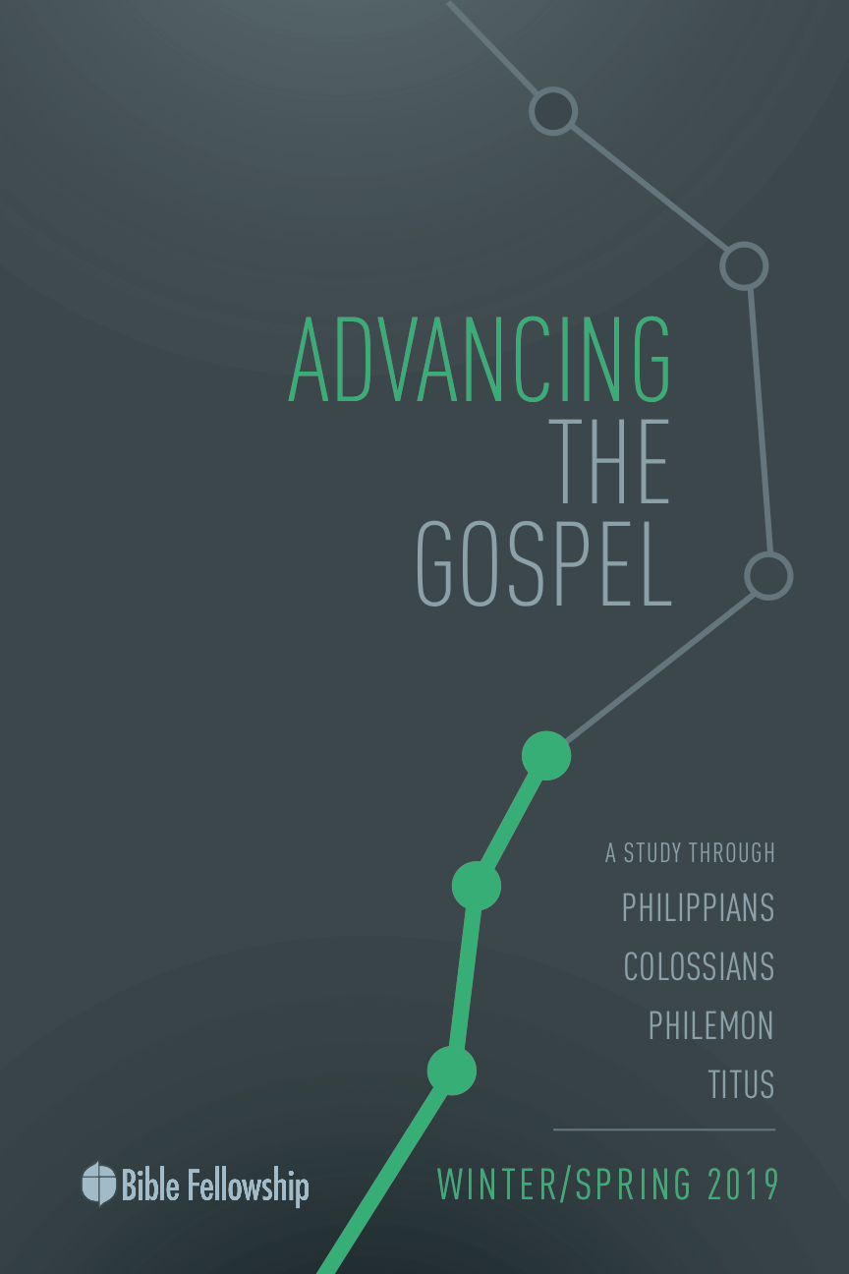

**Main Point: We advance the Gospel when we shine the light of the Gospel in our lives.**

When Paul says that Christians are lights to the world, his goal isn’t to say that Christians simply show the world an alternative way of living. Paul wants Christians to see it’s not merely about conduct, it’s about hope. It’s about life. The way to true life, the way to receive rescue from sin and death, is through Jesus. Jesus is the way to security, hope, rescue and eternal life. Because Jesus is the hope of the world, Christians use their lives to show the on-looking world where hope and life can be found.

Ask the class to think about the concept of a lighthouse. Standing tall on the coastline in a highly purposed location, the goal of a lighthouse is simple: notify ships of their proximity to the shore. In times of dangerous weather, the lighthouse gives hope for the ships at sea by making them aware of the closeness of land. In other times, the lighthouse protects ships from running up on shallow waters. A lighthouse is built for that purpose. In the same way, this is the goal of the Christian. The Christian stands on the shore, shining the light out on the world, letting others know there is refuge available.

Bring a flashlight to your group time. Have everyone stand up and spread out across the room. Position yourself by the door and turn off the lights. Turn the flashlight on and move the light across the room. The objective here is to show that the flashlight allows everyone in the room to know the way out. The flashlight, like a lighthouse, shows the way of rescue.

***If you weren’t familiar with the room, how would you have found the door without the flashlight?***

***In what ways did the flashlight convey the purpose of the Christian life?***

**Week 5, Philippians 2:12-18**

**Book**

**Main Point: We advance the Gospel when we shine the light of the Gospel in our lives.**

**Text Summary:**  Because of Christ, the Philippian Christians now have the power and the example to follow him in godly obedience. However, Paul is getting at a deeper level of obedience than mere rule-following. Paul calls the Philippians to Christlikeness in all areas of life in order to display the beauty of Christ to the world. In serving one another and sacrificing for the Gospel, Christians follow Christ’s example.

**Philippians 2:12-13 [Read]**

**Sub-Point 1:** We shine the light of the Gospel as we seek to know Christ deeper.

For Paul, the basis for everything in the Christian life is found in the example of Christ. He begins this collection of verses with the word “*Therefore,”* centering the art of Christian obedience on the work of Christ and His humility. Paul encourages these partners in the Gospel to conduct their lives in a manner worthy of the Gospel (Philippians 1:27), in light of Christ’s work. Paul calls these Christians to obey, and to look to Jesus who has gone before them and modeled faithful obedience and a godly dependence on their behalf and for their sake. As mentioned, the Christian’s obedience is not centered on rules. Hansen writes, “When Paul commends believers for their obedience, he is affirming their commitment to live the kind of life that corresponds to the gospel of Christ by obeying Christ. Obedience is defined not in legal terms but in relational terms as knowing Christ, being like him, and serving him.”[1] It is a way of life, following in the footsteps of Christ, not a showy obedience for Paul.

***What are characteristics of a life lived in “a manner worthy of the Gospel”? Use Scripture if possible.***

Paul writes “Work out your own salvation with fear and trembling” (v. 12). Despite common confusion on this verse, Paul was not telling the Christians of Philippi to achieve their salvation on their own effort, that their salvation required them to save themselves. This idea directly contradicts Paul’s Gospel treatise in Ephesians 2:1-10, that salvation is by God’s grace and not our works, so that none can boast. Keep in mind Paul’s call to live in a manner worthy of the Gospel in 1:27. This is his aim in all his exhortations. As Christians work out their salvation, they are not achieving it, but rather displaying the proof of it as God works in them. Paul’s point here is that once grace saves us, grace continues to work in us. This is the truth from John 15:5 when we abide in the vine, we bear fruit. What is inwardly true produces outward manifestations of that truth. The idea is that the Philippians were to make their salvation external because God had made it internal.[2]

***What are common ways God’s children try to achieve their own salvation?***

***What does it mean that God will produce outward proof of inward salvation?***

And this “working out” that takes place happens, Paul says, with fear and trembling. Here’s what Paul is not saying: “Be scared of God in all that you do, always unsure of where you stand with Him as you continue to seek His approval.” Rather, this phrase describes someone who stands in awe of God and approaches Him with great reverence (Exodus 3:5; 1 Samuel 12:24; Hebrews 12:28). This was the nature of how priests approached God throughout the Old Testament. The rituals surrounding entering the temple where God’s presence dwelled were quite extensive. Now, because of Christ, God’s Spirit dwells in His children. Therefore, knowing God works and moves in and through the life of the Christian should make us live in reverent awe. God’s presence is in you, Paul says!

This is why we shine the light of the Gospel as we seek to know Christ—we behold Him for all that He is and we are humbled by the fact that His Spirit works in us and shows us signs of our salvation as He is active in our lives. The deeper we know God—and know that He is at work in us (v. 13)—the more we shine the light of the Gospel. When we know that God works among us, we remain aware of our own inability to achieve salvation for ourselves, as well as live the Christian life altogether. The Christian depends on God daily—for obedience, as well as for outward displays of the Gospel at work within us. This is the “lifelong obedience of believers, which leads us to growth in Christlikeness.”[3]

***How does verse 13 give the Christian confidence in daily living the life God calls us to?***

Paul says look to Jesus’ example. Paul’s call for obedience is not disconnected from the power needed to live out that obedience. And that power comes as believers rest in the finished work of Christ. Believers won’t shine the light of the Gospel by looking to their own efforts to live lives worthy of the Gospel. That’s works-based righteousness. And that isn’t the hope of Christ!

**Philippians 2:14-16 [Read]**

**Sub-Point 2:** We shine the light of the Gospel as we seek to become more like Christ.

***How does a spirit of grumbling and complaining bring accusation against the Christian?***

Hebrews 12 explains that it was for joy that Christ endured the Cross and the shame that came with it. The writer also describes Jesus as the author and perfecter of our faith. This is the example that Paul exhorts Christians toward in verses 14-16. Paul gives several directives to the Philippians in these three verses, and Christ is the pioneer for them all.

“Do all things without grumbling or disputing,” Paul writes in verse 14. Relational disputes and the tendency to complain negatively affects the Church’s witness to the world. How will the Church show unity and be of the same heart and mind (as Paul writes in 2:2) if bickering and complaining are what characterize the interactions within the Church? Paul continues to urge the Philippians to be like Jesus. The apostle Peter described Christ in this way in his first letter: “He [Jesus] did not commit sin, and no deceit was found in his mouth; when he was insulted, he did not insult in return; when he suffered, he did not threaten but entrusted himself to the one who judges justly” (1 Peter 2:22-23). Look to Jesus’ example as He bore the weight of sin and the shame of the Cross, and let it produce a spirit of gladness instead of complaining.

Why does Paul say this? Verse 15 explains: Don’t give the surrounding culture anything that would bring accusation to Christ or His Church. He encourages these Christians to “be blameless and innocent, children of God without blemish in the midst of a crooked and twisted generation.” In other words, don’t let the ways of the outside world come in and taint the body of Christ. Again, continue to live out the calling of the Gospel in a manner that is worthy of Christ’s life and sacrifice. Keep in mind, this exhortation follows the Christ Hymn from 2:1-11. Because of this, the Christian can rest in the reality that Paul isn’t calling Christians to live Spirit-filled, Spirit-empowered lives without the help of the Spirit. Moreover, Christ already lived the life we couldn’t live in our place.

***How does the example of Christ act as an antidote for the spirit of grumbling?***

The cornerstone of the Christian life isn’t the moral purity and perfection of Christians. The cornerstone of the Christian life is the purity and perfection of Christ Jesus given in the Christian’s place. This is why the life of the Christian shines a light to the world, because the life of the Christian points to Christ, not the Christian. This is what Paul means when he writes in verse 16, “holding fast to the word of life …” The Church must not depart from the truth of God’s Word, for it is God’s Word that contains the hope of life found in the message of the Gospel.

***In the midst of a crooked and twisted generation, what does it look like for the Church to hold fast to the Word of life?***

Paul exhorts these Philippian Christians to a life of joy, a life of holiness, a life that proclaims the hope of the Gospel, and a life that stands on God’s Word.

**Philippians 2:17-18 [Read]**

**Sub-Point 3:** We shine the light of the Gospel as we serve like Christ.

***How has Paul used his life for the sake of the body of Christ? (Use Scripture if possible.)***

Paul gave his life for the Gospel. According to verse 17, he was “poured out as a drink offering” for the sake of the faith of these Philippian brothers and sisters. This language concerning Paul’s sacrifice connects back to verse 7 when Paul writes of Christ that He “emptied himself, by taking the form of a servant.” This is the way forward for Christians. This is how the life of the Christian shines as a Gospel light in the world and for the world. Paul understands the Christian calling is one of sacrifice and service. Jesus said, “By this all people will know that you are my disciples, if you have love for one another” (John 13:35).

For this reason, the Church shines one of the truest lights of the Gospel when it seeks to serve the world like Christ. Paul says, “Even if my life is emptied for your sake, I am glad and will rejoice.” Paul encourages the believers to be glad and rejoice with him because serving others with Christlike sacrifice is evidence of the Gospel that the on-looking world cannot ignore (v. 18). Therefore, the Church should experience joy and celebration when Christians follow Christ in service and sacrifice. Paul writes in 1:21, “For me to live is Christ, and to die is gain.” Paul came to the Corinthian believers explaining, “For I decided to know nothing among you except Jesus Christ and him crucified” (1 Corinthians 2:2). As Christ emptied Himself to bring about salvation for God’s children, Christians must empty themselves to shine a light on Christ’s sacrifice for those not yet redeemed. Paul understood this. So, too, must the Church if the Gospel is to advance and shine brightly in a dark world.

***How does the Christian experience joy in the midst of sacrifice?***

**Week 5, Philippians 2:12-18**

**Took**

**Main Point: We advance the Gospel when we shine the light of the Gospel in our lives.**

Gospel ministry was the driving purpose of Paul’s life. He also saw the life of the Church, in conduct and generosity, as central to that purpose. In the midst of the temptation to be discontent and think about our own needs first, Paul challenges us to think differently through the example of Christ and himself, but also through a command. The mission to which God has called all His children is not easy, but it is possible through His indwelling presence and totally worth it. True joy comes through working alongside God and our brothers and sisters for the Gospel. An important aspect of that work is replacing grumbling with rejoicing. When the world sees this kind of conduct and attitude in your life, you become a lighthouse for Jesus.

***How is the Christian witness similar to the role of a lighthouse?***

***What are specific “storms of life” you know of that are happening right now for those close to you or those with whom you come into contact daily?***

***In what ways can you shine your light of hope in Jesus for them as you interact with them?***

**Challenges**

***Obediently work out your salvation.*** We must conduct our lives knowing that our faithful, obedient life of trust in God is both a result of His presence and the opportunity for more of His power. When we don’t feel as though God is there, we trust that He is at work and we joyfully obey. When we don’t think we can go any further, we hold onto the promise that God will keep filling our tank. Our growth and His mission are His delight.

***Put away all grumbling and disputing.*** The stakes are far too high for us to live lives full of grumbling. We must repent and ask for forgiveness for our complaint-filled, discontented hearts. God wants us to shine His glory and serve as His witnesses to the world. We must intentionally work toward being content and we must pray for God’s help. Also, we can serve our brothers and sisters by helping one another replace complaining with rejoicing.

1. G. Walter Hansen, *The Letter to the Philippians*, The Pillar New Testament Commentary (Grand Rapids: Eerdmans, 2009), 171.
2. Richard R. Melick, *Philippians, Colossians, Philemon*, The New American Commentary vol. 32 (Nashville: Broadman Press, 1991), 110.
3. Tony Merida et al., *Exalting Jesus in Philippians*, Christ-Centered Exposition Commentary (Nashville: Holman Reference, 2016), 106.