**Week 7: Losing Is Gaining** *Philippians 3:1-11*

**Hook**

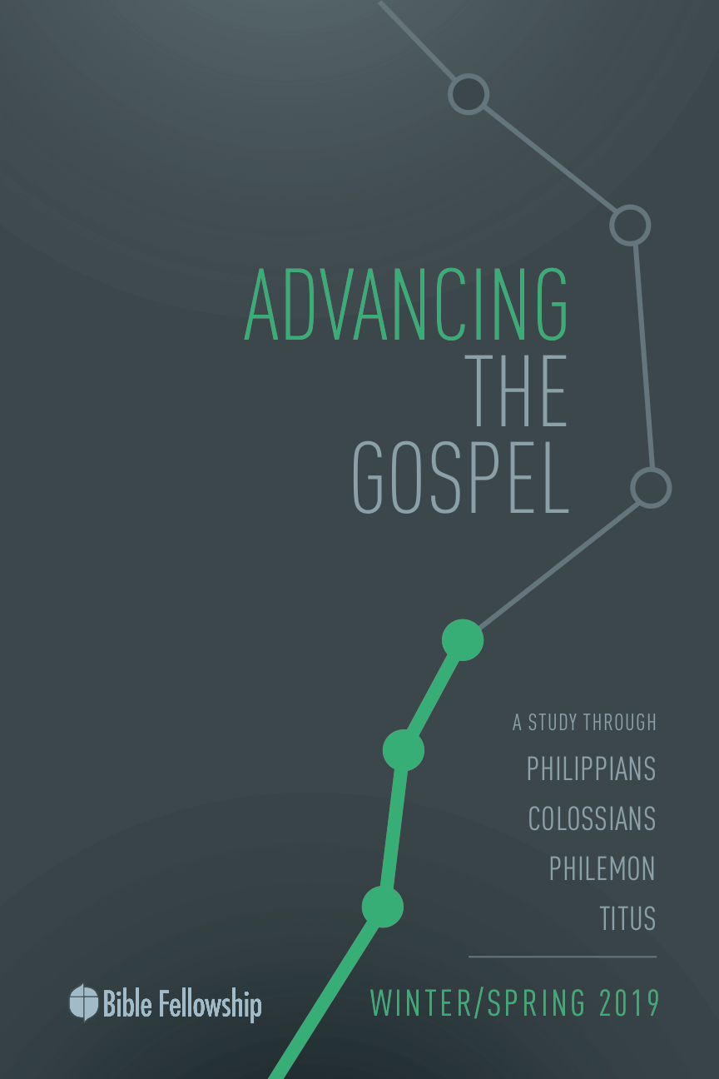

**Main Point: We advance the Gospel when our identity is rooted in Christ.**

Christ transforms a believer’s identity. As Paul explains, we have died and been raised with Christ. It is no longer we who live, but Christ who lives within us (Galatians 2:20). A change in identity is also a common practice in Hollywood. This exercise will test participants’ knowledge of famous actors and musicians’ real identities.

***Directions:*** Refer to the real names and stage names found in Appendix A (located at the end of this lesson). The point of this trivia game is simply to consider how common it is for people in the entertainment industry to change their identities. It will also help as we consider how we think about them once we know their true identity. Read the real names and allow participants to guess the famous stage name of the person.

***What stage name would you consider for yourself? Why?***

***How does knowing someone’s true identity change how we view them?***

***Why is identity so important for a Christian?***

***How does knowing your true identity change the way you live?***

**Week 7, Philippians 3:1-11**

**Book**

**Main Point: We advance the Gospel when our identity is rooted in Christ.**

**Text Summary:**  Paul explains that the Gospel above all changes the way he views his own life and his own earthly status, as well as accomplishments. He compares his earthly prestige with his heavenly privilege, explaining that earthly prestige is left wanting in light of what one gains in Christ. Because of the incomparable value of Christ, Paul was able to endure suffering and hardship with great joy. Through Christ, Paul was filled with a powerful hope, looking beyond temporary circumstances to what awaits those in Christ.

**Philippians 3:1-6 [Read]**

**Sub-Point 1:** The confidence of the Christian is not found in earthly accomplishments.

Paul begins a new section with in Philippians 3, returning to his teachings and encouragement to the Philippian church. In Philippians 3:1, he says, “finally brothers,” which is later repeated in Philippians 4:8. Paul often used the phrase for “finally” at points other than the end, meaning “moreover” or “additionally” (1 Corinthians 4:2; 1 Thessalonians 4:1; 2 Thessalonians 3:1).[1] And, this repetition is connected to his command to “rejoice in the Lord,” his refrain for the letter, running through all his teachings and encouragements. Apparently, the Philippians needed the message because Paul points out that it’s no trouble for him to repeat it and he will do so because it’s for their benefit (v. 1). Joy in the Lord is a stable foundation for the Christian. The word used here for “safe” is also used in Hebrews 6:19 to describe our hope as a “steadfast anchor.”

This first verse helps Paul bridge into a new topic, carrying along the emphasis of joy, which will be especially important for the weightiness of his following points.

***Why is it safe for Christians to be consistently reminded of the true nature of the Gospel? (v.1)***

Paul directs his focus in verses 2-3 to contrast false teachers with the true signs of followers of Christ. Paul exhorts his Philippian friends to “Watch out for dogs” (v. 2). The repetition of “look out” (three times) is the strongest emphasis he could give in writing. If he were speaking this warning, it would come with a raised voice and perhaps clapping or stomping.

Interestingly, Paul uses the word “dog” (*kuon/kunas*). This term was a very strong insult, implying “the most despicable, insolent, and miserable of creatures.”[2] It was typically a term used by Jews against the Gentiles (Matthew 15:26), but Paul flips the term to speak against those bringing a false gospel.[3] He goes on to call them “evil workers,” similar to the words used in Philippians 2:12–13 and 25.

These false teachers, often referred to as Judaizers, were teaching that faith alone was not enough.[4] The Judaizers believed one could only be a part of the people of God through circumcision, and Paul wants to be clear that this teaching is heresy and those teaching such claims were enemies of the Cross (Galatians 5:12). He calls this circumcision party “mutilators.” This is a play on the normal word for “circumcision” (*peritome*) with “mutilation” (*katatome*), both rooted in the word for “cut” (*tome*).

***How should we respond to someone teaching against the Gospel?***

***Why might Paul keep repeating the idea to rejoice?***

True believers “worship by spirit,” Paul explains (v. 3). The root of worship is one’s spiritual relationship with God; not dependent on the flesh or heritage. The truly “circumcised” are circumcised in the heart by faith (Deuteronomy 30:6; Jeremiah 4:4; Romans 2:29).

Paul continues to give further qualification to the child of God’s confidence. He gives three descriptions for the true people of God:

1. *The true people of God worship by the spirit.* True worship isn’t about legalism and conformity to the law. Instead, Paul points the Philippians inwardly, a worship energized and focused by the Holy Spirit.[5]
2. *The true people of God glory in Christ Jesus.* The word for “glory” (*kaucheomai*) normally means “boast,” as Paul states in 1 Corinthians 1:31, taken from Jeremiah 9:24, “Let those who boast, boast in the Lord.” This is certainly meant to emphasize the gracious work of Christ on the believer’s behalf.
3. *The true people of God put no confidence in the flesh.* Paul longs for his readers to know that the flesh is certainly not capable of saving itself. Only the gracious exchange by Christ, the righteous for the unrighteous, can do this (Romans 1:17; 1 Peter 31:8).

There was a time in Paul’s life when he had confidence in the flesh and in verses 4-6, he recites his pedigree. Paul gives his resume for earthly confidence, if it had any merit (v. 4). This list for fleshly confidence is intended to show that Paul is just as qualified, if not more so, as the Judaizers (according to their own standards). He divides his list into two parts, his heritage and his obedience.

***Heritage***

There is no aspect of his life that could disqualify Paul, according to his Jewish tradition.

* *“circumcised on the eighth day” (v. 5)* The “eighth day,” precise to the law for those born of Hebrew parents (Leviticus 12:3). This shows that Paul was not a convert to Judaism.
* *“of the tribe of Benjamin”* (v. 5) He even gives his tribal heritage. Benjamin was the youngest of Jacob’s sons. This tribe, along with Judah, made up the southern kingdom of Israel. They were considered pure Israelites since they were the ones who rebuilt the temple and they were not lost in exile like many from the ten northern tribes.
* *“Hebrew of Hebrews” (v. 5)* The final quality in this category, *“Hebrew of Hebrews”* emphasizes the purity of his heritage, as both of his parents were pure Jews. His statement here is reminiscent of 2 Corinthians 11:22, where Paul addressed the issue of boasting in earthly heritage.

The picture Paul paints for the Philippians is that they should not be intimidated by false teachers who claim another gospel contrary to what he originally delivered to them (Galatians 1:6–9). Paul shows that based on earthly qualifications, he sits at the top.

***In what ways does Paul’s resume give his argument to boast only in Christ so much weight?***

***Obedience***

Paul’s second category is obedience, where he touts his knowledge and zeal for the law.

* *“a Pharisee” (v. 5)* Josephus, a Jewish historian from the first century, said Pharisees were “influential moral leaders who are esteemed most skillful in the exact explication of their laws.”[6] The word *Pharisee* is from Aramaic and means “the separated ones, separatists,”[7] which speaks to their zeal to reform and purify Judaism. This is why Paul mentions his work in persecuting the Church.
* *“as to righteousness under the law, blameless”* (v. 6) This meant he had not violated any of the hundreds of laws, including all the purity and sacrificial rituals. He was not only a pure Jew by birth, he was a pure Jew by his adherence to the letter of the law. However, even though Paul could be considered righteous as it pertained to the law, he knew this “righteousness” was not sufficient. He needed an alien righteousness and resurrection,[8] which are only possible in Christ (1 Corinthians 15:20–22).

Basing faith and eternal confidence on something such as works-based righteousness or earthly heritage will fail every time. Paul teaches that the hope and confidence for the Christian is found in Christ alone. Prestigious earthly pedigrees come with many benefits, but they do not transfer to our heavenly account. The true Gospel will only advance when the Church holds onto and displays the work of Christ alone.

***What are common things that people place their confidence in within the current culture?***

***Why is it easy for the foundation of one’s confidence to shift?***

***What does it look like practically to boast in Christ?***

***How might the Church be affected and encouraged if believers did not put any confidence in the flesh?***

**Philippians 3:7-8 [Read]**

**Sub-Point 2:** The worth of the Christian is rooted in what Christ has done for them

***What does Jesus offer Paul that his accomplishments cannot?***

Paul continues his attack against false teachings. Having put forward his stellar resume, he now explains his view of this resume. In verse 7, he draws a parallel between “gain” (*kerdos*) and “loss” (*zemia*). These are economic and accounting terms.[9] The implication for “loss” references the situation of damaged goods for a merchant, as used in Acts 27:10. The Pharisees considered these characteristics and accomplishments to be central to their standing before God and, subsequently, their hope for resurrection. So, Paul’s view of them as damaged goods speaks volumes about his transformed perspective on the world and theology.

He builds on this image of loss in verse 8, adding that for the sake of Christ he has suffered great loss, yet considers it all as “rubbish.” This word means “excrement, manure, garbage, kitchen scraps,”[10] a vibrant image for his audience. What other Pharisees deemed the most valuable things in this life, Paul claims are worthless.

He continues the wordplay to emphasize his point. He says he considers it all loss in order that he might “gain” Christ, using the same word as at the beginning of verse 7. He is, in effect, saying, “I used to think being a Pharisee was gain, but now I know that being a Christian is gain.” The implication is that he lost his place, identity and worth in this world, but has gained his life in return. The phrase is possibly from Jesus’s teaching, “What shall it profit a man if he gains (*kerdaino*) the whole world and forfeits (*zemio*) his own soul?” (Matthew 16:26; Mark 8:36).[11]

***Why is it hard for us to let go of our grip on our earthly gain?***

***How did your perspective about what makes you “you” change when you became a believer?***

In Paul’s mind, gaining Christ is worth any amount of loss in this life. Moreover, it’s what Christ has done for the Christian that brings the most value. What humanity can accomplish for themselves is worthless in the sight of God. This is why Paul can lose everything else. His worth comes from what Christ offers freely.

Paul set his former life aside for the sake of Christ. His gain in return was beatings, prison, mockery, and countless other sufferings. But, his spiritual gain was Christ. Paul understood that eternal status, given by Christ, was more valuable than any earthly title or religious qualification. Paul measured worth by what he received in Jesus.

Paul’s mentality toward his identity and loss in this world was a tool in his mission to serve Jesus. Holding onto his resume would only restrict him from putting his full trust and worth in Christ, hindering him from following wherever God might lead. As the Church shows that true value and worth are found in Christ and His life in our place, the Gospel moves forward in a powerful way.

***How does holding on to this world hurt the Christian’s ability to advance the Gospel?***

***What are some areas you personally can loosen your grip? How could others help in this?***

**Philippians 3:8-11 [Read]**

**Sub-Point 3:** The joy of the Christian comes from knowing Christ.

Paul’s goal above all else is to know Christ (v. 8). The loss of his prior identity and all that came with it are not even comparable to his newfound identity in Christ. In verse 8, he states that this “loss” could be considered as such because of the “surpassing worth of knowing Christ Jesus, my Lord.” Paul’s deep, personal relationship with Christ brought great value and great joy.

The Old Testament idea of “knowing” is explained as “living in a close relationship with something or somebody, such a relationship as to cause what may be called communion.”[12] One commentator includes a few characteristics of what it likely meant for Paul: “the personal acquaintance of Christ Jesus (Acts 9:4–6),” “receiving the revelation of Christ Jesus (2 Corinthians 4:6; Galatians 1:12),” and “acknowledging him as my Lord” which naturally “includes the submission of every thought and every act (2 Corinthians 10:5–6) to Christ Jesus the Lord.”[13] This multifaceted view of knowledge would have undergirded Paul’s devotion and passion.

***How does knowing Jesus change Paul’s life? How does Jesus change the life of all believers?***

For Paul, knowing God was not a one-dimensional, mental assent to truth. It was a life-consuming knowledge connected to a person. This is because “knowledge is not simply an affair of intelligence; it is an affair of the heart, in the biblical sense of the heart as the center and source of the whole inner life in its full complex of thought, desire, and moral decision.”[14]

One of the main reasons Paul was so enamored by the knowledge of God is due to his understanding of grace. In verse 9, he explains the unbelievable reality that through the Cross, the righteousness of Christ is applied to the sinner’s account. And this comes not by fulfilling the law, but through faith. In this, Paul is repudiating the “righteousness” he mentioned in verse 6, which centered on earthly works and obedience to the law. Such righteousness was damaged goods compared to the righteousness of Christ. There was no eternal value in such obedience because man can never obey God fully without the power and Spirit of God. It was this grace, knowing what God had done for him in Christ despite his own sin, that allowed Paul to suffer with joy. And in such suffering, Paul became acquainted with Christ even more.

Paul viewed his suffering as evidence of his union with Christ and future “resurrection from the dead,” but he sees this future resurrection as the reason for hope to endure his present suffering (vv. 10-11). Growing in the knowledge of Christ means growing in conformity to Him (Romans 8:29; 2 Corinthians 3:18). And what does it mean to be conformed to Him but to imitate Him, humbly and sacrificially obeying God and serving others? When this is our goal in life, we will grow in our knowledge of God and the Gospel will advance. More importantly, the Christian will find true joy.

***How can we have confidence that we know Jesus?***

***How does knowing we are justified by Christ’s righteousness and not our own change us?***

***What are some implications of the Resurrection? How does it give the Christian hope for today?***

**Week 7, Philippians 3:1-11**

**Took**

**Main Point: We advance the Gospel when our identity is rooted in Christ.**

Paul’s own life pattern, from prestige to humble service, mirrors Christ’s example. Paul has the pedigree and trajectory to be a powerful and prestigious person in his time. Yet, through a life-altering encounter with Christ, he let go of that identity and fully embraced his new life and identity in Christ. Paul sees his growth in the knowledge of Christ as worth any hardship life might bring. His example reminds us that we, too, must look out for false teaching that would lead us astray from these life-changing truths. As he writes to Timothy, “For the time is coming when people will not endure sound teaching, but having itching ears they will accumulate for themselves teachers to suit their own passions” (2 Timothy 4:3). Since our hope is in Christ and His Resurrection, we must not fall prey to the traps of this life.

***Why is our self-made identity worthless compared to our identity in Christ?***

***How might our freedom affect our church?***

**Challenges**

***Let go of your earthly identity.*** Our identity is often the most important thing about us. Perhaps it is anchored in a hobby, a sports team, a career, a country or a relationship. In any case, those things should only be tools for serving others and advancing the Gospel. It is dangerous when a good thing becomes the source of our life. Although it is tough to see our earthly identities as secondary, it is essential to our growth and faithfulness to God’s mission.

***Seek to know Christ.*** Seeking to know someone you cannot see can be quite challenging and mysterious. However, it is the role of Scripture, the Holy Spirit, Christian community and the process of working out our salvation to help us know God. We must first have the desire to know and grow. In this pursuit, God will not hide Himself. He wants to be known by you. But this pursuit requires us to consider all else as secondary. God is not like a hobby or an earthly friend. He is the all-powerful and holy Creator God. Knowing Him is an immense privilege.

***Live in light of the Resurrection.*** The purpose of our lives is not to get the most stuff before we die. Our lives are, on one hand, temporary, yet on the other, eternal. Despite the earthliness of our lives, Scripture reminds us not to be in love with the world, since it is all passing away. Instead, we should live joyfully with a loose grip on our earthly lives, hoping and longing for the day when our sight will be made full. This will make our partnership in Christ’s sufferings here not only endurable, but meaningful.

Appendix A – Questions and Answers

1. Real name: Lawrence Harvey Zeigler

Stage name: Larry King

1. Real name: Maurice Micklewhite

Stage name: Michael Caine

1. Real name: Edda Kathleen van Heemstra Hepburn-Ruston

Stage name: Audrey Hepburn

1. Real name: Frances Gumm

Stage name: Judy Garland

1. Real name: Ramon Antonio Gerard Estevez

Stage name: Martin Sheen

1. Real name: Peter Gene Hernandez

Stage name: Bruno Mars

1. Real name: Eileen Regina Edwards

Stage name: Shania Twain

1. Real name: Archibald Alexander Leach

Stage name: Cary Grant

1. Real name: Norma Jean Mortensen

Stage name: Marilyn Monroe

1. Real name: Ehrich Weiss

Stage name: Harry Houdini

1. Real name: Anna Mae Bullock

Stage name: Tina Turner

1. Real name: Marion Mitchell Morrison

Stage name: John Wayne

1. Peter Thomas O’Brien, *The Epistle to the Philippians: A Commentary on the Greek Text*, The New International Greek Testament Commentary (Grand Rapids: Eerdmans, 1991), 349.
2. Gerhard Kittel, Geoffrey William Bromiley, and Gerhard Friedrich, *Theological Dictionary of the New Testament* (Grand Rapids: Eerdmans, 1964), 3:1101.
3. Richard R. Melick, *Philippians, Colossians, Philemon*, The New American Commentary vol. 32 (Nashville: Broadman Press, 1991), 127.
4. Hansen, *The Letter to the Philippians*, 218.
5. Richard R. Melick, [*Philippians, Colossians, Philemon*](https://ref.ly/logosres/nac32?ref=Bible.Php3.3-4a&off=1578&ctx=boast+(kauchaomai)%2c+~and+Paul+consciously), vol. 32, The New American Commentary (Nashville: Broadman & Holman Publishers, 1991), 128.
6. Hansen, *The Letter to the Philippians*, 225.
7. Hansen, *The Letter to the Philippians*, 226.
8. Stanley J. Grenz, *Theology for the Community of God* (Grand Rapids: W.B. Eerdmans, 2000), 436.
9. O’Brien, *The Epistle to the Philippians*, 383.
10. Hansen, *The Letter to the Philippians*, 236.
11. O’Brien, *The Epistle to the Philippians*, 391.
12. O’Brien, *The Epistle to the Philippians*, 388.
13. Hansen, *The Letter to the Philippians*, 234.
14. John Murray, *The Problem of God: Yesterday and Today* (Yale University Press, 1965), 21.