**Week 8: Being a Citizen** *Philippians 3:12-21*

**Hook**

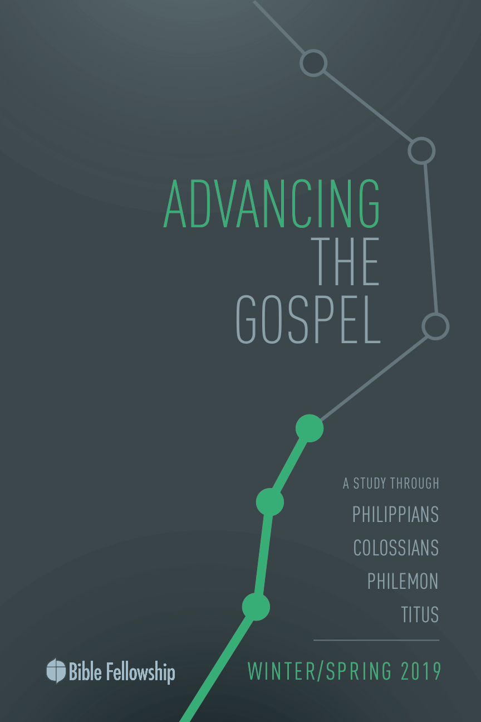

**Main Point: We advance the Gospel when we live as citizens of heaven.**

Almost everyone on the planet is a citizen of some country or community; often living together with a common language or languages. In this exercise, participants will attempt to correctly order the top 10 most-spoken languages in the world.

***Directions:*** Instruct participants to find a partner to work with for this game. They will need a pen and paper to record answers. Instruct them to number from one to 10, allowing space after each number to record answers. (Then find the first block of languages in Appendix A. This list is in random order.) Call out each language and have participants place that language next to the number they think corresponds to its ranking. After all 10 languages have been read, refer to Appendix B for the correctly ordered list, based on the number of native speakers. The team with the most correct answers wins the game.

***What languages do you know or have you studied?***

***What other countries have you lived in or visited? How did the folks you encountered view their citizenship?***

***How does our view of citizenship affect the way we view ourselves and others?***

**Week 8, Philippians 3:12-21**

**Book**

**Main Point: We advance the Gospel when we live as citizens of heaven.**

**Text Summary:** Paul’s earthly goal was to be united with Christ in suffering. But Paul explains that his ultimate goal was to be united with Christ in His Resurrection, that he would experience the resurrection from the dead and be united with Christ for eternity. This is what kept him going. This is the prize for the Christian—not earthly rewards. Because the Christian’s citizenship is in heaven, the Christian looks to the coming glory that awaits when Christ returns, not to the fading glory offered on this side of eternity.

**Philippians 3:12-16 [Read]**

**Sub-Point 1:** Stand with confidence in the redemption offered through Christ.

***Why is it significant that Paul focuses on what lies ahead of him instead of focusing on his past (vv. 13-14)?***

Even though he is the great apostle Paul, even *he* has not yet arrived. Paul emphasizes that he is still pursuing and growing in the knowledge and power of Christ. It is not something, he says, that he can make or has made on his own (v. 13). For Paul, everything about his ministry is a product of God’s work and God’s faithfulness. Paul attributes the work to Christ and Christ alone.

In verse 12, Paul makes it clear that he “presses on” (*dioko*) because Christ “made me his own.” Incredibly, the word for “press on” is the same he uses to describe him “persecuting” the Church in Philippians 3:6. He used to pursue the Church to tear it down, but now he pursues Christ to build up the Church. Yet, this is not Paul’s own doing. The only reason he is able to do any of this work is because of the work Christ has done in him. This is the work that Paul is focused on. Paul isn’t focused on his own sinful past and all that he brought against the Church. Through the power of Christ at work in Paul, Paul redirects his focus.

***Why do you think Paul stresses what God has done in and through him, not boasting of his own accomplishments?***

Just as a runner has “one thing” on his mind, so Paul has a single and central goal for his life. He specifies what this goal is. In verse 14, he “presses on” toward the “goal” for the “prize” of the “upward calling,” building on the image of a runner. Just as a runner would never win if he kept looking back to where he started, so Paul “forgets” his past because of his overwhelming joy and desire for what lies ahead.[1] This even includes all of Paul’s resume mentioned in verses 4-6. As one commentator states, “God’s call draws men and women into relationship with his Son through the preaching of the gospel and gives them the experience and the prospect of living and growing in Christ Jesus.”[2] This is the goal and central purpose of Paul’s life.

Concerning verse 15, throughout the New Testament the word “mature” (*teleios*) seems to simply mean “full” or “not lacking.” Paul’s use here is likely meant to play off his use of it in verse 12.[3] It perhaps means “those who think they are mature” ought to think the way he just described: perfectionism or the idea of having arrived spiritually in this life is an immature way of thinking. The believer is on a perpetual trajectory of growth until the day of Christ; a continual process of faith, submission, pursuit, revelation and obedience. Because of what Jesus has done, believers already have a righteous position in Christ; it’s time for the Philippians to live up to what they already have (v. 16).

***What might it look like for the Church to live and operate with a “one goal” mindset such as the one Paul addresses in these verses?***

As Paul boldly yet gently instructs, the life of a believer is one of perpetual pursuit. It’s important to understand there is a clear distinction between earning and effort.[4] While earning is exactly what Paul is teaching against, effort is exactly what he is trying to promote. Our effort is not for our own bank account, but for the treasure house of Christ.

**Philippians 3:17-19 [Read]**

**Sub-Point 2:** The Christian follows the example of those who set their minds not on this world, but on Christ.

***Why is living a life worthy of imitation important for the Christian?***

In Philippians 2:5, the first call for imitation was to imitate Christ. And now in verse 17, Paul instructs the Philippians to imitate him. Although Paul is not perfect, he is seeking to be more like Christ and has no qualms in asking the believers to observe and imitate him.[5] Growth often comes from the imitation of others, the same is true in the Christian life.[6] Not only should the Philippians, and other believers, imitate Paul, they should also imitate other mature believers (v. 17).

***Who are some believers that you have imitated? What have you learned from them?***

***How does discipleship aid in this imitation process? Whom are you currently discipling?***

Imitating mature Christians such as Paul is important, because there are other, dangerous alternative examples. Paul mournfully describes these false teachers in verses 18 and 19. In verse 18, Paul’s compassion and the weight he felt are displayed, as he gives his report with tears, the only place recorded that Paul mentions crying.[7] He warns the Philippians of those who’ve gone astray, not with pride or anger, but a broken heart.

The Philippians were not to live lives of indulgence and safety, but of sacrifice and courage. This is the life Paul espoused and likewise believes is central to following and knowing Christ. But others were not living this way. They did not strive to know Christ and the power of His Resurrection, nor share in His sufferings (Philippians 3:10). Instead, in verse 19, they had earthly “minds/thinking,” contrasted elsewhere in this letter (Philippians 2:2, 5; 3:15).

These false teachers are described as enemies of the Cross. They were focused on their own physical desires (“their god is their belly”); they sought their own glory and thus brought themselves shame (“they glory in their shame”); and they were consumed with earthly things (v. 19).[8] Sadly, their end is destruction.

Paul warns his audience that they must choose to have either the mind of Christ or the mind of earth. A person’s life follows his or her mindset and puts it on display, both of which correspond to a true identity and relationship with Christ or lack thereof.

Paul is clear: Christ is the ultimate example that Christians follow. However, there is a reality to the human experience that necessitates good role models in the faith. Christians must strive to imitate those following in Paul’s example as well as strive to be an example for others to imitate. Christians have been called to salvation for God’s glory and for the sake of others. The church lives this calling when we set our minds on the things of Christ, not the things of this world.

***How might intentional discipleship affect the Church?***

***In what way is the Church affected when believers set their minds on the things of this world?***

**Philippians 3:20-21 [Read]**

**Sub-Point 3:** Look forward to renewal of all things when Christ returns.

As described in Philippians 1:27, the Philippians were proud of their citizenship in Rome, despite being located in Macedonia. Paul utilizes this aspect to highlight their true or primary citizenship. Despite all the privileges and responsibilities of Roman citizenship, a heavenly one is far exceeding.

Moreover, Paul wants the Philippians to see that the one, true Savior is of heaven, not Rome. It was a common belief in Rome at the time that Caesar Augustus was the “savior of the world” because he restored order and peace.[9] Of Paul’s usage of the term “Savior” in connection to Jesus, Hansen writes that Paul “[explicitly] (and we must assume deliberately) speaks of Jesus in language which echoes, and hence deeply subverts, language in common use among Roman imperial subjects to describe Caesar.”[10] Paul wants his readers to turn their focus and hope to Jesus, not Caesar. This shift for the Philippian believers is meant to take their eyes and pride away from what is seen and turn their hearts to hope in the unseen.

Paul wants the believers to find their hope in the kingdom that is coming, not in the one found in Rome. This change in perspective would help them to imitate Paul, to live a “cross-shaped life.” Such a life “eagerly awaits” the coming of Jesus. This phrase occurs a few other times with the same idea (1 Corinthians 1:7; Galatians 5:5; Hebrews 9:28). Paul knows the danger of complacency, as described in verses 18–19.

As the root of their hope, in verse 21, Paul describes the certain future for believers. Though they are to endure whatever trials God brings their way, eventually their hope will turn to sight, pain erased, disease done away with, and death no more. Because of this hope, their concerns ought not be too focused on this earthly life.[11] Verse 21 gives great hope for the Christian because Paul says Christ will return and “transform our lowly body to be like his glorious body.” This verb that Paul uses envisions a dramatic, supernatural event when Christ will “change the form” of our body from lowly to glorious.[12] This allows the Christian to hope in eager anticipation for the day when their bodies will be free of sin, decay, weakness, suffering and death. What glorious hope!

***How does the Christian’s hope in resurrection help one to live a “cross-shaped life”?***

The believer can truly live free and need not fear, as the writer of Hebrews stated, “… through death he [destroyed] the one who has the power of death, that is, the devil, and delivers all those who through fear of death were subject to lifelong slavery” (Hebrews 2:14–15). All things are in subjection to Christ, death and the mortal body included.

Because of this citizenship, one quite distinct from our earthly affiliations, we eagerly await His transformation of our humble bodies. With this mentality and freedom, the Christian’s life will exude the power of Christ, advancing the Gospel in their Church, in their community, and to the ends of the earth.

***What does one’s citizenship in heaven mean for his or her life right now?***

***According to this passage, why is Philippians 2:6–13 so relevant to one’s faith and conduct?***

**Week 8, Philippians 3:12-21**

**Took**

**Main Point: We advance the Gospel when we live as citizens of heaven.**

Paul’s life is a wonderful picture of what can be done when we fully commit our lives to knowing Christ and put our hope in the power of His Resurrection. This only happens when we see the foundation of our lives rooted in God rather than the temporary affiliations of the here and now. Despite the usefulness and purpose of our earthly citizenship, we are called to view it through the lens of our eternal citizenship.

According to the Unites States Citizenship and Immigration Services, American citizens have certain responsibilities:

***Rights***

* Freedom to express yourself.
* Freedom to worship as you wish.
* Right to a prompt, fair trial by jury.
* Right to vote in elections for public officials.
* Right to apply for federal employment requiring U.S. citizenship.
* Right to run for elected office.
* Freedom to pursue “life, liberty, and the pursuit of happiness.”

***Responsibilities***

* Support and defend the Constitution.
* Stay informed of the issues affecting your community.
* Participate in the democratic process.
* Respect and obey federal, state and local laws.
* Respect the rights, beliefs and opinions of others.
* Participate in your local community.
* Pay income and other taxes honestly, and on time, to federal, state and local authorities.
* Serve on a jury when called upon.
* Defend the country if the need should arise[13]

***Discussion***

***What privileges are granted to citizens of heaven?***

***What responsibilities accompany those on earth who are citizens of heaven?***

**Challenges**

***Passionately pursue Christ as your one thing.*** In our day and age, being passionate about something is a quality people appreciate. However, as Christians, we aren’t supposed to just pick something to be passionate about. We have been given the most solid and meaningful thing in all eternity to drive our passion. The beautiful thing is that we don’t have to lay aside all other interests, but rather orient them around our greatest passion. If we are doctors, we are to be the best doctors we can be for Jesus. If we are car mechanics, we are to be the best mechanics we can be for Jesus. If we are preachers, we are to be the best preachers we can be for Jesus. He is the sun of our galaxy, drawing in our interests like planets through the gravity of His glory.

***Seek godly examples.*** Although the world is full of bad examples, if we pray and look, we will find shining stars. These stars may be humble and spend little, if any, time in the spotlight, or they may be leaders of important ministries, perhaps a friend or an acquaintance. Regardless, we need to seek out someone to help us grow—for ourselves and for the sake of those who will follow us.

***Live as heavenly citizens.*** Our family and home are near and dear to us, as they should be. The family unit is the oldest and most important social component for us as humans, created by God Himself. This is why Scripture so often talks in familial terms such as father, brothers and sisters, and children of God. However, as much as we love our earthly community and should seek to love them well, our call is to do so through the lens of our heavenly family. This will require sacrifice at times and prioritizing God’s leading, even at the cost of our earthly affiliations. Despite being hard, it frees us and gives us eternal vision and purpose.

**___________________________________**

**Appendix A – Top 10 Languages (random order)**

* Spanish
* Arabic
* Bengali
* Mandarin
* Punjabi
* Russian
* English
* Portuguese
* Hindi
* Japanese

**Appendix B – Languages in Order for Number of Native Speakers (in 2010)**

Language Speakers (in millions)

1. Mandarin 955
2. Spanish 405
3. English 360
4. Hindi 310
5. Arabic 295
6. Portuguese 215
7. Bengali 205
8. Russian 155
9. Japanese 125
10. Punjabi 100

1. Hansen, *The Letter to the Philippians*, 255.
2. Hansen, *The Letter to the Philippians*, 257.
3. Hansen, *The Letter to the Philippians*, 258.
4. Merida et al., *Exalting Jesus in Philippians*, 152.
5. Robert P. Lightner, [“Philippians,”](https://ref.ly/logosres/bkc?ref=Bible.Php3.17&off=64&ctx=be+more+Christlike%2c+~Paul+did+not+hesitat) in *The Bible Knowledge Commentary: An Exposition of the Scriptures*, ed. J. F. Walvoord and R. B. Zuck, vol. 2 (Wheaton, IL: Victor Books, 1985), 662.
6. Robert P. Lightner, [“Philippians,”](https://ref.ly/logosres/bkc?ref=Bible.Php3.17&off=64&ctx=be+more+Christlike%2c+~Paul+did+not+hesitat) in *The Bible Knowledge Commentary: An Exposition of the Scriptures*, ed. J. F. Walvoord and R. B. Zuck, vol. 2 (Wheaton, IL: Victor Books, 1985), 662.
7. Melick, *Philippians, Colossians, Philemon*, 142.
8. Robert P. Lightner, [“Philippians,”](https://ref.ly/logosres/bkc?ref=Bible.Php3.18-19&off=830&ctx=tomach.+They+had+in+~mind+only+their+own+) in *The Bible Knowledge Commentary: An Exposition of the Scriptures*, ed. J. F. Walvoord and R. B. Zuck, vol. 2 (Wheaton, IL: Victor Books, 1985), 662.
9. Hansen, *The Letter to the Philippians, 269.*
10. Ibid., 270.
11. Melick, *Philippians, Colossians, Philemon*, 144.
12. Hansen, *The Letter to the Philippians, 272.*
13. https://www.uscis.gov/citizenship/learners/citizenship-rights-and-responsibilities