# Week 3, Joshua 3 & 4 Hook

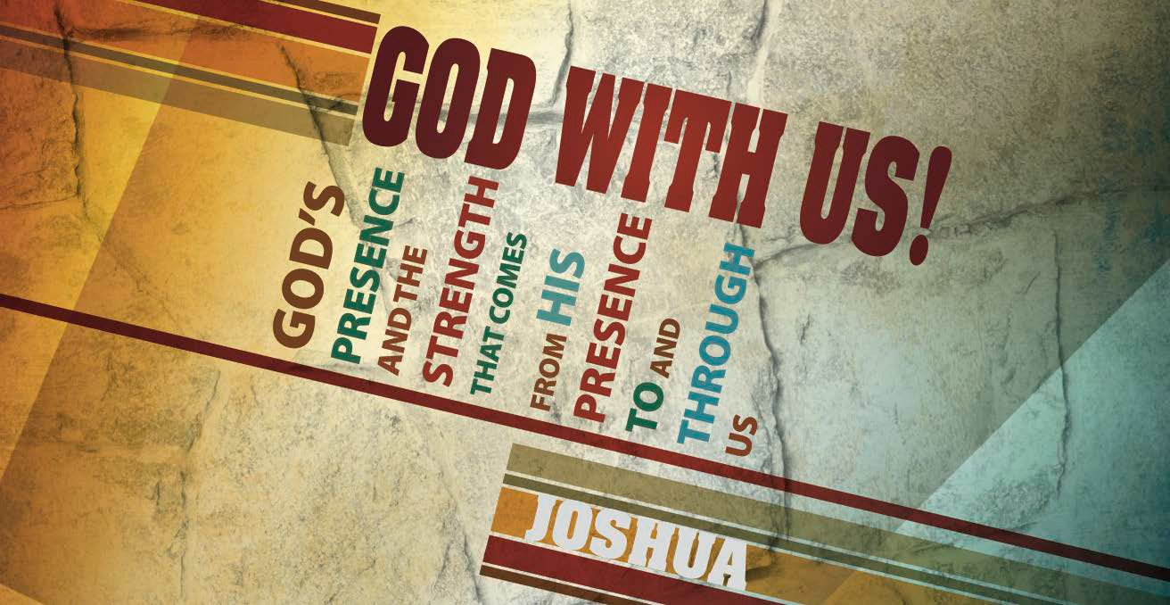

## Main Point: God provides leadership to the believer.

**Current Event:** Monuments are intended to commemorate historically significant events, individuals and ideas. Some monuments are more obscure than others.

1. Which of the following is an actual monument dedicated to Abraham Lincoln?
   1. Lincoln Stove Top Hat Monument B. The Great Beard Bridge

C. Lincoln Watermelon Monument

Answer: C. Lincoln Watermelon Monument. Found in Lincoln, Ill., the memorial is a life-size statue of a watermelon. In 1853 the future president was an attorney for a railroad company and was instrumental in creating a new town along the tracks in Illinois. Legend goes that Lincoln was eating a piece of watermelon when he agreed to contribute his name to the newly formed community.

1. This object fell from the sky, crashed through a roof, struck the home’s resident, and thereby earned its own memorial. Name that object.
   1. meteorite B. satellite antenna
2. the rudder of a Wright brothers airplane

Answer: A. meteorite. In 1954 the space object struck Mrs. Ann Hodges in her Sylacauga, Ala., home. Although she was merely bruised by the meteorite, the event is the only known occurrence of an object from space striking someone on earth.1

## Discussion Questions:

What memorials have you visited that made the greatest impact on you?

What are some of your favorite monuments that memorialize historic events? In what ways do the monuments capture the significance of the events?

In your life, what are some positive moments that have defined you? How do you remind yourself of those moments during times of discouragement?

1 <http://news.travel.aol.com/2009/11/10/americas-strangest-monuments/>

# Week 3, Joshua 3 & 4 Book

## Main Point: God provides leadership to the believer.

**Text Summary:** The Israelites follow the presence of the Lord through the waters of the Jordan River into the Promised Land in a crossing reminiscent of their miraculous exit from Egypt through the Red Sea. At Joshua’s prompting, the occasion is memorialized forever by an altar erected in the midst of the waters.

## Joshua 3:1–17 (Read)

**Sub Point: God’s desire and intent is to lead His children.**

The spies return from Jericho with a good report and Joshua marches his people toward the Jordan, in preparation to invade Canaan. The journey from Shittim to the powerful Jordan was seven miles. Once they arrive, the Israelites camp for three days. The Bible Knowledge Commentary describes the state of the river:

*The delay also gave everyone an opportunity to get close and see the river, now a strong and rapid current due to the melting of the winter snows of Mount Hermon in the north. They must have faltered at the seeming impossibility of the crossing.**2*

The obstacle before the people is clear and overwhelming; God was going to move a nation across the Jordan at one of the most difficult times of the year. The people would have little doubt that only the power of the LORD would provide a way into Canaan. At the close of the third day, officers alert the people: God is moving and we will follow.

The instructions for the people to cross the river featured a few components:

* 1. **Follow God’s direction (v. 4).** The people are to walk 2,000 cubits (about one-half mile) behind the Ark of the Covenant. 3 The ark was generally located in the midst of Israel’s ranks; but for this mission, the presence of the LORD needed to lead the way.4 God was going to lead His people on a path they had not known before. As it is true for believers today, it was imperative that the people lean not on their own wisdom but instead follow the trail blazed by the LORD.
  2. **Consecrate yourselves (v. 5).** The people were preparing to have an encounter with the living God and they needed to be ready. They were to sanctify themselves; actions

2 Donald K. Campbell, “Joshua,” in *The Bible Knowledge Commentary: An Exposition of the Scriptures*, ed. J. F. Walvoord and R. B. Zuck, vol. 1 (Wheaton, IL: Victor Books, 1985), 333–334.

3 Crossway Bibles, *The ESV Study Bible* (Wheaton, IL: Crossway Bibles, 2008), 398.

4 Broadman, 312

involved in sanctifying often included washing one’s clothes and temporarily abstaining from sexual relations.5 Their leader, Joshua, not his subordinates, told the people to be prepared because the LORD was about to do something incredible.

* 1. **Choose 12 representatives (v. 12).** A man from each tribe of Israel would be called up.
  2. **Watch as God cuts off the river (v. 13).** As the soles of the priests carrying the ark rested in the Jordan, the waters stood in a heap. Israel would gain a confidence and strength from the wondrous display; this appreciation for the capability of the Lord would reinforce their belief that God was with them and would defeat the inhabitants of Canaan (v. 10).

The crossing of the Jordan remains a model of how to enter territory as a child of God: Follow His lead. It is Jesus Christ who goes before us and it’s as we follow Him that we begin to see. In fact, we are to follow the presence of God for precisely the same reason Israel was to follow the ark of the covenant—we have not been this way before and we do not know the way to go (3:4). Jesus said it this way:

*“I am the way, and the truth, and the life. No one comes to the Father except through me” (John 14:6).*

***Read the instructions given about crossing the Jordan in Joshua 3:2–4. Discuss: What was Israel to do?***

***Why were they to do it that way?***

***In what way is this similar to the way we follow the Lord today? How is it different?***

## Joshua 4:1–24 (Read)

**Sub Point: God’s leadership and victories in a believer’s life should be remembered.**

Few knew the value of passing on God’s legacy to the next generation as well as Joshua. He and Caleb saw an entire generation wiped out because of unbelief (Numbers 14:28–30) and they stood as story bearers to the next generation. Now, at this defining moment in history, Joshua says to the people, *“Take twelve stones from here out of the midst of the Jordan … and bring them over with you”* (4:3).

Two memorials are constructed in this passage:

5 Crossway Bibles, *The ESV Study Bible* (Wheaton, IL: Crossway Bibles, 2008), 398.

1. The leaders of each tribe are instructed to carry stones from the midst of the Jordan and arrange them in a memorial in the middle of the encampment at Gilgal in the Promised Land (4:20).
2. Joshua himself arranged twelve stones into a memorial in the middle of the Jordan (4:9).

Joshua emphasized that the memorials originated from “where the priests’ feet stood firmly” (4:3, 9). In other words, the stories to be memorialized had to do with the moment when the priests’ feet touched the waters—“as soon as the feet of the priests were dipped in the brink of the water” the waters were cut off and the people crossed on dry land (3:15–16). One can see the cooperation between God and man: God did the work of cutting off the waters as man obeyed by stepping his feet into the river.

Memorials remind of us of things that once were and inspire us to what things might be. The steps across the Jordan should not be lost on one generation alone but were meant to inspire and encourage future Israelites. When little ones asked about the stones, parents were to answer:

*“Then you shall let your children know, ‘Israel passed over this Jordan on dry ground.’ For the Lord your God dried up the waters of the Jordan for you until you passed over, as the Lord your God did to the Red Sea, which he dried up for us until we passed over” (4:23).*

***Where else in the Bible does God encourage Israel to have faith by reminding them of past events?***

***Are there works that God has accomplished in your life from which you draw encouragement? What are they?***

***Have you intentionally built a memorial around a “God work” in your life?***

***How do you pass “God stories” on to your children? What is something you could begin doing to ensure you are more intentional about it?***

# Week 3, Joshua 3 & 4 Took



## Main Point: God provides leadership to the believer.

**In Today’s Culture:** The Lincoln Memorial is the most-visited monument in America with more than 7 million patrons a year.6 The structure was designed to resemble the Parthenon, the birthplace of democracy, in honor of a man who fought so fiercely to defend it. The building is supported by 36 pillars, one pillar for each of the states that had been reunited at the time of Lincoln’s death. The main chamber hosts a statue of the President and is flanked by two other chambers, each focused on one of the President’s most significant speeches: the Gettysburg Address (a display of Lincoln’s resolve to see an end to the Civil War and focus on equality) and his Second Inaugural Address (highlighting the president’s compassion and desire for unity).7

## Discussion Questions:

What leadership qualities do you admire in President Lincoln?

Describe a time in your life when you truly followed God’s leadership. What aspects of God’s character did He reveal to you during that experience?

**Lesson Conclusion:** God’s presence leads His people into new territory in miraculous ways. It’s only by following Him that we can truly receive all that is intended for our lives since “we have not passed this way before” (3:4). When God accomplishes a great work in our life, it ought to be memorialized—both to remind ourselves and to teach our children.

6 <http://experience.usatoday.com/weekend/story/my-weekend-experience/2015/07/02/42-most-visited-> monuments-memorials-america/27006811/

7 <http://www.nps.gov/linc/learn/historyculture/lincoln-memorial-design-and-symbolism.htm>

## Challenge:

**Follow God.** Scripture says we are to let the peace of Christ rule in our hearts (Colossians 3:15). Much like a compass, the peace of God will point us in His direction. This is always affirmed by His Word and by reliable advisors. Consider your heart: Is the peace of God ruling in it?

**Remember His works.** Anxiety robs us of peace. Take time to remember what God has done in your life. Write down the victories, place a reminder of His workings somewhere that you see often. Be encouraged by His faithfulness and allow His past workings in your life to prod you to greater obedience and courage. God will continue to guide you in victory (2 Corinthians 2:14).

**Teach about His works.** Review the things that God has done in your life. What stories are you willing to share with others? Sharing our testimonies of God’s work in our lives helps us overcome difficulty (Revelation 12:11).