# Week 4, Joshua 5 Hook

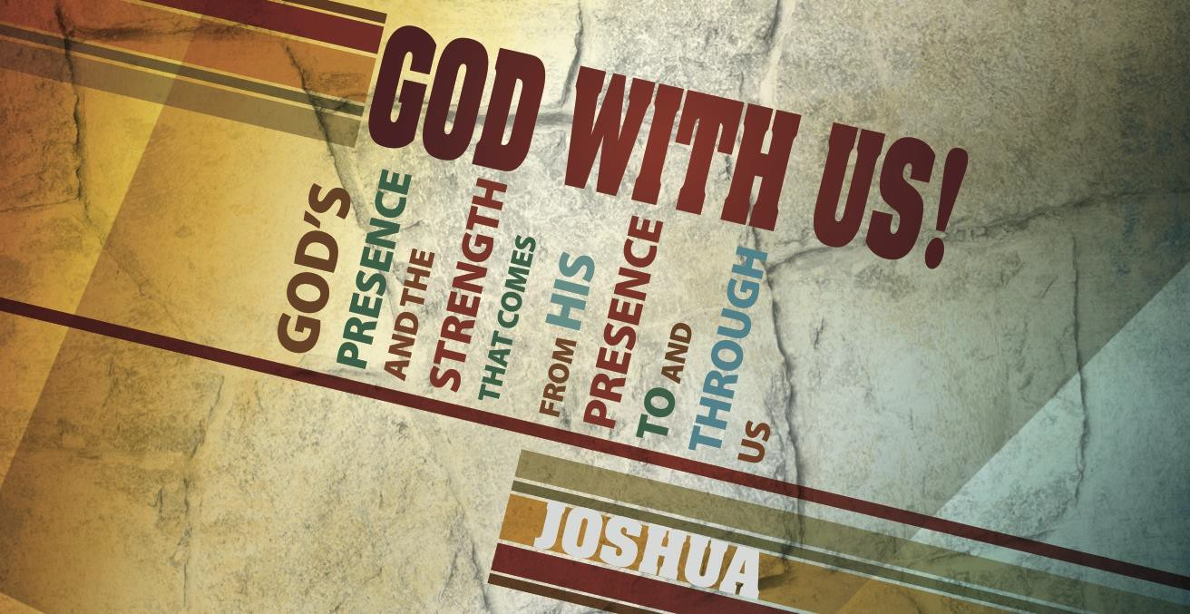

## Main Point: God demands priority. Activity

Have your class watch the video at: [https://www.youtube.com/watch?](http://www.youtube.com/watch?v=Ahg6qcgoay4)v=[Ahg6qcgoay4](http://www.youtube.com/watch?v=Ahg6qcgoay4)

The video is an awareness test sponsored by Transport for London encouraging motorists to be aware of cyclists. The video features two teams passing two basketballs back and forth. The viewer is tasked with counting the number of times a particular team passes the ball. For most who watch the video, they are so focused on counting the passes that they miss a pronounced abnormality. After you play the video for your class, ask by show of hands who noticed the strange addition to the basketball game.

The Christian is often weighed down by the tyranny of the urgent; he is locked in a battle between his willingness to walk with the Lord in obedience and a desire to tend to what he views as pressing. We can run the risk of missing what God truly desires from us because we are overtaken by what we believe must be accomplished first. In today’s lesson, Joshua and the Israelites are reminded of God’s desire for His people’s obedience, His protection, His willingness to fight for them and His inevitable victory.

## Discussion Questions:

Describe a time when your lack of attention caused you to pay consequences.

Has there ever been a time when you honored the Lord (whether it was with time, money, etc.) even though it may have seemed counterintuitive?

In what ways can we remind ourselves to place worshipping God as a priority when other things in life may seem like they are more important?

# Joshua 5 Book

## Main Point: God’s presence demands priority.

**Text Summary:** Upon entering the Promised Land, Joshua and the Israelites set up camp at Gilgal. There they obey the Lord by observing circumcision and Passover. In so doing, they make themselves vulnerable to the surrounding enemies, but when the Commander of the LORD’s army appears to Joshua, we realize Israel’s protection is assured because the LORD Almighty is *for* them and *with* them.

## Joshua 5:1–9 (Read)

**Sub Application: Choose obedience over the “urgent.”**

Warriors wear armor to protect themselves. The kind of ground combat Israel was expecting with the people of Canaan required shields and helmets and breastplates. Yet the first thing Joshua commands his army do is to be circumcised. To a modern reader, this action seems poorly timed at best. The people are now in the combat zone, the kings of the Amorites and Canaanites are intimidated by what God has done in the Jordan, and it would seem that the time is right for God’s people to strike their enemies. Why would God call Israel to pause and be circumcised?

Circumcision is meaningful. Initiated by God with Abraham in Genesis 17, it was a sign of the covenant between God and His chosen people and was an outward sign of their inner dependence on Him. They were His. They showed they belonged to Him by their obedience.

Like baptism is an outward sign of a relationship already established, so, too, the act of circumcision was a reminder and symbol of God’s covenant with Israel.1 The special relationship that God established with Israel demanded holiness on the part of the people.2 In Scripture, the symbolism of circumcision represents separation, purity and loyalty to the covenant.3

1 Michael Rydelnik and Michael G. Vanlaningham, *The Moody Bible Commentary* (Chicago: Moody Publishers, 2014), 74.

2 Crossway Bibles, *The ESV Study Bible* (Wheaton, IL: Crossway Bibles, 2008), 80.

3 Allen P. Ross, “Genesis,” in *The Bible Knowledge Commentary: An Exposition of the Scriptures*, ed. J. F. Walvoord and R. B. Zuck, vol. 1 (Wheaton, IL: Victor Books, 1985), 58.

Joshua had walked with Israel in the wilderness. God had wiped an entire generation of people off of the earth because of their rebellion; Joshua was one of two who were spared to enter the Promised Land. One can only imagine that the 40 years of wilderness wandering *forever etched in his mind* the horror of disobeying the LORD.

Before any battle was to take place, the LORD desired the Israelites to once again engage in a reminder of His covenant with them. Obedience and faith would be required for the Israelites to taste victory in Canaan. Weapons were of little benefit in comparison to the overwhelming resources that God would willingly bring to battle for Israel. Although it appears that an act like mass circumcision would leave the nation vulnerable in a hostile land, it was in fact reminding them of their need to be spiritually prepared for what was to come. Obedience and a pursuit of holiness are of utmost priority.

***Can you recall a time when you obeyed God in a way that felt very vulnerable? Did He show up as a protector on your behalf?***

***Israel experienced freedom from slavery’s shame, or “reproach,” after they obeyed God’s command to be circumcised (Joshua 5:9). In what ways can we carry shame into Christianity, even after we escape sin’s bondage?***

***Describe a time in your life when the tyranny of the urgent misshaped your priorities? How did God redeem this time in your life?***

## Joshua 5:10–15 (Read)

**Sub Application: Trust that the LORD will provide.**

Immediately after the army’s circumcision, Israel observed Passover. Exodus 12:48 explains that, *“No uncircumcised person shall eat (the Passover).”* The nation of Israel is putting God first in the land of Canaan by doing things His way—and it is why they experience later victories.

The celebration of Passover at Gilgal indicates a new era, highlighted by the fact that immediately after Israel observed Passover, the manna that had fallen in the wilderness—six days a week, for 40 years, without fail—ceased. For the first time, families would begin to gather around home-cooked meals of bread, meat, fruit, milk and honey. Celebrating Passover as the manna ceased is a sign to God that while He was leading them in a different direction as to how He would provide for them, they still had unwavering dedication to God.

Meanwhile, Joshua is walking the land and finds himself near Jericho. He draws his sword when he sees a man standing near him and extends the question: *“Are you for us*

*or for our adversaries” (5:13)?* Joshua’s exchange with the Commander is somewhat curious: The Commander answers Joshua’s question with a straightforward *no.* It is then that the man reveals Himself as the “Commander of the Army of the LORD” and Joshua falls on his face.

This encounter is unique because this was obviously more than just a normal man. Many scholars consider this to be a “Christophany.” *The Moody Bible Commentary* says that “Joshua recognized his visitor as a divine being. It was not a matter of whose side

the visitor was on; it was a matter of whose side Joshua was on.”4

Joshua then asks “What does my lord say to his servant?” (v. 14). The answer may have been unexpected to Joshua; however it bears significance, especially regarding the language that was used. Recall the story of Moses and the burning bush in Exodus 3.

This was the time in Moses’ journey where he was being commissioned to begin his leadership.

Exodus 3:5 uses a similar statement to the one being used in Joshua. Exodus 3:5 states, “Then he said, ‘Do not come near; take your sandals off your feet, for the place on which you are standing is holy ground.’” Joshua 5:15 states, “And the commander of the LORD’s army said to Joshua, ‘Take off your sandals from your feet. For the place where you are standing is holy.’ And Joshua did so.”

Joshua had taken the leadership role from Moses. Although the responsibilities of Joshua will be different from those of Moses, the significance in the similar statement is that the God who was there when Moses was serving would be the same God who works through Joshua.

***Joshua obeyed God by putting first things first******circumcision before Passover. Read Matthew 6:33. Are there some priorities in your life that the LORD wants you to rearrange?***

***What about keeping the Passover might help the Israelites as they prepare to take the Promised Land?***

***God had provided manna for Israel in the desert and now provides the fruit of Canaan. How has the LORD provided for you in your life?***

4 Michael Rydelnik and Michael G. Vanlaningham, *The Moody Bible Commentary* (Chicago: Moody Publishers, 2014), 320-21.

# Week 4, Joshua 5

**Took**



## Main Point: God’s presence demands priority.

Ad campaigns like the one viewed in today’s Hook are developed in efforts to raise the awareness of drivers. Too many distractions vie for the attention of vehicle operators: a desire to arrive at a destination quickly, the radio, a ringing phone, children in the back seat are just a few. In efforts to direct drivers, more than 80 types of warning and regulatory signs are placed on the roads (in Texas alone).5

## Discussion Questions:

Describe a time when you missed a warning sign on the road. Describe a time when you missed a warning sign from the Lord.

What are some tools that God uses to equip believers in an effort to help us arrange and maintain proper priorities?

What are some priorities that you need to reevaluate this week?

**Lesson Conclusion:** God’s presence led Israel through the Jordan and into the Gilgal encampment. Joshua remained a steadfast leader who was sure to keep first things first, starting with Israel’s honoring God in circumcision and Passover. Their priorities pointed to their faith: It was God alone who got them there and it was God alone who would keep them.

## Challenge:

**Examine.** The kingdom of God is replete with paradoxes. Is the LORD asking you to lead by serving (maybe a boss, employee, family member or neighbor)? Is the LORD showing

5 <http://dps.texas.gov/internetforms/Forms/DL-7.pdf>

you a misbelief (about Him, yourself, others) that must die so that He can enliven your heart? Allow Him to show you and trust Him to protect you.

**Decide.** As He shows you things, write them down. With each point, decide: Will I choose His protection over my own? Will I choose His way over my rationale? Will I trust Him to lead as I follow?

**Worship.** God is with you. Take off your shoes as you stand before Him and trust Him to answer you, help you, forgive you, strengthen you, and guide you. Trust that He will

remove the shame (or “reproach”) that misbelief and disobedience have caused and that He will empower you. God hears your prayers.