# Week 7, Joshua 9–10:27 Hook

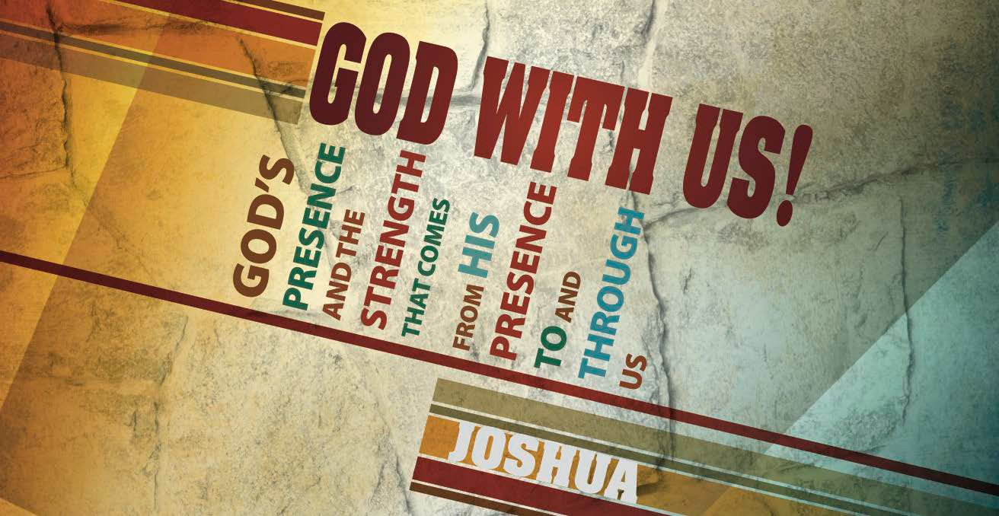

## Main Point: God honors His covenant.

**Current Event:** In 1977, the executives at 20th Century Fox made a deal with a young filmmaker by the name of George Lucas. In exchange for a mere $20,000, 20th Century Fox agreed to give Lucas full product merchandising rights for all *Star Wars* films produced. At the time, the executives didn’t know how *Star Wars* would do as a series. Films are measured by their bottom dollar, and 20th Century Fox was willing to bet that *Star Wars* wouldn’t take off.

Little did the executives know that *Star Wars* would be a massive success—not just in terms of the box office, but also in creating a cultural phenomenon. To date, there have been seven films produced with a total of $5.8 billion earned at the box office. Merchandise revenue alone brought in $3 billion and continues to increase annually. 20th Century Fox lacked the foresight to see that their agreement with Lucas would end up costing them.

Sometimes we make poor decisions in life that we end up regretting. The beauty of having a relationship with the Lord is that He remains with us even when we make poor decisions.

## Discussion Questions:

Have you ever made a decision you later regretted?

Is there someone in your life who made a poor choice and needs God to redeem him or her?

Why do we have a hard time recognizing the presence of God during difficult seasons?

# Joshua 9–10:27 Book

## Main Point: God honors His covenant.

**Text Summary:** The neighboring Gibeonites approach Israel as though they were faraway sojourners seeking asylum. The Israelites enter into a covenant before they realize the lie, but cannot go back on their word. The Gibeonites’ lives are spared and, now as an ally, Israel comes to their rescue when surrounding city-states band together to attack. Israel enters into its first defensive battle and the Lord brings them victory.

## Joshua 9 (Read)

**Sub Point: Consult the Lord before taking action.**

Have you ever entered into a bad agreement? Israel did. Their cunning neighbors, the inhabitants of Gibeon, knew the end was near. The Gibeonites feared for their lives. Word spread concerning the victories of Israel. So what did they do? They deceived the Israelites into thinking they were sojourners from a far land. This is important because Israel was allowed to make peace with cities and their inhabitants that were far from them, but not cities that the Israelites were dispossessing, cities that were near to them.1 This shows the reason for their need for deception.

That was the Gibeonites’ appeal: Make peace with us and take us as your servants.

The book of Joshua also describes the children of Israel’s complaint against Joshua and the leaders for not asking the Lord’s counsel (9:14) before entering into the agreement. Once again, Israel acts out before consulting the Lord, just as in the defeat at Ai. No inquiry is made to His will, rather Israel’s leaders act on their own accord.2 Through the deception of the Gibeonites, the reader is reminded of the deception that Israel planned and executed at Ai. Now, Israel is the one falling prey to a devised scheme.3

The chapter concludes only after repeatedly emphasizing that the Gibeonites were subjected to God’s curse and forced to become Israel’s servants. Yet their lives are protected and, as we will see in the next chapter, God honors Israel’s agreement—even if it was a bad one—because God is faithful to His covenant, even when we are not.

1 Howard, David [1998] *New American Commentary: Joshua.* Nashville: B&H Publishers, p. 223.

2 Hess, Richard [1996] *Tyndale Old Testament Commentary: Joshua*. Downers Grove: IVP Academic, p. 198.

3 Longman III, Tremper and David E. Garland, [2012] *The Expositor’s Bible Commentary, Revised Edition: Numbers– Ruth,* Grand Rapids: Zondervan, p. 920.

*“And we know that for those who love God all things work together for good, for those who are called according to his purpose”* (Romans 8:28).

***Why did Israel enter into the bad agreement? How could they have avoided it? Read Joshua 9:14.***

***Do you believe that God remains with you when you make a bad decision? Are there certain conditions that invite His cooperation?***

***Tell of a time you have seen Romans 8:28 come to pass.***

## Joshua 10:1–27 (Read)

**Sub Point: God is in control of our failures.**

Despite the bad agreement, God honored the covenant between the Israelites and the Gibeonites. Here, at the sign of threat, Gibeon calls out for help like much of the pleas described in the Psalms. In Psalms the constant cry for help is made from the child of God to Him, asking Him to remember His covenant.4 And He does.

Five Canaanite kings band together to attack the Gibeonites because of their new allegiance and Gibeon asks Joshua for help. This is the first battle Israel enters into as something other than the aggressor, rather Israel is responding to the plea of her allies.5 Israel is up against insurmountable odds when God gives Joshua this promise:

*“Do not fear them, for I have given them into your hands. Not a man of them shall stand before you”* (10:8).

The big question was whether the Israelites would make good on their commitment.6 Would they follow through with their promise? Israel did follow through, and God intervened on behalf of His children.

Here again, we see Israel at war. How do we reconcile this subject of “holy war?” Religious battles still rage for land and power. God is not calling us to wage war on humanity—our battle is not with flesh and blood, but spiritual principalities and powers (Ephesians 6:12). These Old Testament accounts are symbols and shadows of the New Testament reality we have in Christ.

## When spiritual darkness threatens, do we trust that God brings us the same sweeping victory He brought Joshua?

4 Hess, Richard [1996] *Tyndale Old Testament Commentary: Joshua*. Downers Grove: IVP Academic, p. 212.

5 Ibid., p. 205.

6 Howard, David [1998] *New American Commentary: Joshua.* Nashville: B&H Publishers, p. 233.

The Israelites entered into a bad agreement with the Gibeonites, but the Lord flipped it for good. In one battle, they conquered more land than ever. The Bible says:

*“There has been no day like it before or since, when the Lord heeded the voice of a man, for the Lord fought for Israel*“ (10:14).

God is powerful and acts on Israel’s behalf. He gives the men strength to fight; He sends natural forces to their aid in the form of hail and earthquakes; and He supernaturally extends a day when “the sun stopped in the midst of heaven” (10:13).

The gospels record another one-of-a-kind day: The sun went black, the earth quaked, and the dead rose from the grave (Mark 15:33, Matthew 27:51–52). On this day, Jesus waged war on death, hell and the grave and arose victorious—our Savior. Like the kings who were executed in Joshua’s time (10:26), Jesus made a public spectacle of our enemies:

*“He has made (you) alive together with Him, having forgiven you all trespasses.… Having disarmed principalities and powers, He made a public spectacle of them, triumphing over them in it”* (Colossians 2:13b, 15 NKJV).

Trust Christ! Rejoice in His victory! Satan is under our feet (10:24–25).

***Read 10:6. Given the circumstances, how do you think Israel felt about defending the Gibeonites? Read 10:8—how did God seem to feel about it?***

***The enemy kings’ execution is graphic. Read Colossians 2:13–15. What did the total annihilation of our enemy look like?***

***The LORD gave Joshua victory, yet Israel still fought. Jesus disarmed Satan, yet we still fight darkness. What does our everyday fight look like? What does our everyday victory look like?***

# Week 7, Joshua 9–10:27 Took



## Main Point: God honors His covenant.

**In Today’s Culture:** God is with us even when we make poor decisions. He promises that He will never leave us nor forsake us—through the good times and the bad ones. That’s a promise that gives us hope. The Israelites made a poor choice with the Gibeonites, but God’s presence never departed from them. God worked mightily through their bad decision to reveal how great He is by giving them victory over their enemies.

## Discussion Questions

* How has God’s presence worked in your life to help you through a difficult time?
* How can we stay in tune with God’s presence working in our life?

**Lesson Conclusion:** God told Israel to destroy every inhabitant of the Promised Land, yet He cooperated with the unfortunate treaty Joshua made with neighboring Gibeon. The Lord used the allegiance to conquer five Canaanite kings, turning a bad agreement into something good. God cooperates with His children while still ensuring His Word will come to pass.

## Challenge

**Seek Counsel.** Israel’s bad treaty reminds us to seek God before every decision and not cave under the pressures of time and people. Many bad decisions can be avoided if we just seek the counsel of God through prayer and His Word.

**Trust God.** Israel upheld her covenant with the Gibeonites and God upheld His covenant with Israel in the battle. God can make bad circumstances work together for good. The Bible affirms that God is working all things together for good for those who are in Christ (Romans 8:28). As believers, we need to embrace this truth when we are struggling to see God’s purpose.

**Remember Christ’s Victory.** One of the most helpful points of meditation for Christians is Christ’s victorious Resurrection. Through His Resurrection, Christ declared victory over death, disease and suffering. We now have a hope to cling to during trying seasons in our life.