# A green palm frond next to the word Hosanna with the Hope Church logo.

# Hope Presbyterian Church Accessible Worship Folder and Slide Deck Transcription

**April 13, 2025**

[www.hopechurchcolumbus.org](http://www.hopechurchcolumbus.org)

Pastor—Joe Haack—[joe@hopechurchcolumbus.org](mailto:joe@hopechurchcolumbus.org)

Youth Pastor—Wes Piehl—[wes@hopechurchcolumbus.org](mailto:wes@hopechurchcolumbus.org)

Deacons—[deacons@hopechurchcolumbus.org](mailto:deacons@hopechurchcolumbus.org)

Operations Manager—Nichole Redinger—[operations@hopechurchcolumbus.org](mailto:operations@hopechurchcolumbus.org)

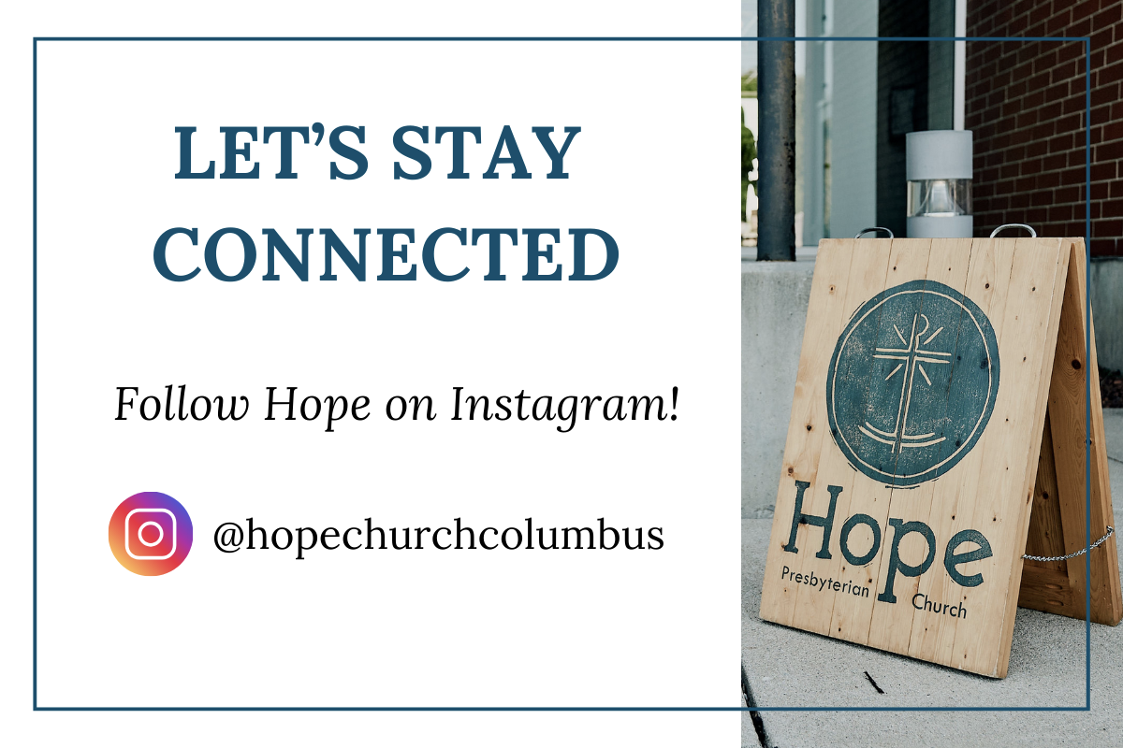

## A green palm frond next to the word Hosanna.

## CALL TO WORSHIP

Zechariah 9:9, NLT

### LEADER

Rejoice, O people of Zion! Shout in triumph, O people of Jerusalem!

### ALL

Look, your king is coming to you. He is righteous and victorious, yet he is humble, riding on a donkey—riding on a donkey’s colt.

## A green palm frond next to the word Hosanna.

## DOXOLOGY

Lyrics: Thomas Ken, 1674

Praise God from whom all blessings flow;

Praise him all creatures here below;

Praise him above, ye heavenly host;

Praise Father, Son, and Holy Ghost.

Amen.

## A green palm frond next to the word Hosanna.

## HYMN

### We Will Feast

CCLI# 7041364 Sandra McCracken

We will feast

In the house of Zion

We will sing

With our hearts restored

“He has done great things,”

We will say together

We will feast

And weep no more

We will not be burned by the fire

He is the Lord our God

We are not consumed by the flood

Upheld, protected, gathered up

We will feast

In the house of Zion

We will sing

With our hearts restored

“He has done great things,”

We will say together

We will feast

And weep no more

In the dark of night before the dawn

My soul be not afraid

For the promised morning, oh how long?

Oh God of Jacob, be my strength

We will feast

In the house of Zion

We will sing

With our hearts restored

“He has done great things,”

We will say together

We will feast

And weep no more

Every vow we’ve broken and betrayed

You are the faithful one

And from the garden to the grave

Bind us together, bring shalom

We will feast

In the house of Zion

We will sing

With our hearts restored

“He has done great things,”

We will say together

We will feast

And weep no more

Yes, we will feast

And weep no more

## A green palm frond next to the word Hosanna.

## HYMN

### Missing Not One

Will Duvall | CCLI #71119943

Missing not one

In the starry hosts displayed

Created for the glory of

The one who calls them each by name

Holy, holy, holy is the

Lord God who reigns

With power and in mercy as

The universe proclaims

How deep, how wide

How long, how high is

The perfect love of Christ

The perfect love of Christ

Nothing can separate us

No, not one thing could ever take us from

The perfect love of Christ

The perfect love of Christ

Missing not one

From before the world was made

Sinners ransomed for the glory of

The one who calls them each by name

Holy, holy, holy is the

Lord God who reigns

With scars in his hands and feet

The wounds that still proclaim

How deep, how wide

How long, how high is

The perfect love of Christ

The perfect love of Christ

Nothing can separate us

No, not one thing could ever take us from

The perfect love of Christ

The perfect love of Christ

Missing not one

Of our sins and our mistakes

Our wasted years of guilt and shame

Our brokenness, our tears, our pain

Missing not one

No, not one, He brings them all under

The blood of the cross

He forgives and He redeems them all

Missing not one

Of our sins and our mistakes

Our wasted years of guilt and shame

Our brokenness, our tears, our pain

Missing not one

No, not one, He brings them all under

The blood of the cross

He forgives and He redeems them all

How deep, how wide

How long, how high is

The perfect love of Christ

The perfect love of Christ

Nothing can separate us

No, not one thing could ever take us from

The perfect love of Christ

The perfect love of Christ

The perfect love of Christ

The perfect love of Christ

## A green palm frond next to the word Hosanna.

## CONFESSION OF SIN

### LEADER

Loving God, you rode a donkey and came in peace, humbled yourself and gave yourself for us.

### ALL

We confess our lack of humility.

### LEADER

As you entered Jerusalem, the crowds shouted “Hosanna: ‘Save us now!’” On Good Friday they shouted “Crucify!”

### ALL

We confess our praise is often empty. We sing “Hosanna,” but cry “Crucify.”

### LEADER

As the crowd laid their palms in front of you, you took no glory for yourself.

### ALL

We confess that we want to be accepted and take the easy way. We do not stay true to your way. Forgive us, Lord, and empower us to follow in the way of obedience. Amen.

## SILENT CONFESSION

## A green palm frond next to the word Hosanna.

## HYMN

### When I Survey The Wondrous Cross

CCLI Song # 7197337 Isaac Watts | Lowell Mason | Nathan Drake

When I survey the wondrous cross

On which the Prince of glory died

My richest gain I count but loss

And pour contempt on all my pride

Forbid it Lord that I should boast

Save in the death of Christ my God

All the vain things that charm me most

I sacrifice them through his blood

See from His head His hands His feet

Sorrow and love flow mingled down

Did e’er such love and sorrow meet

Or thorns compose so rich a crown

Were the whole realm of nature mine

That were an offering far too small

Love so amazing so divine

Demands my soul my life my all

## ASSURANCE OF PARDON

Philippians 2:6–11 NLT

### LEADER

Though he was God, he did not think of equality with God as something to cling to. Instead, he gave up his divine privileges; he took the humble position of a slave and was born as a human being. When he appeared in human form, he humbled himself in obedience to God and died a criminal’s death on a cross.

### ALL

Therefore, God elevated him to the place of highest honor and gave him the name above all other names, that at the name of Jesus every knee should bow, in heaven and on earth and under the earth, and every tongue declare that Jesus Christ is Lord, to the glory of God the Father.

## A green palm frond next to the word Hosanna.

## HYMN

### I Want to Know You

CCLI #7073331 | (c) 2016, CityAlight Jonny Robinson, Rich Thompson, James Proctor, and Michael Farren

I've tried in vain

A thousand ways

My fears to quell

My hopes to raise

But what I need

Your word has said

Is ever, only

Jesus

You died, You live

You reign, You plead

There's love in all

Your words and deeds

This weary heart

Finds all it needs

In ever, only Jesus

I want to know You

Jesus my Lord

King of the Heavens

King of my soul

I trade my treasures

And all my rewards

Jesus to know You

Then know You more

Though some should curse me

For Your name

I have no fear

I have no shame

You stand with me

For all my days

My ever, only

Jesus

I want to know You

Jesus my Lord

King of the Heavens

King of my soul

I trade my treasures

And all my rewards

Jesus to know You

Then know You more

Like wave after wave on the ocean

Like all of the sand on the shore

Your beauty and glory are endless

O Jesus I must know You more

Like wave after wave on the ocean

Like all of the sand on the shore

Your beauty and glory are endless

O Jesus I must know You more

I want to know You

Jesus my Lord

King of the Heavens

King of my soul

I trade my treasures

And all my rewards

Jesus to know You

Then know You more

Jesus to know You

Then know You more

## TITHES AND OFFERINGS

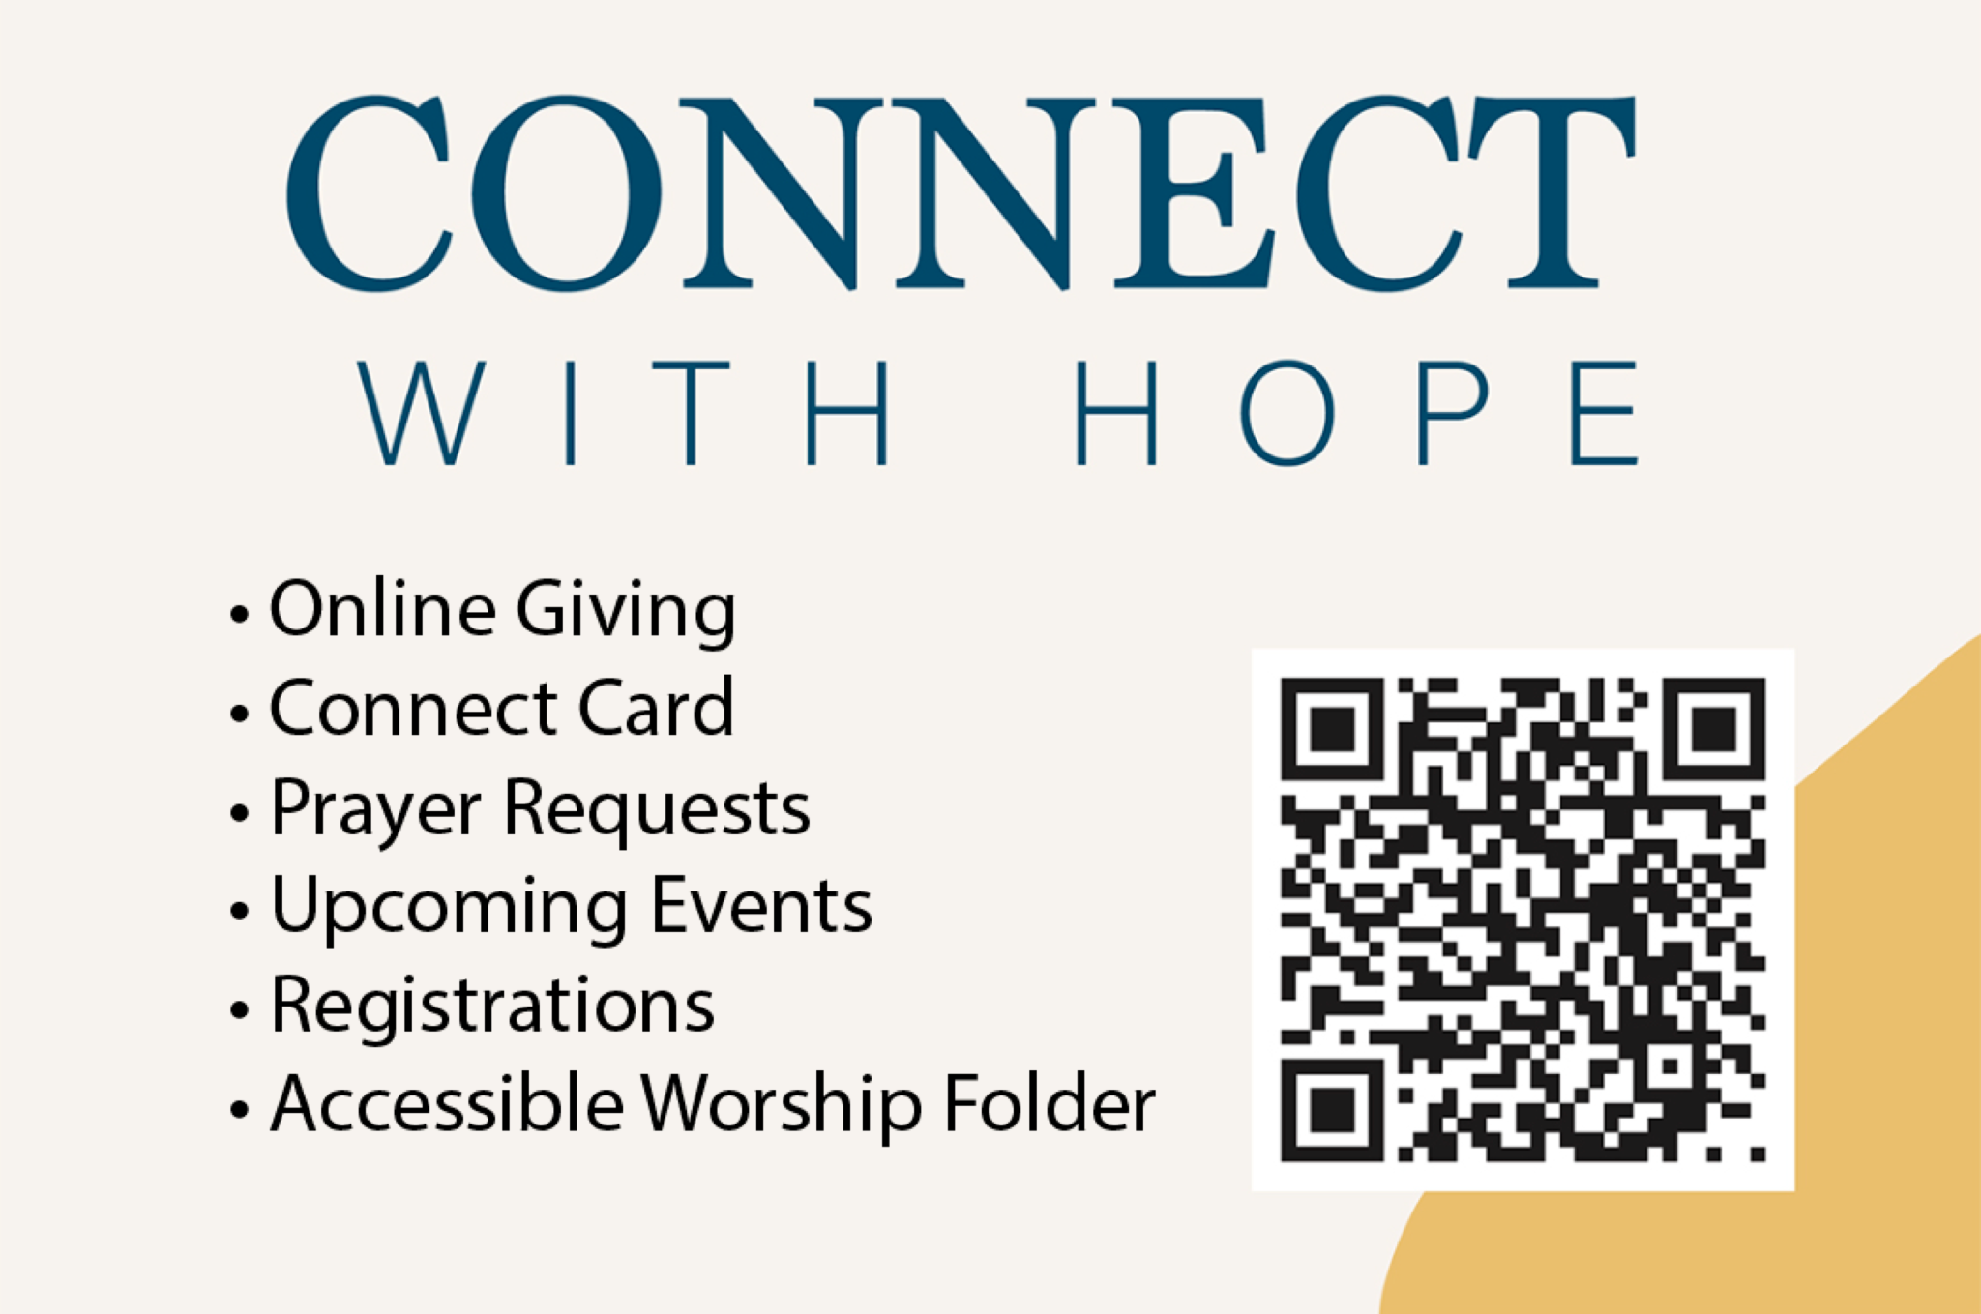

## HOPE HAPPENINGS AND ANNOUNCEMENTS

Holy Week
April 13 Palm Sunday Service
April 18 Good Friday Service at Scarlet City Church 
(pre-register for childcare. QR code leads to https://scarletcitychurch.churchcenter.com/registrations/events/2741120.)
April 20 Easter Sunday Service and Brunch



## PASSING THE PEACE

## SCRIPTURE READING

Luke 6:27–36

### LEADER

The Word of the Lord

### ALL

Thanks be to God

## MESSAGE

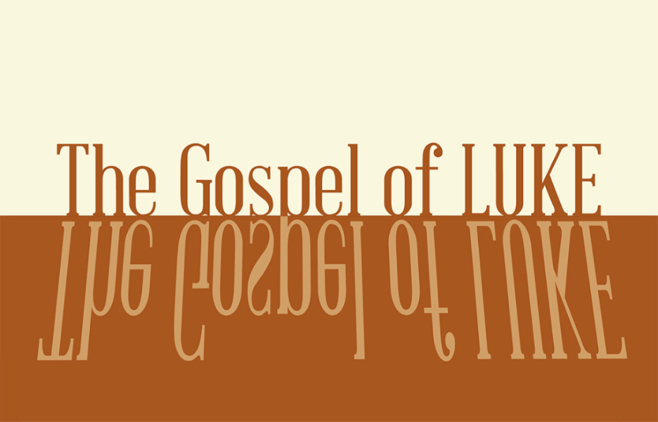

### Slide 1

calculated kindness

### Slide 2

32 “If you love those who love you, what credit is that to you? Even sinners love those who love them. 33 And if you do good to those who are good to you, what credit is that to you? Even sinners do that. 34 And if you lend to those from whom you expect repayment, what credit is that to you? Even sinners lend to sinners, expecting to be repaid in full.

Luke 6:32–36, NIV

### Slide 3

27 “But to you who are listening I say: Love your enemies, do good to those who hate you, 28 bless those who curse you, pray for those who mistreat you. 29 If someone slaps you on one cheek, turn to them the other also. If someone takes your coat, do not withhold your shirt from them. 30 Give to everyone who asks you, and if anyone takes what belongs to you, do not demand it back. 31 Do to others as you would have them do to you.

Luke 6:27–31

### Slide 4

“Jesus came into a world in which his fellow Jews had every reason to be angry at Rome. They were an occupied country—overtaxed, exploited, and subject to all the indignities of colonial rule.”

### Slide 5

"Nonetheless, these early Jewish Christians, who had all the historical ammunition needed to seek the ruin of their Gentile oppressors, made it their mission to convert a largely hostile Roman world.”

Esau McCaulley

### Slide 6

35 But love your enemies, do good to them, and lend to them without expecting to get anything back.

Luke 6:35

### Slide 7

Then your reward will be great, and you will be children of the Most High, because he is kind to the ungrateful and wicked. 36 Be merciful, just as your Father is merciful.”

Luke 6:35–36

### Slide 8

"For if, when we were enemies, we were reconciled to God by the death of his Son, much more, being reconciled, we shall be saved by his life” (Romans 5:10).

### Slide 9

Then your reward will be great, and you will be children of the Most High, because he is kind to the ungrateful and wicked. 36 Be merciful, just as your Father is merciful.”

Luke 6:35–36

### Slide 10

“When blessing replaces rage and revenge, the one who suffers violence refuses to retaliate in kind and chooses instead to encounter violence with an embrace. But how can people give up violence in the midst of a life- threatening conflict if their identity is wrapped up in rejecting the beliefs and practices of their enemies? Only those who refuse to be defined by their enemies can bless them.”

Miroslav Volf

### Slide 11

Then your reward will be great, and you will be children of the Most High, because he is kind to the ungrateful and wicked. 36 Be merciful, just as your Father is merciful.”

Luke 6:35–36



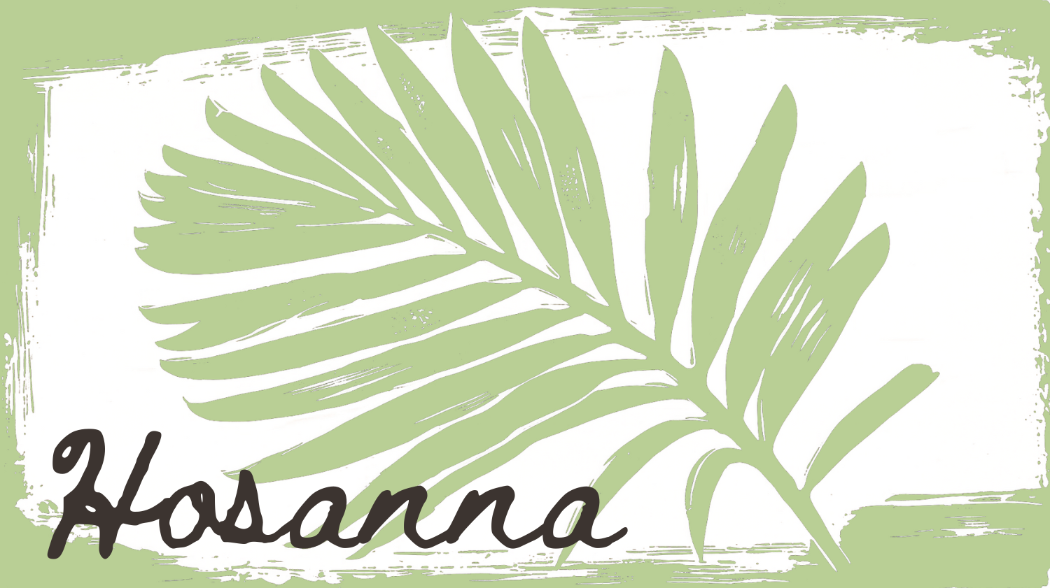

## Confession of Faith

Heidelberg Catechism Q. 43

### LEADER

What further benefit do we receive from Christ's sacrifice and death on the cross?

### ALL

Through Christ's death our old nature is crucified, put to death, and buried with him, so that the evil desires of the flesh may no longer reign in us, but that we may offer ourselves to him as a sacrifice of thankfulness.

## THE LORD’S SUPPER

### 1 Corinthians 11:23–26

The Lord Jesus, on the night when he was betrayed took bread and when he had given thanks, he broke it and said, “This is my body which is broken for you. Do this in remembrance of me.” In the same way also he took the cup, after supper, saying, “This cup is the new covenant in my blood. Do this as often as you drink it, in remembrance of me."

## A green palm frond next to the word Hosanna.

## HYMN

### Abide

[Default Arrangement] by Aaron Keyes, Aaron Williams, and Dee Wilson CCLI Song # 7168160 CCLI License # 20115471

For my waking breath, for my daily bread

I depend on You, I depend on You

For the sun to rise, for my sleep at night

I depend on You, I depend on You

You’re the way the truth and the life

You’re the well that never runs dry

I’m the branch and You are the vine

Draw me close and teach me to abide

Where the Spirit leads, as I’m following

I depend on You, I depend on You

For the victories, still in front of me

I depend on You, I depend on You

You’re the way the truth and the life

You’re the well that never runs dry

I’m the branch and You are the vine

Draw me close and teach me to abide

Be my strength, my song in the night

Be my all, my treasure, my prize

I am Yours, forever You're mine

Draw me close and teach me to abide

When I pass through death, as I enter rest

I depend on You, I depend on You

For eternal life, to be raised with Christ

I depend on You, I depend on You

You’re the way the truth and the life

You’re the well that never runs dry

I’m the branch and You are the vine

Draw me close and teach me to abide

Where the Spirit leads, as I’m following

I depend on You, I depend on You

For the victories, still in front of me

I depend on You, I depend on You

You’re the way the truth and the life

You’re the well that never runs dry

I’m the branch and You are the vine

Draw me close and teach me to abide

Be my strength, my song in the night

Be my all, my treasure, my prize

I am Yours, forever You're mine

Draw me close and teach me to abide

Would You teach me,

would You teach me to abide

I depend on You, I depend on You

## A green palm frond next to the word Hosanna.

## STUDENT SEND OFF

## BENEDICTION

Isaiah 42:1–4

“Look at my servant, whom I strengthen.

He is my chosen one, who pleases me.

I have put my Spirit upon him.

He will bring justice to the nations.

He will not shout

or raise his voice in public.

He will not crush the weakest reed

or put out a flickering candle.

He will bring justice to all who have been wronged.

He will not falter or lose hear

until justice prevails throughout the earth.

Even distant lands beyond the sea will wait for his instruction."

## HOPE HAPPENINGS

### CARMEN HOUSE SPEAKER SERIES

**April 18, 2025 @COHatch Gateway, 4:30–5:45 p.m.**

Speaker Dylan Crosson “We Call This Friday Good: How have Christians observed Good Friday & why does it matter?” QR code leads to https://www.carmenhouse.org/speaker-series/we-call-this-friday-good.

### GOOD FRIDAY SERVICE

April 18, 2025 6:30pm @Scarlet City Please Pre-register for childcare (Nursery/Pre-K only) Register for childcare at https://scarletcitychurch.churchcenter.com/registrations/events/2741120.

### HOPE KIDS—TEACHERS NEEDED

We are in need of at least 2 Pre-K teachers for children’s church. Please contact Wes at wes@hopechurchcolumbus.org if you are interested in serving.

### HOLY WEEK

April 13—Palm Sunday Service

April 18—Good Friday Service at Scarlet City

April 20—Easter Sunday Service & Brunch

## Digital Connect Card

We’re glad you’re here! Let’s stay connected; please fill out the form at the following link: <https://hopechurchcolumbus.churchcenter.com/people/forms/281549>.