# Cover of the bulletin for Easter Sunday April 20, 2025 with a flower illustration.

# Hope Presbyterian Church Accessible Worship Folder and Slide Deck Transcription

**April 20, 2025**

[www.hopechurchcolumbus.org](http://www.hopechurchcolumbus.org)

Pastor—Joe Haack—[joe@hopechurchcolumbus.org](mailto:joe@hopechurchcolumbus.org)

Youth Pastor—Wes Piehl—[wes@hopechurchcolumbus.org](mailto:wes@hopechurchcolumbus.org)

Deacons—[deacons@hopechurchcolumbus.org](mailto:deacons@hopechurchcolumbus.org)

Operations Manager—Nichole Redinger—[operations@hopechurchcolumbus.org](mailto:operations@hopechurchcolumbus.org)

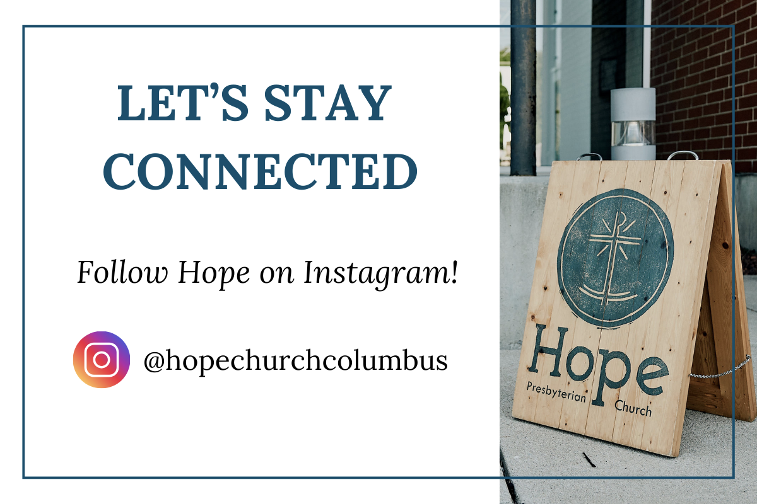

## Easter Sunday superimposed over the Hope Church logo.

## EASTER SUNDAY REFLECTION

Arise, arise, and with his burial linen dry thine eyes.

—George Herbert

## CALL TO WORSHIP

Zechariah 9:9, NLT

### LEADER

Alleluia! Christ is risen.

### ALL

He is risen indeed. Alleluia!

### LEADER

Praise the God and Father of our Lord Jesus Christ.

### ALL

He has given us new life and hope. He has raised Jesus from the dead.

### LEADER

God has claimed us as his own.

### ALL

He has brought us out of darkness. He has made us light to the world.

### LEADER

Alleluia! Christ is risen.

### ALL

He is risen indeed. Alleluia!

## DOXOLOGY

Lyrics: Thomas Ken, 1674

Praise God from whom all blessings flow;

Praise him all creatures here below;

Praise him above, ye heavenly host;

Praise Father, Son, and Holy Ghost.

Amen.

## PRAYER OF INVOCATION

### LEADER

O living Lord, on the first Easter Day you stood in the midst of your disciples as the conqueror of sin and death and spoke to them your peace. Come to us, we pray, in your risen power and make us glad with your presence, and by your Holy Spirit may we be strong to serve you and spread abroad your good news, for the glory of your great name. Amen.

## Easter Sunday superimposed over the Hope Church logo.

## HYMN

### Christ The Lord Is Risen Today!

CCLI Song # 27965 Charles Wesley | Samuel Arnold

Christ the Lord is risen today, Alleluia!

Sons of men and angels say, Alleluia!

Raise your joys and triumphs high, Alleluia!

Sing, ye heavens, and earth reply, Alleluia!

Lives again our glorious King, Alleluia!

Where, O death, is now thy sting? Alleluia!

Once he died our souls to save, Alleluia!

Where thy victory, O grave? Alleluia!

Love's redeeming work is done, Alleluia!

Fought the fight, the battle won, Alleluia!

Death in vain forbids him rise, Alleluia!

Christ has opened paradise, Alleluia!

Soar we now where Christ has led, Alleluia!

Following our exalted Head, Alleluia!

Made like him, like him we rise, Alleluia!

Ours the cross, the grave, the skies, Alleluia!

## HYMN

### Graves into Gardens

CCLI #7138219 Brandon Lake, Chris Brown, Steven Furtick, and Tiffany Hammer

I searched the world but it couldn’t fill me

Man’s empty praise and treasures that fade

Are never enough

Then You came along

And put me back together

And every desire is now satisfied

here in Your love

Oh there’s nothing better than You

There’s nothing better than You

Lord there’s nothing, nothing is better than You

I’m not afraid to show You my weakness

My failures and flaws,

Lord You’ve seen them all

And You still call me friend

‘Cause the God of the mountain

Is the God of the valley

There’s not a place Your mercy and grace

Won’t find me again

Oh there’s nothing better than You

There’s nothing better than You

Lord there’s nothing, nothing is better than You

Oh there’s nothing better than You

There’s nothing better than You

Lord there’s nothing, nothing is better than You

You turn mourning to dancing

You give beauty for ashes

You turn shame into glory

You’re the only one who can.

You turn mourning to dancing

You give beauty for ashes

You turn shame into glory

You’re the only one who can.

You turn graves into gardens

You turn bones into armies

You turn seas into highways

You’re the only one who can

You’re the only one who can

Oh there’s nothing better than You

There’s nothing better than You

Lord there’s nothing, nothing is better than You

Oh there’s nothing better than You

There’s nothing better than You

Lord there’s nothing, nothing is better than You

## Easter Sunday superimposed over the Hope Church logo.

## CONFESSION OF SIN

### ALL

Lord, bring new life where we are worn and tired; new love where we have turned hard-hearted; forgiveness where we feel hurt and where we have wounded; and the joy and freedom of your Holy Spirit where we are prisoners of ourselves.

## SILENT CONFESSION

## HYMN

### Jerusalem

CCLI Song # 7003218 Jonny Robinson | Rich Thompson | Tiarne Tranter

See Him in Jerusalem

Walking where the crowds are

Once these streets had sung to Him

Now they cry for murder

Such a frail and lonely man

Holding up the heavy cross

See Him walking in Jerusalem

On the road to save us

See Him there upon the hill

Hear the scorn and laughter

Silent as a lamb He waits

Praying to the Father

See the king who made the sun

And the moon and shining stars

Let the soldiers hold and nail Him down

So that He could save them

See Him there upon the cross

Now no longer breathing

Dust that formed the watching crowds

Takes the blood of Jesus

Feel the earth is shaking now

See the veil is split in two

And He stood before the wrath of God

Shielding sinners with His blood

See the empty tomb today

Death could not contain Him

Once the servant of the world

Now in victory reigning

Lift your voices to the One

Who is seated on the throne

See Him in the New Jerusalem

Praise the One who saved us

Praise the One who saved us

Lift your voices to the One

Who is seated on the throne

See Him in the New Jerusalem

Praise the One who saved us

Praise the One who saved us

## GRACE ASSURANCE

1 Corinthians 15:54–57, NLT

### LEADER

Death is swallowed up in victory. O death, where is your victory? O death, where is your sting? For sin is the sting that results in death, and the law gives sin its power.

### ALL

But thank God! He gives us victory over sin and death through our Lord Jesus Christ.

## Easter Sunday superimposed over the Hope Church logo.

## HYMN

### In Christ Alone

CCLI Song # 3350395 Keith Getty | Stuart Townend

In Christ alone

My hope is found

He is my light

My strength, my song

This cornerstone

This solid ground

Firm through the fiercest drought and storm

What heights of love

What depths of peace

When fears are stilled

When strivings cease

My comforter

My all in all

Here in the love of Christ

I stand

In Christ alone

Who took on flesh

Fullness of God

In helpless babe

This gift of love

And righteousness

Scorned by the ones

He came to save

’Til on that cross

As Jesus died

The wrath of God

Was satisfied

For every sin

On Him was laid

Here in the death of Christ

I live

There in the ground

His body lay

Light of the world

By darkness slain

Then bursting forth

In glorious day

Up from the grave

He rose again

And as He stands

In victory

Sin's curse has lost its grip on me

For I am His

And He is mine

Bought with the precious blood of Christ

No guilt in life

No fear in death

This is the power of Christ in me

From life's first cry

To final breath

Jesus commands my destiny

No power of hell

No scheme of man

Can ever pluck me from His hand

’Til He returns

Or calls me home

Here in the power of Christ I'll stand

No power of hell

No scheme of man

Can ever pluck me from His hand

’Til He returns

Or calls me home

Here in the power of Christ I'll stand

## Easter Sunday superimposed over the Hope Church logo.

## TITHES AND OFFERINGS



## HOPE HAPPENINGS AND ANNOUNCEMENTS

## PASSING THE PEACE

## SCRIPTURE READING

John 20:1–18

### LEADER

The Word of the Lord

### ALL

Thanks be to God

## MESSAGE



### Slide 1

The promise of novelty

### Slide 2

There’s nothing new on this earth.

Year after year it’s the same old thing.

Does someone call out, “Hey, this is new”?

Don’t get excited—it’s the same old story.

Ecclesiastes 1:9-10 (The Message)

### Slide 3

Rooted in a real resurrection.

### Slide 4

Therefore, if anyone is in Christ, the new creation has come: The old has gone, [behold] the new is here!

2 Corinthians 5:17 (NIV)

### Slide 5

“3 For what I received I passed on to you as of first importance: that Christ died for our sins according to the Scriptures, 4 that he was buried, that he was raised on the third day according to the Scriptures, 5 and that he appeared to Cephas, and then to the Twelve. 6 After that, he appeared to more than five hundred of the brothers and sisters at the same time, most of whom are still living, though some have fallen asleep. 7 Then he appeared to James, then to all the apostles, 8 and last of all he appeared to me also, as to one abnormally born.

1 Corinthians 15:3-5, NIV

### Slide 6

And if Christ weren’t raised, then all you’re doing is wandering about in the dark, as lost as ever... If all we get out of Christ is a little inspiration for a few short years, we’re a pretty sorry lot. But the truth is that Christ has been raised up, the first in a long legacy of those who are going to leave the cemeteries.

1 Co 15:17–20, The Message

### Slide 7

Headed toward a real restoration.

### Slide 8

Therefore, if anyone is in Christ, the new creation has come: The old has gone, the new is here!

2 Corinthians 5:17 (NIV)



## Confession of Faith

Heidelberg Catechism Q. 45

### LEADER

How does Christ's resurrection benefit us?

### ALL

First, by his resurrection he has overcome death, so that he could make us share in the righteousness which he had obtained for us by his death. Second, by his power we too are raised up to a new life. Third, Christ's resurrection is to us a sure pledge of our glorious resurrection.

## THE LORD’S SUPPER

### 1 Corinthians 11:23–26

The Lord Jesus, on the night when he was betrayed took bread and when he had given thanks, he broke it and said, “This is my body which is broken for you. Do this in remembrance of me.” In the same way also he took the cup, after supper, saying, “This cup is the new covenant in my blood. Do this as often as you drink it, in remembrance of me."

## Easter Sunday superimposed over the Hope Church logo.

## HYMN

### Is He Worthy?

CCLI #7108951 Ben Shive and Andrew Peterson

Do you feel the world is broken?

We do.

Do you feel the shadows deepen?

We do.

Do you know that all the dark won’t stop

the light from getting through?

We do.

Do you wish that you could see it all made new?

We do.

Is all creation groaning?

It is.

Is a new creation coming?

It is.

Is the glory of the Lord

to be the light within our midst?

It is.

Is it good that we remind

ourselves of this?

It is.

Is anyone worthy?

Is anyone whole?

Is anyone able to break the seal

and open the scroll?

The Lion of Judah

Who conquered the grave

He is David’s root and the lamb who died

To ransom the slave

Is He worthy?

Is He worthy?

Of all blessing and honor and glory?

Is He worthy of this?

He is!

Does the Father truly love us?

He does.

Does the Spirit move among us?

He does.

And does Jesus, our Messiah,

hold forever those He loves?

He does.

Does our God intend to dwell

again with us?

He does.

Is anyone worthy?

Is anyone whole?

Is anyone able to break the seal

and open the scroll?

The Lion of Judah

Who conquered the grave

He is David’s root and the lamb who died

To ransom the slave

From every people and tribe

Every nation and tongue

He has made us a kingdom and priests to God

To reign with the Son

Is He worthy?

Is He worthy?

Of all blessing and honor and glory?

Is He worthy?

Is He worthy?

Is He worthy of this?

He is!

Is He worthy?

Is He worthy?

He is!

## Easter Sunday superimposed over the Hope Church logo.

## BENEDICTION

Hebrews 13:20–21

May the God of peace, who raised to life the great shepherd of the sheep, make us ready to do his will in every good thing, through Jesus Christ, to whom be glory forever and ever. Alleluia! Amen.

## HOPE HAPPENINGS

### HOPE KIDS—TEACHERS NEEDED

We are in need of at least 2 Pre-K teachers for children’s church. Please contact Wes at wes@hopechurchcolumbus.org if you are interested in serving.

### HOPE YOUTH**—**BLUEPRINT

April 27th at 6:30 p.m. Students in 6th–12th grade are invited to join Hope Youth as we look at Jesus’ most famous teaching, the Sermon on the Mount. We meet at the Piehl home—5364 Amy Lane, 43235.

## Digital Connect Card

We’re glad you’re here! Let’s stay connected; please fill out the form at the following link: <https://hopechurchcolumbus.churchcenter.com/people/forms/281549>.