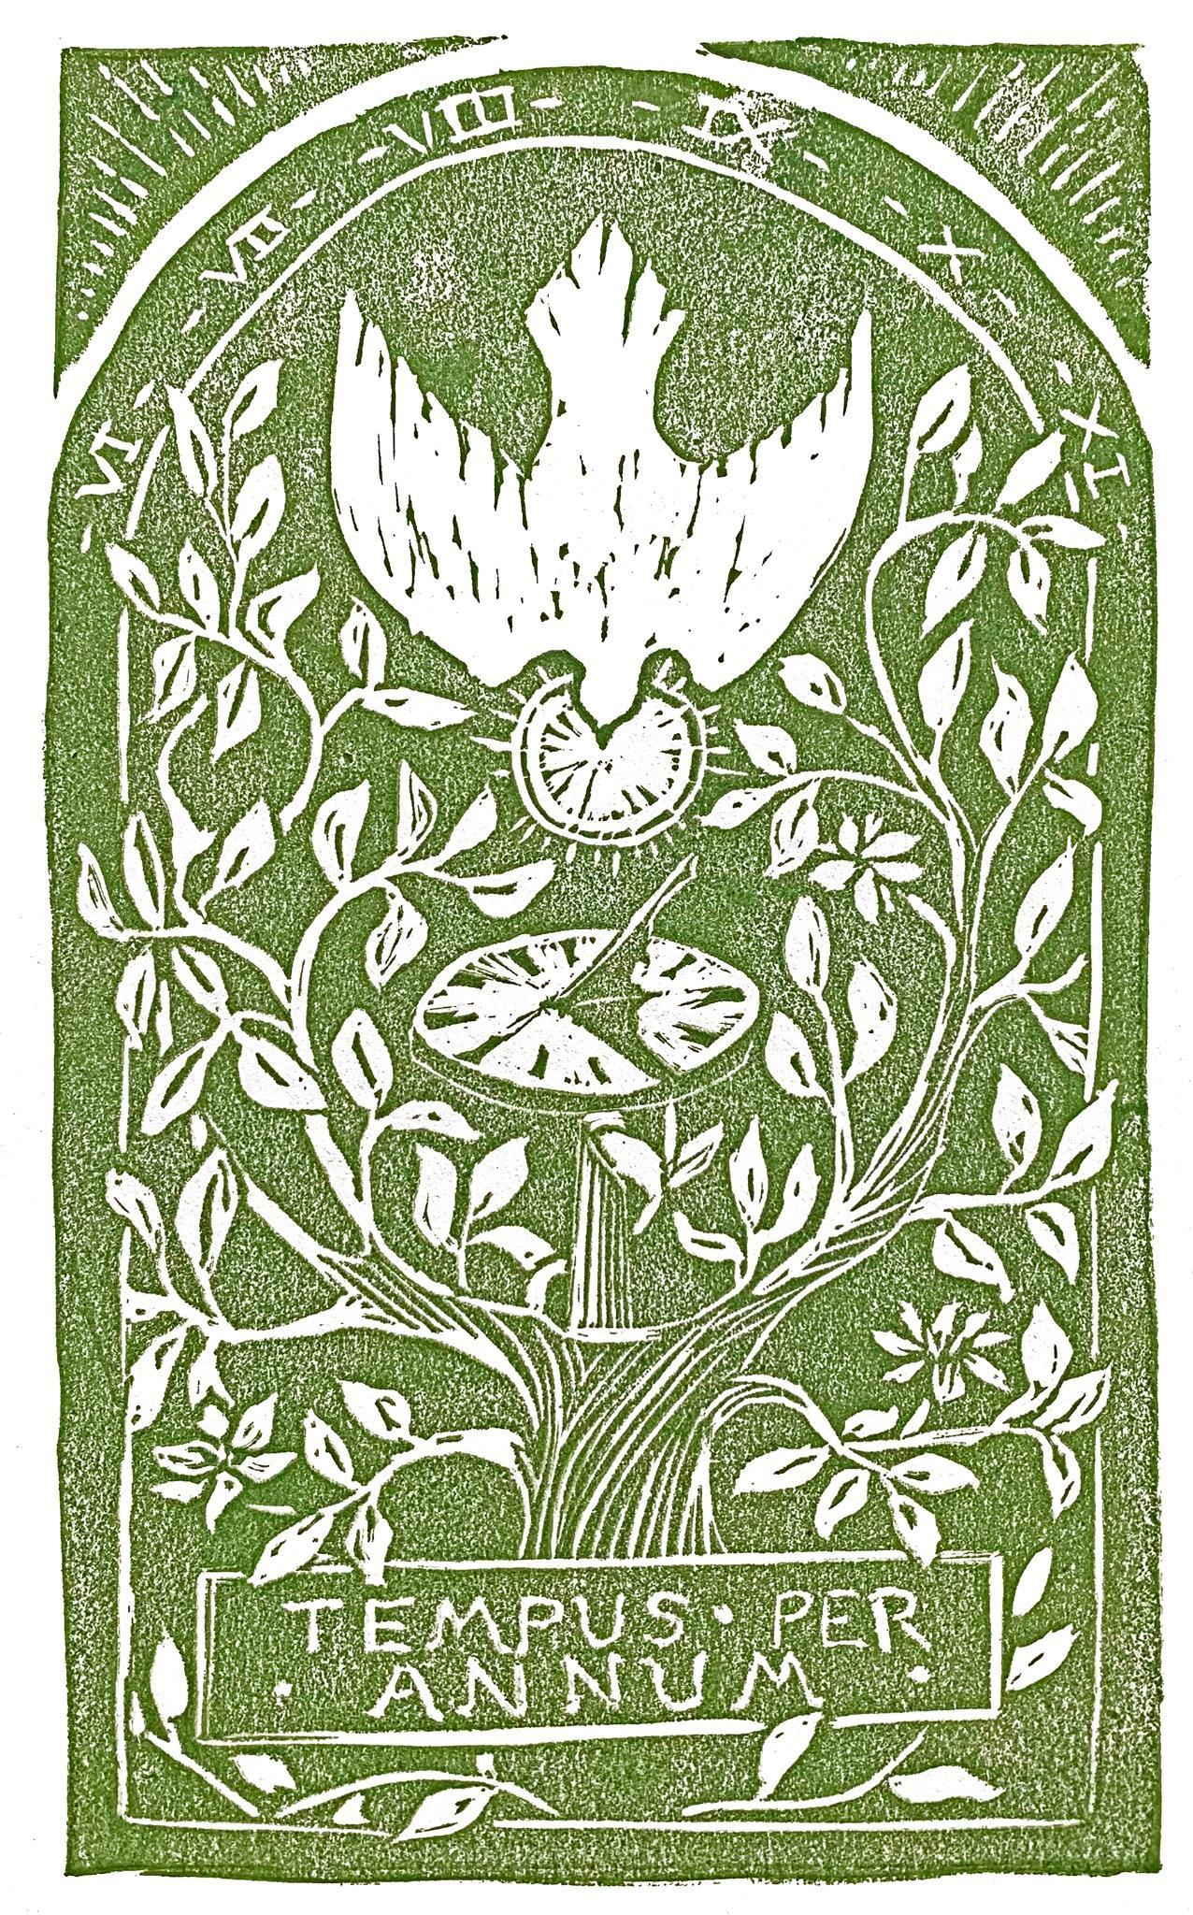

# Hope Presbyterian Church Accessible Worship Folder and Slide Deck Transcription

**April 27, 2025**

[www.hopechurchcolumbus.org](http://www.hopechurchcolumbus.org)

Pastor—Joe Haack—[joe@hopechurchcolumbus.org](mailto:joe@hopechurchcolumbus.org)

Youth Pastor—Wes Piehl—[wes@hopechurchcolumbus.org](mailto:wes@hopechurchcolumbus.org)

Deacons—[deacons@hopechurchcolumbus.org](mailto:deacons@hopechurchcolumbus.org)

Operations Manager—Nichole Redinger—[operations@hopechurchcolumbus.org](mailto:operations@hopechurchcolumbus.org)

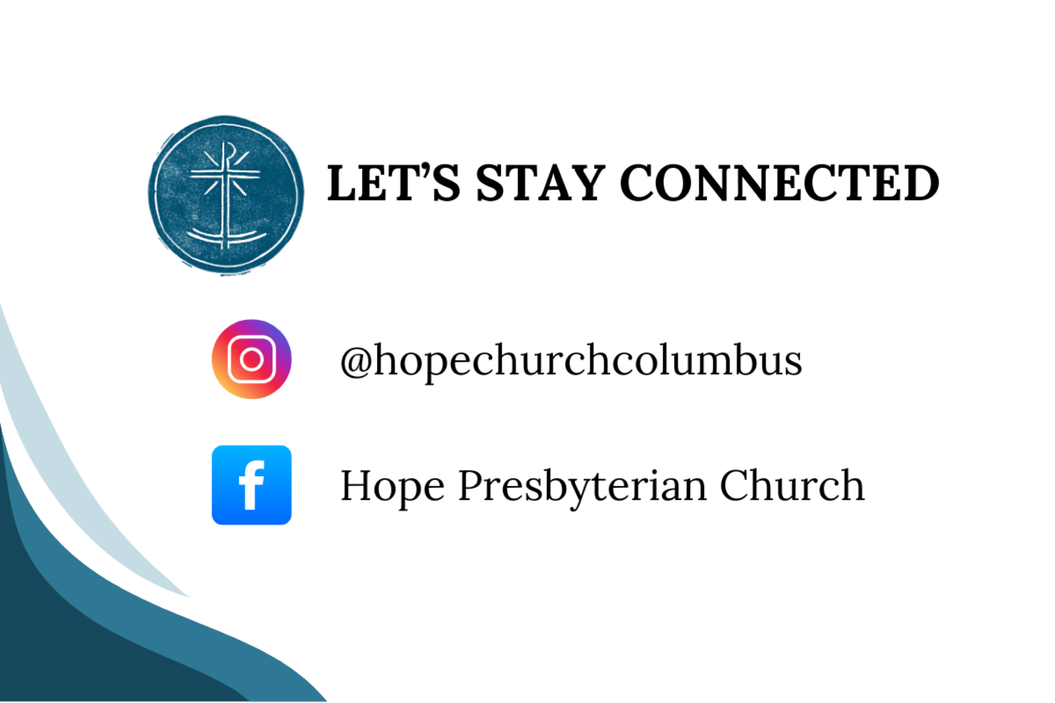

## CALL TO WORSHIP

### LEADER

Come to the Lord, who is rich in grace; approach our God, who is full of mercy.

### ALL

We will praise God with all our heart and glorify the name of the Most High forever.



## DOXOLOGY

Lyrics: Thomas Ken, 1674

Praise God from whom all blessings flow;

Praise him all creatures here below;

Praise him above, ye heavenly host;

Praise Father, Son, and Holy Ghost.

Amen.



## HYMN

### Be Thou My Vision

CCLI Song # 7056332

Eleanor Henrietta Hull | Mary Elizabeth Byrne | Russell Mauldin

Be Thou my vision

O Lord of my heart

Naught be all else to me

Save that Thou art

Thou my best thought

By day or by night

Waking or sleeping

Thy presence my light

Be Thou my wisdom

And Thou my true word

I ever with Thee

And Thou with me, Lord

Thou my great Father

I Thy true son

Thou in me dwelling

And I with Thee one

Riches I heed not

Nor man’s empty praise

Thou mine inheritance

Now and always

Thou and Thou only

First in my heart

High King of Heaven

My treasure Thou art

High King of Heaven

My victory won

May I reach Heaven’s joys

O bright Heav’n’s sun

Heart of my own heart

Whate’er befall

Still be my vision

O ruler of all



## HYMN

### We Are Listening

CCLI #4809412 | Jeremy Quillo

Father, I

Long to be wise

To see with new eyes

The truth that was written by Your hand

Father, speak

Your truth into me

Because I still believe

That You will help me understand

We are listening to Your word

We are listening to Your word

Morning and evening we come

To delight in the words of our God

Give us eyes to see

Give us faith to hear

That the Word has come

That the Word is here

Father, I

Long to see Christ

The truth and new life

The Word that made the universe

Father, speak

Now I believe

I have been set free

By the Word that lived and died for me

We are listening to Your word

We are listening to Your word

Morning and evening we come

To delight in the words of our God

Give us eyes to see

Give us faith to hear

That the Word has come

That the Word is here

We are listening to Your word

We are listening to Your word

Morning and evening we come

To delight in the words of our God

Give us eyes to see

Give us faith to hear

That the Word has come

That the Word is here

We are listening to Your word

We are listening to Your word



## CONFESSION OF SIN

### LEADER

Is not this the fast I choose: to loose the bonds of injustice; to share your bread with the hungry; to bring the homeless poor into your house;

to clothe the naked? Then your light shall break forth like the dawn, and your healing shall spring up quickly. Having heard these promises, let us confess our sins.



## HYMN

### Guide Me O Thou Great Jehovah

CCLI #4562223 | John Hughes, Paul Leddington Wright, Peter Williams, and William Williams

Guide me, O Thou great Jehovah

Pilgrim through this barren land

I am weak, but Thou art mighty

Hold me with Thy powerful hand

Bread of heaven

Feed me now and evermore

Bread of heaven

Feed me now and evermore

Open now the crystal fountain

Whence the healing stream doth flow

Let the fire and cloudy pillar

Lead me all my journey through

Strong deliverer

Be Thou still my strength and shield

Strong deliverer

Be Thou still my strength and shield

When I tread the verge of Jordan

Bid my anxious fears subside

Death of deaths and hell’s destruction

Land me safe on Canaan’s side

Songs of praises

I will ever give to Thee

Songs of praises

I will ever give to Thee

Land me safe on Canaan’s side

Bid my anxious fears

Bid my anxious fears

Land me safe on Canaan’s side

Bid my anxious fears

Bid my anxious fears

Goodbye



## GRACE ASSURANCE

### LEADER

Return to the Lord your God, for he is gracious and merciful, slow to anger, and abounding in steadfast love.

### ALL

In Christ, we are forgiven! Thanks be to God for his indescribable gift!



## HYMN

### Justice Will Roll Down

CCLI Song # 5759949 Sandra McCracken

Oh my love you have grown so cold

To the world outside to the house next door

She who has been loved much has so much to give

Mercy is the fragrance of the broken

Justice will roll down

Oh justice will roll down

From high upon those mountains

With a mighty river sound

It will roll down

It will roll down

Oh my child I will be your light

In your secret pain in the dark of night

No enemy no conqueror

will steal your life from Me

I am your salvation and your victory

Justice will roll down

Oh justice will roll down

From high upon those mountains

With a mighty river sound

It will roll down

It will roll down

Soon oh soon when the trumpet sounds

Every knee will bend every heart will pound

I have made a new world

Where the servant is the King

Oppression will be over and the slave set free

Justice will roll down

Oh justice will roll down

From high upon those mountains

With a mighty river sound

It will roll down

It will roll down

## TITHES AND OFFERINGS

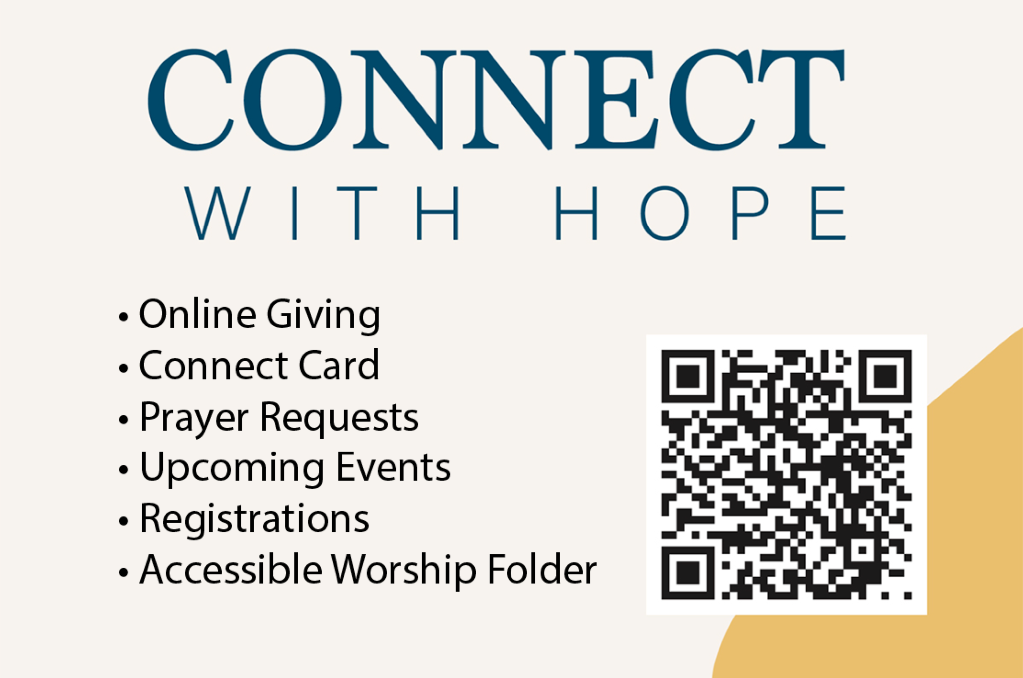

## HOPE HAPPENINGS AND ANNOUNCEMENTS

Preparing for Sunday - sermon prompts, scripture, Spotify playlist
QR code attached that leads to hopechurchcolumbus.org/prepare

## PASSING THE PEACE

## SCRIPTURE READING

Luke 6:37–42

### LEADER:

The Word of the Lord

### ALL:

Thanks be to God

## MESSAGE

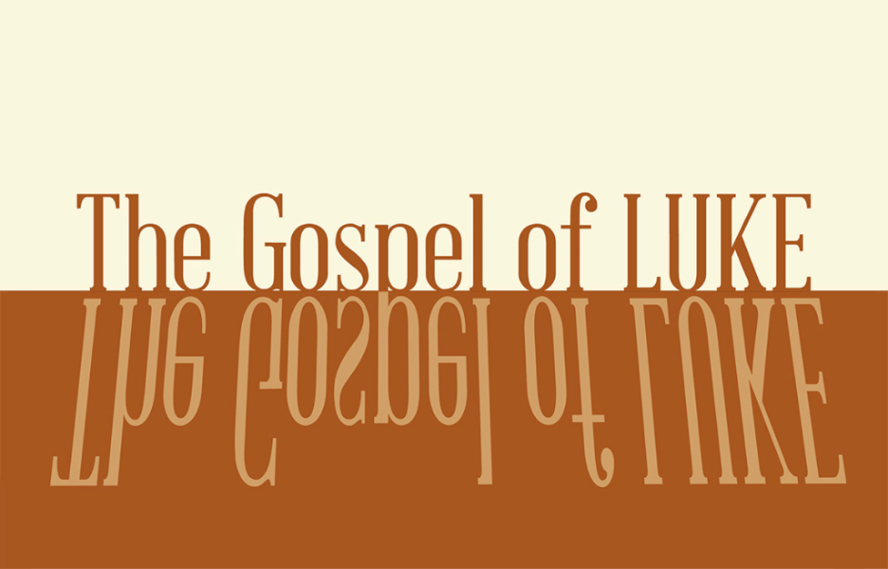

## CONFESSION OF FAITH

Heidelberg Catechism Q. 45

### LEADER

How does Christ's resurrection benefit us?

### ALL

First, by his resurrection he has overcome death, so that he could make us share in the righteousness which he had obtained for us by his death. Second, by his power we too are raised up to a new life. Third, Christ's resurrection is to us a sure pledge of our glorious resurrection.

## THE LORD’S SUPPER

### 1 Corinthians 11:23–26

The Lord Jesus, on the night when he was betrayed took bread and when he had given thanks, he broke it and said, “This is my body which is broken for you. Do this in remembrance of me.” In the same way also he took the cup, after supper, saying, “This cup is the new covenant in my blood. Do this as often as you drink it, in remembrance of me."



## HYMN

### All Things New

Words: Horatius Bonar, 1779; Music: Clint Wells, 2009

CCLI #: 3268915

Come Lord and tarry not

Bring the long-looked-for day

O why these years of waiting here

These ages of delay?

Come for Thy saints still wait

Daily ascends their sigh

The Spirit and the Bride say “Come”

Dost Thou not hear the cry?

O come and make all things new

Come and make all things new

O come and make all things new

Build up this ruined earth

Come and make all things new

Come for creation groans

Impatient of Thy stay

Worn out with these long years of woe

These ages of delay

Come for love waxes cold

Its steps are faint and slow

Faith now is lost in unbelief

Hope’s lamp burns dim and low

O come and make all things new

Come and make all things new

O come and make all things new

Build up this ruined earth

Come and make all things new

All things new



## BENEDICTION

Grace and peace to you from God our Father and the Lord Jesus Christ, who gave himself for our sins to rescue us from the present evil age, according to the will of our God and Father, to whom be glory for ever and ever.

## HOPE HAPPENINGS

### HOPE KIDS—TEACHERS NEEDED

We are in need of several teachers for children’s church. Please contact Wes at wes@hopechurchcolumbus.org if you are interested in serving.

### HOPE YOUTH—BLUEPRINT

April 27th @6:30pm

Students in 6th–12th grade are invited to join Hope Youth as we look as Jesus' most famous teaching, the Sermon on the Mount. We meet at the Piehl home—5364 Amy Lane, 43235.

## Digital Connect Card

We’re glad you’re here! Let’s stay connected; please fill out the form at the following link: <https://hopechurchcolumbus.churchcenter.com/people/forms/281549>.