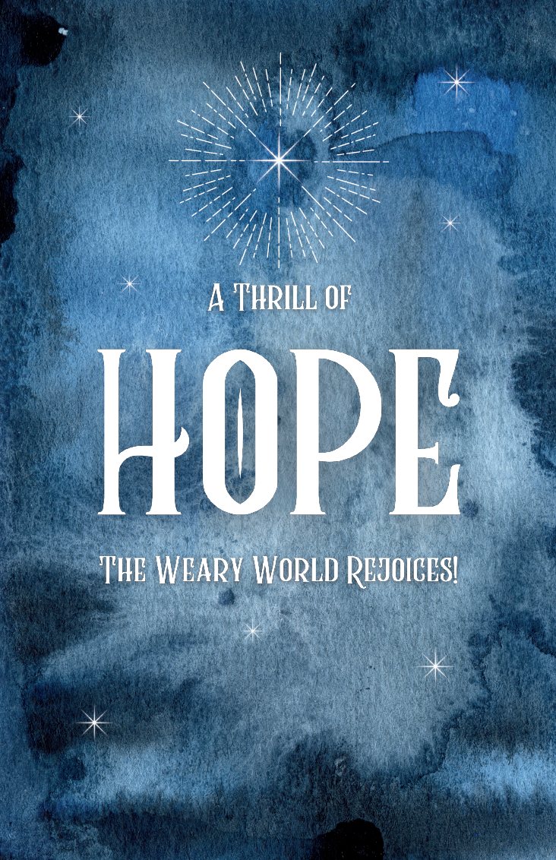

# Hope Presbyterian Church Accessible Worship Folder and Slide Deck Transcription

**December 20, 2024**—**Carol Service: An Evening of Carols & Candlelight**

[www.hopechurchcolumbus.org](http://www.hopechurchcolumbus.org)

Pastor—Joe Haack—[joe@hopechurchcolumbus.org](mailto:joe@hopechurchcolumbus.org)

Youth Pastor—Wes Piehl—[wes@hopechurchcolumbus.org](mailto:wes@hopechurchcolumbus.org)

Deacons—[deacons@hopechurchcolumbus.org](mailto:deacons@hopechurchcolumbus.org)

Operations Manager—Nichole Redinger—[operations@hopechurchcolumbus.org](mailto:operations@hopechurchcolumbus.org)

Carol Night
An Evening of Carols and Candlelight
December 20, 2024 at 6:30 p.m.
Nationwide & Ohio Farm Bureau 4-H Center

## Welcome

## Call to Worship

### Reader

How long O lord? How long will you hide yourself? Who will save us from the grave? Where is your steadfast love? Praise be to God! He has made a covenant with his chosen one. He has promised redemption to those who fear him. He has pledged his grace to us throughout all generations. Come, let us sing of the steadfast love of the Lord. Let us make known his faithfulness. Blessed be the Lord forever! Amen. (Based on Psalm 89)

## Opening Prayer

### Reader

Gracious God, you are the hope and desire of all nations. Our world is shattered by injustice. Our hearts are broken with sorrow. Our souls are heavy with longing for grace and mercy. Open our ears that we may hear your promises of redemption. Open our eyes that we may see them fulfilled in Christ. Open our lips that we might speak forth your praise. Amen.

## Carols

### O Come All Ye Faithful

CCLI Song # 31054 C. Frederick Oakeley | John Francis Wade

O come all ye faithful

Joyful and triumphant

O come ye, O come ye

To Bethlehem

Come and behold Him

Born the king of angels

Oh come, let us adore Him

Oh come, let us adore Him

Oh come, let us adore Him

Christ the Lord

Sing choirs of angels

Sing in exultation

Sing all ye citizens

Of Heaven above

Glory to God

Glory in the highest

Oh come, let us adore Him

Oh come, let us adore Him

Oh come, let us adore Him Christ the Lord

Yea, Lord, we greet thee

Born this happy morning

Jesus, to Thee be all glory giv’n

Word of the Father, now in flesh appearing

Oh come, let us adore Him

Oh come, let us adore Him

Oh come, let us adore Him

Christ the Lord

Oh come, let us adore Him

Christ the Lord

### Come Thou Long Expected Jesus

CCLI Song # 4299967 Charles Wesley | Derek Webb | Sandra McCracken

Come Thou long-expected Jesus

Born to set Thy people free

From our fears and sins release us

Let us find our rest in Thee

Israel's strength and consolation

Hope of all the saints Thou art

Dear desire of every nation

Joy of every longing heart

Come Thou long awaited Emmanuel

Born Thy people to deliver

Born a Child and yet a King

Born to reign in us forever

Now Thy gracious kingdom bring

By Thine own eternal Spirit

Rule in all our hearts alone

By Thine all sufficient merit

Raise us to Thy glorious throne

Come Thou long awaited Emmanuel

## Please Be Seated

## Reading

### Genesis 3:1–6 and 13–15

#### READER

Now the serpent was more crafty than any other beast of the field that the LORD God had made. He said to the woman, “Did God actually say, ‘You shall not eat of any tree in the garden’?” And the woman said to the serpent, “We may eat of the fruit of the trees in the garden, but God said, ‘You shall not eat of the fruit of the tree that is in the midst of the garden, neither shall you touch it, lest you die.’” But the serpent said to the woman, “You will not surely die. For God knows that when you eat of it your eyes will be opened, and you will be like God, knowing good and evil.” So when the woman saw that the tree was good for food, and that it was a delight to the eyes, and that the tree was to be desired to make one wise, she took of its fruit and ate, and she also gave some to her husband who was with her, and he ate.

Then the LORD God said to the woman, “What is this that you have done?” The woman said, “The serpent deceived me, and I ate.” The LORD God said to the serpent, “Because you have done this, cursed are you above all livestock and above all beasts of the field; on your belly you shall go, and dust you shall eat all the days of your life.

#### ALL

I will put enmity between you and the woman, and between your offspring and her offspring; he shall bruise your head, and you shall bruise his heel.”

## Please Stand

## Carol

### Creator of the Stars of Night

CCLI Song # 4299967 Charles Wesley | Derek Webb | Sandra McCracken

Creator of the stars of night

Thy people’s everlasting light

O Christ, redeemer of us all

We pray You hear us when we call

Come, oh come

Come, oh come

Come, oh come

To us

When this old world

Drew on toward night

You came

But not in splendor bright

Not as a monarch

But the child

Of Mary virgin mother mild

Come, oh come

Come, oh come

Come, oh come

To us

## Please Be Seated

## Reading

### Isaiah 10:33–11:5

#### READER

Behold, the Lord GOD of hosts

will lop the boughs with terrifying power;

the great in height will be hewn down, and the lofty will be brought low.

He will cut down the thickets of the forest with an axe, and Lebanon will fall by the Majestic One.

#### ALL

There shall come forth a shoot from the stump of Jesse, and a branch from his roots shall bear fruit.

And the Spirit of the LORD shall rest upon him,

the Spirit of wisdom and understanding,

the Spirit of counsel and might,

the Spirit of knowledge and the fear of the LORD.

And his delight shall be in the fear of the LORD. He shall not judge by what his eyes see,

or decide disputes by what his ears hear, but with righteousness he shall judge the poor,

and decide with equity for the meek of the earth; and he shall strike the earth with the rod of his mouth,

and with the breath of his lips he shall kill the wicked. Righteousness shall be the belt of his waist,

and faithfulness the belt of his loins.

## Carol

### O Come O Come Emmanuel

CCLI Song # 31982 John Mason Neale | Thomas Helmore

O come O come Emmanuel

And ransom captive Israel

That mourns in lonely exile here

Until the Son of God appear

Rejoice rejoice Emmanuel

Shall come to thee O Israel

O come Thou Dayspring come and cheer

Our spirits by Thine advent here

Disperse the gloomy clouds of night

And death's dark shadows put to flight

Rejoice rejoice Emmanuel

Shall come to thee O Israel

O come Thou Wisdom from on high

And order all things far and nigh

To us the path of knowledge show

And cause us in her ways to go

Rejoice rejoice Emmanuel

Shall come to thee O Israel

O come Desire of nations bind

All peoples in one heart and mind

Bid envy strife and quarrels cease

Fill the whole world with heaven's peace

Rejoice rejoice Emmanuel

Shall come to thee O Israel

## Reading

### Isaiah 9:2–7

#### READER

The people who walked in darkness have seen a great light;

those who dwelt in a land of deep darkness, on them has light shone.

You have multiplied the nation; you have increased its joy;

they rejoice before you

as with joy at the harvest,

as they are glad when they divide the spoil.

For the yoke of his burden,

and the staff for his shoulder,

the rod of his oppressor,

you have broken as on the day of Midian.

For every boot of the tramping warrior in battle tumult and every garment rolled in blood

will be burned as fuel for the fire.

#### ALL

For to us a child is born, to us a son is given;

and the government shall be upon his shoulder, and his name shall be called

Wonderful Counselor, Mighty God, Everlasting Father, Prince of Peace.

Of the increase of his government and of peace there will be no end,

on the throne of David and over his kingdom, to establish it and to uphold it

with justice and with righteousness

from this time forth and forevermore.

The zeal of the LORD of hosts will do this.

## Please Stand

## Carol

### Let All Mortal Flesh Keep Silence

Traditional Public Domain

Let all mortal flesh keep silence

And with fear and trembling stand

Ponder nothing earthly minded

For with blessing is His hand

Christ our God to earth descendeth

Our full homage to demand

King of Kings, yet born of Mary

As of old on earth He stood

Lord of Lords, in human vesture

In the body and the blood

He will give to all the faithful

His own self for heavenly food

Rank on rank the host of Heaven

Spreads its vanguard on the way

As light of light descendeth

From the realms of endless day

That the powers of hell may vanish

As the darkness clears away

At his feet the six-winged seraph

Cherubim with sleepless eye

Veil their faces to the presence

As with ceaseless voice they cry

Alleluia, Lord Most High

Alleluia, Lord Most High

### What Child Is This

Traditional Public Domain

What Child is this, who, laid to rest,

On Mary's lap is sleeping?

Whom angels greet with anthems sweet,

While shepherds watch are keeping?

This, this is Christ the King,

Whom shepherds guard and angels sing;

Haste, haste to bring Him laud,

The babe, the son of Mary

Why lies He in such mean estate

Where ox and ass are feeding?

Good Christian, fear; for sinners here

The silent Word is pleading

Nails, spears shall pierce him through

The word made flesh for me, for you;

Hail, hail the word made flesh

The babe, the son of Mary

So bring Him incense, gold, and myrrh,

Come, peasant, king, to own Him;

The King of Kings salvation brings,

Let loving hearts enthrone Him

Raise, raise a song on high

The virgin sings her lullaby

Joy, joy for Christ is borne

The babe, the son of Mary

## Please Be Seated

## Reading

### Luke 2:1–7

#### READER

In those days a decree went out from Caesar Augustus that all the world should be registered. This was the first registration when Quirinius was governor of Syria. And all went to be registered, each to his own town. And Joseph also went up from Galilee, from the town of Nazareth, to Judea, to the city of David, which is called Bethlehem, because he was of the house and lineage of David, to be registered with Mary, his betrothed, who was with child. And while they were there, the time came for her to give birth. And she gave birth to her firstborn son and wrapped him in swaddling cloths and laid him in a manger, because there was no place for them in the inn.

## Please Stand

## Carol

### O Holy Night

Lyrics by: Adolphe Adam

O holy night

The stars are brightly shining

It is the night

Of our dear Savior’s birth

Long lay the world

In sin and error pining

Til’ He appeared

And the soul felt its worth

A thrill of hope

The weary world rejoices

For yonder breaks

A new and glorious morn

Fall on your knees

O hear the angel voices

O night divine

O night when Christ was born

O night divine

O night, O night divine

Truly He taught us

To love one another

His law is love

And His gospel is peace

Chains He shall break

For the slave is our brother

And in His Name

All oppression shall cease

Sweet hymns of joy

In grateful chorus raise we

Let all within us

Praise His holy Name

Christ is the Lord!

Oh Praise His name forever

His power and glory

Evermore proclaim

His power and glory

Evermore proclaim

## Reading

### Luke 2:8–20

#### READER

And in the same region there were shepherds out in the field, keeping watch over their flock by night. And an angel of the Lord appeared to them, and the glory of the Lord shone around them, and they were filled with fear. And the angel said to them, “Fear not, for behold, I bring you good news of great joy that will be for all the people. For unto you is born this day in the city of David a Savior, who is Christ the Lord. And this will be a sign for you: you will find a baby wrapped in swaddling cloths and lying in a manger.” And suddenly there was with the angel a multitude of the heavenly host praising God and saying, “Glory to God in the highest, and on earth peace among those with whom he is pleased!”

When the angels went away from them into heaven, the shepherds said to one another, “Let us go over to Bethlehem and see this thing that has happened, which the Lord has made known to us.” And they went with haste and found Mary and Joseph, and the baby lying in a manger. And when they saw it, they made known the saying that had been told them concerning this child. And all who heard it wondered at what the shepherds told them. But Mary treasured up all these things, pondering them in her heart. And the shepherds returned, glorifying and praising God for all they had heard and seen, as it had been told them.

## Carol

### Joy to the World

Joy to the world!

The Lord is come!

Let earth receive her King

Let every heart prepare Him room

And heav'n and nature sing

and heav'n and nature sing,

 and heav'n and heav'n and nature sing!

Joy to the earth! the Saviour reigns:

Let men their songs employ;

While fields and floods,

 rocks, hills, and plains

Repeat the sounding joy

 Repeat the sounding joy

Repeat, repeat the sounding joy.

No more let sins and sorrows grow,

Nor thorns infest the ground;

 He comes to make his blessings flow

Far as the curse is found,

Far as the curse is found,

 Far as, far as the curse is found.

He rules the world with truth and grace,

And makes the nations prove

The glories of his righteousness,

 And wonders of his love,

And wonders of his love,

 And wonders, wonders of his love

## Please Be Seated

## Reading

### Matthew 2:1–12

#### READER

Now after Jesus was born in Bethlehem of Judea in the days of Herod the king, behold, wise men from the east came to Jerusalem, saying, “Where is he who has been born king of the Jews? For we saw his star when it rose and have come to worship him.” When Herod the king heard this, he was troubled, and all Jerusalem with him; and assembling all the chief priests and scribes of the people, he inquired of them where the Christ was to be born. They told him, “In Bethlehem of Judea, for so it is written by the prophet: “‘And you, O Bethlehem, in the land of Judah, are by no means least among the rulers of Judah; for from you shall come a ruler who will shepherd my people Israel.’”

Then Herod summoned the wise men secretly and ascertained from them what time the star had appeared. And he sent them to Bethlehem, saying, “Go and search diligently for the child, and when you have found him, bring me word, that I too may come and worship him.” After listening to the king, they went on their way. And behold, the star that they had seen when it rose went before them until it came to rest over the place where the child was. When they saw the star, they rejoiced exceedingly with great joy. And going into the house they saw the child with Mary his mother, and they fell down and worshiped him. Then, opening their treasures, they offered him gifts, gold and frankincense and myrrh. And being warned in a dream not to return to Herod, they departed to their own country by another way.

## Please Stand

## Carol

### Hark The Herald Angels Sing

CCLI Song # 27738 Charles Wesley | Felix Mendelssohn-Bartholdy

Hark! the herald angels sing

Glory to the newborn King!

Peace on earth and mercy mild

God and sinners reconciled

Joyful, all ye nations, rise

Join the triumph of the skies

With th' angelic host proclaim:

"Christ is born in Bethlehem!”

Hark! the herald angels sing

Glory to the newborn King!

Christ, by highest Heaven adored

Christ, the everlasting Lord

Late in time behold Him come

Offspring of the favored One

Veiled in flesh, the Godhead see

Hail, the incarnate deity

Pleased, as man, with men to dwell

## Reading

From John 1:1–14

#### Reader

In the beginning was the Word, and the Word was with God, and the Word was God.

#### All

In him was life,

and the life was the light of men.

#### Reader

He was in the world,

and the world was made through him, yet the world did not know him.

#### All

He came to his own,

and his own people did not receive him.

#### Reader

But to all who did receive him,

who believed in his name,

he gave the right to become children of God,

#### All

And the Word became flesh and dwelt among us, and we have seen his glory,

glory as of the only Son from the Father,

full of grace and truth.

## Carol

### Hallelujah! Christ is Coming

John 1:1–14 Written by Nelson Koscheski (BMI), Ryan Flanigan (BMI), Marty Reardon (ASCAP); © 2019 Common Hymnal Digital (BMI), Ryan Flanigan Music (BMI)

The first Advent broke darkness' sway,

Christ's birth made night as bright as day;

When Jesus spoke the truth was known,

When Jesus walked the way was shown,

When Jesus died all death was slain, When Jesus rose 'twas life's refrain.

Hallelujah! Christ is coming

Lord, we wait for you

Hallelujah! Christ is coming

Lord, we wait for you

We wait for you

Yet still the dark with light contends:

Until the Lord Most High descends

His people bear their cross of pain,

His people from the world abstain,

His people thirst for wisdom still,

His people seek his kingdom's will

Hallelujah! Christ is coming

Lord, we wait for you

Hallelujah! Christ is coming

Lord, we wait for you

We wait for you

He will return to end the fight,

To banish all the powers of night;

When Christ returns our hope is sealed,

When Christ returns the world is healed,

When Christ returns he is the prize,

When Christ returns the dead will rise.

Hallelujah! Christ is coming

Lord, we wait for you

Hallelujah! Christ is coming

Lord, we wait for you

We wait for you

## Please Be Seated

## Reading

### Luke 1:68 and 77–79

#### Reader

“Blessed be the Lord God of Israel,

for he has visited and redeemed his people

#### All

to give knowledge of salvation to his people in the forgiveness of their sins,

#### Reader

because of the tender mercy of our God, whereby the sunrise shall visit us from on high

#### All

to give light to those who sit in darkness and in the shadow of death,

to guide our feet into the way of peace.”

## Please Stand

## Carol

## Procession outside for lighting of candles.

### Silent Night

Public Domain

Silent night! Holy night!

All is calm, all is bright,

Round yon virgin mother and child! Holy Infant,

so tender and mild, Sleep in heavenly peace,

Sleep in heavenly peace.

Silent night! Holy night!

Shepherds quake at the sight,

Glories streams from heaven afar,

Heavenly hosts sing: "Alleluia."

Christ the Savior is born,

Christ the Savior is born.

Silent night! Holy night!

Son of God, love's pure light

Radiant beams from Thy holy face,

With the dawn of redeeming grace.

Jesus, Lord, at Thy birth,

Jesus, Lord, at Thy birth.

Silent night! Holy night!

Wondrous star, lend thy light;

With the angels let us sing,

Alleluia to our King;

Christ the Savior is born,

Christ the Savior is born.

## Reading

### Revelation 21:3 and 22:16–17

#### Reader

And I heard a loud voice from the throne saying, “Behold, the dwelling place of God is with man. He will dwell with them, and they will be his people, and God himself will be with them as their God.

“I, Jesus, have sent my angel to testify to you about these things for the churches. I am the root and the descendant of David, the bright morning star.”

The Spirit and the Bride say, “Come.” And let the one who hears say, “Come.” And let the one who is thirsty come; let the one who desires take the water of life without price.

## Carol

### Joy to the Word

Lyrics by: Isaac Watts

Joy to the world!

The Lord is come!

Let earth receive her King

Let every heart prepare Him room

And heav'n and nature sing

and heav'n and nature sing,

and heav'n and heav'n and nature sing!

Joy to the earth! the Saviour reigns:

Let men their songs employ;

While fields and floods,

rocks, hills, and plains

Repeat the sounding joy

Repeat the sounding joy

Repeat, repeat the sounding joy.

No more let sins and sorrows grow,

Nor thorns infest the ground;

He comes to make his blessings flow

Far as the curse is found,

Far as the curse is found,

Far as, far as the curse is found.

He rules the world with truth and grace,

And makes the nations prove

The glories of his righteousness,

And wonders of his love,

And wonders of his love,

And wonders, wonders of his love

## Benediction