

Hope Presbyterian Church Accessible Worship Folder and Slide Deck Transcription
December 1, 2024—Week 1 of Advent
www.hopechurchcolumbus.org
Pastor—Joe Haack—joe@hopechurchcolumbus.org
Youth Pastor—Wes Piehl—wes@hopechurchcolumbus.org
Deacons—deacons@hopechurchcolumbus.org
Operations Manager—Nichole Redinger—operations@hopechurchcolumbus.org


Prayer of Preparation

ALL
Approach the mountain, climb up the mountain, and you that climb it, do not go down it. There you will be safe, there you will be protected; Christ is your mountain of refuge. And where is Christ? At the right hand of the Father, since he has ascended into heaven.—Augustine

Call to Worship

Leader
It shall come to pass in the latter days that the mountain of the house of the LORD shall be established as the highest of the mountains, and shall be lifted up above the hills; and all the nations shall flow to it, and many peoples shall come, and say:

All
“Come, let us go up to the mountain of the LORD, to the house of the God of Jacob, that he may teach us his ways and that we may walk in his paths.”

Leader
For out of Zion shall go forth the law, and the word of the LORD from Jerusalem. He shall judge between the nations, and shall decide disputes for many peoples; and they shall beat their swords into plowshares, and their spears into pruning hooks; nation shall not lift up sword against nation, neither shall they learn war anymore.

All
O, house of Jacob, come, let us walk in the light of the LORD.
—from Is. 2:2-5, ESV

DOXOLOGY
Lyrics: Thomas Ken, 1674
Praise God from whom all blessings flow;
Praise him all creatures here below;
Praise him above, ye heavenly host;
Praise Father, Son, and Holy Ghost.
Amen.

Prayer of Invocation

Leader
God of Israel, with expectant hearts, we your people await Christ’s coming. As once he came in humility, so now may he come in glory, that he may make all things perfect in your everlasting kingdom.

All
For he is Lord for ever and ever. Amen.

HYMNS

O COME O COME EMMANUEL
CCLI Song # 31982 John Mason Neale | Thomas Helmore
O come, O come, Emmanuel
And ransom captive Israel
That mourns in lonely exile here
Until the Son of God appear
Rejoice, rejoice, Emmanuel
Shall come to thee, O Israel
O come, Thou Rod of Jesse, free
Thine own from Satan’s tyranny
From depths of Hell Thy people save
And give them victory o’er the grave
Rejoice, rejoice, Emmanuel
Shall come to thee, O Israel
O come, Thou Day-Spring
Come and cheer
Our spirits by Thine advent here
Disperse the gloomy clouds of night
And death’s dark shadows put to flight
Rejoice, rejoice, Emmanuel
Shall come to thee, O Israel
O come, Thou Key of David, come
And open wide our heavenly home
Make safe the way that leads on high
And close the path to misery
Rejoice, rejoice, Emmanuel
Shall come to thee, O Israel

O COME ALL YE FAITHFUL
CCLI Song # 31054 C. Frederick Oakeley | John Francis Wade
O come all ye faithful
Joyful and triumphant
O come ye,
O come ye
To Bethlehem
Come and behold Him
Born the king of angels
Oh come, let us adore Him
Oh come, let us adore Him
Oh come, let us adore Him
Christ the Lord
Sing choirs of angels
Sing in exultation
Sing all ye citizens
Of Heaven above
Glory to God
Glory in the highest
Oh come, let us adore Him
Oh come, let us adore Him
Oh come, let us adore Him
Christ the Lord
Yea, Lord, we greet thee
Born this happy morning
Jesus, to Thee be all glory giv’n
Word of the Father, now in flesh appearing
Oh come, let us adore Him
Oh come, let us adore Him
Oh come, let us adore Him Christ the Lord
Oh come, let us adore Him Christ the Lord

CONFESSION OF SIN
From Rom. 13:11-14, NIV

Leader
The hour has already come for you to wake up from your slumber, because our salvation is nearer now than when we first believed.

All
The night is nearly over; the day is almost here.

Leader
So let us put aside the deeds of darkness and put on the armor of light. Let us behave decently, as in the daytime, not in carousing and drunkenness, not in sexual immorality and debauchery, not in dissension and jealousy. Rather, clothe yourselves with the Lord Jesus Christ, and do not think about how to gratify the desires of the flesh.

All
O, Holy Child of Bethlehem, descend to us, we pray. Cast out our sin and enter in; be born in us today.

HYMN

COMFORT, COMFORT NOW MY PEOPLE
CCLI Song # 7187522 Catherine Winkworth | Johann G. Olearius | W. Zachary Taylor
Comfort, comfort now my people
Tell of His peace with no end
Comfort, comfort those in darkness
Tell them that God's pardon waits for them
The glory of the Lord now on Earth is shed
In deserts far and near
He will raise what's dead
His peace has now been spoken
His word is never broken
The kingdom of our God is now here
Straight shall, straight shall
Be what's crooked
Making all the rougher places plain
Let your, let your Hearts be humble
Befitting our God's glory
And His reign
The glory of the Lord now on Earth is shed
In deserts far and near
He will raise what's dead
His peace has now been spoken
His word is never broken
The kingdom of our God is now here
Let the valleys rise to meet Him
The hills all will bow down
Let the valleys rise to greet Him
The hills bow down in praise
Let the valleys rise to greet Him
The hills bow down in praise
The glory of the Lord now on Earth is shed
In deserts far and near
He will raise what's dead
The glory of the Lord now on Earth is shed
In deserts far and near
He will raise what's dead
His peace has now been spoken
His word is never broken
The kingdom of our God is now here
Comfort, comfort now my people
Comfort, comfort now my people

Grace Assurance
Based on Phil ch. 1 and 2

LEADER
Almighty God, by whose providence our Savior, Jesus Christ, came among us in great humility, will sanctify you with the light of his blessing and set you free from all sin. He who began a good work in you will carry it on to completion until the day of Christ Jesus.

HYMN

He Who Is Mighty
CCLI Song # 7031870 Kate DeGraide | Rebecca Elliott
Oh, the mercy our God has shown
To those who sit in death’s shadow
The sun on high pierced the night
Born was the Cornerstone
Unto us a Son is given
Unto us a Child is born
He Who is mighty
Has done a great thing
Taken on flesh
Conquered death’s sting
Shattered the darkness
And lifted our shame
Holy is His name
Oh, the freedom our Savior won
The yoke of sin has been broken
Once a slave, now by grace
No more condemnation
Unto us a Son is given
Unto us a Child is born
He Who is mighty
Has done a great thing
Taken on flesh
Conquered death’s sting
Shattered the darkness
And lifted our shame
Holy is His name
He Who is mighty
Has done a great thing
Taken on flesh
Conquered death’s sting
Shattered the darkness
And lifted our shame
Holy is His name
Now my soul magnifies the Lord
I rejoice in the God Who saves
I will trust His unfailing love
I will sing His praises all my days
Now my soul magnifies the Lord
I rejoice in the God Who saves
I will trust His unfailing love
I will sing His praises all my days
He Who is mighty
Has done a great thing
Taken on flesh
Conquered death’s sting
Shattered the darkness
And lifted our shame
Holy is His name
He Who is mighty
Has done a great thing
Taken on flesh
Conquered death’s sting
Shattered the darkness
And lifted our shame
Holy is His name

TITHES AND OFFERINGS


HOPE HAPPENINGS AND ANNOUNCEMENTS
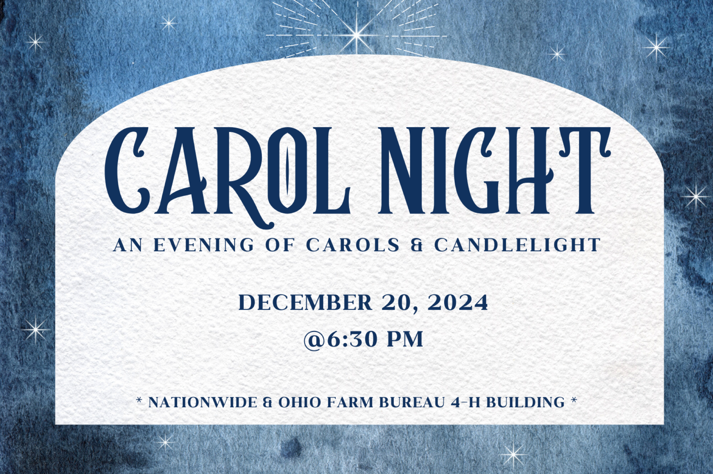


PASSING THE PEACE

SCRIPTURE READING
Luke 1:1–4

MESSAGE

Slide 1
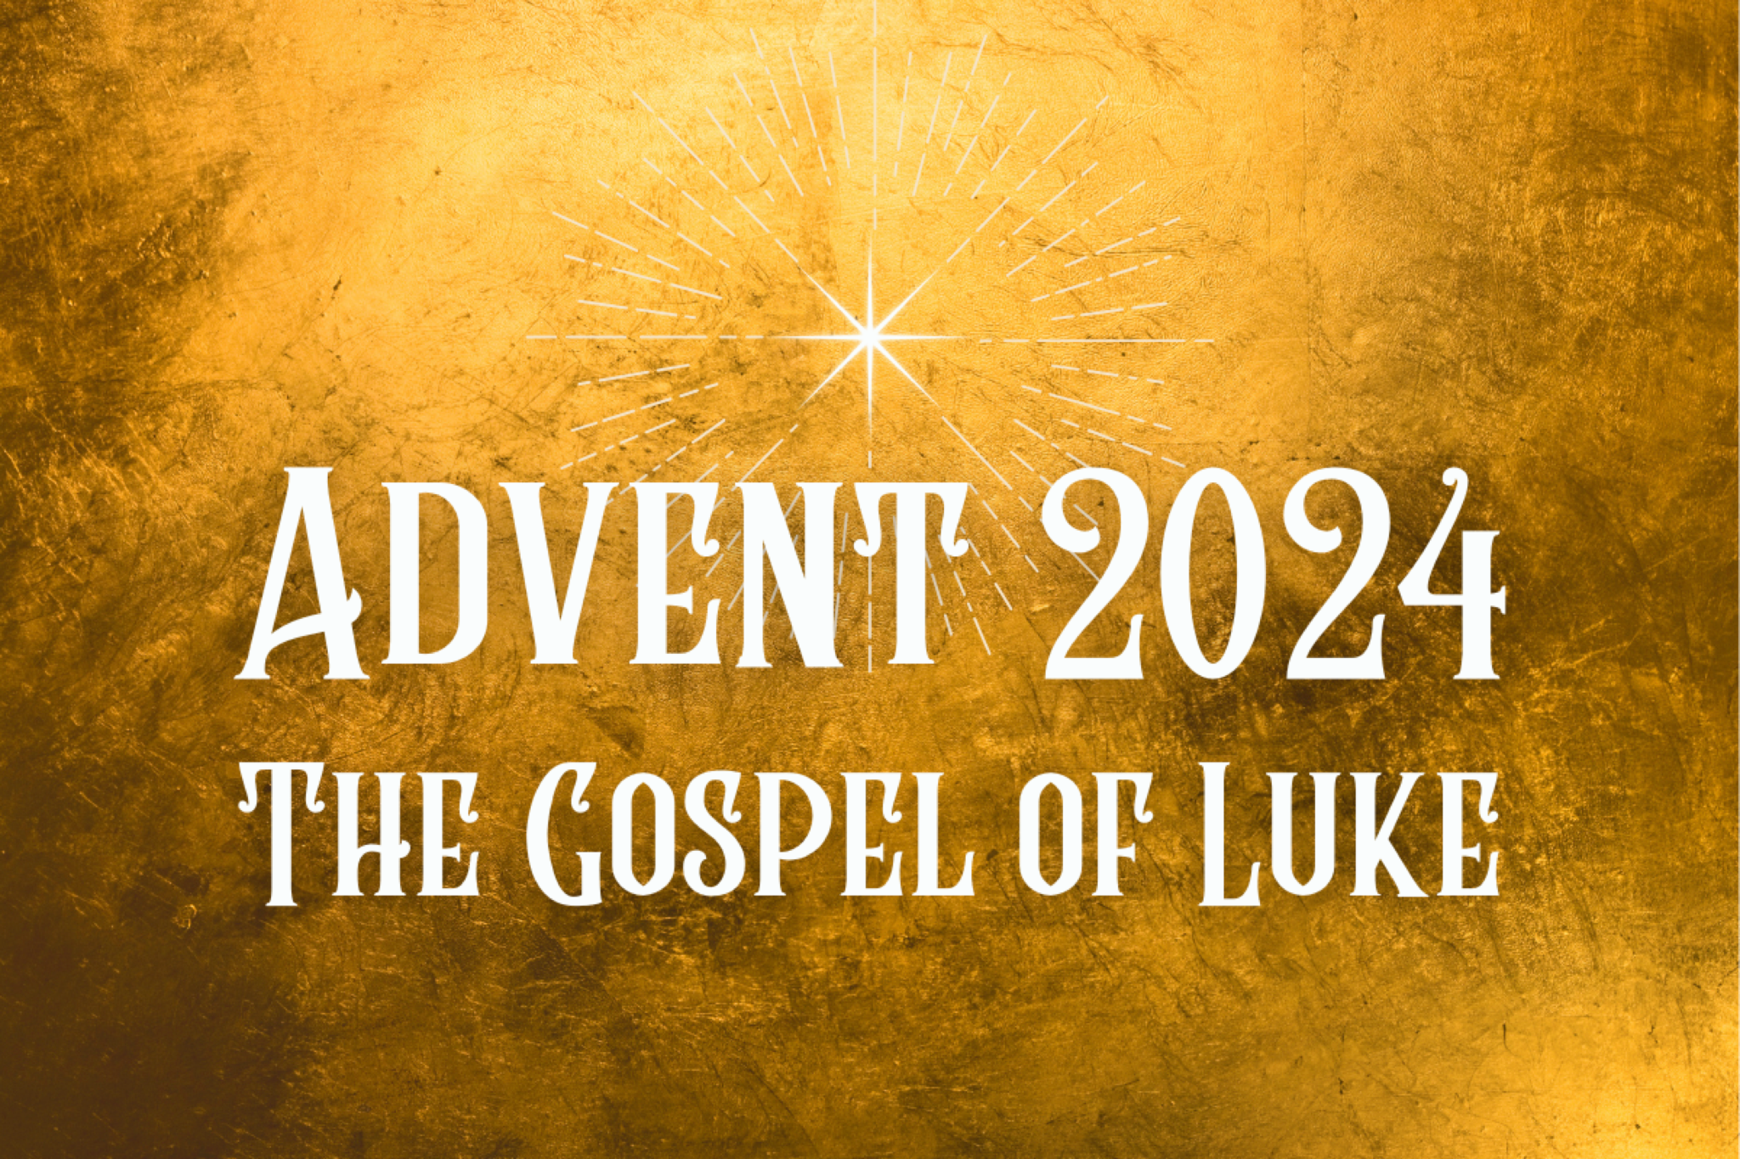

Slide 2
1/ Christianity is a story (not a skill)
2/ Christianity is about divine descent (not human climbing)
3/ Christianity is outside-in (not inside-out)

Slide 3
1/ Christianity is a story (not a skill)

Slide 4
1/ Christianity is a story (not a skill)
Inasmuch as many have undertaken to compile a narrative of the things that have been accomplished among us,
Luke 1:1

Slide 5
1/ Christianity is a story (not a skill)
10 And while they were gazing into heaven as he went, behold, two men stood by them in white robes, 11 and said, “Men of Galilee, why do you stand looking into heaven? This Jesus, who was taken up from you into heaven, will come in the same way as you saw him go into heaven” (Ac 1:10–11).

Slide 6
Finished & Unfolding

Slide 7
Finished & Unfolding (in very small font to convey less regard for the “unfolding” aspect)

Slide 8
Finished (in very small font to convey less regard for the “finished” aspect) & Unfolding

Slide 9
Finished & Unfolding

Slide 10
2/ Christianity is about divine descent (not human climbing)

Slide 11
2/ Christianity is about divine descent (not human climbing)
Inasmuch as many have undertaken to compile a narrative of the things that have been accomplished among us, just as those who from the beginning were eyewitnesses and ministers of the word have delivered them to us,
Luke 1:1-2

Slide 12
3/ Christianity is outside-in (not inside-out)

Slide 13
3/ Christianity is outside-in (not inside-out)

Slide 14
“it seemed good to me also, having followed all things closely for some time past, to write an orderly account for you, most excellent Theophilus, 4 that you may have certainty concerning the things you have been taught.”
Luke 1:3-4

Slide 15

PROFESSION OF FAITH
So then we confess that God fulfilled the promise made to the early fathers and mothers by the mouth of the holy prophets when he sent the only and eternal Son of God into the world at the time appointed. The Son took the “form of a slave” and was made in “human form,” truly assuming a real human nature, with all its weaknesses, except for sin; being conceived in the womb of the blessed virgin Mary by the power of the Holy Spirit, without male participation. And Christ not only assumed human nature as far as the body is concerned but also a real human soul, in order to be a real human being. For since the soul had been lost as well as the body, Christ had to assume them both to save them both together.
—from Belgic Confession, Art. 18

THE LORD’S SUPPER

1 Corinthians 11:23–26
The Lord Jesus, on the night when he was betrayed took bread and when he had given thanks, he broke it and said, “This is my body which is broken for you. Do this in remembrance of me.” In the same way also he took the cup, after supper, saying, “This cup is the new covenant in my blood. Do this as often as you drink it, in remembrance of me."

HYMN

Hark the Herald Angels Sing
CCLI Song # 27738 Charles Wesley | Felix Mendelssohn-Bartholdy
Hark! the herald angels sing
Glory to the newborn King!
Peace on earth and mercy mild
God and sinners reconciled
Joyful, all ye nations, rise
Join the triumph of the skies
With th' angelic host proclaim:
"Christ is born in Bethlehem!”
Hark! the herald angels sing
Glory to the newborn King!
Christ, by highest Heaven adored
Christ, the everlasting Lord
Late in time behold Him come
Offspring of the favored One
Veiled in flesh, the Godhead see
Hail, the incarnate deity
Pleased, as man, with men to dwell
Jesus, our Emmanuel!
Hark! the herald angels sing
Glory to the newborn King!
Hail the Heaven-born Prince of Peace
Hail the Son of Righteousness
Light and life to all He brings
Risen with healing in His wings
Mild He lays His glory by
Born that man no more may die
Born to raise the son of earth
Born to give them second birth
Hark! the herald angels sing
Glory to the newborn King!

BENEDICTION

LEADER
Do not let your hearts be troubled. You believe in God; believe also in me. My Father’s house has many rooms; if that were not so, would I have told you that I am going there to prepare a place for you? And if I go and prepare a place for you, I will come back and take you to be with me that you also may be where I am.
The one who loves me will be loved by my Father, and I too will love them and show myself to them.
—Jn. 14: 1-3, 21

HOPE HAPPENINGS

Women’s Christmas Party & Mug Swap
Saturday, December 7 at 10 a.m. Join us for a festive brunch and mug swap. Select a mug from your cupboard to exchange and return home with a new-to-you mug! Get creative or cozy, funny or fancy, classic, or weird!
At the Piehl Home 5364 Amy Lane, 43235. Text Michelle at 419–215–7848
RSVP at https://hopechurchcolumbus.churchcenter.com/registrations/events/2569217.

Carol Night
Friday, December 20 at 6:30 p.m. at Nationwide & Ohio Farm Bureau 4-H Center. Join us for Carol Night, an intimate Christmas Carol service filled with the timeless beauty of scripture and traditional Christmas carols. The evening will culminate in a special outdoor candlelit carol, creating a peaceful moment to celebrate the season. After the service, enjoy festive Christmas cookies and warm fellowship. There’s no need to dress up—just come as you are and bring your friends and family.
Please consider bringing christmas cookies or other treats to share as we
extend the welcome of Jesus to friends, family and newcomers that evening!

HOPE KIDS TEACHERS NEEDED
The Hope Kids team is in need of two Elementary teachers and one Preschool teacher. Teachers typically serve once a month. Please consider helping out in this way. Contact Wes for more information at wes@hopechurchcolumbus.org.

HOPE WOMEN'S RETREAT WEEKEND
Save the Date! April 4–6, 2025. More Information Coming Soon!

Digital Connect Card
We’re glad you’re here! Let’s stay connected; please fill out the form at the following link: https://hopechurchcolumbus.churchcenter.com/people/forms/281549.

