

Hope Presbyterian Church Accessible Worship Folder and Slide Deck Transcription
December 15, 2024—Week 3 of Advent
www.hopechurchcolumbus.org
Pastor—Joe Haack—joe@hopechurchcolumbus.org
Youth Pastor—Wes Piehl—wes@hopechurchcolumbus.org
Deacons—deacons@hopechurchcolumbus.org
Operations Manager—Nichole Redinger—operations@hopechurchcolumbus.org


Prayer of Preparation (Reflection before the service)

ALL
The spiritual and holy Zion—that is, the church, the holy multitude of the believers—is justified in Christ and only in him. By him and through him we are also saved as we escape from the harm of the invisible enemies, for we have a Mediator who was incarnated in our form, the king of all, that is, the Word of God the Father... He [the Word] is the armor of good will, the peace, the wall, the one who bestows incorruption.—Cyril of Alexandria

Call to Worship

Leader
Leader:
Sing aloud, O daughter of Zion; shout, O Israel! Rejoice and exult with all your heart, O daughter of Jerusalem! The LORD has taken away the judgments against you; he has cleared away your enemies. The King of Israel, the LORD, is in your midst; you shall never again fear evil. On that day it shall be said to Jerusalem: “Fear not, O Zion; let not your hands grow weak. The LORD your God is in your midst, a mighty one who will save; he will rejoice over you with gladness; he will quiet you by his love; he will exult over you with loud singing. I will gather those of you who mourn for the festival, so that you will no longer suffer reproach.

All
Behold, at that time I will deal with all your oppressors. And I will save the lame and gather the outcast, and I will change their shame into praise and renown in all the earth. At that time I will bring you in, at the time when I gather you together; for I will make you renowned and praised among all the peoples of the earth, when I restore your fortunes before your eyes,” says the LORD.
—from Zeph. 3:14–20, ESV

DOXOLOGY
Lyrics: Thomas Ken, 1674
Praise God from whom all blessings flow;
Praise him all creatures here below;
Praise him above, ye heavenly host;
Praise Father, Son, and Holy Ghost.
Amen.

Prayer of Invocation

Leader
We sing praises to you, LORD, for you have done gloriously; let this be made known in all the earth. We shout, and sing for joy, as inhabitants of Zion, for great in our midst are you, the Holy One of Israel.”
—based on Is. 12:5–6

HYMN

COME THOU LONG EXPECTED JESUS
CCLI Song # 4299967 Charles Wesley | Derek Webb | Sandra McCracken
Come Thou long-expected Jesus
Born to set Thy people free
From our fears and sins release us
Let us find our rest in Thee
Israel's strength and consolation
Hope of all the saints Thou art
Dear desire of every nation
Joy of every longing heart
Come Thou long awaited Emmanuel
Born Thy people to deliver
Born a Child and yet a King
Born to reign in us forever
Now Thy gracious kingdom bring
By Thine own eternal Spirit
Rule in all our hearts alone
By Thine all sufficient merit
Raise us to Thy glorious throne
Come Thou long awaited Emmanuel

CONFESSION OF SIN

Leader
Do you want to know what fruit befits repentance?

All
Love is a fruit of the Spirit. Joy is a fruit of the Spirit. So are peace, patience, kindness, goodness, faithfulness, gentleness, and self-control. We confess that we too often rely on, and live for, ourselves. We confess that we too often do not display the fruit of the Spirit. Lord, have mercy, through Jesus Christ our Lord, Amen.

HYMN

CREATOR OF THE STARS OF NIGHT
CCLI Song # 4299967
Charles Wesley | Derek Webb | Sandra McCracken

Creator of the stars of night
Thy people’s everlasting light
O Christ, redeemer of us all
We pray You hear us when we call
Come, oh come
Come, oh come
Come, oh come To us
When this old world
Drew on toward night
You came
But not in splendor bright
Not as a monarch
But the child
Of Mary virgin mother mild
Come, oh come
Come, oh come
Come, oh come

To us

Grace Assurance

LEADER
For in him all the fullness of God was pleased to dwell, and through him to reconcile to himself all things, whether on earth or in heaven, making peace by the blood of his cross. And you, who once were alienated and hostile in mind, doing evil deeds, he has now reconciled in his body of flesh by his death, in order to present you holy and blameless and above reproach before him.
—from Col. 1:19–22

HYMN

Let All Mortal Flesh Keep Silence
Traditional Public Domain
Let all mortal flesh keep silence
And with fear and trembling stand
Ponder nothing earthly minded
For with blessing is His hand
Christ our God to earth descendeth
Our full homage to demand
King of Kings, yet born of Mary
As of old on earth He stood
Lord of Lords, in human vesture
In the body and the blood
He will give to all the faithful
His own self for heavenly food
Rank on rank the host of Heaven
Spreads its vanguard on the way
As light of light descendeth
From the realms of endless day
That the powers of hell may vanish
As the darkness clears away
At his feet the six-winged seraph
Cherubim with sleepless eye
Veil their faces to the presence
As with ceaseless voice they cry
Alleluia, Lord Most High
Alleluia, Lord Most High

TITHES AND OFFERINGS
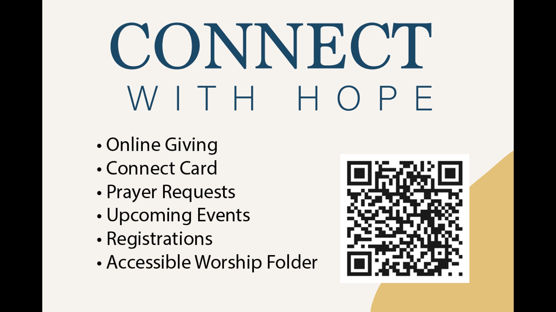

HOPE HAPPENINGS AND ANNOUNCEMENTS

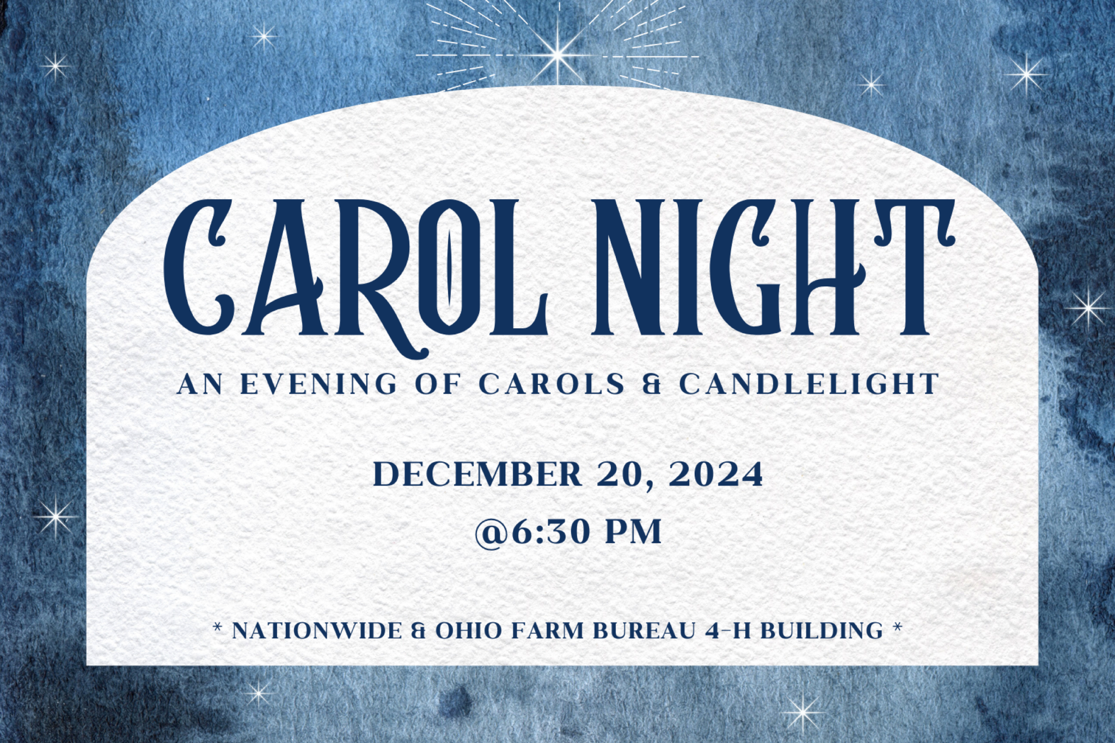



PASSING THE PEACE

SCRIPTURE READING
Luke 1:39–56

MESSAGE

Slide 1
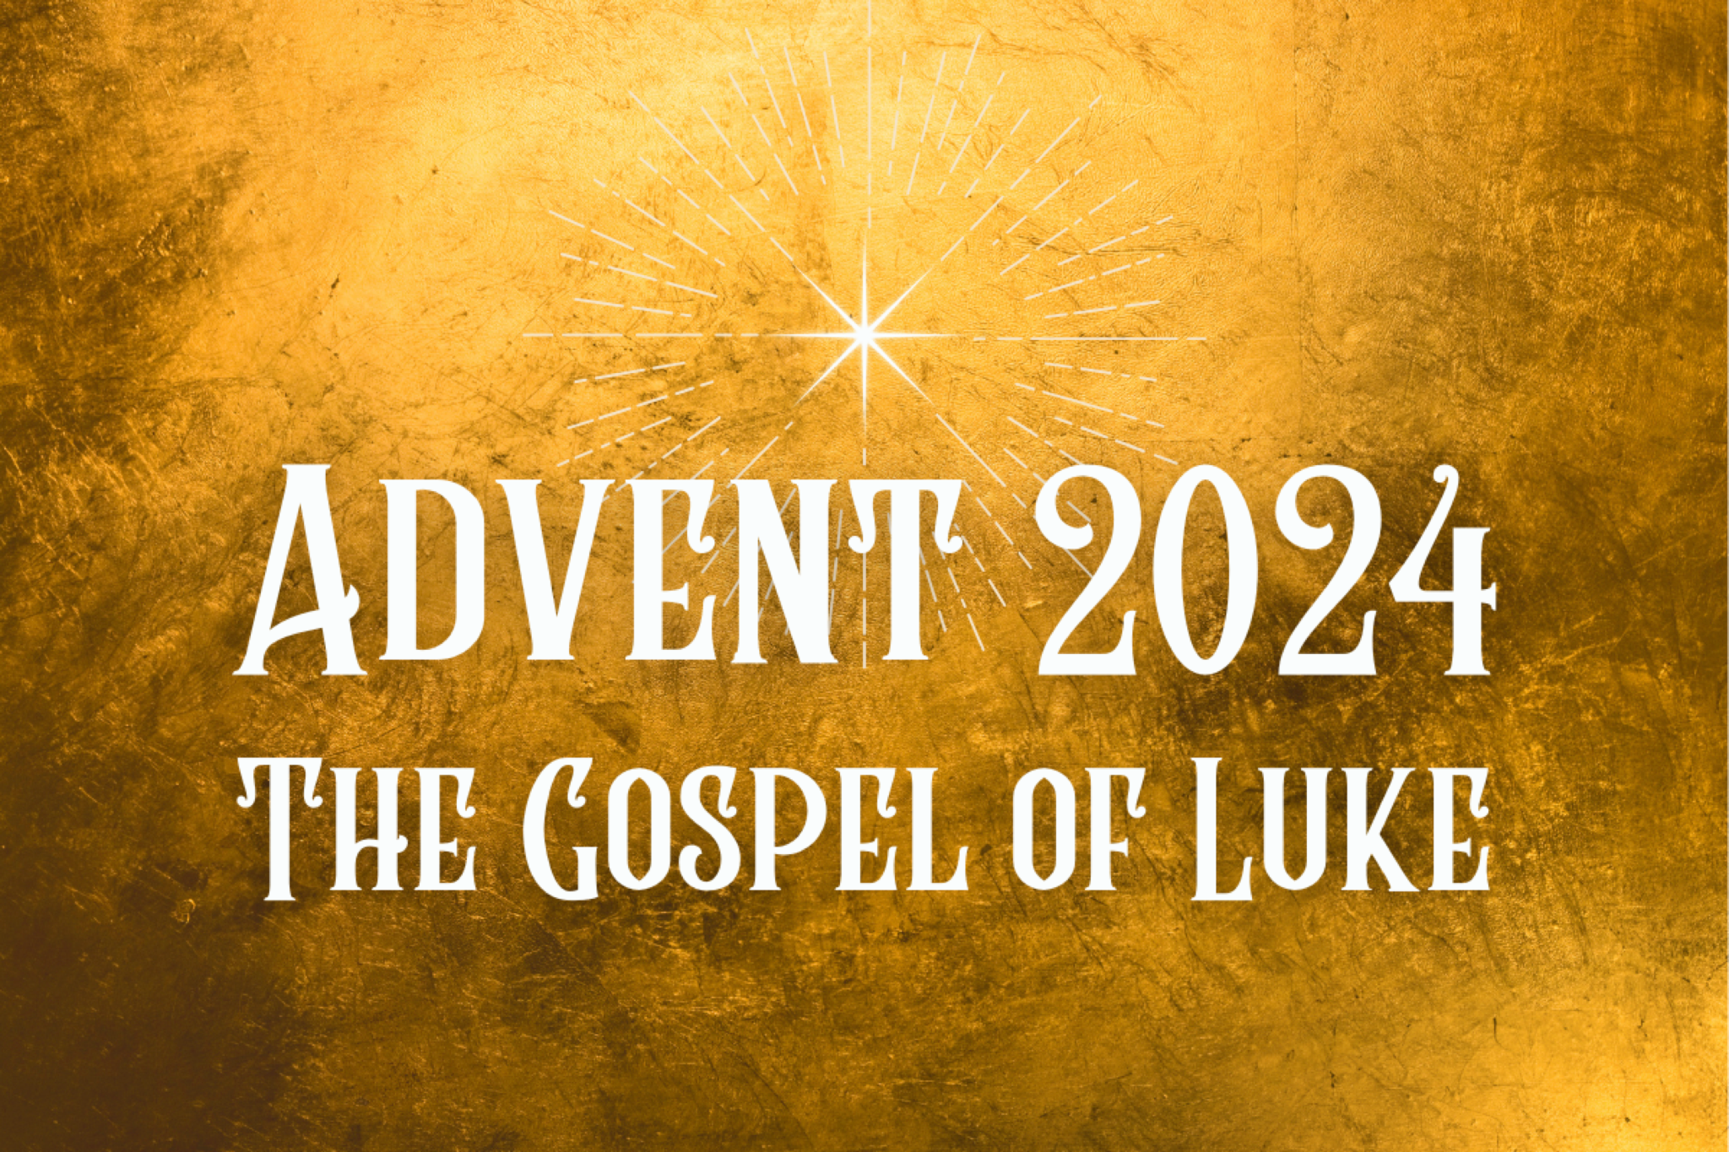

Slide 2
“...it is her ordinariness that makes her so extraordinary. We are to remember her as “blessed among women,” representing qualities that, except for her bearing the Savior of the world, are open to any person” (Dictionary Biblical Imagery).

Slide 3
“It is notable that Elizabeth’s first blessing is in the second person (“Blessed are you ...”), while the second blessing is in the third (“Blessed is she ...”). Thus are others invited to respond, like Mary, with faith.”
—Joel Green

Slide 4
39 In those days Mary arose and went with haste into the hill country, to a town in Judah, 40 and she entered the house of Zechariah and greeted Elizabeth. 41 And when Elizabeth heard the greeting of Mary,
the baby [who in v. 15 was filled with the Holy Spirit “even in the womb”] leaped in her womb.
And Elizabeth was filled with the Holy Spirit, 42 and she exclaimed with a loud cry, “Blessed are you among women, and blessed is the fruit of your womb!

Slide 5
43 And why is this granted to me that the mother of my Lord should come to me? 44 For behold, when the sound of your greeting came to my ears, the baby in my womb leaped for joy. 45 And blessed is she who believed that there would be a fulfillment of what was spoken to her from the Lord” (Lk 1:39–45).

Slide 6
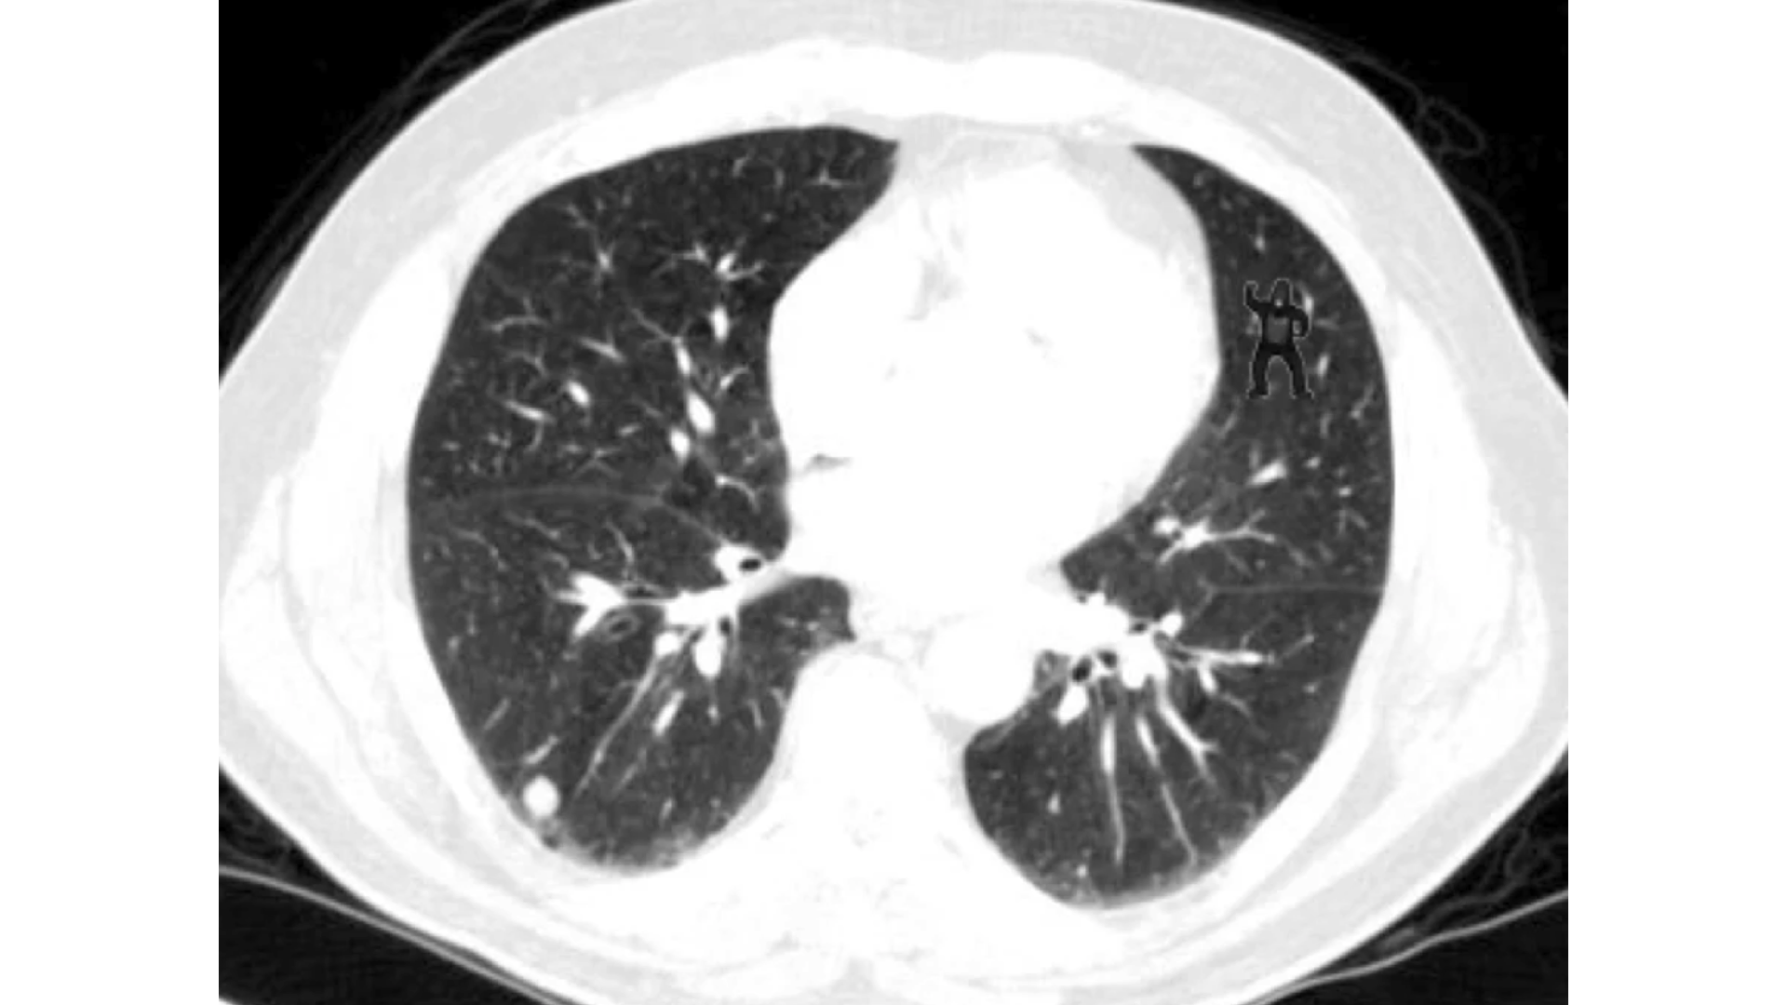

Slide 7
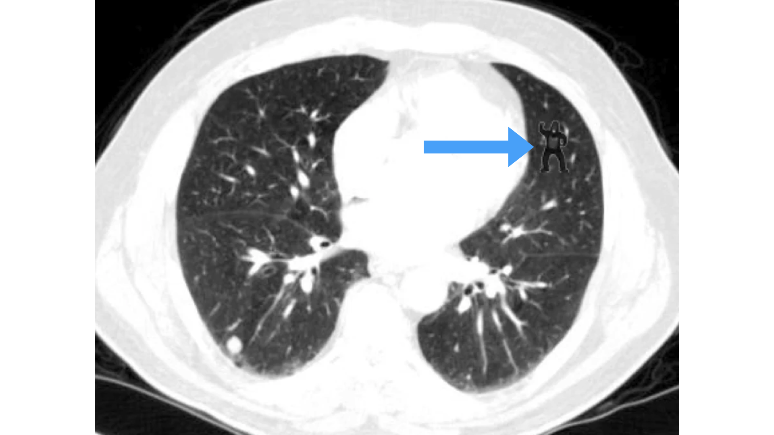

Slide 8


Slide 9

Slide 10
46 And Mary said,
“My soul magnifies the Lord,
47 and my spirit rejoices in God my Savior,
48 for he has looked on the humble estate of his servant.
For behold, from now on all generations will call me blessed;
49 for he who is mighty has done great things for me,
and holy is his name.
50 And his mercy is for those who fear him
from generation to generation.
51 He has shown strength with his arm;
he has scattered the proud in the thoughts of their hearts;
52 he has brought down the mighty from their thrones
and exalted those of humble estate;
53 he has filled the hungry with good things,
and the rich he has sent away empty.
54 He has helped his servant Israel,
in remembrance of his mercy,
55 as he spoke to our fathers,
to Abraham and to his offspring forever.”
56 And Mary remained with her about three months and returned to her home.

Slide 11
“In his Gospel, Luke portrays Mary, the mother of Jesus, as a person who practiced the art of meditation (2:19; 50, 51) ... she kept recalling [these words] and paid careful attention to them over a long period of time so as to clarify her relationship to this strange son of hers.”
—John Kleinig

Slide 12


Slide 13
“In those days Mary arose and went [lit. journeyed] with haste into the hill country, to a town in Judah...” (v. 39)

Slide 14
We must “not relegate Mary’s vision of redemption to some distant future or spiritualize it as though it were not concerned with the social realities of daily existence... The opponents of Jesus, and therefore of God’s purpose, are portrayed as persons who grasp for social respect and positions of honor, who exclude the less fortunate and socially unacceptable from their circles of kinship, who enjoy the power that accompanies their privileged status.”
—Joel Green

Slide 15
Ps 77:2–3; Isa 26:9; Hab 3:18; Ps 24:5; Isa 12:2; Zeph 3:17; Deut 26:7; 1 Sam 9:16; 2 Kgs 14:26; Ps 136:23; Deut 10:17–18; Ps 24:8; Isa 10:20–27; Zeph 3:17; Exod 6:1, 6; 15:16; Deut 3:24; 7:19; 33:27; Pss 78:10; 88:10; 97:1; Isa 26:11; 40:10; 51:9–10; 52:10; 65:12.

Slide 16
“Jesus was providentially placed in a home that took his spiritual growth seriously and used the ordinary means of grace (parental love, spiritual faithfulness, participation in the worshiping community) to foster his spiritual development. He learned the Scriptures and learned... to meditate on them.”
—Jim Wilhoit

Slide 17

PROFESSION OF FAITH
Finally we believe, according to God’s Word, that when the time appointed by the Lord is come (which is unknown to all creatures) and the number of the elect is complete, our Lord Jesus Christ will come from heaven, bodily and visibly, as he ascended, with great glory and majesty, to declare himself the judge of the living and the dead… We look forward to that great day with longing in order to enjoy fully the promises of God in Christ Jesus, our Lord.
—from Belgic Confession, Art. 37

THE LORD’S SUPPER

1 Corinthians 11:23–26
The Lord Jesus, on the night when he was betrayed took bread and when he had given thanks, he broke it and said, “This is my body which is broken for you. Do this in remembrance of me.” In the same way also he took the cup, after supper, saying, “This cup is the new covenant in my blood. Do this as often as you drink it, in remembrance of me."

HYMN

AMEN, AMEN
CCLI Song # 5889747 Kate Robins | Neil Robins
Let every creature rise and bring
Their grateful praises to our King
Angels descend with songs again
And earth repeats a loud amen
Amen amen
Amen amen
I found my life
I found my life in Him
Amen amen
Peace like a river from His throne
Will flow to nations yet unknown
His word a light where all hope is dim
And all tribes unite to cry amen
Amen amen
Amen amen
I found my life
I found my life in Him Amen amen
And in this Child we'll find our rest
And all the meek and lowly blessed
An Infant tongue could sing the hymn
Of hallelujah and amen
Amen amen
Amen amen
I found my life
I found my life in Him
Amen amen

BENEDICTION

LEADER
The Lord, our God, grant you peace; indeed, God has made us rich in all things! Receive the peace of being at rest, that sabbath peace, the peace which knows no end. (Augustine)

HOPE HAPPENINGS

Carol Night
Friday, December 20 at 6:30 p.m. at Nationwide & Ohio Farm Bureau 4-H Center. Join us for Carol Night, an intimate Christmas Carol service filled with the timeless beauty of scripture and traditional Christmas carols. The evening will culminate in a special outdoor candlelit carol, creating a peaceful moment to celebrate the season. After the service, enjoy festive Christmas cookies and warm fellowship. There’s no need to dress up—just come as you are and bring your friends and family.
Please consider bringing christmas cookies or other treats to share as we
extend the welcome of Jesus to friends, family and newcomers that evening!

HOPE YOUTH EPIC RETREAT
JANUARY 24-26, 2025 Register at https://hopechurchcolumbus.churchcenter.com/registrations/events/2631128.

WINTER TRANSPORTATION
As the winter months set in and weather gets colder, it becomes
harder for folks without a vehicle to make it to Sunday morning
worship and other activities.
If you are in need of a ride to a Hope event, please text (614) 526-4194

HOPE WOMEN'S RETREAT WEEKEND
Save the Date! April 4–6, 2025. More Information Coming Soon!

Digital Connect Card
We’re glad you’re here! Let’s stay connected; please fill out the form at the following link: https://hopechurchcolumbus.churchcenter.com/people/forms/281549.

