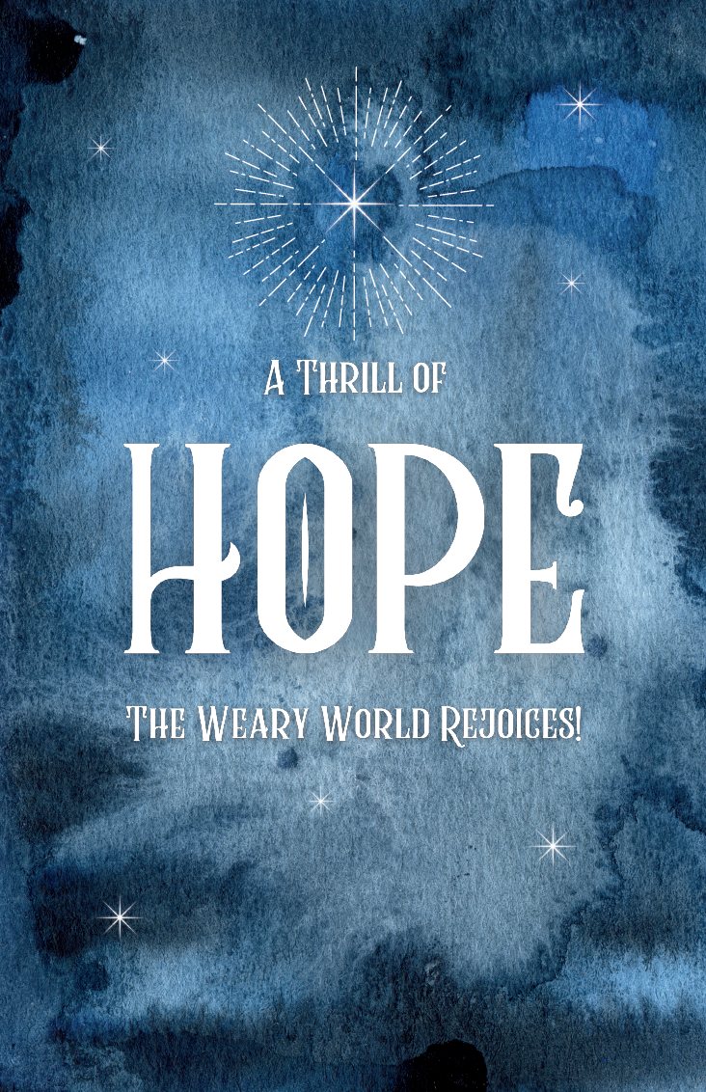

Hope Presbyterian Church Accessible Worship Folder and Slide Deck Transcription
December 22, 2024—Week 4 of Advent
www.hopechurchcolumbus.org
Pastor—Joe Haack—joe@hopechurchcolumbus.org
Youth Pastor—Wes Piehl—wes@hopechurchcolumbus.org
Deacons—deacons@hopechurchcolumbus.org
Operations Manager—Nichole Redinger—operations@hopechurchcolumbus.org


Call to Worship

Leader
A voice cries in the wilderness “Prepare the way of the Lord, make straight in the desert a highway for our God.”

All
Let us prepare to welcome God’s dramatic work in our midst, in our hearts, in our community, and in all of creation. Let us worship God.

DOXOLOGY
Lyrics: Thomas Ken, 1674
Praise God from whom all blessings flow;
Praise him all creatures here below;
Praise him above, ye heavenly host;
Praise Father, Son, and Holy Ghost.
Amen.

HYMN

Angels From the Realms of Glory
Angels from the realms of glory,
wing your flight o'er all the earth;
ye who sang creation's story,
now proclaim Messiah's birth.
Come and worship,
come and worship,
worship Christ the newborn King!
Shepherds in the field abiding,
watching o'er your flocks by night,
God with man is now residing,
yonder shines the infant light;
Come and worship,
come and worship,
worship Christ the newborn King!
Sages, leave your contemplations,
Brighter visions beam afar;
Seek the great desire of nations,
Ye have seen His natal star;
Come and worship,
come and worship,
worship Christ the newborn King!
Saints, before the altar bending,
Watching long in hope and fear;
Suddenly the Lord, descending,
In His temple shall appear.
Come and worship,
come and worship,
worship Christ the newborn King!

Hark the Herald Angels Sing
© Public Domain CCLI Song # 27738 -- CCLI License # 20115471 1
Hark! the herald angels sing,
"Glory to the newborn King!
Peace on earth, and mercy mild,
God and sinners reconciled."
Joyful, all ye nations, rise,
Join the triumph of the skies;
With angelic host proclaim,
"Christ is born in Bethlehem."
Hark! the herald angels sing,
"Glory to the newborn King!
Christ, by highest heaven adored:
Christ, the everlasting Lord;
Late in time behold him come,
Offspring of the favored one
Veiled in flesh, the Godhead see;
Hail, the incarnate Deity:
Pleased, as man, with men to dwell,
Jesus, our Emmanuel!
Hark! the herald angels sing,
"Glory to the newborn King!
Hail! the heaven-born Prince of peace!
Hail! the Son of Righteousness!
Light and life to all he brings,
Risen with healing in his wings
Mild he lays his glory by,
Born that man no more may die:
Born to raise the sons of earth,
Born to give them second birth.
Hark! the herald angels sing,
"Glory to the newborn King!

CONFESSION OF SIN

Leader
From ages past no one has heard, no ear has perceived, no eye has seen any God besides you, who works for those who wait for him. We have all become like one who is unclean, and all our righteous deeds are like a filthy cloth. We all fade like a leaf, and our iniquities, like the wind, take us away from you.

All
Yet, O Lord, you are our Father; and you do not remember our iniquity forever. Restore us, we pray, through the coming of our Lord Jesus, in whom we place our hope and trust. Amen.

HYMN

What Child Is This
© Public Domain CCLI Song # 30983 -- CCLI License # 20115471 1
What Child is this who laid to rest
On Mary's lap is sleeping
Whom angels greet with anthems sweet
While shepherds watch are keeping?
This, this is Christ the King
Whom shepherds guard and angels sing!
Haste, haste to bring Him laud
The Babe the Son of Mary
Why lies He in such mean estate,
Where ox and ass are feeding?
Good Christians, fear, for sinners here
The silent Word is pleading.
Nails, spear shall pierce Him through,
The cross be borne for me, for you.
Hail, hail the Word made flesh,
The Babe, the Son of Mary.
So bring Him incense, gold and myrrh,
Come peasant, king to own Him;
The King of kings salvation brings,
Let loving hearts enthrone Him.
Raise, raise a song on high,
The Virgin sings her lullaby.
Joy, joy for Christ is born,
The Babe, the Son of Mary.

Grace Assurance

Leader
Take comfort in the assurance that even those things that are hidden from memory, or are too deep for our words, are not beyond God’s forgiving love.

All
God, who knows us completely, bestows pardon and peace. Thanks be to God!

HYMN

O Holy Night
© Public Domain CCLI Song # 32015 -- CCLI License # 20115471
O holy night
the stars are brightly shining
It is the night
of our dear Savior’s birth
Long lay the world
in sin and error pining
Till He appeared
and the soul felt its worth
A thrill of hope
the weary world rejoices
For yonder breaks
A new and glorious morn
Fall on your knees
O hear the angel voices
O night divine
O night when Christ was born
O night divine
O night, O night divine
Truly He taught us
to love one another
His law is love
and His gospel is peace
Chains He shall break
For the slave is our brother
And in His Name
All oppression shall cease
Sweet hymns of joy
In grateful chorus raise we
Let all within us
praise His holy Name
Fall on your knees
O hear the angel voices
O night divine
O night when Christ was born
O night divine
O night, O night divine
Christ is the Lord!
Oh Praise His name forever
His power and glory
Evermore proclaim
His power and glory
evermore proclaim
Fall on your knees
O hear the angel voices
O night divine
O night when Christ was born
O night divine
O night, O night divine

TITHES AND OFFERINGS
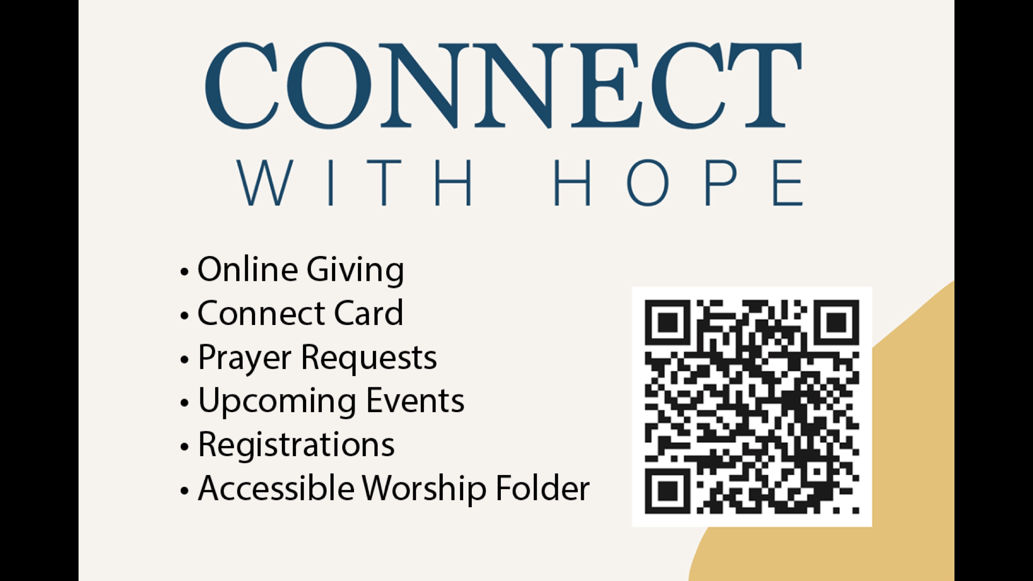

HOPE HAPPENINGS AND ANNOUNCEMENTS

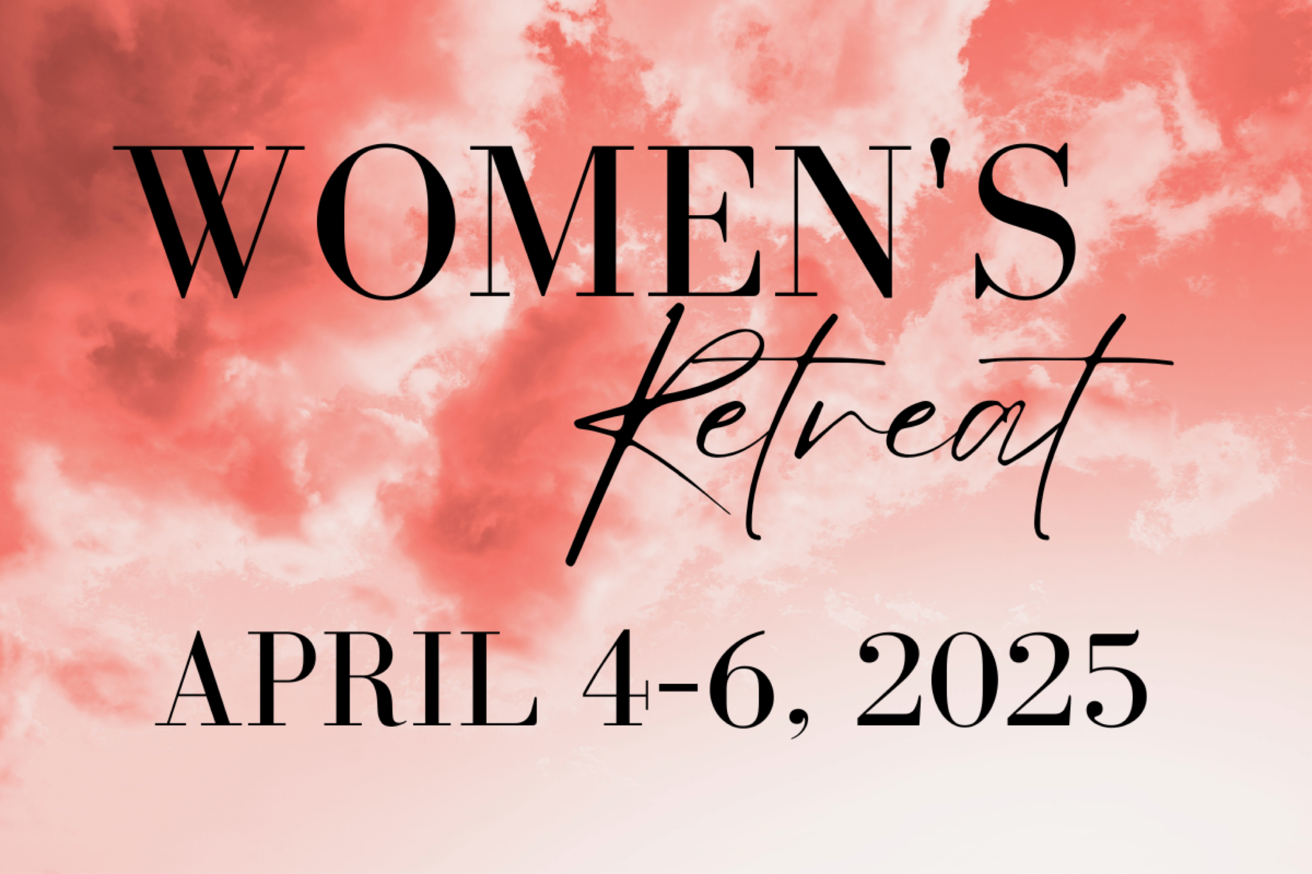

PASSING THE PEACE

SCRIPTURE READING
Luke 1:57–80

SERMON

Slide 1
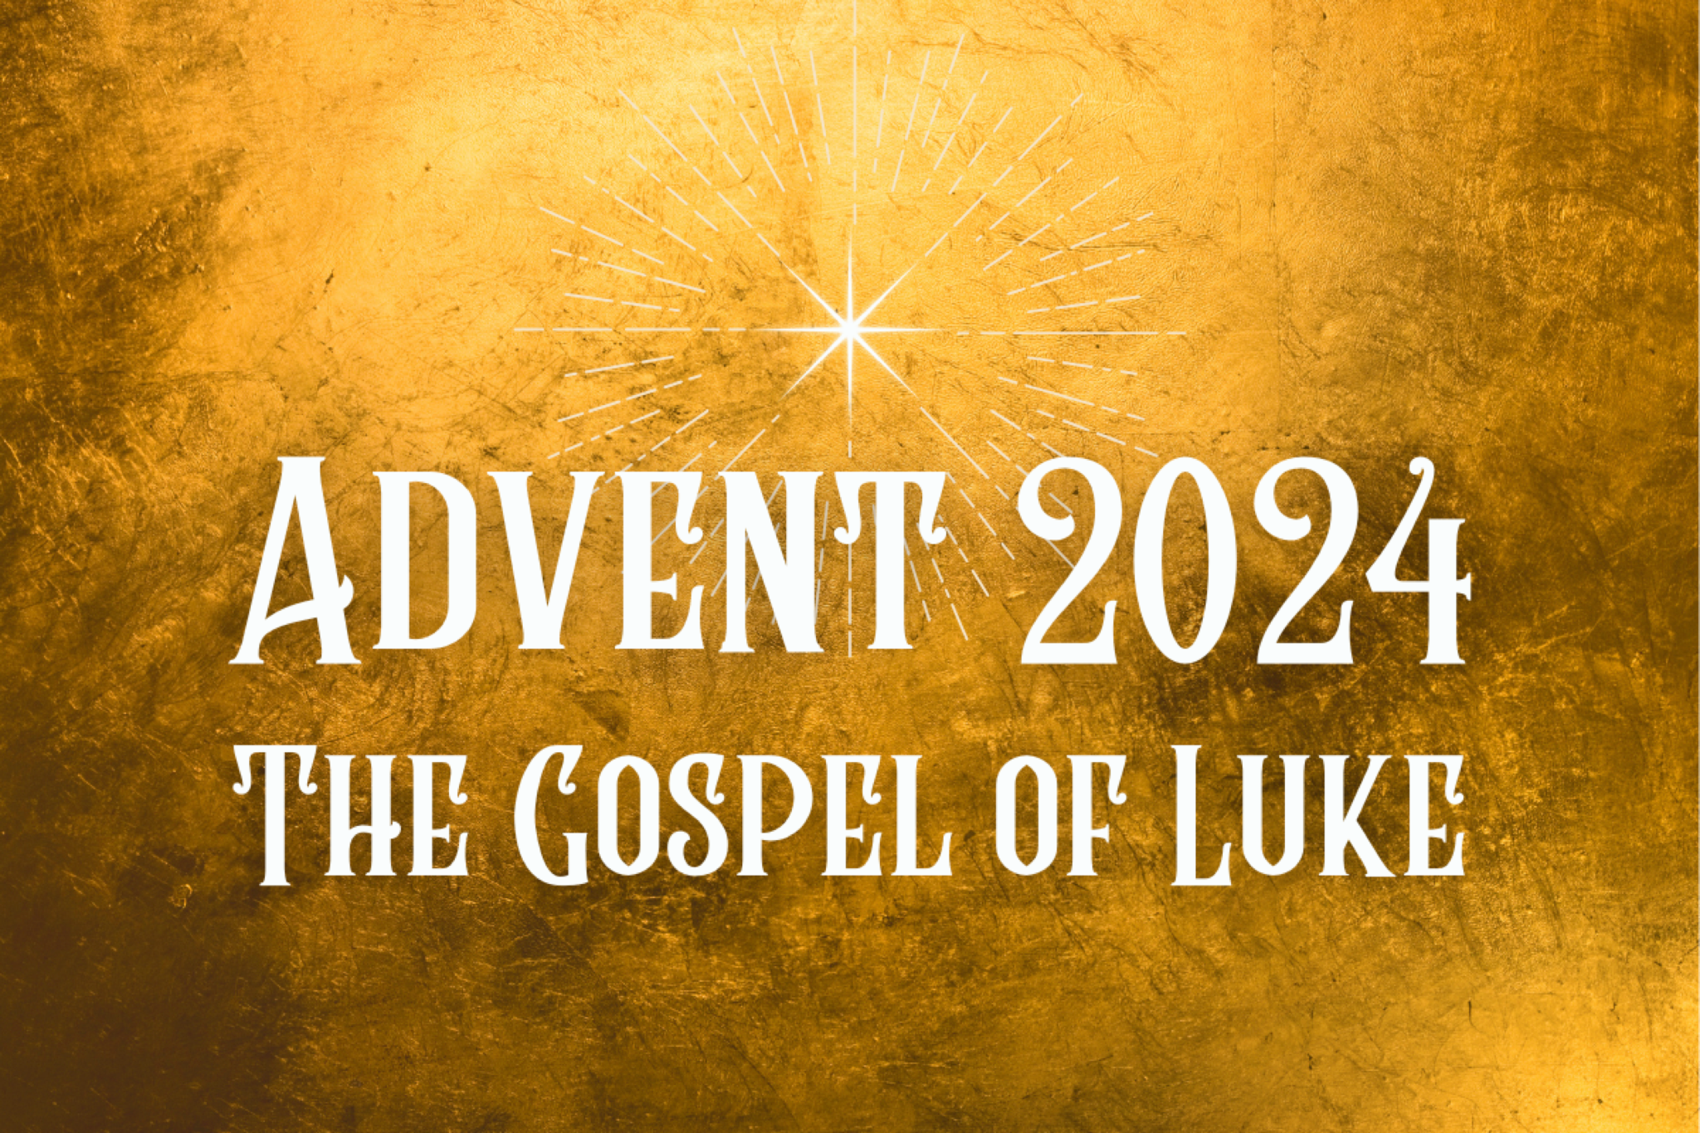

Slide 2
hard pressed on every side, but not crushed; perplexed, but not in despair;
persecuted, but not abandoned;
struck down, but not destroyed.
—2 Corinthians 4:8-9

Slide 3
Reverent Curiosity

Slide 4
57 When it was time for Elizabeth to have her baby, she gave birth to a son. 58 Her neighbors and relatives heard that the Lord had shown her great mercy, and they shared her joy.
59 On the eighth day they came to circumcise the child, and they were going to name him after his father Zechariah, 60 but his mother spoke up and said, “No! He is to be called John.”
61 They said to her, “There is no one among your relatives who has that name.”
62 Then they made signs to his father, to find out what he would like to name the child. 63 He asked for a writing tablet, and to everyone’s astonishment he wrote, “His name is John.” 64 Immediately his mouth was opened and his tongue set free, and he began to speak, praising God.
65 All the neighbors were filled with awe, and throughout the hill country of Judea people were talking about all these things. 66 Everyone who heard this wondered about it, asking, “What then is this child going to be?” For the Lord’s hand was with him.
65 All the neighbors were filled with awe, and throughout the hill country of Judea people were talking about all these things. 66 Everyone who heard this wondered about it, asking, “What then is this child going to be?” For the Lord’s hand was with him.

Slide 5
God moves in a mysterious way, His wonders to perform;
He plants his footsteps in the sea, And rides upon the storm.
Deep in unfathomable mines Of never failing skill;
He treasures up his bright designs, And works His sovereign will.
Ye fearful saints fresh courage take, The clouds ye so much dread
Are big with mercy, and shall break In blessings on your head.
Judge not the Lord by feeble sense, But trust him for his grace;
Behind a frowning providence, He hides a smiling face.
His purposes will ripen fast, Unfolding ev'ry hour;
The bud may have a bitter taste, But sweet will be the flow'r.
Blind unbelief is sure to err, And scan his work in vain;
God is his own interpreter, And he will make it plain.

Slide 6
Spiritual Growth

And the child grew and became strong in Spirit; and he lived in the wilderness until he appeared publicly to Israel (1:80).

Slide 7
Spiritual Renewal

Slide 8
67 And his father Zechariah was filled with the Holy Spirit and prophesied, saying,
68 “Blessed be the Lord God of Israel, for he has visited and redeemed his people
69 and has raised up a horn of salvation for us in the house of his servant David,
70 as he spoke by the mouth of his holy prophets from of old,
71 that we should be saved from our enemies
and from the hand of all who hate us;
72 to show the mercy promised to our fathers
and to remember his holy covenant,
73 the oath that he swore to our father Abraham, to grant us
74 that we,being delivered from hand of our enemies, might serve him without fear,
75 in holiness and righteousness before him all our days.
76 And you, child, will be called the prophet of the Most High; for you will go before the Lord to prepare his ways,
77 to give knowledge of salvation to his people in the forgiveness of their sins,
78 because of the tender mercy of our God, whereby the sunrise shall visit us from on high
79 to give light to those who sit in darkness and in the shadow of death, to guide our feet into the way of peace.”

Slide 9
v. 72—“to show the mercy promised to our fathers...”
v. 78—“because of the tender mercy of our God...”

Slide 10

PROFESSION OF FAITH
Finally we believe, according to God’s Word, that when the time appointed by the Lord is come (which is unknown to all creatures) and the number of the elect is complete, our Lord Jesus Christ will come from heaven, bodily and visibly, as he ascended, with great glory and majesty, to declare himself the judge of the living and the dead… We look forward to that great day with longing in order to enjoy fully the promises of God in Christ Jesus, our Lord.
—from Belgic Confession, Art. 37

THE LORD’S SUPPER

1 Corinthians 11:23–26
The Lord Jesus, on the night when he was betrayed took bread and when he had given thanks, he broke it and said, “This is my body which is broken for you. Do this in remembrance of me.” In the same way also he took the cup, after supper, saying, “This cup is the new covenant in my blood. Do this as often as you drink it, in remembrance of me."

HYMN

All Things New
Come Lord, and tarry not
Bring the long-looked-for day
O why these years of waiting here
These ages of decay
Come, for Thy saints still wait
Daily ascends their sigh
The Spirit and the Bride say, “Come”
Dost Thou not hear the cry
Oh Come and make all things new
Come, and make all things new
Build up this ruined earth
Come and make all things new
Come, for creation groans
Impatient of Thy stay
Worn out with these long years of ill
These ages of delay
Come, for love waxes cold
Its steps are faint and slow
Faith now is lost in unbelief
Hope’s lamp burns dim and low
Oh Come and make all things new
Come, and make all things new
Build up this ruined earth
Come and make all things new
Oh Come and make all things new
Come, and make all things new
Build up this ruined earth
Come and make all things new
All things new
All things new

BENEDICTION

LEADER
Let the beloved of the Lord rest secure in Him, Let Him shield them all day long, Let the one the Lord loves rest between His shoulders. That you might be steadfast, immovable and knowing that your toil in the Lord is not in vain, today and forevermore.

HOPE HAPPENINGS

HOPE YOUTH EPIC RETREAT
JANUARY 24-26, 2025 Register at https://hopechurchcolumbus.churchcenter.com/registrations/events/2631128.

WINTER TRANSPORTATION
As the winter months set in and weather gets colder, it becomes
harder for folks without a vehicle to make it to Sunday morning
worship and other activities.
If you are in need of a ride to a Hope event, please text (614) 526-4194

HOPE WOMEN'S RETREAT WEEKEND
Save the Date! April 4–6, 2025. More Information Coming Soon!

Digital Connect Card
We’re glad you’re here! Let’s stay connected; please fill out the form at the following link: https://hopechurchcolumbus.churchcenter.com/people/forms/281549.

