

Hope Presbyterian Church Accessible Worship Folder and Slide Deck Transcription
December 8, 2024—Week 2 of Advent
www.hopechurchcolumbus.org
Pastor—Joe Haack—joe@hopechurchcolumbus.org
Youth Pastor—Wes Piehl—wes@hopechurchcolumbus.org
Deacons—deacons@hopechurchcolumbus.org
Operations Manager—Nichole Redinger—operations@hopechurchcolumbus.org


Prayer of Preparation

ALL
Hear how the antidote was administered to the flesh: the Word of God became flesh, put his hand into the serpent’s den, removed the venom and took away sin.—Ambrose

Call to Worship

Leader
There shall come forth a shoot from the stump of Jesse, and a branch from his roots shall bear fruit. And the Spirit of the LORD shall rest upon him, the Spirit of wisdom and understanding, the Spirit of counsel and might, the Spirit of knowledge and the fear of the LORD. And his delight shall be in the fear of the LORD. He shall not judge by what his eyes see, or decide disputes by what his ears hear, but with righteousness he shall judge the poor, and decide with equity for the meek of the earth; and he shall strike the earth with the rod of his mouth, and with the breath of his lips he shall kill the wicked. Righteousness shall be the belt of his waist, and faithfulness the belt of his loins.

All
The wolf shall dwell with the lamb, and the leopard shall lie down with the young goat, and the calf and the lion and the fattened calf together; and a little child shall lead them. The cow and the bear shall graze; their young shall lie down together; and the lion shall eat straw like the ox. The nursing child shall play over the hole of the cobra, and the weaned child shall put his hand on the adder’s den. They shall not hurt or destroy in all my holy mountain; for the earth shall be full of the knowledge of the LORD as the waters cover the sea.

Leader
In that day the root of Jesse, who shall stand as a signal for the peoples—
of him shall the nations inquire, and his resting place shall be glorious.
—from Is. 11:1–10, ESV

DOXOLOGY
Lyrics: Thomas Ken, 1674
Praise God from whom all blessings flow;
Praise him all creatures here below;
Praise him above, ye heavenly host;
Praise Father, Son, and Holy Ghost.
Amen.

Prayer of Invocation

Leader
Blessed are you, LORD, the God of Israel, who alone does wondrous things. Blessed be your glorious name forever; may the whole earth be filled with your glory! Amen and Amen!
—based on Ps. 72:18–19

HYMNS

MY SOUL MAGNIFIES THE LORD
CCLI Song # 5601671 Chris Tomlin | Daniel Carson
Good news of great joy
For ev'ry woman ev'ry man
This will be a sign to you
A baby born in Bethlehem
Come and worship do not be afraid
A company of angels
Glory in the highest
And on the earth a peace among
Those on whom His favor rests
Come and worship do not be afraid
My soul my soul magnifies the Lord
My soul magnifies the Lord
He has done great things for me
Great things for me
Unto you a child is born
Unto us a Son is giv'n
Let ev'ry heart prepare His throne
Let ev'ry nation under Heav'n
Come and worship do not be afraid
My soul my soul magnifies the Lord
My soul magnifies the Lord
He has done great things for me
Great things for me
Of His government there will be no end
He'll establish it with His righteousness
And He shall reign on David's throne
And His name shall be from this day on
Wonderful Counselor
Everlasting Father
Wonderful Counselor and His name shall be
Everlasting Father oh yeah
My soul my soul magnifies the Lord
He has done great things for us
Oh yeah
He has done great things
He has done great things
My soul my soul magnifies the Lord
My soul magnifies the Lord
He has done great things for me
Great things for me

Spring Up O Well
© 2021 Advent Birmingham
I’ve been drinking from the rivers that could never stop my thirst
O, Living Water, come
I’ve been seeking satisfaction with no answer to my search
O, Living Water, come
Spring up, O well, within my soul
Spring up, O well, within my soul
‘Cause I have drunk from other cisterns
That could never make me whole
Spring up, O well, within my soul
I’ve been wandering in the desert where the riverbeds are dry
O, Living Water, come
I’ve been looking for the sources for my ever-thirsting cry
O, Living Water, come
Spring up, O well, within my soul
Spring up, O well, within my soul
‘Cause I have drunk from other cisterns
That could never make me whole
Spring up, O well, within my soul
Give me this water
Give me this water
So I will never thirst
Give me this water
Give me this water
So I will never thirst
I am marching to Jerusalem, Its streams are in my sights
O, Living Water, come
There its fountains flow from Calvary’s hill
And burst in crimson life
O, Living Water, come
Spring up, O well, within my soul
Spring up, O well, within my soul
‘Cause I have drunk from other cisterns
That could never make me whole
Spring up, O well, within my soul
I have drunk from other cisterns
That could never make me whole
Spring up, O well, within my soul
Spring up, O well, within my soul

CONFESSION OF SIN

Leader
It is Advent. It is the season in which we prepare our hearts to welcome Christ, who is the bringer of all peace.

All
We confess to you the ways in which we block the peace of Christ in our lives. God of peace, hear our prayer. The rushing and scurrying to get things done, we confess to you, O God of peace. The worry about the little details, we confess to you, O God of peace. The financial burdens we put on ourselves, we confess to you, O God of peace. The impatience and irritability we feel and take out on one another, we confess to you, O God of peace. The bickering and quarreling we get into because we are too busy, we confess to you, O God of peace. Though we make ourselves less than peaceful at this time of the year, your peace is always there for us.

Leader
Instill within us your peace, O God. When we feel overwhelmed, instill within us your peace, O God. When we are filled with worry, instill within us your peace, O God. When we become irritable, instill within us your peace, O God. Fill us with your peace so that we may spread Christ’s peace and love to others. Amen.

HYMN

O COME O COME EMMANUEL
CCLI Song # 31982 John Mason Neale | Thomas Helmore
O come O come Emmanuel
And ransom captive Israel
That mourns in lonely exile here
Until the Son of God appear
Rejoice, rejoice Emmanuel
Shall come to thee O, Israel
O, come Thou Dayspring come
And cheer our spirits by Thine advent here
Disperse the gloomy clouds of night
And death's dark shadows put to flight
Rejoice, rejoice Emmanuel
Shall come to thee O, Israel
O, come Thou Wisdom from on high
And order all things far and nigh
To us the path of knowledge show
And cause us in her ways to go
Rejoice, rejoice Emmanuel
Shall come to thee O, Israel
O, come Desire of nations bind
All peoples in one heart and mind
Bid envy strife and quarrels cease
Fill the whole world with heaven's peace
Rejoice, rejoice Emmanuel
Shall come to thee O, Israel

Grace Assurance

LEADER
For whatever was written in former days was written for our instruction,
that through endurance and through the encouragement of the Scriptures we might have hope. May the God of hope fill you with all joy and peace in believing, so that by the power of the Holy Spirit you may abound in hope.
—from Rom. 15: 4, 13

HYMN

COME THOU FOUNT OF EVERY BLESSING
CCLI Song # 108389 John Wyeth | Robert Robinson
Come Thou fount of ev'ry blessing
Tune my heart to sing Thy grace
Streams of mercy never ceasing
Call for songs of loudest praise
Teach me some melodious sonnet
Sung by flaming tongues above
Praise the mount I'm fixed upon it
Mount of Thy redeeming love
Here I raise mine Ebenezer
Hither by Thy help I'm come
And I hope by Thy good pleasure
Safely to arrive at home
Jesus sought me when a stranger
Wand'ring from the fold of God
He to rescue me from danger
Interposed His precious blood
O to grace how great a debtor
Daily I'm constrained to be
Let Thy grace Lord like a fetter
Bind my wand'ring heart to Thee
Prone to wander Lord I feel it
Prone to leave the God I love
Here's my heart Lord take and seal it
Seal it for Thy courts above

TITHES AND OFFERINGS


HOPE HAPPENINGS AND ANNOUNCEMENTS
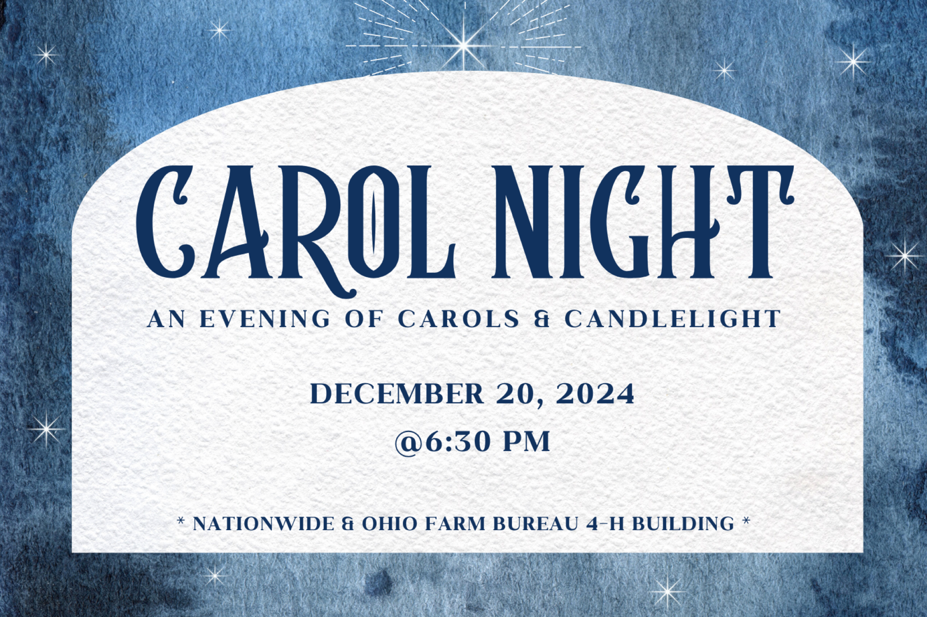


PASSING THE PEACE

SCRIPTURE READING
Luke 1:5–38

MESSAGE

Slide 1


Slide 2
“And the people were waiting for Zechariah, and they were wondering at his delay in the temple” (1:21).

Slide 3
“waiting for the consolation of Israel” (2:25).

Slide 4
14 And you will have joy and gladness, and many will rejoice at his birth, 15 for he will be great before the Lord. And he must not drink wine or strong drink, and he will be filled with the Holy Spirit, even from his mother’s womb. 16 And he will turn many of the children of Israel to the Lord their God, 17 and he will go before him in the spirit and power of Elijah, to turn the hearts of the fathers to the children, and the disobedient to the wisdom of the just, to make ready for the Lord a people prepared” (Lk 1:14–17).

Slide 5
32 He will be great and will be called the Son of the Most High. And the Lord God will give to him the throne of his father David, 33 and he will reign over the house of Jacob forever, and of his kingdom there will be no end” (Lk 1:31– 33).

Slide 6
1/ Waiting on Jesus involves faithful curiosity.
2/ Waiting on Jesus invites prayerful attention.
3/ Waiting on Jesus increases resilient joy.

Slide 7
1/ Waiting on Jesus involves faithful curiosity.

Slide 8
1/ Waiting on Jesus involves faithful curiosity.

Luke 1:11–20 | Luke 1:28–38
“he was troubled” (v 12) | “she was much troubled (v 28)
“the angel said to him” (v 13) | “the angel said to her” (v 30)
“Do not be afraid” (v 13) | “Do not be afraid” (v 30)
“will bear you a son” (v 13) | “you will … bear a son” (v 31)
“and you will name him” (v 13) | “and you will name him” (v 31)
“he will be great” (v 15) | “he will be great” (v 32)
“said to the angel” (v 18) | “said to the angel” (v 34)
“and replying, the angel | “and replying, the angel
said to him” (v 19) | said to her” (v 35)
“Gabriel … God … sent” (v 19) | “Gabriel … sent … God” (v 26)
“and now” (v 20) | “and now” (v 36)

Slide 9
1/ Waiting on Jesus involves faithful curiosity.
“And Zechariah said to the angel, “How shall I know this? For I am an old man, and my wife is advanced in years” (18).

Slide 10
1/ Waiting on Jesus involves faithful curiosity.
“And Zechariah said to the angel, “How shall I know this? For I am an old man, and my wife is advanced in years” (18).

Slide 11
“...you will be silent and unable to speak until the day that these things take place, because you did not believe my words, which will be fulfilled in their time” (20).

Slide 12
1/ Waiting on Jesus involves faithful curiosity.
“How will this be, since I am a virgin?” (34)

Slide 13

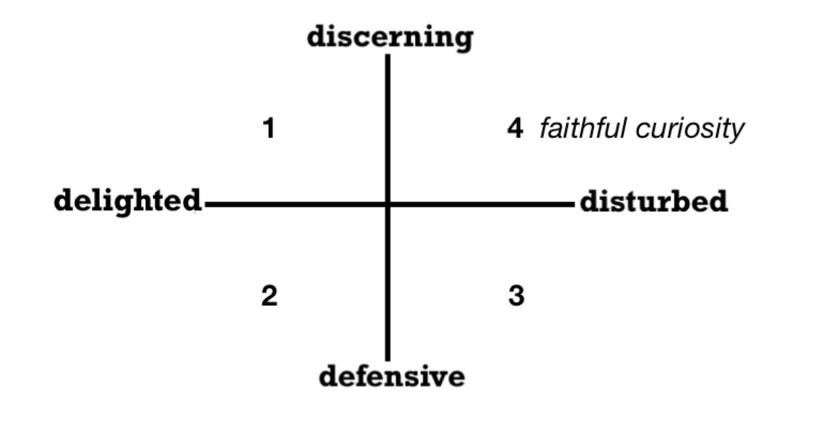

Slide 14
2/ Waiting on Jesus invites prayerful attention.

Slide 15
2/ Waiting on Jesus invites prayerful attention.
“This assertion and the story that follows are not surprising to anyone who knows the history of Israel. That history begins with the barrenness of the elderly Sarah, which seemed to contradict the promise made to Abraham.” —Justo Gonzalez

Slide 16
2/ Waiting on Jesus invites prayerful attention.
Sarah gives unexpected birth to Isaac
Rebekah gives unexpected birth Jacob and Esau Rachel gives unexpected birth to Joseph and Benjamin Manoah’s wife gives unexpected birth to Samson Hannah gives unexpected birth to Samuel.

Slide 17
2/ Waiting on Jesus invites prayerful attention.
“For the word of God will never fail” (37)

Slide 18
3/ Waiting on Jesus increases resilient joy.

Slide 19
3/ Waiting on Jesus increases resilient joy.
v. 14 — You will have great joy and gladness, and many will rejoice at his birth
v. 28 — Rejoice! favored woman! The Lord is with you!

Slide 20
3/ Waiting on Jesus increases resilient joy.
“Imagine the gossips and side glances between neighbors, the pretense of cordial interaction, and the ostracism so poorly disguised. Imagine the shame that Zechariah and Elizabeth have to endure decade after decade.” —D. Chen

Slide 21
3/ Waiting on Jesus increases resilient joy.
17 Even though the fig trees have no blossoms, and there are no grapes on the vines;
even though the olive crop fails,
and the fields lie empty and barren;
even though the flocks die in the fields, and the cattle barns are empty,
18 yet I will rejoice in the Lord!
I will be joyful in the God of my salvation! 19 The Sovereign Lord is my strength!
He makes me as surefooted as a deer,
able to tread upon the heights. (Habakkuk 3)

Slide 22
3/ Waiting on Jesus increases resilient joy.
“Rejoiced, favored woman! The Lord is with you!” (1:28).

Slide 23
1/ Waiting on Jesus involves faithful curiosity.
2/ Waiting on Jesus invites prayerful attention.
3/ Waiting on Jesus increases resilient joy.

Slide 24

PROFESSION OF FAITH
We believe that Jesus Christ, according to his divine nature,
is the only Son of God—eternally begotten, not made or created, for then he would be a creature. He is one in essence with the Father; coeternal; the exact image of the person of the Father and the “reflection of God’s glory,” so then, he is the true eternal God, the Almighty, whom we invoke, worship, and serve.
—from Belgic Confession, Art. 10

THE LORD’S SUPPER

1 Corinthians 11:23–26
The Lord Jesus, on the night when he was betrayed took bread and when he had given thanks, he broke it and said, “This is my body which is broken for you. Do this in remembrance of me.” In the same way also he took the cup, after supper, saying, “This cup is the new covenant in my blood. Do this as often as you drink it, in remembrance of me."

HYMN

TAKE IT EASY
CCLI Song # 7221927 Isaac Wardell | Kate Bluett | Matt Maher | Paul Zach
Take it easy easy
God already loves you completely
Take it easy easy
Rest in the shade of His wings
Lay down your burdens and rest for a while
The Shepherd who seeks you is gentle and kind
There’s nothing to pay for and nothing to earn
And nothing you have to become
Take it easy easy
God already loves you completely
Take it easy easy
Rest in the shade of His wings
Lay down the scales where you weigh out your life
The measures are empty just leave them behind
The distance between His two hands are enough
To tell you the depths of His love
Take it easy easy
God already loves you completely
Take it easy easy
Rest in the shade of His wings
Lay down the armor you brought to the fight
Lay down your weapons and lay down your strife
God’s on your side and He won’t let you go
He already loves who you are
Won’t ask you to be something more
Take it easy easy
God already loves you completely
Take it easy easy
Rest in the shade of His wings

BENEDICTION

LEADER
May God who is everywhere present, filling yet transcending all things; ever acting, yet ever at rest; teach you, the faithful, without the noise of words, guiding you by the Holy Spirit, through Jesus Christ our Lord. Amen.

HOPE HAPPENINGS
HOPE YOUTH CHRISTMAS PARTY
Sunday, December 8th, 6:30–8:00 PM at the Piehl home, 5364 Amy Lane, 43235. We’ll have holidays snacks and desserts, special games, music, and—of course—a White Elephant gift exchange. Contact Wes at wes@hopechurchcolumbus.org

Carol Night
Friday, December 20 at 6:30 p.m. at Nationwide & Ohio Farm Bureau 4-H Center. Join us for Carol Night, an intimate Christmas Carol service filled with the timeless beauty of scripture and traditional Christmas carols. The evening will culminate in a special outdoor candlelit carol, creating a peaceful moment to celebrate the season. After the service, enjoy festive Christmas cookies and warm fellowship. There’s no need to dress up—just come as you are and bring your friends and family.
Please consider bringing christmas cookies or other treats to share as we
extend the welcome of Jesus to friends, family and newcomers that evening!

HOPE KIDS TEACHERS NEEDED
The Hope Kids team is in need of two Elementary teachers and one Preschool teacher. Teachers typically serve once a month. Please consider helping out in this way. Contact Wes for more information at wes@hopechurchcolumbus.org.

HOPE WOMEN'S RETREAT WEEKEND
Save the Date! April 4–6, 2025. More Information Coming Soon!

Digital Connect Card
We’re glad you’re here! Let’s stay connected; please fill out the form at the following link: https://hopechurchcolumbus.churchcenter.com/people/forms/281549.

