

# Hope Presbyterian Church Accessible Worship Folder and Slide Deck Transcription

**February 2, 2025**

[www.hopechurchcolumbus.org](http://www.hopechurchcolumbus.org)

Pastor—Joe Haack—[joe@hopechurchcolumbus.org](mailto:joe@hopechurchcolumbus.org)

Youth Pastor—Wes Piehl—[wes@hopechurchcolumbus.org](mailto:wes@hopechurchcolumbus.org)

Deacons—[deacons@hopechurchcolumbus.org](mailto:deacons@hopechurchcolumbus.org)

Operations Manager—Nichole Redinger—[operations@hopechurchcolumbus.org](mailto:operations@hopechurchcolumbus.org)



## CALL TO WORSHIP

Matthew 12:28–30; Psalm 62:5–6

### LEADER

Jesus says to you: “Come to me, all who labor and are

heavy laden, and I will give you rest. Take my yoke upon

you, and learn from me, for I am gentle and lowly in heart,

and you will find rest for your souls. For my yoke is easy,

and my burden is light.”

### ALL

Yes, my soul, find rest in God; my hope comes from

him. Truly he is my rock and my salvation; he is my

fortress, I will not be shaken.



## DOXOLOGY

Lyrics: Thomas Ken, 1674

Praise God from whom all blessings flow;

Praise him all creatures here below;

Praise him above, ye heavenly host;

Praise Father, Son, and Holy Ghost.

Amen.



## HYMNS

### O Come To The Altar

CCLI Song # 7051511

Chris Brown | Mack Brock | Steven Furtick | Wade Joye ©

Are you hurting and broken within?

Overwhelmed by the weight of your sin?

Jesus is calling

Have you come to the end of yourself?

Do you thirst for a drink from the well?

Jesus is calling

O come to the altar

The Father's arms are open wide

Forgiveness was bought with

The precious blood of Jesus Christ

Leave behind your regrets and mistakes

Come today, there's no reason to wait

Jesus is calling

Bring your sorrows and trade them for joy

From the ashes a new life is born

Jesus is calling

O come to the altar

The Father's arms are open wide

Forgiveness was bought with

The precious blood of Jesus Christ

O come to the altar

The Father's arms are open wide

Forgiveness was bought with

The precious blood of Jesus Christ

Oh what a Savior

Isn't He wonderful

Sing Alleluia!

Christ is risen

Bow down before Him

For He is Lord of all

Sing Alleluia!

Christ is risen

Oh what a Savior

Isn't He wonderful

Sing Alleluia!

Christ is risen

Bow down before Him

For He is Lord of all

Sing Alleluia!

Christ is risen

O come to the altar

The Father's arms are open wide

Forgiveness was bought with

The precious blood of Jesus Christ

Bear your cross as you wait for the crown

Tell the world of the treasure you've found

### ALL CREATURES OF OUR GOD AND KING

CCLI Song # 3608102 | Brent Milligan | David Crowder | St. Francis of Assisi | William Henry Draper

All creatures of our God and king

Lift up your voice and with us sing

O praise Him!

Alleluia!

Thou burning sun

With golden beam

Thou silver moon

With softer gleam

O praise Him!

O praise Him!

Alleluia! Alleluia!

Alleluia!

Thou rushing wind that art so strong

Ye clouds that sail in Heav'n along

O praise Him!

Alleluia!

Thou rising moon in praise rejoice

Ye lights of evening find a voice

O praise Him!

O praise Him!

Alleluia! Alleluia!

Alleluia!

Let all things their creator bless

And worship Him in humbleness

O praise Him!

Alleluia!

Praise, praise the Father

Praise the Son

And praise the Spirit

Three in one

O praise Him!

O praise Him!

Alleluia! Alleluia!

Alleluia!

### ALL CREATURES OF OUR GOD AND KING

CCLI Song # 3608102 | Brent Milligan | David Crowder | St. Francis of Assisi | William Henry Draper

All creatures of our God and king

Lift up your voice and with us sing

O praise Him!

Alleluia!

Thou burning sun

With golden beam

Thou silver moon

With softer gleam

O praise Him!

O praise Him!

Alleluia! Alleluia!

Alleluia!

Thou rushing wind that art so strong

Ye clouds that sail in Heav'n along

O praise Him!

Alleluia!

Thou rising moon in praise rejoice

Ye lights of evening find a voice

O praise Him!

O praise Him!

Alleluia! Alleluia!

Alleluia!

Let all things their creator bless

And worship Him in humbleness

O praise Him!

Alleluia!

Praise, praise the Father

Praise the Son

And praise the Spirit

Three in one

O praise Him!

O praise Him!

Alleluia! Alleluia!

Alleluia!



## CONFESSION OF SIN

Book of Common Prayer

### ALL

Most merciful God,

we confess that we have sinned

against you in thought, word, and deed,

by what we have done,

and by what we have left undone.

We have not loved you with our whole heart;

we have not loved our neighbors as ourselves.

We are truly sorry and we humbly repent,

for the sake of your Son Jesus Christ,

have mercy on us and forgive us;

that we may delight in your will,

and walk in your ways,

to the glory of your Name.

Amen.



## HYMN

### IN FEAST OR FALLOW

CCLI Song # 5759901 Sandra McCracken © 2010 Drink Your Tea Music CCLI License # 20115471

When the fields are dry

and the winter is long

Blessed are the meek,

the hungry, the poor

When my soul is downcast

and my voice has no song

For mercy, for comfort

I wait on the Lord

In the harvest, feast,

or the fallow ground

My certain hope is in Jesus found

My lot, my cup, my portion sure

Whatever comes we shall endure

Whatever comes we shall endure

On a cross of wood

His blood was outpoured

He rose from the ground

like a bird to the sky

Bringing peace to our violence

And crushing death's door

Our Maker incarnate

Our God who provides

In the harvest, feast,

or the fallow ground

My certain hope is in Jesus found

My lot, my cup, my portion sure

Whatever comes we shall endure

Whatever comes we shall endure

Come, oh come

Emmanuel

Come, oh come

Emmanuel

Come, oh come

Emmanuel

Come, oh come

Emmanuel

When the earth beneath me

crumbles and quakes

Not a sparrow falls

nor a hair from my head

Without His hand to guide me

My shield, and my strength

In joy or in sorrow in life or in death

In the harvest, feast,

or the fallow ground

My certain hope is in Jesus found

My lot, my cup, my portion sure

Whatever comes we shall endure

Whatever comes we shall endure

In the harvest, feast,

or the fallow ground

My certain hope is in Jesus found

My lot, my cup, my portion sure

Whatever comes we shall endure

Whatever comes we shall endure

## GRACE ASSURANCE

Ephesians 1:5-7 (NLT)

### LEADER

God decided in advance

to adopt us into his own family

by bringing us to himself through Jesus Christ.

This is what he wanted to do,

and it gave him great pleasure.

### ALL

So we praise God for the glorious grace

he has poured out on us

who belong to his dear Son.

He is so rich in kindness and grace

that he purchased our freedom

with the blood of his Son

and forgave our sins.



## HYMN

### I SHALL NOT WANT

CCLI # 7004369 | Audrey Assad

From the love of my own comfort

From the fear of having nothing

From a life of worldly passions

Deliver me, O God

From the need to be understood

From the need to be accepted

From the fear of being lonely

Deliver me, O God

Deliver me, O God

And I shall not want

No, I shall not want

When I taste your goodness,

I shall not want

When I taste your goodness,

I shall not want

From the fear of serving others

And from the fear of death or trial

And from the fear of humility

Deliver me, O God

Yes, deliver me, O God

And I shall not want

No, I shall not want

When I taste your goodness

I shall not want

No, I shall not want

No, I shall not want

When I taste your goodness

I shall not want

When I taste your goodness

I shall not want

I shall not want

I shall not want

## TITHES AND OFFERINGS



## HOPE HAPPENINGS AND ANNOUNCEMENTS

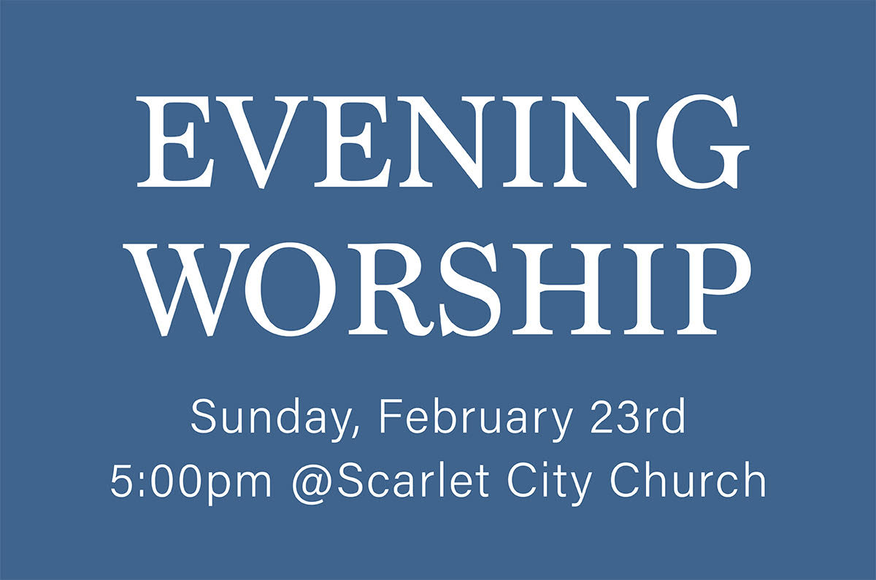

## Blueprint: A Hope Youth Journey Through The Sermon on the Mount. Starting Sunday, February 2, 6:30-8:00 at The Piehl Home.Hope Youth Super Bowl Party! Sunday, February 9, 6:30 - End of Game at The Piehl HomePASSING THE PEACE

## SCRIPTURE READING

Luke 3:1–20

## MESSAGE

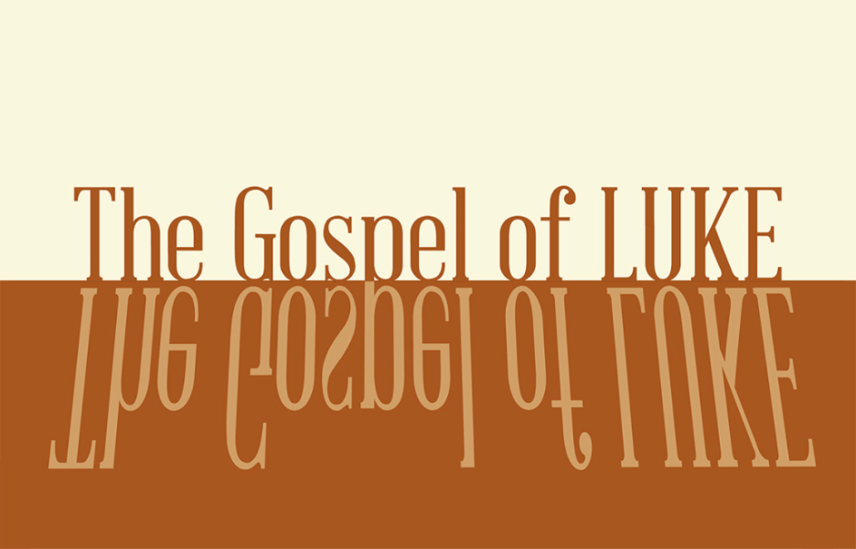

### Slide 1

21 When all the people were being baptized, Jesus was baptized too. And as he was praying, heaven was opened 22 and the Holy Spirit descended on him in bodily form like a dove. And a voice came from heaven: “You are my Son, whom I love; with you I am well pleased” (Luke 3:21–22).

### Slide 2

beloved at the beginning

### Slide 3

21 When all the people were being baptized, Jesus was baptized too. And as he was praying, heaven was opened 22 and the Holy Spirit descended on him in bodily form like a dove. And a voice came from heaven: “You are my Son, whom I love; with you I am well pleased” (Luke 3:21–22).

### Slide 4

But when the fullness of time had come, God sent forth his Son, born of woman, born under the law, 5 to redeem those who were under the law, so that we might receive adoption as sons. 6 And because you are sons, God has sent the Spirit of his Son into our hearts, crying, “Abba! Father!” 7 So you are no longer a slave, but a son, and if a son, then an heir through God.” (Ga 4:4–7).

### Slide 5

“We are not merely adopted; we are so united to Christ that his Sonship is now ours. We share in the Son’s relationship with the Father” (Coe & Strobel).

### Slide 6

“As Christians, we wake each morning as those who are baptized. We are united with Christ and the approval of the Father is spoken over us. We are marked from our first waking moment by an identity that is given to us by grace: an identity that is deeper and more real than any other identity we will don that day” (Tish Warren).

### Slide 7

He was the son, so it was thought, of Joseph... the son of David, the son of Jesse...

the son of Judah, the son of Jacob,

the son of Isaac, the son of Abraham...

the son of Seth, the son of Adam, the son of God.

Luke 3:23–37

### Slide 8

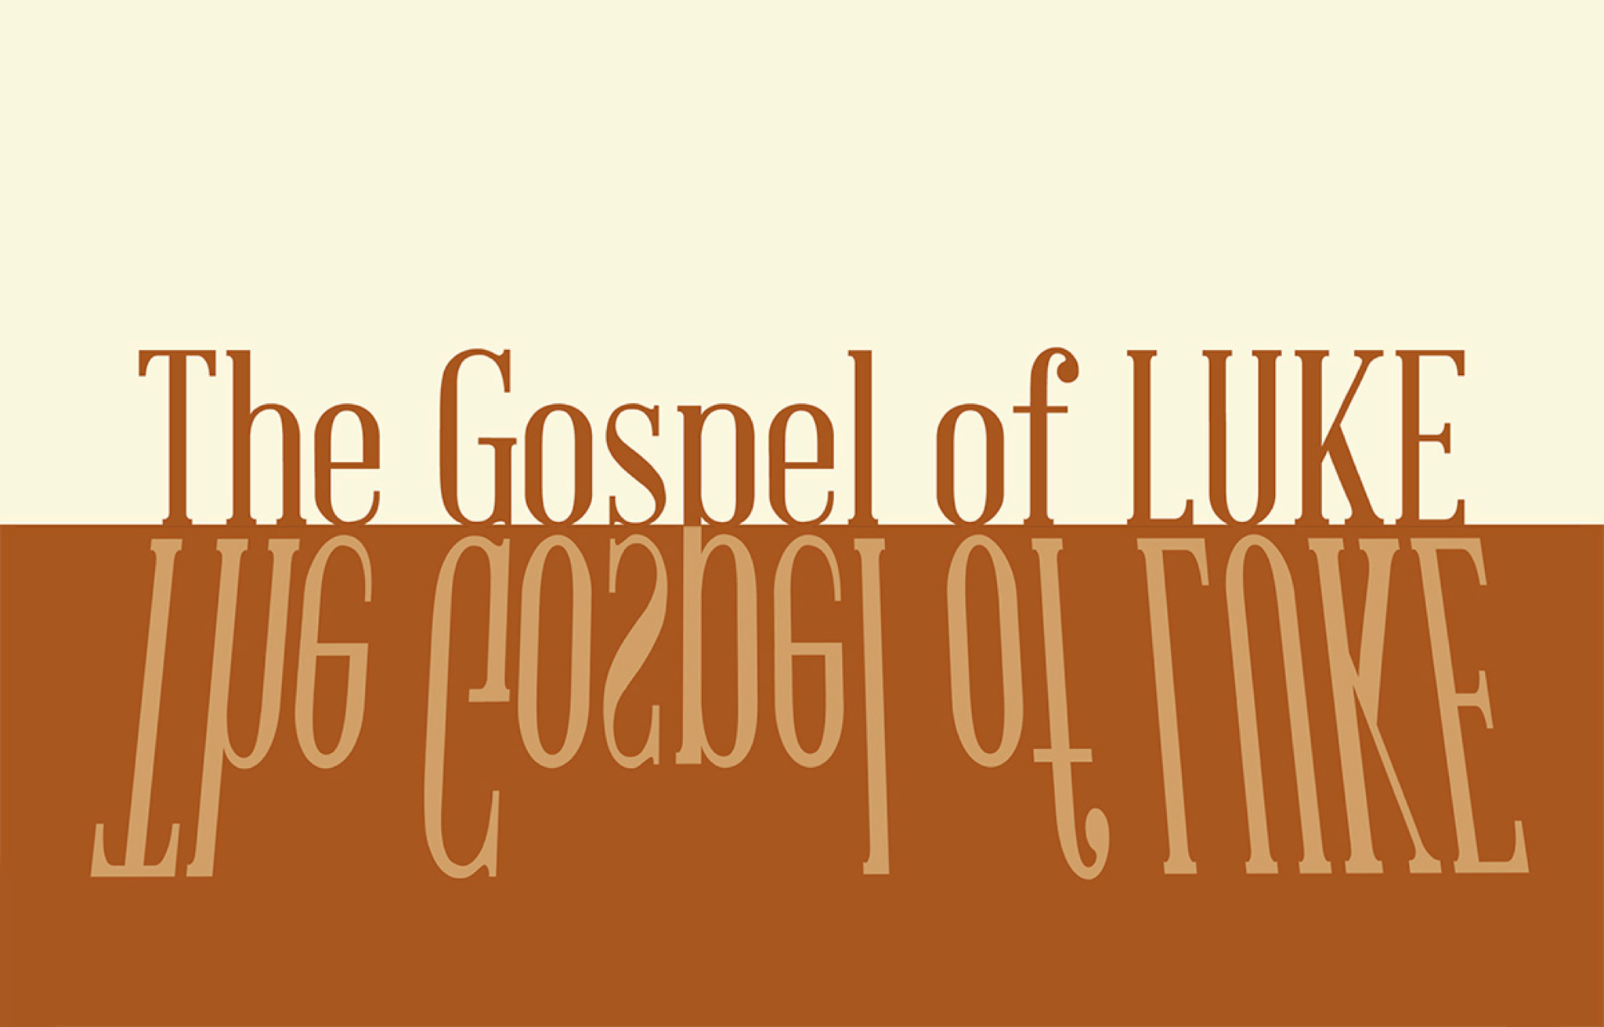

## PROFESSION OF FAITH

The Lord’s Prayer

**ALL**

Our Father, who art in heaven,

Hallowed be thy Name.

Thy Kingdom come.

Thy will be done in earth,

As it is in heaven.

Give us this day our daily bread.

And forgive us our trespasses,

As we forgive those who trespass against us.

And lead us not into temptation,

But deliver us from evil.

For thine is the kingdom,

The power, and the glory,

For ever and ever.

Amen.

## THE LORD’S SUPPER

### 1 Corinthians 11:23–26

The Lord Jesus, on the night when he was betrayed took bread and when he had given thanks, he broke it and said, “This is my body which is broken for you. Do this in remembrance of me.” In the same way also he took the cup, after supper, saying, “This cup is the new covenant in my blood. Do this as often as you drink it, in remembrance of me."



## HYMN

### Good Good Father

CCLI Song # 7036612 Anthony Brown | Pat Barrett

I've heard a thousand stories

Of what they think You’re like

But I've heard the tender whisper

Of love in the dead of night

You tell me that You’re pleased

And that I'm never alone

You're a Good Good Father

It's who You are

It's who You are

It's who You are

And I'm loved by You

It's who I am

It's who I am

It's who I am

I've seen many searching for answers

Far and wide

But I know we're all searching for answers

Only You provide

Because You know just what we need

Before we say a word

You're a Good Good Father

It's who You are

It's who You are

It's who You are

And I'm loved by You

It's who I am

It's who I am

It's who I am

You are perfect in all of Your ways

You are perfect in all of Your ways

You are perfect in all of Your ways to us

Love so undeniable I can hardly speak

Peace so unexplainable I can hardly think

As You call me deeper still

As You call me deeper still

As You call me deeper still

Into love love love

You're a Good Good Father

It's who You are

It's who You are

It's who You are

And I'm loved by You

It's who I am

It's who I am

It's who I am

### Hope Church Columbus logo featuring a stamped chi-rho cross superimposed on an anchor.

## BENEDICTION

1 Thessalonians 5:24

May God himself, the God of peace, sanctify you through and through. May your whole spirit, soul and body be kept blameless at the coming of our Lord Jesus Christ. The one who calls you is faithful, and he will do it.

## HOPE HAPPENINGS

### GALENTINE’S DAY SOIREE

Thursday, February 13, 2025

7:30 p.m. at the Haack home

888 Timberman Rd. 43212

HOPE LADIES! Join us for an evening of fun & fellow- ship! This is a super casual event, perfect to bring a friend! Bring a treat, snack or drink to share if you’d like–or just show up! We're so excited just to hang out!

### HOPE WOMEN'S RETREAT WEEKEND

April 4–6, 2025

Mohican Haven Lodge in Brickhaven, Ohio

Registration is now open!

### EVENING WORSHIP—FEBRUARY 23rd at 5 p.m.

On Sunday, Feb, 23rd, we will not have access to the 4-H building and will instead be meeting for evening worship at Scarlet City Church (114 Morse Rd.)

### PROVIDE A MEAL FOR SHAN BIBLE STUDIES

Please consider teaming up with a friend, neighbor, family, etc. to make a meal for 12 women who are part of the She Has a Name Thrivers Group. They meet and eat dinner together once a month. Please no pizza! We like to save that for emergencies. Healthier/balanced meals are appreciated. QR code link leads to the [signup page](https://m.signupgenius.com/#!/showSignUp/8050E4DACAC2AABF85-54430420-shan).

### SUBSCRIBE TO CARMEN HOUSE SUBSTACK

Get updates and offerings from Carmen House Christian Study

Center, and its director, Aaron Badenhop. QR code link leads to the [signup page](https://carmenhouse.substack.com/p/accepting-an-invitation?utm_campaign=post&triedRedirect=true).

## Digital Connect Card

We’re glad you’re here! Let’s stay connected; please fill out the form at the following link: <https://hopechurchcolumbus.churchcenter.com/people/forms/281549>.