

Hope Presbyterian Church Accessible Worship Folder and Slide Deck Transcription
January 5, 2025
www.hopechurchcolumbus.org
Pastor—Joe Haack—joe@hopechurchcolumbus.org
Youth Pastor—Wes Piehl—wes@hopechurchcolumbus.org
Deacons—deacons@hopechurchcolumbus.org
Operations Manager—Nichole Redinger—operations@hopechurchcolumbus.org


Preparation for Worship

Leader
“In biblical faith, knowledge of the true God is not attainable by human effort. We cannot summon up the presence of the living Jesus by efforts of our own, however “spiritual”; his presence is his to give. Any manifestation that reveals Jesus’ true identity occurs because the power of God is at work upon the eyes, ears, and hearts of the recipients. The unfolding of the Epiphany season is therefore a record of God’s definitive and unique actions in the One who has been born in Bethlehem.”—Fleming Rutledge

Call to Worship

LEADER
Arise, shine, for your light has come, and the glory of the LORD rises upon you.

ALL
See, darkness covers the earth and thick darkness is over the peoples, but the LORD rises upon you and his glory appears over you. Nations will come to your light, and kings to the brightness of your dawn.

DOXOLOGY
Lyrics: Thomas Ken, 1674
Praise God from whom all blessings flow;
Praise him all creatures here below;
Praise him above, ye heavenly host;
Praise Father, Son, and Holy Ghost.
Amen.

Prayer of Invocation

LEADER
Eternal God, by a star you led Magi to the worship of your Son. Guide the nations of the earth by your light, that the whole world may see your glory, through Jesus Christ, our Lord, who lives and reigns with you and the Holy Spirit, one God, now and forever. Amen.

HYMN

COME THOU FOUNT OF EVERY BLESSING
CCLI Song # 108389 John Wyeth | Robert Robinson
Come Thou fount of ev'ry blessing
Tune my heart to sing Thy grace
Streams of mercy never ceasing
Call for songs of loudest praise
Teach me some melodious sonnet
Sung by flaming tongues above
Praise the mount I'm fixed upon it
Mount of Thy redeeming love
Here I raise mine Ebenezer
Hither by Thy help I'm come
And I hope by Thy good pleasure
Safely to arrive at home
Jesus sought me when a stranger
Wand'ring from the fold of God
He to rescue me from danger
Interposed His precious blood
O to grace how great a debtor
Daily I'm constrained to be
Let Thy grace Lord like a fetter
Bind my wand'ring heart to Thee
Prone to wander Lord I feel it
Prone to leave the God I love
Here's my heart Lord take and seal it
Seal it for Thy courts above

A DAY FOR SINGING
CCLI Song # 7223272 Jess Ray Langdon | Jessie Early | Mitch Wong | Natalie Leonhardt
Mercy rising with the rising of the sun
Goodness rushing in and filling up my lungs
Your faithfulness is here and now
The evidence is all around
I bless Your name I give You praise
Today is a day for singing
Awake my soul come on praise the Lord
Today is a day for singing
Oh my soul praise the Lord
Oh my soul today is a day for singing
A new song is welling up from deep inside of me
There's new life hallelujah I have been redeemed
I bless Your name I give You praise
Today is a day for singing
Awake my soul come on praise the Lord
Today is a day for singing
Oh my soul praise the Lord
Oh my soul today is a day for singing
Today is a day for singing
From the valley to the mountain
The desert to the fountain
Oh I will praise You
From the morning to the evening
As long as I am breathing
Today is a day for singing
From the valley to the mountain
The desert to the fountain
Oh I will praise You
From the morning to the evening
As long as I am breathing
Today is a day for singing
I bless Your name I give You praise
Today is a day for singing
Awake my soul come on praise the Lord
Today is a day for singing
Oh my soul praise the Lord
Oh my soul today is a day for singing

CONFESSION OF SIN

ALL
Almighty and merciful God, we confess that we have sinned against you and one another in both our actions and our inactions. We recognize that in Jesus Christ our light has come, yet often we choose to walk in shadows and ignore the light. Gracious God, forgive our sins and remove from us the veil of darkness that shrouds our lives. Amen.

HYMN

PASS ME NOT O GENTLE SAVIOR
CCLI Song # 41594 Fanny Jane Crosby | William Howard Doane
Pass me not, O gentle savior
Hear my humble cry
While on others Thou art calling
Do not pass me by
Savior, savior
Hear my humble cry
While on others Thou art calling
Do not pass me by
Let me at Thy throne of mercy
Find a sweet relief
Kneeling there in deep contrition
Help my unbelief
Savior, savior
Hear my humble cry
While on others Thou art calling
Do not pass me by
Trusting only in Thy merit
Would I seek Thy face
Heal my wounded, broken spirit
Save me by Thy grace
Savior, savior
Hear my humble cry
While on others
Thou art calling
Do not pass me by
Thou the spring of all my comfort
More than life to me
Whom have I on Earth beside Thee?
Whom in Heav'n but Thee?
Savior, savior
Hear my humble cry
While on others Thou art calling
Do not pass me by

Assurance of Pardon
Based on John 1:9, 12, NIV

LEADER
The true light that gives light to everyone was coming into the world. Yet to all who did receive him, to those who believed in his name, he gave the right to become children of God.

HYMN

BEEN SO GOOD
CCLI Song # 7213072 © Brandon Lake Music | For Humans Publishing | Maverick City Publishing | Music by Elevation Worship Publishing
I call You faithful
For the promises You've kept
And every need You've met
Lord I'm so grateful
You were with me every step
And I never will forget
('Cause) When I think of how You've blessed me
How Your hand has never let me go
You never let me go
You have been so good to me
God I can't believe how You love me
What a friend You have been
So good to me
God I can’t believe how You love me
What a friend (You have been)
I call You Savior
For the blood that washed me clean
For the wrongs that You've redeemed
I know You're able
My eyes don't have to see
One more reason to believe
('Cause) When I think of how You've blessed me
How Your hand has never let me go
You never let me go
Cause You have been so good to me
God I can't believe how You love me
What a friend You have been
So good to me
God I can’t believe how You love me
What a friend (You have been)
You have been so good to me
God I can't believe how You love me
What a friend You have been
So good to me
God I can’t believe how You love me
What a friend (You have been)
For every morning
For every open door
I call You faithful
And I just want to thank You Lord
For every mountain
For every time You brought me through
I call You faithful
And I just want to thank You Lord
For Your forgiveness
For how You never turned away
I call You faithful
And I just wanna thank You Lord
For Your salvation
You paid the price I couldn't pay
I call You faithful
And I just want to thank You Lord
Oh oh
I just wanna thank You Lord
Oh oh
I just wanna thank You Lord
You have been so good to me
God I can't believe how You love me
What a friend You have been
So good to me
God I can’t believe how You love me
What a friend (You have been)
You have been so good to me
God I can't believe how You love me
What a friend You have been
So good to me
God I can’t believe how You love me
What a friend (You have been)

TITHES AND OFFERINGS


HOPE HAPPENINGS AND ANNOUNCEMENTS




PASSING THE PEACE

SCRIPTURE REFERENCE
1 Peter 2:4–8
Luke 2:21–40

SERMON SLIDES

Slide 1
Epiphany: Unspeakable Glory and Pain

Slide 2
1. Ordinary faithfulness always matters.

Slide 3
On the eighth day, when it was time to circumcise the child, he was named Jesus, the name the angel had given him before he was conceived. When the time came for the purification rites required by the Law of Moses, Joseph and Mary took him to Jerusalem to present him to the Lord (as it is written in the Law of the Lord, “Every firstborn male is to be consecrated to the Lord” ), and to offer a sacrifice in keeping with what is said in the Law of the Lord: “a pair of doves or two young pigeons.
Luke 2:21-24 (NIV)

Slide 4
When Joseph and Mary had done everything required by the Law of the Lord, they returned to Galilee to their own town of Nazareth. And the child grew and became strong; he was filled with wisdom, and the grace of God was on him. Luke 2:39-40 (NIV)

Slide 5
"But I am convinced that we have drifted from the true focus of God's activity in this world. It is not to be found in the extraordinary, but in the ordinary, the everyday. The problem is not that we are too active, but that we are recklessly frenetic. We have grown accustomed to quick fixes and easy solutions. We have grown accustomed to running sprints instead of training for the long-distance marathon. We have plenty of energy. The danger is that we will burn ourselves out on restless anxieties and unrealistic expectations... What we are called to do every day, right where God has placed us, is rich and rewarding.”
–Michael Horton, Ordinary

Slide 6
1. Ordinary faithfulness always matters.
2. Being with God positions us to see what God sees.

Slide 7
"Now there was a man in Jerusalem called Simeon, who was righteous and devout. He was waiting for the consolation of Israel, and the Holy Spirit was on him. It had been revealed to him by the Holy Spirit that he would not die before he had seen the Lord’s Messiah. Moved by the Spirit, he went into the temple courts.” (v. 25–27a)
"There was also a prophet, Anna, the daughter of Penuel, of the tribe of Asher. She was very old; she had lived with her husband seven years after her marriage, and then was a widow until she was eighty-four. She never left the temple but worshiped night and day, fasting and praying.” (v. 36–37)

Slide 8
“In silent prayer, we are constantly called to let go of the need to achieve mastery or to perform well. When ever I hear of people being recognized spiritual masters, or masters of prayer, I don't think of them as people who have some kind of secret sauce that makes their prayer life extraordinary; I think of them as people who have determined day in and day out to return to the simple act of being with God. There is no such thing as being professionals at prayer. We are always beginners.”
–Rich Villodas, The Deeply Formed Life

Slide 9
1. Ordinary faithfulness always matters.
2. Being with God positions us to see what God sees.
3. Jesus changes everything, and that’s glorious but not always easy.

Slide 10
When the parents brought in the child Jesus to do for him what the custom of the Law required, Simeon took him in his arms and praised God, saying: “Sovereign Lord, as you have promised, you may now dismiss your servant in peace. For my eyes have seen your salvation, which you have prepared in the sight of all nations: a light for revelation to the Gentiles, and the glory of your people Israel.”
The child’s father and mother marveled at what was said about him. Then Simeon blessed them and said to Mary, his mother: “This child is destined to cause the falling and rising of many in Israel, and to be a sign that will be spoken against, so that the thoughts of many hearts will be revealed. And a sword will pierce your own soul too.” (v. 27–35)

Slide 11
When the parents brought in the child Jesus to do for him what the custom of the Law required, Simeon took him in his arms and praised God, saying: “Sovereign Lord, as you Coming up to them at that very moment, she [Anna] gave thanks to God and spoke about the child to all who were looking forward to the redemption of Jerusalem. (v. 38)

Slide 12
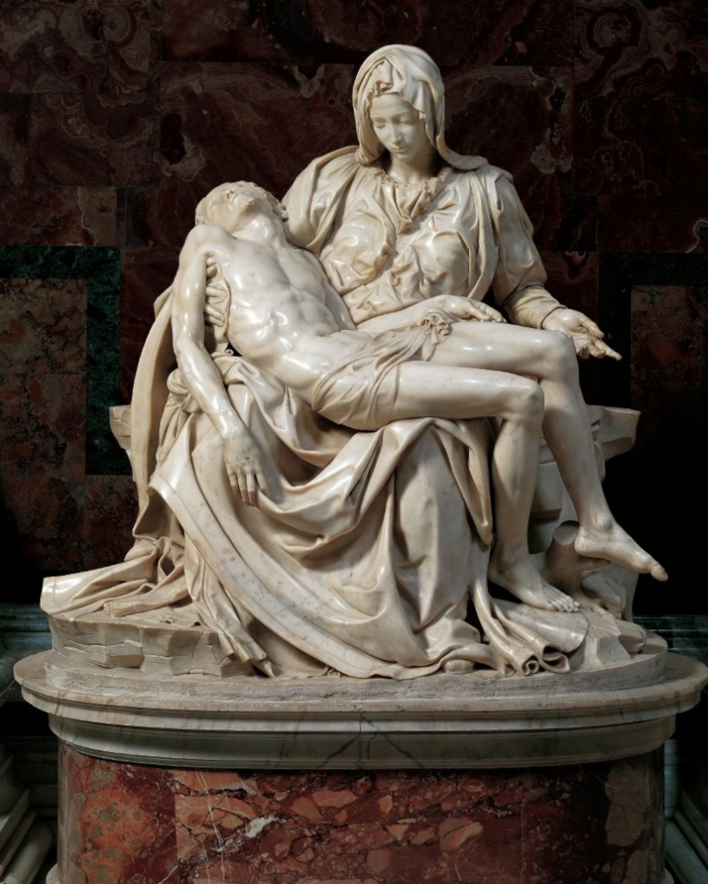

Slide 13
Dear Lord,
Thank you for all I am predestined to become, and for your persistence in seeing that I become it.
Help me to understand that the more the marble wastes, the more the statue grows. Help me to love the person I am becoming more than I long for the person I am losing.
It is a difficult process, Lord, this losing of the self, and sometimes I can't understand what you are doing in my life.
Help me to see that in the difficult... are the friendly forces, the hands that work on us. More than I fear the hammer that is wielded against me, help me to love the hand that holds the hammer and keeps it from crushing me.
More than I doubt the chisel that gouges me, help me to trust the hand that guides the chisel and uses it to shape me into the beautiful image of Christ.
In his name I pray,
Amen
By Ken Gire, Shaped by the Cross

PROFESSION OF FAITH
The Lord’s Prayer

All
Our Father in heaven,
hallowed be your name,
your kingdom come,
your will be done,
on earth as it is in heaven.
Give us today our daily bread
and forgive us our debts,
as we also have forgiven our debtors.
And lead us not into temptation,
but deliver us from evil.
Amen.

THE LORD’S SUPPER

1 Corinthians 11:23–26
The Lord Jesus, on the night when he was betrayed took bread and when he had given thanks, he broke it and said, “This is my body which is broken for you. Do this in remembrance of me.” In the same way also he took the cup, after supper, saying, “This cup is the new covenant in my blood. Do this as often as you drink it, in remembrance of me."

HYMN

YET NOT I BUT THROUGH CHRIST IN ME
CCLI SONG#: 7121852 Jonny Robinson, Michael Farren, Rich Thompson
What gift of grace
Is Jesus my redeemer
There is no more for Heaven now to give
He is my joy
My righteousness and freedom
My steadfast love
My deep and boundless peace
To this I hold
My hope is only Jesus
For my life is wholly bound to His
Oh how strange and divine
I can sing: all is mine!
Yet not I, but through Christ in me
The night is dark
But I am not forsaken
For by my side, the Savior He will stay
I labor on
In weakness and rejoicing
For in my need
His power is displayed
To this I hold
My shepherd will defend me
Through the deepest valley He will lead
Oh the night has been won
And I shall overcome!
Yet not I, but through Christ in me
No fate I dread
I know I am forgiven
The future sure
The price it has been paid
For Jesus bled and suffered
For my pardon
And He was raised
To overthrow the grave
To this I hold
My sin has been defeated
Jesus now and ever is my plea
Oh the chains are released
I can sing: I am free!
Yet not I, but through Christ in me
With every breath
I long to follow Jesus
For He has said
That He will bring me home
And day by day
I know He will renew me
Until I stand with joy before the throne
To this I hold
My hope is only Jesus
All the glory evermore to Him
When the race is complete
Still my lips shall repeat:
Yet not I, but through Christ in me!
To this I hold
My hope is only Jesus
All the glory evermore to Him
When the race is complete
Still my lips shall repeat:
Yet not I, but through Christ in me!
When the race is complete
Still my lips shall repeat:
Yet not I, but through Christ in me!
Yet not I, but through Christ in me!
Yet not I, but through Christ in me!

BENEDICTION
Now to God who is able to strengthen you according to my gospel and the proclamation of Jesus Christ, according to the revelation of the mystery that was kept secret for long ages but is now disclosed, and through the prophetic writings is made known to all the Gentiles, according to the command of the eternal God, to bring about the obedience of faith— to the only wise God, through Jesus Christ, to whom be the glory forever! Amen.—Romans 16:25-27, NRSV

HOPE HAPPENINGS

HOPE YOUTH
January 12, 2025
6:30–8:00 p.m. at the Piehl home
Hope Youth invites those in grades 6 through 12 are invited to join us for Life Revealed, an Alpha-style walk through Luke and Acts. Reach out to Wes for more details: wes@hopechurchcolumbus.org.

GALENTINE’S DAY SOIREE
Thursday, February 13, 2025
7:30 p.m. at the Haack home
888 Timberman Rd. 43212
HOPE LADIES! Join us for an evening of fun & fellow- ship! This is a super casual event, perfect to bring a friend! Bring a treat, snack or drink to share if you’d like–or just show up! We're so excited just to hang out!

HOPE WOMEN'S RETREAT WEEKEND
Save the Date! April 4–6, 2025. More Information Coming Soon!

ACCESSIBILITY TEAM HELP WANTED
The Accessibility Team is looking for 1-2 more team members. Contact Michelle Piehl for more info: piehl.michelle@gmail.com.

WINTER TRANSPORTATION
As the winter months set in and weather gets colder, it becomes
harder for folks without a vehicle to make it to Sunday morning
worship and other activities. If you are in need of a ride to a Hope event, please text 614–526–4194.

Digital Connect Card
We’re glad you’re here! Let’s stay connected; please fill out the form at the following link: https://hopechurchcolumbus.churchcenter.com/people/forms/281549.

