

Hope Presbyterian Church Accessible Worship Folder and Slide Deck Transcription
January 19, 2025
www.hopechurchcolumbus.org
Pastor—Joe Haack—joe@hopechurchcolumbus.org
Youth Pastor—Wes Piehl—wes@hopechurchcolumbus.org
Deacons—deacons@hopechurchcolumbus.org
Operations Manager—Nichole Redinger—operations@hopechurchcolumbus.org


Reflection
Almighty God, we pray for your blessing on the church in this place. Here may the faithful find salvation, and the careless be awakened. Here may the doubting find faith, and the anxious be encouraged. Here may the tempted find help, and the sorrowful find comfort. Here may the weary find rest, and the strong be renewed. Here may the aged find consolation and the young be inspired; through Jesus Christ, our Lord. Amen

CALL TO WORSHIP

LEADER
Praise the LORD, my soul; all my inmost being, praise his holy name.

ALL
Praise the LORD, my soul, and forget not all his benefits

LEADER
Praise the LORD, you his angels, you mighty ones who do his bidding, who obey his word.

ALL
Praise the LORD, all his heavenly hosts, you his servants who do his will.

LEADER
Praise the LORD, all his works everywhere in his dominion.

ALL
Praise the LORD, my soul.

DOXOLOGY
Lyrics: Thomas Ken, 1674
Praise God from whom all blessings flow;
Praise him all creatures here below;
Praise him above, ye heavenly host;
Praise Father, Son, and Holy Ghost.
Amen.

HYMNS

Great Things
CCLI #7111321 | Jonas Myrin and Phil Wickham Phil Wickham Music (Fair Trade Music Publishing [c/o Essential Music Publishing LLC]), Simply Global Songs; Sing My Songs (Fair Trade Music Publishing [c/o Essential Music Publishing LLC]), and Remaining portion is unaffiliated
Come, let us worship our King
Come, let us bow at His feet
He has done great things
See what our Savior has done
See how His love overcomes
He has done great things
He has done great things
Hero of Heaven
You conquered the grave
You free every captive
And break every chain
O God You have done great things
We dance in Your freedom
Awake and alive
O Jesus, our Savior
Your name lifted high O God
You have done great things
You've been faithful
Through every storm
You'll be faithful forevermore
You have done great things
And I know You will do it again
For Your promise is Yes and Amen
You will do great things
God You do great things
Hero of Heaven
You conquered the grave
You free every captive
And break every chain
O God You have done great things
We dance in Your freedom
Awake and alive
O Jesus, our Savior
Your name lifted high
O God You have done great things
Hallelujah
God above it all
Hallelujah
God unshakable
Hallelujah You have done great things
Hallelujah
God above it all
Hallelujah
God unshakable
Hallelujah You have done great things
Hero of Heaven
You conquered the grave
You free every captive
And break every chain
O God You have done great things
We dance in Your freedom
Awake and alive
O Jesus, our Savior
Your name lifted high O God You have done great things
O God You do great things

A Day for Singing
CCLI Song # 7223272 Jess Ray Langdon | Jessie Early | Mitch Wong | Natalie Leonhardt
Mercy rising with the rising of the sun
Goodness rushing in and filling up my lungs
Your faithfulness is here and now The evidence is all around
I bless Your name I give You praise
Today is a day for singing
Awake my soul
Come on praise the Lord
Today is a day for singing
Oh my soul
Praise the Lord
Oh my soul Today is a day for singing
A new song Is welling up From deep inside of me
There's new life
Hallelujah I have been redeemed
I bless Your name I give You praise
Today is a day for singing
Awake my soul
Come on praise the Lord
Today is a day for singing
Oh my soul
Praise the Lord
Oh my soul Today is a day for singing
From the valley to the mountain
The desert to the fountain
Oh I will praise You
From the morning to the evening
As long as I am breathing
Today is a day for singing
From the valley to the mountain
The desert to the fountain
Oh I will praise You
From the morning to the evening
As long as I am breathing
Today is a day for singing
I bless Your name I give You praise
Today is a day for singing
Awake my soul
Come on praise the Lord
Today is a day for singing
Oh my soul
Praise the Lord
Oh my soul Today is a day for singing
I bless Your name I give You praise
Today is a day for singing
Awake my soul
Come on praise the Lord
Today is a day for singing
Oh my soul
Praise the Lord
Oh my soul Today is a day for singing

CONFESSION OF SIN

LEADER
Gracious God, our sins are too heavy to carry, too real to hide, and too deep to undo. Forgive what our lips tremble to name, what our hearts can no longer bear, and what has become for us a consuming fire of judgment. Set us free from a past that we cannot change; open to us a future in which we can be changed; and grant us grace to grow more and more in your likeness and image; through Jesus Christ, the light of the world.

ALL
Amen.

HYMN

Nothing But the Blood of Jesus
CCLI Song # 21332 Robert Lowry
What can wash away my sin?
Nothing but the blood of Jesus
What can make me whole again?
Nothing but the blood of Jesus
Oh, precious is the flow
That makes me white as snow
No other fount I know
Nothing but the blood of Jesus
For my pardon, this I see
Nothing but the blood of Jesus
For my cleansing, this my plea
Nothing but the blood of Jesus
Oh, precious is the flow
That makes me white as snow
No other fount I know
Nothing but the blood of Jesus
Nothing can for sin atone
Nothing but the blood of Jesus
Naught of good that I have done
Nothing but the blood of Jesus
Oh, precious is the flow
That makes me white as snow
No other fount I know
Nothing but the blood of Jesus
This is all my hope and peace
Nothing but the blood of Jesus
This is all my righteousness
Nothing but the blood of Jesus
Oh, precious is the flow
That makes me white as snow
No other fount I know
Nothing but the blood of Jesus

GRACE ASSURANCE
from 1 John 1:5, 7, NRSV

LEADER
This is the message we have heard from God and proclaim to you, that God is light and in God there is no darkness at all. If we walk in the light, as God is in the light, we have fellowship with one another, and the blood of Jesus his Son cleanses us from all sin.

HYMN

All Sufficient Merit
CCLI Song # 7212933 Bethany Barnard | Bryan Fowler | Shane Barnard
All sufficient merit,
shining like the sun
A fortune I inherit
by no work I have done
My righteousness I forfeit
at my Savior’s cross
Where all sufficient merit
did what I could not
In love He condescended
Eternal now in time
A life without a blemish
the Maker made to die
The law could never save us,
our lawlessness had won
Until the pure and spotless
lamb had finally come
It is done, it is finished
No more debt I owe
Paid in full
All sufficient merit now my own
I lay down my garments,
any empty boast
Good works now all corrupted
by the sinful host
I'm dressed in my Lord Jesus,
a crimson robe made white
No more fear of judgment
His righteousness is mine
It is done, it is finished
No more debt I owe
Paid in full
All sufficient merit now my own
It is done, it is finished
No more debt I owe
Paid in full
All sufficient merit now my own
All sufficient merit
firm in life and death
The joy of my salvation
shall be my final breath
When I stand accepted
before the throne of God
I’ll gaze upon my Jesus
and thank Him for the cross
Yes I’ll thank Him for the cross
It is done, it is finished
No more debt I owe
Paid in full
All sufficient merit now my own
It is done, it is finished
No more debt I owe
Paid in full
All sufficient merit now my own

TITHES AND OFFERINGS


HOPE HAPPENINGS AND ANNOUNCEMENTS



PASSING THE PEACE

SCRIPTURE READING
Luke 2:41–52

MESSAGE


Slide 1
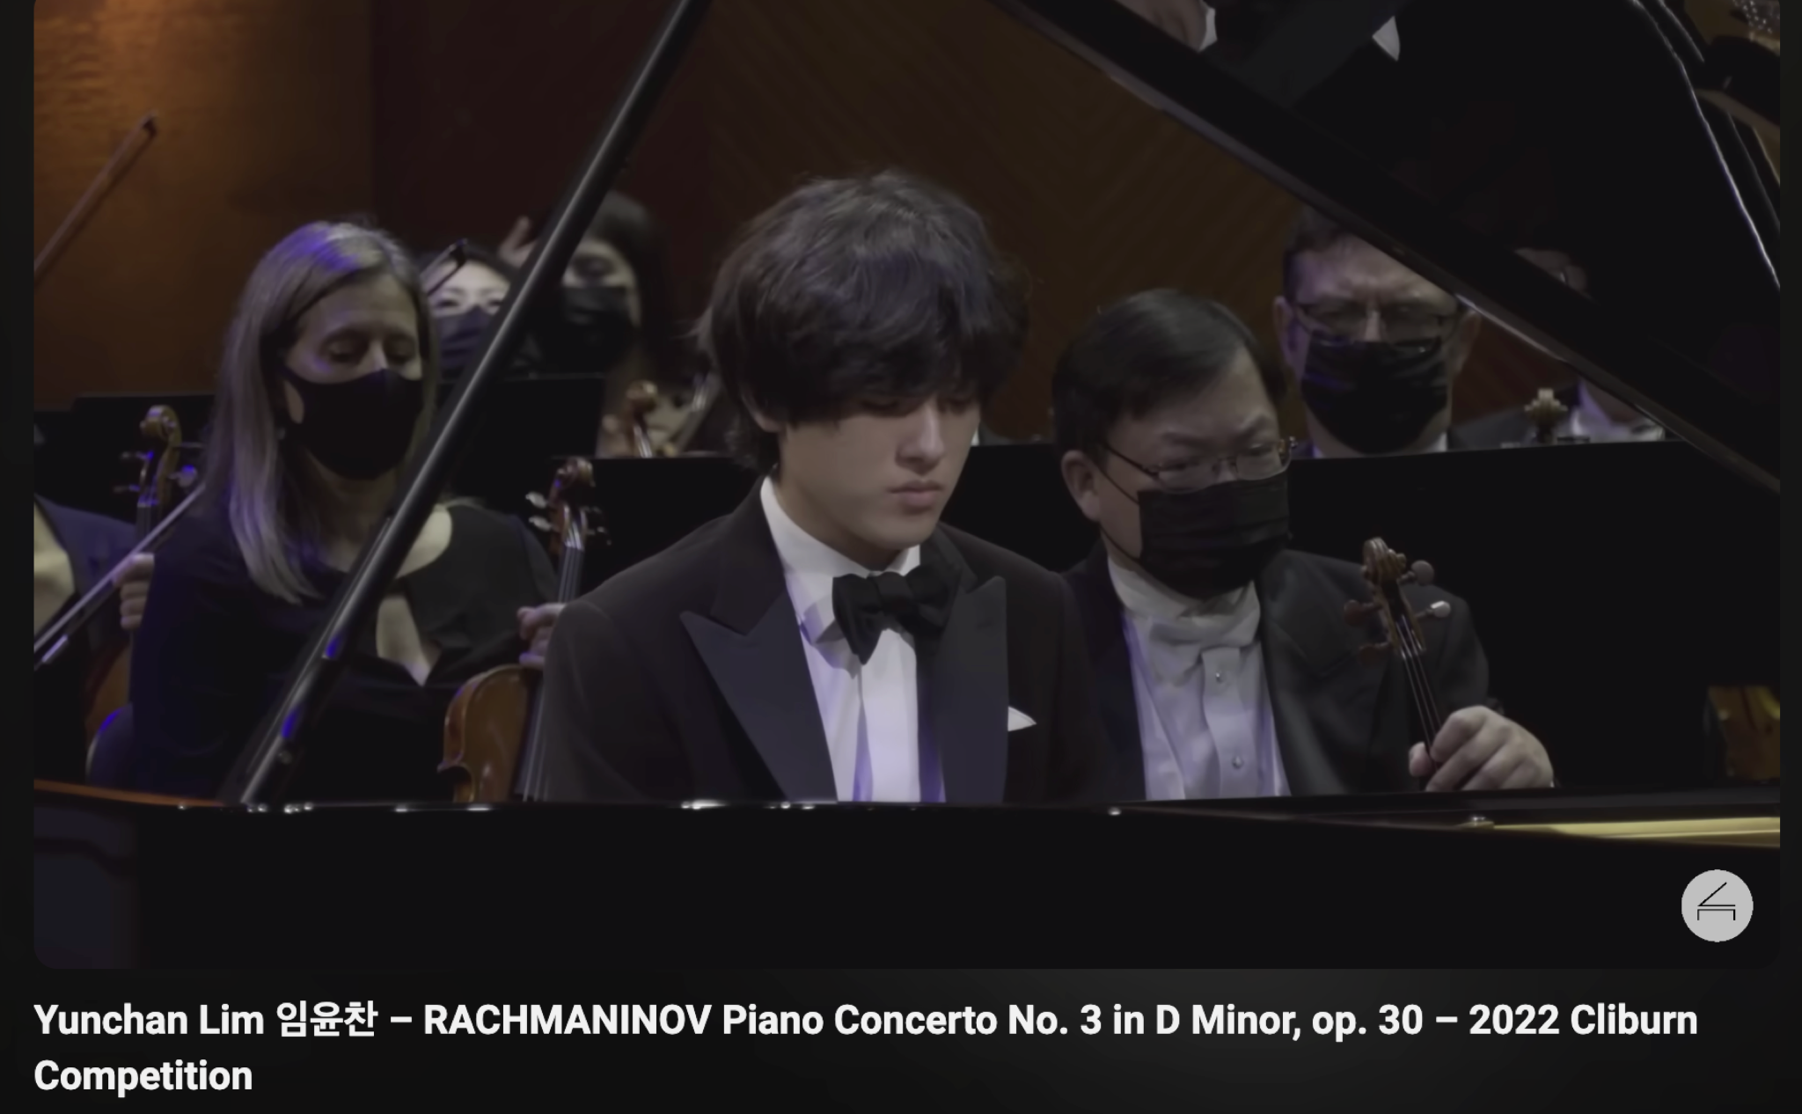

Slide 2
“Son, why have you treated us so? Behold, your father and I have been searching for you in great distress” (48).

Slide 3
“Why were you looking for me? Did you not know that I must be about my Father’s business” (49)?

Slide 4
“they didn’t understand what he meant” (50)

Slide 5
“she stored all these things in her heart” (51).

Slide 6
1. Biblical Meditation

Slide 7
1. Biblical Meditation
46 And Mary said, “My soul magnifies the Lord,
47 and my spirit rejoices in God my Savior,
48 for he has looked on the humble estate of his servant. For behold, from now on all generations will call me blessed;
49 for he who is mighty has done great things for me, and holy is his name.
50 And his mercy is for those who fear him from generation to generation.
51 He has shown strength with his arm; he has scattered the proud in the thoughts of their hearts;
52 he has brought down the mighty from their thrones and exalted those of humble estate;
53 he has filled the hungry with good things, and the rich he has sent away empty.
54 He has helped his servant Israel, in remembrance of his mercy,
55 as he spoke to our fathers, to Abraham and to his offspring forever.” (Lk 1:46–55)

Slide 8


Slide 9
2. Relational Humility

Slide 10
2. Relational Humility
51 And he went down with them and came to Nazareth and was submissive to them. And his mother treasured up all these things in her heart. 52 And Jesus increased in wisdom and in stature and in favor with God and man.

Slide 11
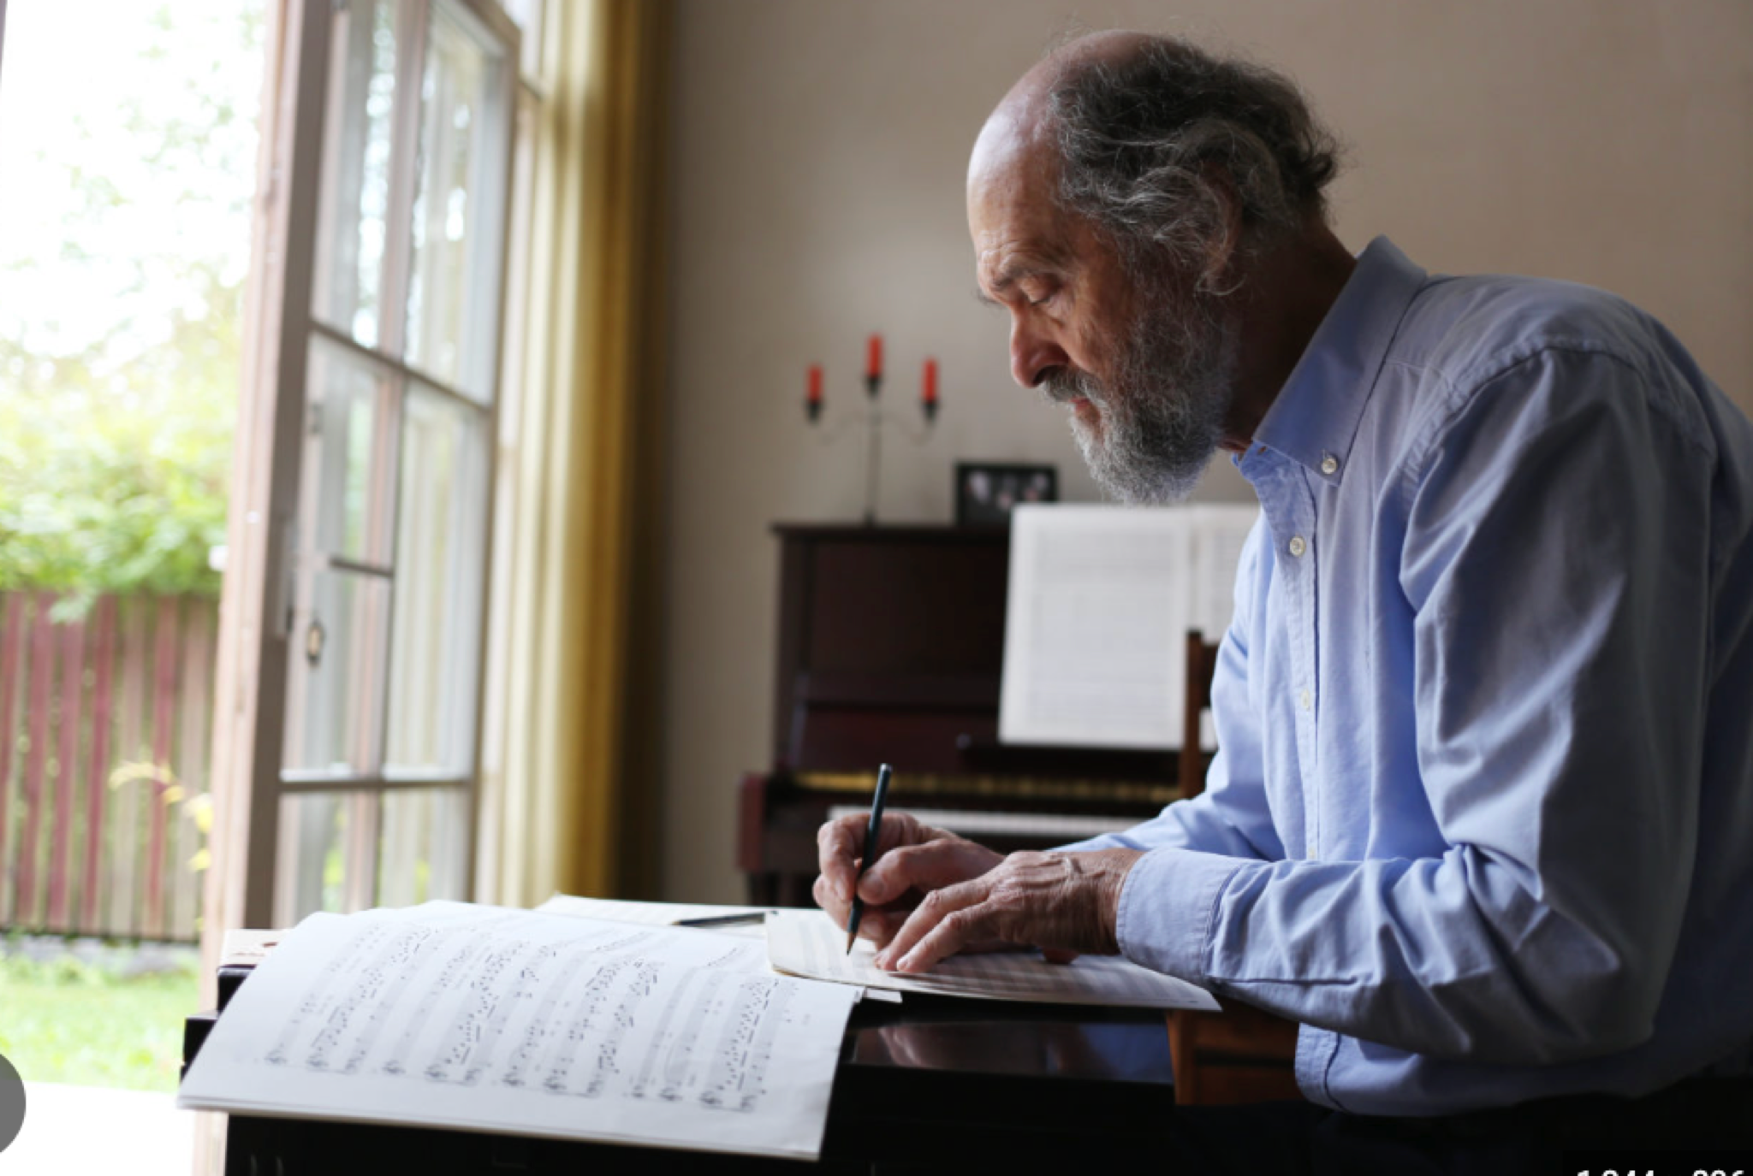

Slide 12
3. Holy Patience

Slide 13
3. Holy Patience
49 And all his acquaintances and the women who had followed him from Galilee stood at a distance watching these things (Lk 23:49).

Slide 14
3. Holy Patience
“…standing by the cross of Jesus were his mother and his mother’s sister, Mary the wife of Clopas, and Mary Magdalene. 26 When Jesus saw his mother and the disciple whom he loved standing nearby, he said to his mother, “Woman, behold, your son!” 27 Then he said to the disciple, “Behold, your mother!” And from that hour the disciple took her to his own home (Jn 19:25–27).

Slide 15
“Have patience with everything unsolved in your heart. Do not search for answers now which cannot be given to you because you could not live them! It is a matter of living everything. Live the question now. Perhaps you will then gradually, without noticing it, one distant day, live right into the answer.” Ranier Marie Rilke

Slide 16
“[the] tax collector prayed in truths — opening his heart to the Lord and throwing himself on the mercy of God. The man used the deep worries and fears of his heart to come into God’s presence, whereas the Pharisee used his religious life to keep prayer tidy and distracted from the messy truths of his heart.” Coe & Strobel


PROFESSION OF FAITH
The Lord’s Prayer
ALL
Our Father, who art in heaven,
Hallowed be thy Name.
Thy Kingdom come.
Thy will be done in earth,
As it is in heaven.
Give us this day our daily bread.
And forgive us our trespasses,
As we forgive those who trespass against us.
And lead us not into temptation,
But deliver us from evil.
For thine is the kingdom,
The power, and the glory,
For ever and ever.
Amen.

THE LORD’S SUPPER

1 Corinthians 11:23–26
The Lord Jesus, on the night when he was betrayed took bread and when he had given thanks, he broke it and said, “This is my body which is broken for you. Do this in remembrance of me.” In the same way also he took the cup, after supper, saying, “This cup is the new covenant in my blood. Do this as often as you drink it, in remembrance of me."

HYMN

Abide With Me
CCLI Song # 43190 Henry Francis Lyte | William Henry Monk
Abide with me; fast falls the eventide;
The darkness deepens; Lord with me abide.
When other helpers fail and comforts flee,
Help of the helpless, abide with me.
Thou on my head, in early youth didst smile;
And, though rebellious, and perverse meanwhile,
Thou hast not left me, oft as I left Thee,
On to the close Lord, abide with me.
I need Thy presence, every passing hour.
What but Thy grace, can foil the tempter’s power?
Who, like Thyself, my guide and stay can be?
Through cloud and sunshine, abide with me.
I fear no foe, with Thee at hand to bless
Ills have no weight, tears lose their bitterness
Where is thy sting death? Where grave thy victory?
I triumph still, abide with me.
Hold Thou Thy cross, before my closing eyes;
Shine through the gloom, and point me to the skies.
Heaven’s morning breaks, and earth’s vain shadows flee;
In life, in death, Lord, abide with me.

BENEDICTION
May the blessing of God, the giver of every good and perfect gift; and of Christ, who summons us to service; and of the Holy Spirit, who inspires generosity and love, be with us all.

HOPE HAPPENINGS

HOPE YOUTH
January 19, 2025
6:30–8:00 p.m. at the Piehl home
Hope Youth invites those in grades 6 through 12 are invited to join us for Life Revealed, an Alpha-style walk through Luke and Acts. Reach out to Wes for more details: wes@hopechurchcolumbus.org.

GALENTINE’S DAY SOIREE
Thursday, February 13, 2025
7:30 p.m. at the Haack home
888 Timberman Rd. 43212
HOPE LADIES! Join us for an evening of fun & fellow- ship! This is a super casual event, perfect to bring a friend! Bring a treat, snack or drink to share if you’d like–or just show up! We're so excited just to hang out!

HOPE WOMEN'S RETREAT WEEKEND
April 4–6, 2025
Mohican Haven Lodge in Brickhaven, Ohio
Registration is now open!

ACCESSIBILITY TEAM HELP WANTED
The Accessibility Team is looking for 1-2 more team members. Contact Michelle Piehl for more info: piehl.michelle@gmail.com.

WINTER TRANSPORTATION
As the winter months set in and weather gets colder, it becomes harder for folks without a vehicle to make it to Sunday morning worship and other activities. If you are in need of a ride to a Hope event, please text 614–526–4194.

Digital Connect Card
We’re glad you’re here! Let’s stay connected; please fill out the form at the following link: https://hopechurchcolumbus.churchcenter.com/people/forms/281549.

