

Hope Presbyterian Church Accessible Worship Folder and Slide Deck Transcription
January 26, 2025
www.hopechurchcolumbus.org
Pastor—Joe Haack—joe@hopechurchcolumbus.org
Youth Pastor—Wes Piehl—wes@hopechurchcolumbus.org
Deacons—deacons@hopechurchcolumbus.org
Operations Manager—Nichole Redinger—operations@hopechurchcolumbus.org


Reflection
Dear God, silence all voices within our minds but your own. Help us to seek and be able to follow your will. May our prayers be joined with those of our sisters and brothers in the faith, that together we may glorify your name and enjoy your fellowship forever. In Jesus’ name, Amen.

CALL TO WORSHIP
Ps 95:1, 2, 56, 7 NIV

LEADER
Come, let us sing for joy to the LORD; let us shout aloud to the Rock of our salvation.

ALL
Let us come before him with thanksgiving and extol him with music and song.

LEADER
Come, let us bow down in worship

ALL
Let us kneel before the LORD our Maker

LEADER
For he is our God

ALL
and we are the people of his pasture, the flock under his care.

DOXOLOGY
Lyrics: Thomas Ken, 1674
Praise God from whom all blessings flow;
Praise him all creatures here below;
Praise him above, ye heavenly host;
Praise Father, Son, and Holy Ghost.
Amen.

HYMNS

Holy Holy Holy
Public Domain
Holy, holy, holy!
Lord God, almighty
Early in the morning
Our song shall rise to Thee
Holy, holy, holy!
Merciful and mighty
God in three persons
Blessed Trinity
Holy, holy, holy!
All the saints adore Thee
Casting down their golden crowns
Around the glassy sea
Cherubim and seraphim
Falling down before Thee
Who wert and art
And evermore shall be
Holy, holy, holy!
Though the darkness hide Thee
Though the eye of sinful man
Thy glory may not see
Only Thou art holy
There is none beside Thee
Perfect in power, in love, and purity
Holy, holy, holy!
Lord God, almighty
All Thy works shall praise Thy name
In earth, and sky, and sea
Holy, holy, holy!
Merciful and mighty
God in three persons
Blessed Trinity

A Mighty Fortress
CCLI Song # 4590051 Martin Luther | Chris Bergmann
A mighty fortress is our God,
A bulwark never failing;
Our helper He, amid the flood
Of mortal ills prevailing;
For still our ancient foe
doth seek to work us woe;
His craft and power are great,
and, armed with cruel hate,
On earth is not his equal.
Did we in our own strength confide,
Our striving would be losing
Were not the right Man on our side,
The Man of God’s own choosing:
Dost ask who that may be?
Christ Jesus, it is He;
Lord of Hosts, His name,
from age to age the same,
And He must win the battle.
And though this world, with devils filled,
Should threaten to undo us,
We will not fear, for God hath willed
His truth to triumph through us:
And though this world, with devils filled,
Should threaten to undo us,
We will not fear, for God hath willed
His truth to triumph through us:
A mighty fortress is our God,
His kingdom is forever

CONFESSION OF SIN

LEADER
We cannot come before God unless we are first honest with ourselves about who we are, about the mistakes we make, and about how well or poorly we care for others. In this spirit, let us offer our prayers to God.

ALL
Merciful God, we confess that we have sinned against you in thought, word, and deed, by what we have done, and by what we have left undone. We have not loved you with our whole heart and mind and strength. We have not loved our neighbors as ourselves. In your mercy forgive what we have been, help us amend what we are, and direct what we shall be, so that we may delight in your will and walk in your ways, to the glory of your holy name. Through Christ, our Lord. Amen.

HYMN

At the Foot of the Cross
CCLI Song # 3440858 Tre Sheppard
At the foot of the Cross,
Where I kneel in adoration
And I lay my burdens down
I exchange all my sin
For the promise of salvation
And Your name across my brow
At the foot of the Cross
I give up my vain ambition
And I leave my selfish pride
In the peace that is there,
will You restore my vision?
In all the places I am blind
I will wait here at the Cross
At the foot of the Cross
There is healing for the nations
There is rest for those who wait
And the love that we find is the hope of all creation
We are stunned by what You gave
We will wait here at the Cross
We will wait at the cross,
a hungry generation
With our broken hearts and lives
Will You hear? Will You come?
Will You fill our desperation?
Oh God let this be the time
We will wait here at the Cross

GRACE ASSURANCE
from Micah 7:18-20, NRSV

LEADER
Who is a God like you, pardoning iniquity and passing over the transgression of the remnant of your possession? He does not retain his anger forever, because he delights in showing clemency. He will again have compassion upon us; he will tread our iniquities under foot. You will cast all our sins into the depths of the sea. You will show faithfulness to Jacob and unswerving loyalty to Abraham, as you have sworn to our ancestors from the days of old.

HYMN

Justice Will Roll Down
CCLI Song # 5759949 Sandra McCracken
Oh my love you have grown so cold
To the world outside to the house next door
She who has been loved much has so much to give
Mercy is the fragrance of the broken
Justice will roll down
Oh justice will roll down
From high upon those mountains
With a mighty river sound
It will roll down
It will roll down
Oh my child I will be your light
In your secret pain in the dark of night
No enemy no conqueror
will steal your life from Me
I am your salvation and your victory
Justice will roll down
Oh justice will roll down
From high upon those mountains
With a mighty river sound
It will roll down
It will roll down
Soon oh soon when the trumpet sounds
Every knee will bend every heart will pound
I have made a new world
where the servant is the King
Oppression will be over and the slave set free
Justice will roll down
Oh justice will roll down
From high upon those mountains
With a mighty river sound
It will roll down
It will roll down

TITHES AND OFFERINGS


HOPE HAPPENINGS AND ANNOUNCEMENTS

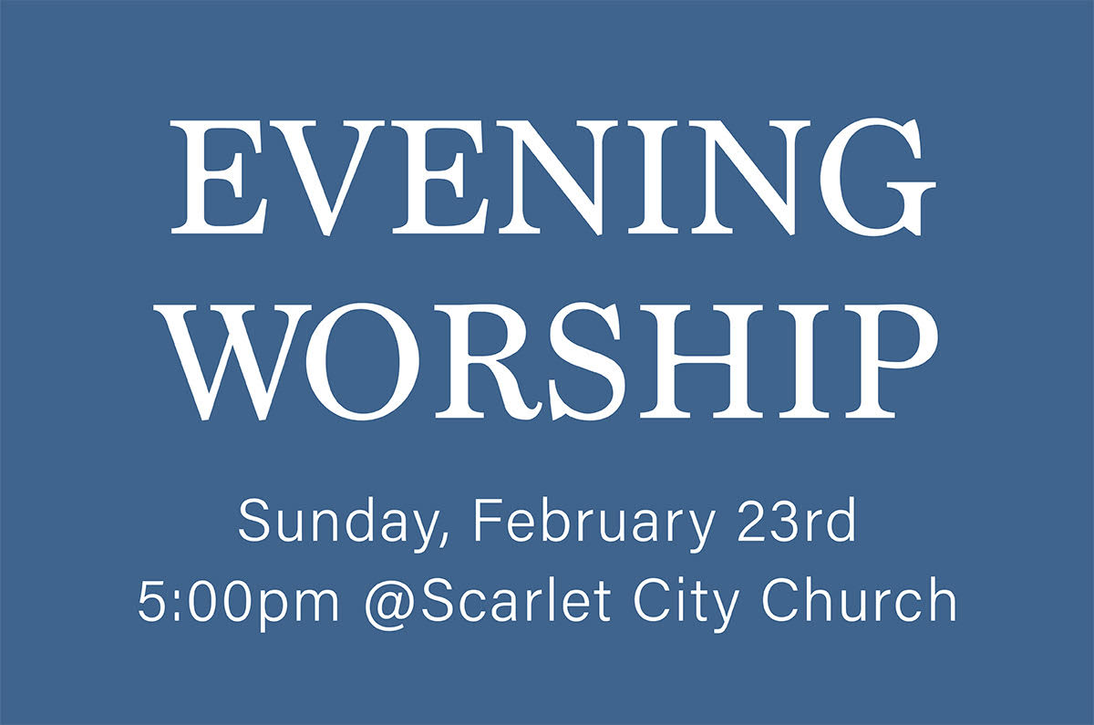

PASSING THE PEACE

SCRIPTURE READING
Luke 3:1–20

MESSAGE
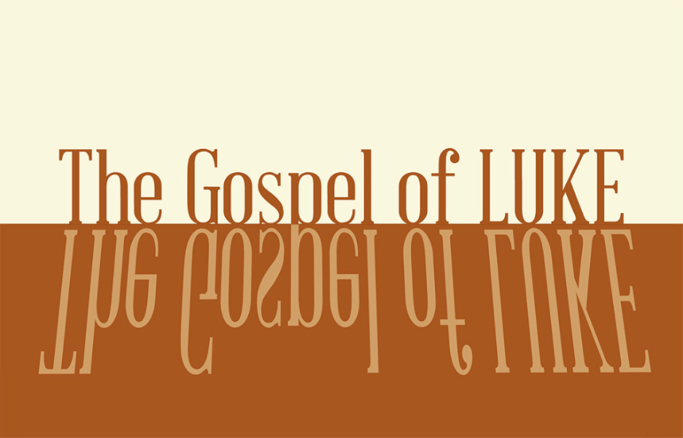

Slide 1
“The people were waiting expectantly” (15)

Slide 2
In the fifteenth year of the reign of Tiberius Caesar—when Pontius Pilate was governor of Judea, Herod tetrarch of Galilee, his brother Philip tetrarch of Iturea and Traconitis, and Lysanias tetrarch of Abilene—2 during the high- priesthood of Annas and Caiaphas, the word of God came to John son of Zechariah in the wilderness (3:1-2).

Slide 3
“those final years [of Tiberius’ reign] have been characterized as a period of pure terror. Pilate, prefect of the Roman province of Judea... is known from Jewish sources as “inflexible, a blend of self-will and relentlessness,” whose administration was marked by briberies, insults, robberies, outrages, wanton injuries, frequent executions without trial, and endless savage ferocity.”
-Joel Green

Slide 4
“...wondering in their hearts if John might possibly be the Messiah” (15)

Slide 5
4 “A voice of one calling in the wilderness, ‘Prepare the way for the Lord, make straight paths for him. 5 Every valley shall be filled in,
every mountain and hill made low. The crooked roads shall become straight, the rough ways smooth. 6 And all people will see God’s salvation.’

Slide 6
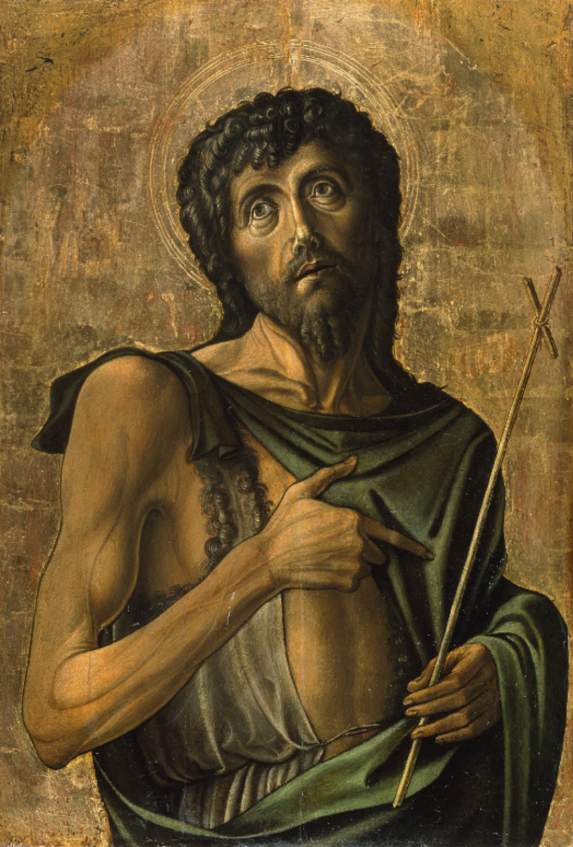

Slide 7
1/ Jesus intrudes our real life.
2/ Jesus transforms our real life.

Slide 8
1/ Jesus intrudes our real life

Slide 9
1/ Jesus intrudes our real life
v. 2—“... the word of God came...”

Slide 10


Slide 11
1/ Jesus intrudes our real life
And do not begin to say to yourselves, ‘We have Abraham as our father.’ For I tell you that out of these stones God can raise up children for Abraham (8).

Slide 12
1/ Jesus intrudes our real life
“Produce fruit in keeping with repentance.... 9 The ax is already at the root of the trees, and every tree that does not produce good fruit will be cut down and thrown into the fire” (8-9).

Slide 13
1/ Jesus intrudes our real life
10 “What should we do then?” the crowd asked. 11 John answered, “Anyone who has two shirts should share with the one who has none, and anyone who has food should do the same.”
12 Even tax collectors came to be baptized. “Teacher,” they asked, “what should we do?” 13 “Don’t collect any more than you are required to,” he told them.
14 Then some soldiers asked him, “And what should we do?” He replied, “Don’t extort money and don’t accuse people falsely—be content with your pay.”

Slide 14
2/ Jesus transforms our real life

Slide 15
2/ Jesus transforms our real life
16 John answered them all, “I baptize you with water. But one who is more powerful than I will come, the straps of whose sandals I am not worthy to untie. He will baptize you with the Holy Spirit and fire. 17 His winnowing fork is in his hand to clear his threshing floor and to gather the wheat into his barn, but he will burn up the chaff with unquenchable fire.” 18 And with many other words John exhorted the people and proclaimed the good news to them.

Slide 16
2/ Jesus transforms our real life
“Our prayer life is our Christian life miniaturized... prayer becomes the first testing ground for the beliefs we affirm. To test our belief that God is the one who forgives, we come out of hiding with the worst of ourselves... We test [the truth that nothing can separate us from his love, Romans 8:38-39] in prayer as we hold our lives open to the God who forgives... [and ask] ‘Lord will this separate me from you?’” (Coe/Strobel)

Slide 17
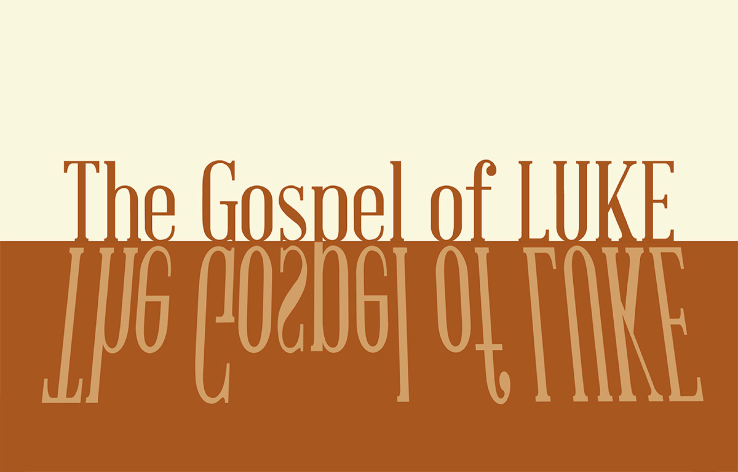

PROFESSION OF FAITH
The Lord’s Prayer
ALL
Our Father, who art in heaven,
Hallowed be thy Name.
Thy Kingdom come.
Thy will be done in earth,
As it is in heaven.
Give us this day our daily bread.
And forgive us our trespasses,
As we forgive those who trespass against us.
And lead us not into temptation,
But deliver us from evil.
For thine is the kingdom,
The power, and the glory,
For ever and ever.
Amen.

THE LORD’S SUPPER

1 Corinthians 11:23–26
The Lord Jesus, on the night when he was betrayed took bread and when he had given thanks, he broke it and said, “This is my body which is broken for you. Do this in remembrance of me.” In the same way also he took the cup, after supper, saying, “This cup is the new covenant in my blood. Do this as often as you drink it, in remembrance of me."

HYMN

Holy is the Lord
CCLI Song # 4158039 Chris Tomlin | Louie Giglio
We stand and lift up our hands
For the joy of the Lord is our strength
We bow down and worship Him now
How great how awesome is He
And together we sing
Everyone sing
Holy is the Lord God Almighty
The earth is filled with His glory
Holy is the Lord God Almighty
The earth is filled with His glory
The earth is filled with His glory
It is rising up all around
It's the anthem of the Lord's renown
It's rising up all around
It's the anthem of the Lord's renown
We stand and lift up our hands
For the joy of the Lord is our strength
We bow down and worship Him now
How great how awesome is He
And together we sing
Everyone sing
Holy is the Lord God Almighty
The earth is filled with His glory
Holy is the Lord God Almighty
The earth is filled with His glory
The earth is filled with His glory

BENEDICTION
May our Lord Jesus Christ, the one who came with grace and truth, also fill your hearts with grace and truth, as you serve him in the days ahead. And may the joy of the Lord—Father, Son, and Holy Spirit— be your strength. Amen.

HOPE HAPPENINGS

GALENTINE’S DAY SOIREE
Thursday, February 13, 2025
7:30 p.m. at the Haack home
888 Timberman Rd. 43212
HOPE LADIES! Join us for an evening of fun & fellow- ship! This is a super casual event, perfect to bring a friend! Bring a treat, snack or drink to share if you’d like–or just show up! We're so excited just to hang out!

HOPE WOMEN'S RETREAT WEEKEND
April 4–6, 2025
Mohican Haven Lodge in Brickhaven, Ohio
Registration is now open!

ACCESSIBILITY TEAM HELP WANTED
The Accessibility Team is looking for 1–2 more team members. Contact Michelle Piehl for more info: piehl.michelle@gmail.com.

WINTER TRANSPORTATION
As the winter months set in and weather gets colder, it becomes harder for folks without a vehicle to make it to Sunday morning worship and other activities. If you are in need of a ride to a Hope event, please text 614–526–4194.

Digital Connect Card
We’re glad you’re here! Let’s stay connected; please fill out the form at the following link: https://hopechurchcolumbus.churchcenter.com/people/forms/281549.

