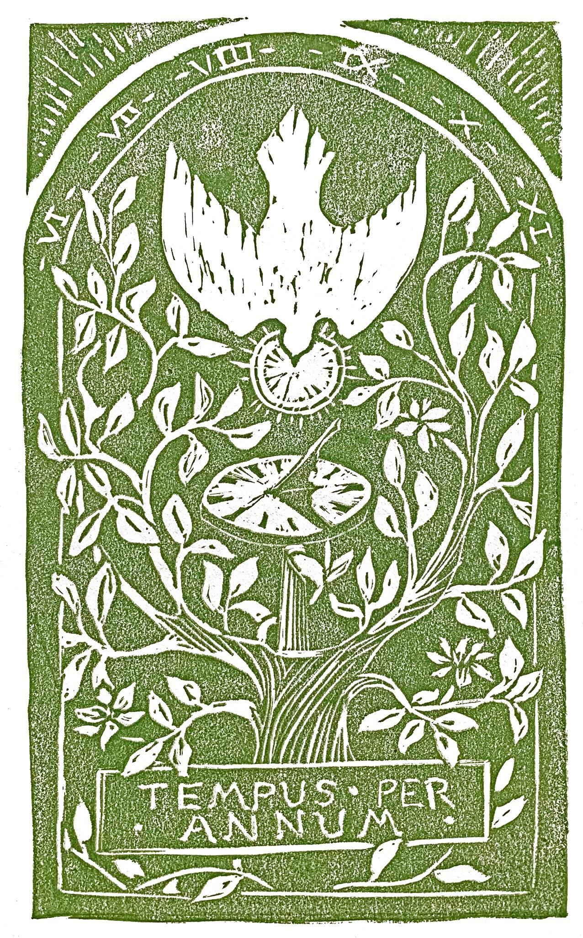

Hope Presbyterian Church Accessible Worship Folder and Slide Deck Transcription
June 8, 2025
www.hopechurchcolumbus.org
Pastor—Joe Haack—joe@hopechurchcolumbus.org
Youth Pastor—Wes Piehl—wes@hopechurchcolumbus.org
Deacons—deacons@hopechurchcolumbus.org
Operations Manager—Nichole Redinger—operations@hopechurchcolumbus.org
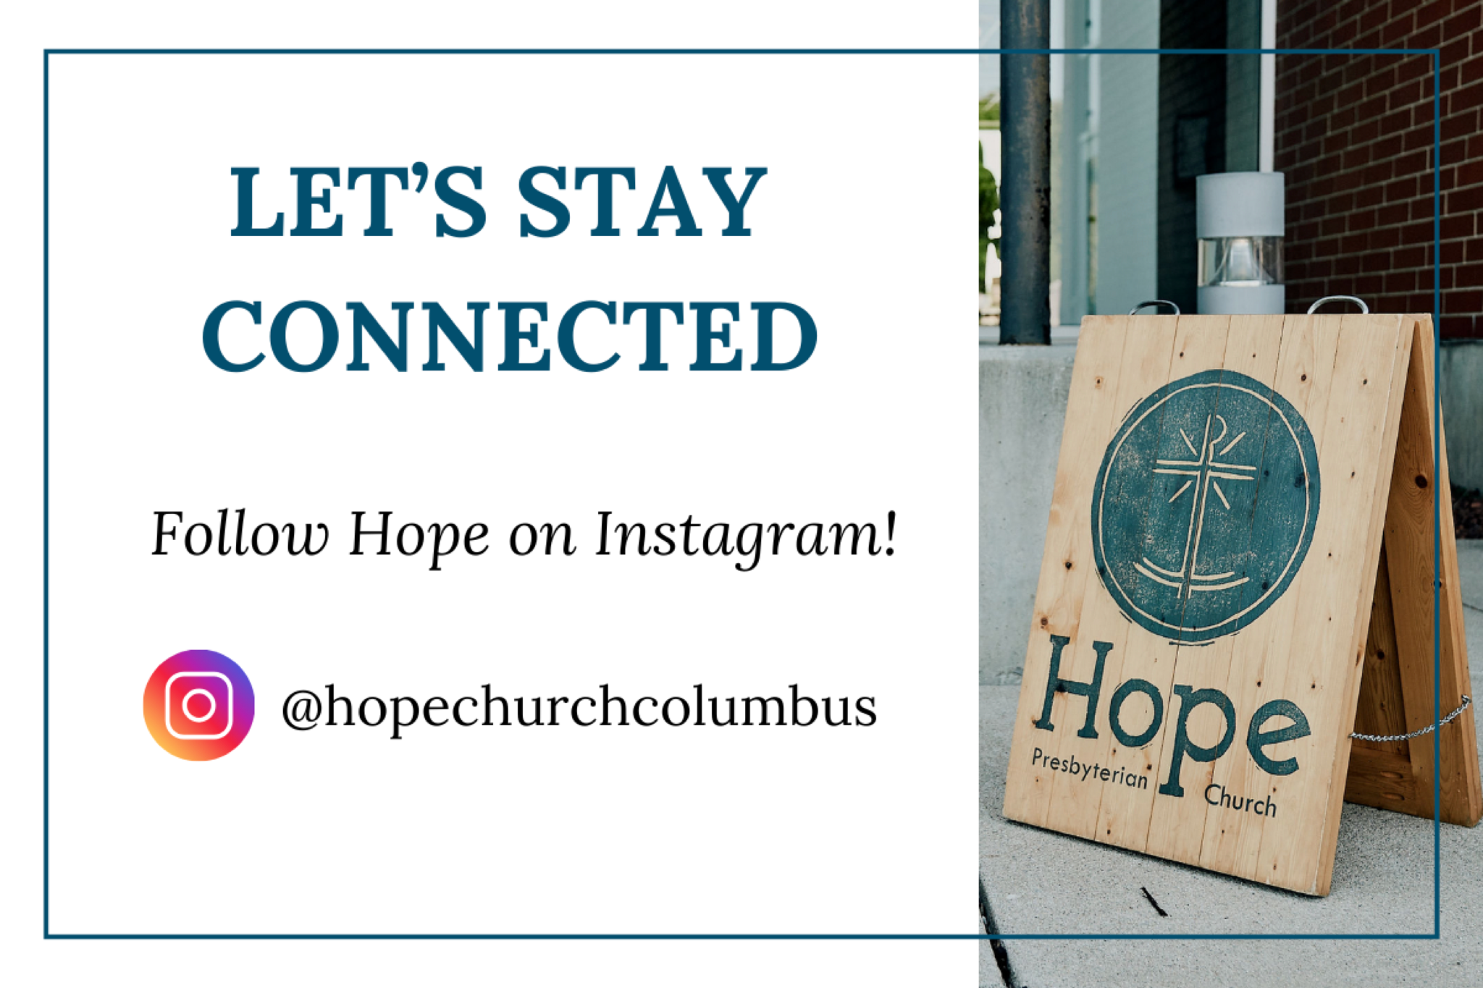

REFLECTION
based on a prayer of Benedict of Nursia
"Almighty God, by the illumination of the Holy Spirit, give us wisdom to perceive you, intellect to understand you, diligence to seek you, patience to wait for you, eyes to behold you, a heart to meditate on you and life to proclaim you, through the power of the Spirit of our Lord Jesus Christ."

CALL TO WORSHIP
John 14:15-17, ESV

LEADER
[Jesus said] If you love me, you will keep my commandments. And I will ask the Father, and he will give you another Helper, to be with you forever, even the Spirit of truth, whom the world cannot receive, because it neither sees him nor knows him. You know him, for he dwells with you and will be in you.

ALL
We praise you and thank you Father for sending us the Spirit as our Helper to live within us forever. Amen.

DOXOLOGY
Lyrics: Thomas Ken, 1674
Praise God from whom all blessings flow;
Praise him all creatures here below;
Praise him above, ye heavenly host;
Praise Father, Son, and Holy Ghost.
Amen.

Prayer of Invocation

HYMN

Come Thou Fount
CCLI Song # 108389
John Wyeth | Robert Robinson
Come Thou fount of ev'ry blessing
Tune my heart to sing Thy grace
Streams of mercy never ceasing
Call for songs of loudest praise
Teach me some melodious sonnet
Sung by flaming tongues above
Praise the mount I'm fixed upon it
Mount of Thy redeeming love
Here I raise mine Ebenezer
Hither by Thy help I'm come
And I hope by Thy good pleasure
Safely to arrive at home
Jesus sought me when a stranger
Wand'ring from the fold of God
He to rescue me from danger
Interposed His precious blood
O to grace how great a debtor
Daily I'm constrained to be
Let Thy grace Lord like a fetter
Bind my wand'ring heart to Thee
Prone to wander Lord I feel it
Prone to leave the God I love
Here's my heart Lord take and seal it
Seal it for Thy courts above

Prayer of Remembrance
based upon Romans 8:16-17

ALL
We pray that your Spirit would bear witness with our spirit that we are children of God. Deepen our experience of being your children, heirs of God and fellow heirs with Christ, provided we suffer with him in order that we may also be glorified with him.

HYMN

Holy, Holy, Holy
CCLI Song # 3501780
John Bacchus Dykes
Holy, holy, holy!
Lord God, almighty
Early in the morning
Our song shall rise to Thee
Holy, holy, holy!
Merciful and mighty
God in three persons
Blessed Trinity
Holy, holy, holy!
All the saints adore Thee
Casting down their golden crowns
Around the glassy sea
Cherubim and seraphim
Falling down before Thee
Who wert and art
And evermore shall be
Holy, holy, holy!
Though the darkness hide Thee
Though the eye of sinful man
Thy glory may not see
Only Thou art holy
There is none beside Thee
Perfect in power, in love, and purity
Holy, holy, holy!
Lord God, almighty
All Thy works shall praise Thy name
In earth, and sky, and sea
Holy, holy, holy!
Merciful and mighty
God in three persons
Blessed Trinity

CONFESSION OF SIN

ALL
Merciful God, we confess that we too easily take for granted the gift of the Holy Spirit. We confess that we too often take for granted your promise that the Spirit will never leave us. We confess that we too often ignore or resist the guidance of your Spirit. Renew us now, by the Holy Spirit we pray. Amen.

HYMN

Jesus Cast a Look on Me
Words: John Berridge
Music: Matthew Perryman Jones
Jesus cast a look on me,
Give me sweet simplicity
Make me poor and keep me low,
Seeking only Thee to know
All that feeds my busy pride,
Cast it evermore aside
Bid my will to Thine submit,
Lay me humbly at Thy feet
Make me like a little child,
Of my strength and wisdom spoiled
Seeing only in Thy light,
Walking only in Thy might
Leaning on Thy loving breast,
Where a weary soul can rest
Feeling well the peace of God,
Flowing from His precious blood
In this posture let me live,
And hosannas daily give
In this temper let me die,
And hosannas ever cry!

GRACE ASSURANCE
John 14:1-3, 25-27 ESV

LEADER
[Jesus said] Let not your hearts be troubled. Believe in God; believe also in me. In my Father’s house are many rooms. If it were not so, would I have told you that I go to prepare a place for you? And if I go and prepare a place for you, I will come again and will take you to myself, that where I am you may be also. And you know the way to where I am going. These things I have spoken to you while I am still with you. But the Helper, the Holy Spirit, whom the Father will send in my name, he will teach you all things and bring to your remembrance all that I have said to you. Peace I leave with you; my peace I give to you.

HYMN

The Goodness of Jesus
CCLI Song # 7121854
Fiona Aghajanian | Harrison Druery | Jaywan Maxwell | Jonny Robinson | Michael Farren | Rich Thompson
Come you weary heart now to Jesus
Come you anxious soul now and see
There is perfect love
And comfort in your tears
Rest here in His wondrous peace
Oh the goodness,
The goodness of Jesus
Satisfied He is all that I need
May it be, come what may
That I rest all my days
In the goodness of Jesus
Come find what this world cannot offer
Come and find your joy here complete
Taste the living water
Never thirst again
Rest here in His wondrous peace
Oh the goodness,
The goodness of Jesus
Satisfied He is all that I need
May it be, come what may
That I rest all my days
In the goodness of Jesus
Come and find your hope now in Jesus
He is all He said He would be
Grace is overflowing
From the Savior’s heart
Rest here in His wondrous peace
Oh the goodness,
The goodness of Jesus
Satisfied He is all that I need
May it be, come what may
That I rest all my days
In the goodness of Jesus
Oh the goodness,
The goodness of Jesus
Satisfied He is all that I need
May it be, come what may
That I rest all my days
In the goodness of Jesus
May it be, come what may
That I rest all my days
In the goodness of Jesus

TITHES AND OFFERINGS


HOPE HAPPENINGS AND ANNOUNCEMENTS




PASSING THE PEACE

SCRIPTURE READING
Luke 8:1-21

LEADER
The Word of the Lord.

ALL
Thanks be to God.

MESSAGE
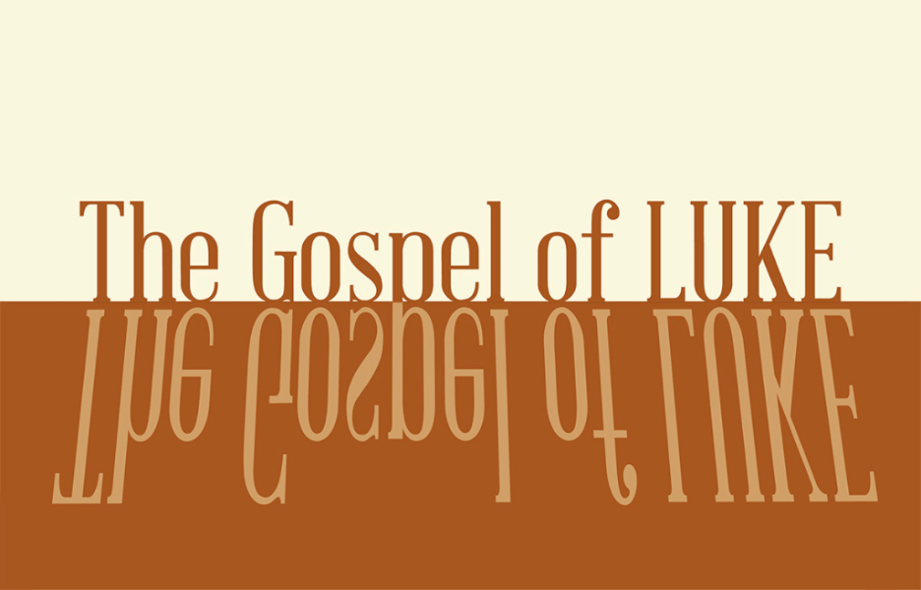

Slide 1
v. 8—whoever has ears to hear, let them hear…
v. 9—though hearing, they may not understand…
v. 12—ones who hear [the word of God]…
v. 13—when they hear…
v. 14—those who hear
v. 15—who hear the word…

Slide 2
v. 18—consider carefully how you listen

Slide 3
“Jesus’ point is not only to counsel ‘hearing’ but also to specify the nature of ‘appropriate’ (and ‘inappropriate’) hearing.” -Joel Green

Slide 4
contemplative & active

Slide 5
contemplative & active

Slide 6
5 “A farmer went out to sow his seed. As he was scattering the seed, some fell along the path; it was trampled on, and the birds ate it up. 6 Some fell on rocky ground, and when it came up, the plants withered because they had no moisture. 7 Other seed fell among thorns, which grew up with it and choked the plants. 8 Still other seed fell on good soil. It came up and yielded a crop, a hundred times more than was sown” (Lk 8:5–8).

Slide 7
8 When he said this, he called out, “Whoever has ears to hear, let them hear.” 9 His disciples asked him what this parable meant. 10 He said, “The knowledge of the secrets of the kingdom of God has been given to you, but to others I speak in parables, so that, “‘though seeing, they may not see; though hearing, they may not understand.’ (Lk 8:8–10)

Slide 8
11 “This is the meaning of the parable: The seed is the word of God. 12 Those along the path are the ones who hear, and then the devil comes and takes away the word from their hearts, so that they may not believe and be saved. 13 Those on the rocky ground are the ones who receive the word with joy when they hear it, but they have no root. They believe for a while, but in the time of testing they fall away. 14 The seed that fell among thorns stands for those who hear, but as they go on their way they are choked by life’s worries, riches and pleasures, and they do not mature. 15 But the seed on good soil stands for those with a noble and good heart, who hear the word, retain it, and by persevering produce a crop. (Lk 8:11–15).

Slide 9
v. 5—some fell along (para)
v. 6—some fell on (epi)
v. 7—some fell among (en meso)
v. 8—some fell into (eis)

Slide 10


Slide 11


Slide 12
contemplative & active

Slide 13
11 “This is the meaning of the parable: The seed is the word of God. 12 Those along the path are the ones who hear, and then the devil comes and takes away the word from their hearts, so that they may not believe and be saved. 13 Those on the rocky ground are the ones who receive the word with joy when they hear it, but they have no root. They believe for a while, but in the time of testing they fall away. 14 The seed that fell among thorns stands for those who hear, but as they go on their way they are choked by life’s worries, riches and pleasures, and they do not mature. 15 But the seed on good soil stands for those with a noble and good heart, who hear the word, retain it, and by persevering produce a crop. (8:11-15)

Slide 14
16 “No one lights a lamp and hides it in a clay jar or puts it under a bed. Instead, they put it on a stand, so that those who come in can see the light. 17 For there is nothing hidden that will not be disclosed, and nothing concealed that will not be known or brought out into the open. 18 Therefore consider carefully how you listen. Whoever has will be given more; whoever does not have, even what they think they have will be taken from them.” (Lk 8:16–18).

Slide 15
After this, Jesus traveled about from one town and village to another, proclaiming the good news of the kingdom of God. The Twelve were with him, 2 and also some women who had been cured of evil spirits and diseases: Mary (called Magdalene) from whom seven demons had come out; 3 Joanna the wife of Chuza, the manager of Herod’s household; Susanna; and many others. These women were helping to support them out of their own means. (Lk 8:1–3).

Slide 16
19 Now Jesus’ mother and brothers came to see him, but they were not able to get near him because of the crowd. 20 Someone told him, “Your mother and brothers are standing outside, wanting to see you.” 21 He replied, “My mother and brothers are those who hear God’s word and put it into practice.”

Slide 17
contemplative & active

Slide 18
contemplative & active

PROFESSION OF FAITH

ALL
EPC Essentials
The Holy Spirit has come to glorify Christ and to apply the saving work of Christ to our hearts. He convicts us of sin and draws us to the Savior. Indwelling our hearts, He gives new life to us, empowers and imparts gifts to us for service. He instructs and guides us into all truth, and seals us for the day of redemption.

SERVICE OF THE TABLE
If you have communicant children who are participating in the Lord's Supper, you may pick them up from Hope Kids at this time.

THE LORD’S SUPPER

1 Corinthians 11:23–26
The Lord Jesus, on the night when he was betrayed took bread and when he had given thanks, he broke it and said, “This is my body which is broken for you. Do this in remembrance of me.” In the same way also he took the cup, after supper, saying, “This cup is the new covenant in my blood. Do this as often as you drink it, in remembrance of me."

HYMN

All Must Be Well
CCLI Song # 5617634
Mary Bowly Peters | Matthew S. Smith
Through the love of God our savior
All will be well
Free and changeless is His favor
All is well
Precious is the blood that healed us
Perfect is the grace that sealed us
Strong the hand stretched forth to shield us
All must be well
Though we pass through tribulation
All will be well
Ours is such a full salvation
All is well
Happy still in God confiding
Fruitful if in Christ abiding
Steadfast through the Spirit's guiding
All must be well
We expect a bright tomorrow
All will be well
Faith can sing through days of sorrow
All is well
On our Father's love relying
Jesus every need supplying
Yes in living or in dying
All must be well
On our Father's love relying
Jesus every need supplying
Yes in living or in dying
All must be well

BENEDICTION
1 Corinthians 2:9-10
What no eye has seen, what no ear has heard, and what no human mind has conceived —the things God has prepared for those who love him—These are the things God has revealed to us by his Spirit.

HOPE HAPPENINGS

“WHO IS HOPE EPC?”
If you are interested in learning more about membership at Hope, use the following link to sign up for more information: https://hopechurchcolumbus.churchcenter.com/unproxy/registrations/events/2941425

NEWCOMER’S BRUNCH
June 15, 2025

CONGREGATIONAL MEETING/VISION SURVEY
Please plan on staying after morning worship for a brief Congregational Meeting on June 22, 2025. At our last family meeting we invited you to join us in prayerfully envisioning what it would look like for Hope to live out our values in the next 5-10 years. As we approach our next congregational meeting on June 22nd, would you consider taking this survey by following this link: https://hopechurchcolumbus.churchcenter.com/people/forms/920195

WOMEN’S SUMMER PARTY
June 27, 2025 @ 7:30 PM
Join the women of Hope for an evening of fellowship at the Redinger Home. Bring a snack, dessert or drink if you would like, or just show up! 2512 Swansea Rd, 43221.

JUBILEE SUNDAY
This will be a more scaled-back service and no childcare or Hope Kids activities will be available. There will be a designated self-serve nursery area for parents to utilize during the service, if needed. On Jubilee Sunday, the worship service is crafted with kids in mind, to celebrate our youngest members and honor our Hope Kids volunteers by giving them a week off from serving.

Digital Connect Card
We’re glad you’re here! Let’s stay connected; please fill out the form at the following link: https://hopechurchcolumbus.churchcenter.com/people/forms/281549.

