

Hope Presbyterian Church Accessible Worship Folder and Slide Deck Transcription
March 2, 2025
www.hopechurchcolumbus.org
Pastor—Joe Haack—joe@hopechurchcolumbus.org
Youth Pastor—Wes Piehl—wes@hopechurchcolumbus.org
Deacons—deacons@hopechurchcolumbus.org
Operations Manager—Nichole Redinger—operations@hopechurchcolumbus.org
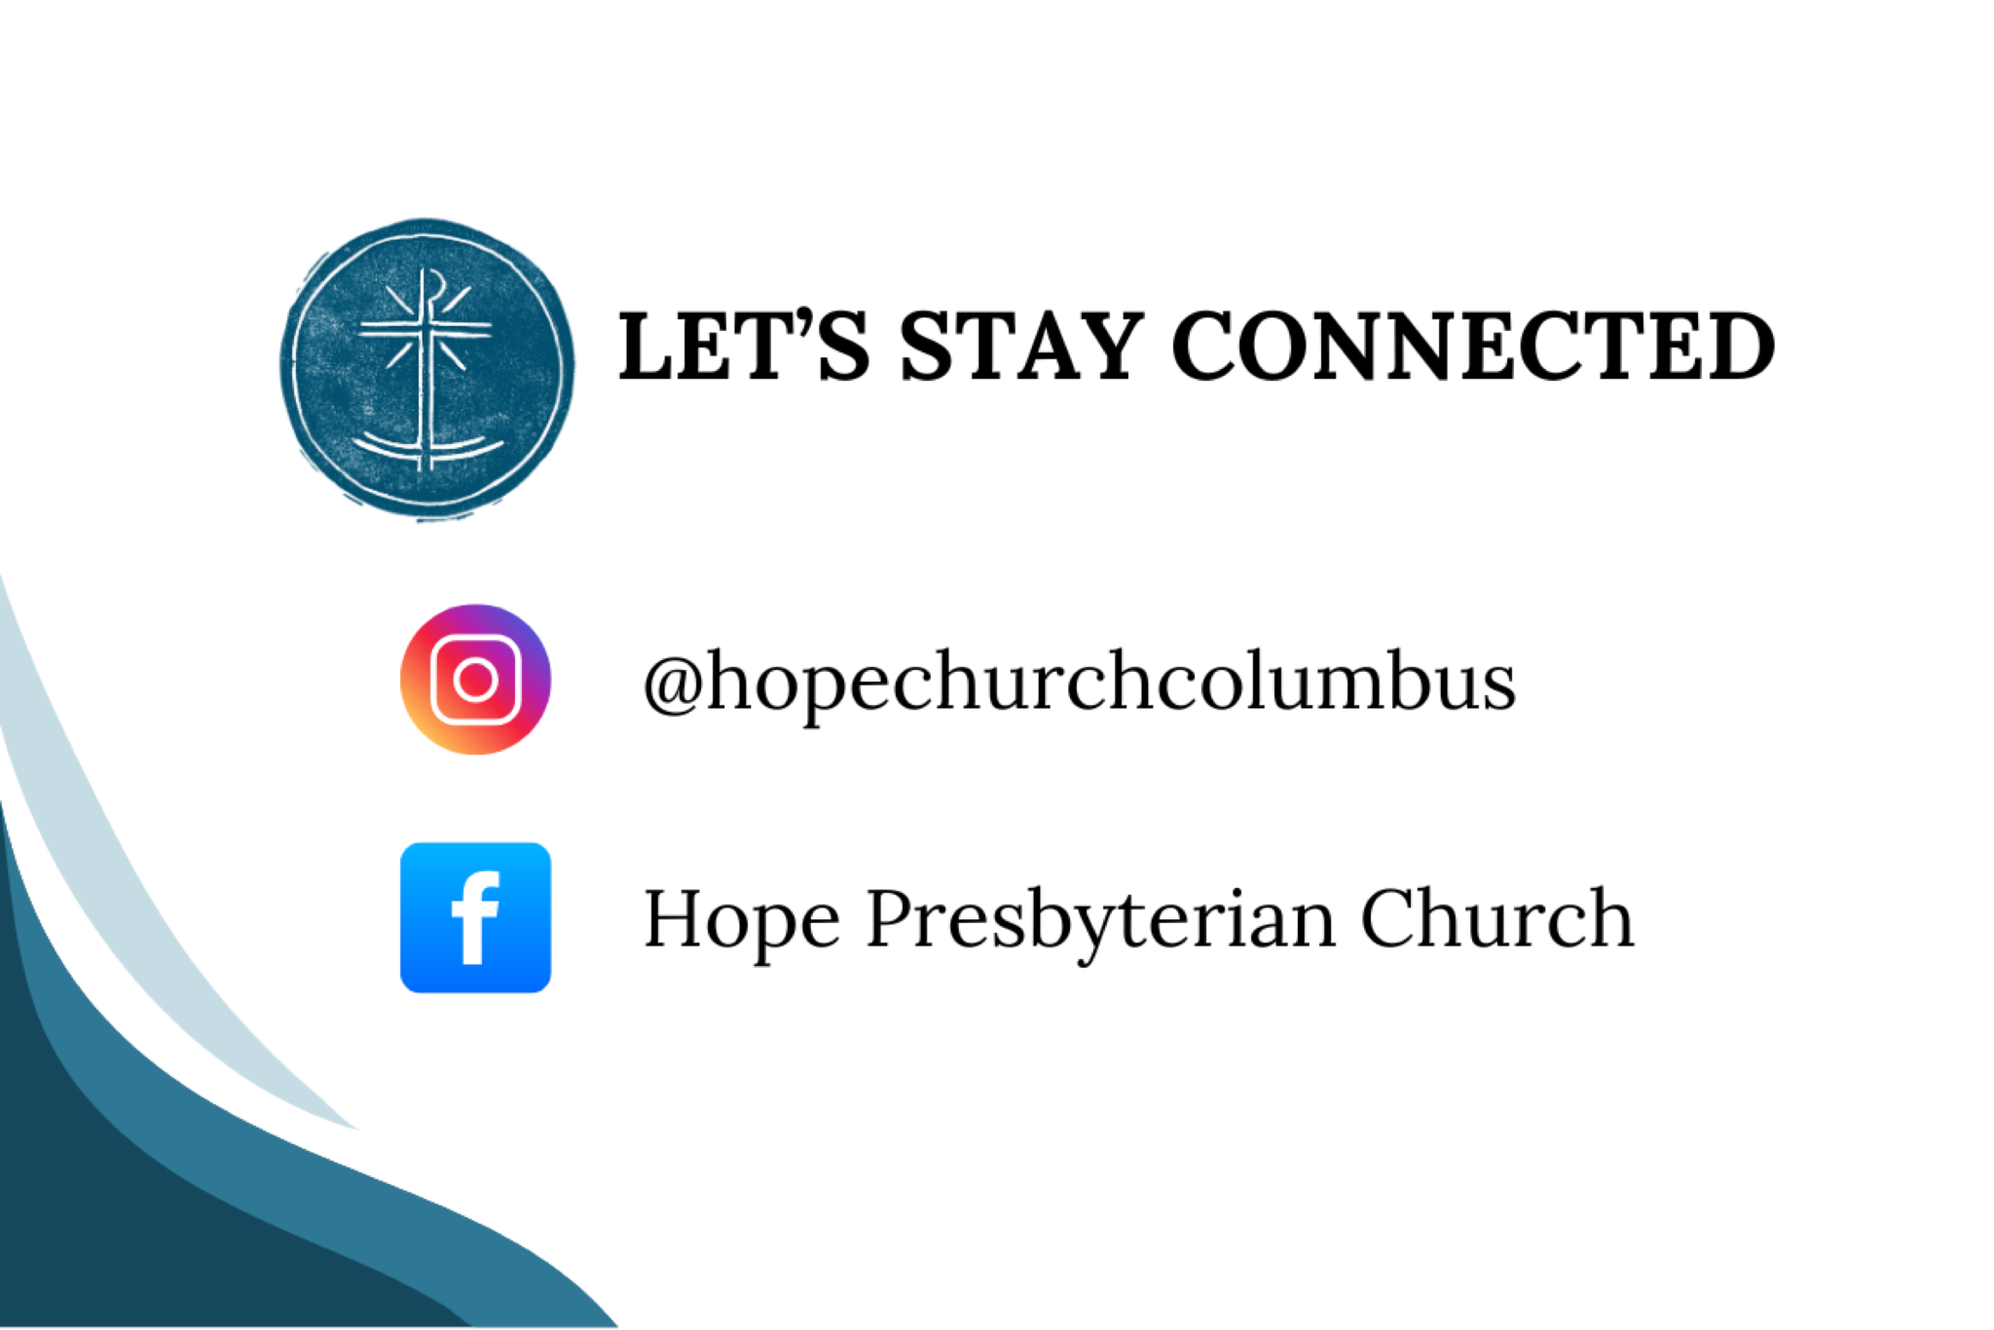

PREPARATION FOR WORSHIP
One refuge from evil must be sought, God. Do not trust in princes. Do not be exalted in the uncertainty of wealth. Do not be proud of bodily strength. Do not pursue the splendor of human glory. None of these things save you. All are transient. All are deceptive. There is one refuge: God.
—Basil the Great

CALL TO WORSHIP
Psalm 86:8-10

LEADER
There is none like you, O Lord, nor are there any works like yours.

ALL
All the nations you have made shall come and bow down before you, O Lord, and shall glorify your name. For you are great and do wondrous things, you alone are God.


DOXOLOGY
Lyrics: Thomas Ken, 1674
Praise God from whom all blessings flow;
Praise him all creatures here below;
Praise him above, ye heavenly host;
Praise Father, Son, and Holy Ghost.
Amen.

Prayer of Invocation

HYMN

O The Deep Deep Love of Jesus
Public Domain.
Words: Samuel Trevor Francis.
Music: Welsh Melody (Adapt. Thomas John Williams)
O the deep, deep love of Jesus,
Vast, unmeasured, boundless, free!
Rolling as a mighty ocean
In its fullness over me!
Underneath me, all around me,
Is the current of Thy love
Leading onward, leading homeward
To Thy glorious rest above!
O the deep, deep love of Jesus,
Spread His praise from shore to shore!
How He loveth, ever loveth,
Changeth never, nevermore!
How He watches o’er His loved ones,
Died to call them all His own;
How for them He intercedeth,
Watcheth o’er them from the throne!
O the deep, deep love of Jesus,
Love of every love the best!
’Tis an ocean vast of blessing,
’Tis a haven sweet of rest!
O the deep, deep love of Jesus,
’Tis a heaven of heavens to me;
And it lifts me up to glory,
For it lifts me up to Thee!

Prayer of Remembrance
Based on Heidelberg Catechism #6

ALL
God, we remember the beginning. We remember that you created human beings good, in your creation you called good, that you have made each one of us in your image, that you made us precious in your sight. You made us in true righteousness and holiness, so that we might rightly know you, so that we might love you with our whole hearts, and so that we might live with you in eternal blessedness, to praise and glorify you, our loving Creator.

HYMN

A Day for Singing
CCLI Song # 7223272 Jess Ray Langdon | Jessie Early | Mitch Wong | Natalie Leonhardt
Mercy rising with the rising of the sun
Goodness rushing in and filling up my lungs
Your faithfulness is here and now
The evidence is all around
I bless Your name
I give You praise
Today is a day for singing
Awake my soul
Come on praise the Lord
Today is a day for singing
Oh my soul
Praise the Lord
Oh my soul
Today is a day for singing
A new song
Is welling up from deep inside of me
There's new life
Hallelujah I have been redeemed
I bless Your name
I give You praise
Today is a day for singing
Awake my soul
Come on praise the Lord
Today is a day for singing
Oh my soul
Praise the Lord
Oh my soul
Today is a day for singing
From the valley to the mountain
The desert to the fountain
Oh I will praise You
From the morning to the evening
As long as I am breathing
Today is a day for singing
From the valley to the mountain
The desert to the fountain
Oh I will praise You
From the morning to the evening
As long as I am breathing
Today is a day for singing
I bless Your name
I give You praise
Today is a day for singing
Awake my soul
Come on praise the Lord
Today is a day for singing
Oh my soul
Praise the Lord
Oh my soul
Today is a day for singing
I bless Your name
I give You praise
Today is a day for singing
Awake my soul
Come on praise the Lord
Today is a day for singing
Oh my soul
Praise the Lord
Oh my soul
Today is a day for singing

CONFESSION OF SIN
Psalm 51

LEADER
When we gather to praise God, we remember that we are people who have preferred our wills to his. Accepting his power to become new persons in Christ, let us confess our sin before God and one another.

ALL
Have mercy on me, O God, according to your steadfast love; according to your abundant mercy blot out my transgressions. Wash me thoroughly from my iniquity, and cleanse me from my sin. For I know my transgressions, and my sin is ever before me. Against you, you alone, have I sinned, and done what is evil in your sight, so that you are justified in your sentence and blameless when you pass judgment. You desire truth in the inward being; therefore teach me wisdom in my secret heart. Hide your face from my sins, and blot out all my iniquities. Create in me a clean heart, O God, and put a new and right spirit within me. Do not cast me from your presence, and do not take your holy spirit from me.

HYMN

Rock of Ages Cleft for Me
CCLI Song # 40588
Augustus Montague Toplady | Thomas Hastings
© Words: Public Domain; Music: Public Domain
Rock of Ages
Cleft for me
Let me hide myself in Thee
Let the water and the blood
From Thy wounded side which flowed
Be of sin the double cure
Cleanse me from its guilt and power
Not the labors of my hands
Can fulfill Thy law's demands
Could my zeal no respite know
Could my tears forever flow
All for sin could not atone
Thou must save
And Thou alone
Whoa, oh, oh
Whoa, oh, oh
Nothing in my hands I bring
Simply to the cross I cling
Naked, come to Thee for dress
Helpless, look to Thee for grace
Foul, I to the fountain fly
Wash me, Savior, or I die
Whoa, oh, oh
Whoa, oh, oh
While I draw my fleeting breath
When mine eyelids close in death
When I soar through tracts unknown
See Thee on Thy judgment throne
Rock of ages
Cleft for me
Let me hide myself in Thee
Rock of ages
Cleft for me
Let me hide myself in Thee

GRACE ASSURANCE
Psalm 103:8–13

LEADER
The LORD is merciful and gracious, slow to anger and abounding in steadfast love. He will not always accuse, nor will he keep his anger forever. He does not deal with us according to our sins, nor repay us according to our iniquities. For as the heavens are high above the earth,
so great is his steadfast love toward those who fear him; as far as the east is from the west, so far he removes our transgressions from us. As a father has compassion for his children, so the LORD has compassion for those who fear him.

HYMN

Reckless Love
CCLI Song # 7089641
Caleb Culver | Cory Asbury | Ran Jackson
© 2017 Cory Asbury Publishing; Richmond Park Publishing; Watershed Worship Publishing; Bethel Music Publishing
Before I spoke a word
You were singing over me
You have been so, so good to me
Before I took a breath
You breathed Your life in me
You have been so, so kind to me
Oh the overwhelming
Never-ending
Reckless love of God
Oh it chases me down
Fights 'til I'm found
Leaves the ninety-nine
I couldn't earn it
I don't deserve it
Still You give Yourself away
Oh the overwhelming
Never-ending
Reckless love of God
When I was Your foe
Still Your love fought for me
You have been so, so good to me
When I felt no worth
You paid it all for me
You have been so, so kind to me
Oh the overwhelming
Never-ending
Reckless love of God
Oh it chases me down
Fights 'til I'm found
Leaves the ninety-nine
I couldn't earn it
I don't deserve it
Still You give Yourself away
Oh the overwhelming
Never-ending
Reckless love of God
There's no shadow You won't light up
Mountain You won't climb up
Coming after me
There's no wall You won't kick down
Lie You won't tear down
Coming after me
There's no shadow You won't light up
Mountain You won't climb up
Coming after me
There's no wall You won't kick down
Lie You won't tear down
Coming after me
There's no shadow You won't light up
Mountain You won't climb up
Coming after me
There's no wall You won't kick down
Lie You won't tear down
Coming after me
There's no shadow You won't light up
Mountain You won't climb up
Coming after me
There's no wall You won't kick down
Lie You won't tear down
Coming after me
Oh the overwhelming
Never-ending
Reckless love of God
Oh it chases me down
Fights 'til I'm found
Leaves the ninety-nine
I couldn't earn it
I don't deserve it
Still You give Yourself away
Oh the overwhelming
Never-ending
Reckless love of God

TITHES AND OFFERINGS


HOPE HAPPENINGS AND ANNOUNCEMENTS
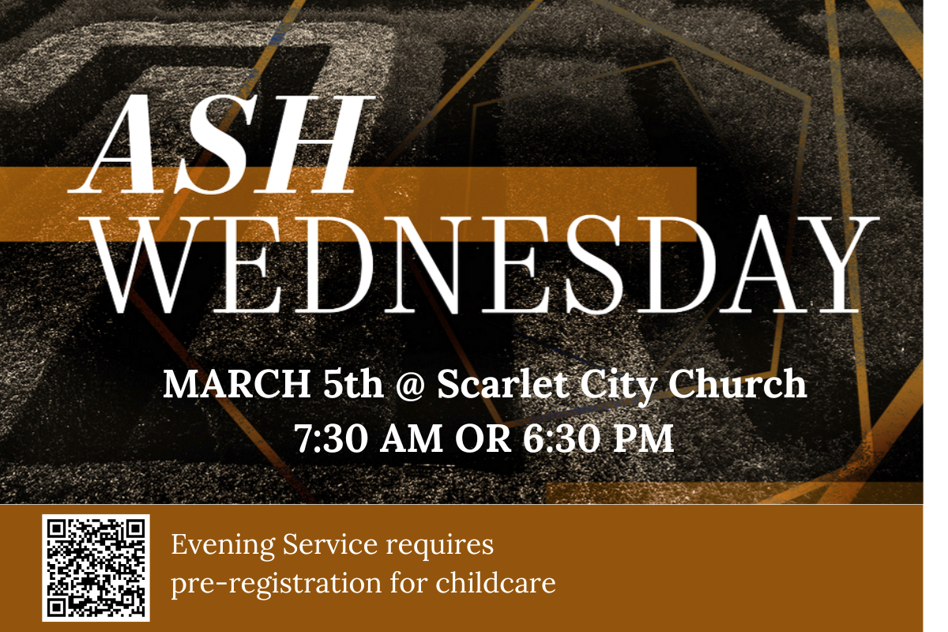



PASSING THE PEACE

SCRIPTURE READING
Luke 5:1-11

MESSAGE


CONFESSION OF FAITH
Heidelberg Catechism #86

LEADER
Since we have been delivered from our misery by grace alone through Christ, without any merit of our own, why must we yet do good works?

ALL
Because Christ, having redeemed us by his blood, also renews us by his Holy Spirit to be his image, so that with our whole life we may show ourselves thankful to God for his benefits, and he may be praised by us. Further, that we ourselves may be assured of our faith by its fruits, and that by our godly walk of life we may win our neighbours for Christ.

THE LORD’S SUPPER

1 Corinthians 11:23–26
The Lord Jesus, on the night when he was betrayed took bread and when he had given thanks, he broke it and said, “This is my body which is broken for you. Do this in remembrance of me.” In the same way also he took the cup, after supper, saying, “This cup is the new covenant in my blood. Do this as often as you drink it, in remembrance of me."

HYMN

Abide
[Default Arrangement] by Aaron Keyes, Aaron Williams, and Dee Wilson
CCLI Song # 7168160
CCLI License # 20115471
For my waking breath,
for my daily bread
I depend on You,
I depend on You
For the sun to rise,
for my sleep at night
I depend on You,
I depend on You
You’re the way, the truth, and the life
You’re the well that never runs dry
I’m the branch and You are the vine
Draw me close and teach me to abide
Where the Spirit leads,
as I’m following
I depend on You,
I depend on You
For the victories,
still in front of me
I depend on You,
I depend on You
You’re the way, the truth, and the life
You’re the well that never runs dry
I’m the branch and You are the vine
Draw me close and teach me to abide
Be my strength,
my song in the night
Be my all,
my treasure, my prize
I am Yours,
forever You're mine
Draw me close
and teach me to abide
When I pass through death,
as I enter rest
I depend on You,
I depend on You
For eternal life,
to be raised with Christ
I depend on You,
I depend on You
You’re the way, the truth, and the life
You’re the well that never runs dry
I’m the branch and You are the vine
Draw me close and teach me to abide
Be my strength,
my song in the night
Be my all,
my treasure, my prize
I am Yours,
forever You're mine
Draw me close
and teach me to abide
You’re the way the truth and the life
You’re the well that never runs dry
I’m the branch and You are the vine
Draw me close and teach me to abide
Be my strength,
my song in the night
Be my all,
my treasure, my prize
I am Yours,
forever You're mine
Draw me close
and teach me to abide
I depend on You,
I depend on You

BENEDICTION
May the Lord guard you and guide you, so that when the race of life is run, you may sleep in peace and rest in Him. May God be with you to the end, that your sleep may be rest indeed, in perfect security in that blessed eternity. —Augustine

HOPE HAPPENINGS

HOPE WOMEN'S RETREAT WEEKEND
April 4–6, 2025
Mohican Haven Lodge in Brickhaven, Ohio
Registration is now open!
https://hopechurchcolumbus.churchcenter.com/registrations/events/2720946

ASH WEDNESDAY
March 5, 2025 at Scarlet City Church Hope is invited to join Scarlet City Church for one of their Ash Wednesday gatherings as we enter the Lenten season together. On March 5, choose from one at 7:30 a.m. and another at 6:30 p.m. The evening service will have childcare provided.

CARMEN HOUSE SPEAKER SERIES
March 21, 2025 at COHatch Gateway, 6:30–8:00 p.m.
Speaker Dr. Ben Burkholder “Why Does Virtue Still Matter in a Secular Age? Reflections on Aristotle and Aquinas for the 21st Century”

CRU VISION DINNER—APRIL 12, 2025
Hope is grateful that many students who join us on Sunday mornings have been deeply impacted by involvement in Cru. To hear more about what God is up to at Cru at OSU and to learn how you can help, save the date for their Vision Dinner. Contact Kendall for more information at kendall.laflin@cru.org.

Digital Connect Card
We’re glad you’re here! Let’s stay connected; please fill out the form at the following link: https://hopechurchcolumbus.churchcenter.com/people/forms/281549.

