# A wholly lamb linocut with a Hope Church Columbus logo featuring a stamped chi-rho cross superimposed on an anchor

# Hope Presbyterian Church Accessible Worship Folder and Slide Deck Transcription

**March 23, 2025**

[www.hopechurchcolumbus.org](http://www.hopechurchcolumbus.org)

Pastor—Joe Haack—[joe@hopechurchcolumbus.org](mailto:joe@hopechurchcolumbus.org)

Youth Pastor—Wes Piehl—[wes@hopechurchcolumbus.org](mailto:wes@hopechurchcolumbus.org)

Deacons—[deacons@hopechurchcolumbus.org](mailto:deacons@hopechurchcolumbus.org)

Operations Manager—Nichole Redinger—[operations@hopechurchcolumbus.org](mailto:operations@hopechurchcolumbus.org)

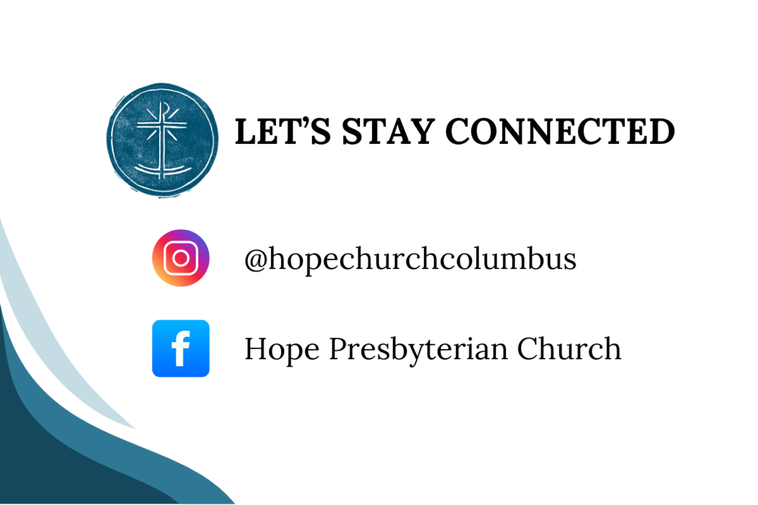

## PREPARATION FOR WORSHIP (Reflection before the Service)

“The hour has come for the Son of man to be glorified.” Glorified—referring to the cross. For from it the power of the Lord was made known, because it changed the shame into glory—the insult into honor, the curse into blessing, the gall into sweetness, the vinegar into milk, the slap in his face into freedom, death into life. The hour has come, for the Son of man to be glorified. (Proclus of Constantinople)

## CALL TO WORSHIP

(Hebrews 5:7–10)

### Leader

In the days of his flesh, Jesus offered up prayers and supplications, with loud cries and tears, to him who was able to save him from death, and he was heard because of his reverence. Although he was a son, he learned obedience through what he suffered. And being made perfect, he became the source of eternal salvation to all who obey him, being designated by God a high priest after the order of Melchizedek.

### All

Glory be to the Father

And to the Son

And to the Holy Spirit

One God, now and forever. Amen.



## DOXOLOGY

Lyrics: Thomas Ken, 1674

Praise God from whom all blessings flow;

Praise him all creatures here below;

Praise him above, ye heavenly host;

Praise Father, Son, and Holy Ghost.

Amen.

## Hope Church Columbus logo featuring a stamped chi-rho cross superimposed on an anchor.Prayer of Invocation

## HYMN

### What a Friend We Have in Jesus

Charles Crozat Converse and Joseph Medlicott Scriven CCLI Song # 27714 -- CCLI License # 20115471 1

What a friend we have in Jesus,

all our sins and griefs to bear!

What a privilege to carry

everything to God in prayer!

O what peace we often forfeit,

O what needless pain we bear,

all because we do not carry

everything to God in prayer!

Have we trials and temptations?

Is there trouble anywhere?

We should never be discouraged;

take it to the Lord in prayer!

Can we find a friend so faithful

who will all our sorrows share?

Jesus knows our every weakness;

take it to the Lord in prayer!

Are we weak and heavy laden,

cumbered with a load of care?

Precious Savior, still our refuge--

take it to the Lord in prayer!

Do your friends despise, forsake you?

Take it to the Lord in prayer!

In his arms he'll take and shield you;

you will find a solace there.



## Prayer of Remembrance

(Psalm 139:13-16)

### All

For you formed my inward parts; you knitted me together in my mother’s womb.I praise you, for I am fearfully and wonderfully made. Wonderful are your works; my soul knows it very well. My frame was not hidden from you, when I was being made in secret, intricately woven in the depths of the earth. Your eyes saw my unformed substance; in your book were written, every one of them, the days that were formed for me, when as yet there was none of them.

## HYMN

### Thy Mercy My God

© 2001 Same Old Dress Music CCLI Song # 3422560 -- CCLI License # 20115471

Thy mercy, my God

Is the theme of my song

The joy of my heart

And the boast of my tongue

Thy free grace alone

From the first to the last

Has won my affection

And bound my soul fast

Without Thy sweet mercy,

I could not live here

Sin would reduce me

To utter despair

But through Thy free goodness,

My spirit's revived

And He, that first made me

Still keeps me alive

Thy mercy is more

Than a match for my heart

Which wonders to feel

Its own hardness depart

Dissolved by Thy goodness

I fall to the ground

And weep for the praise

Of the mercy I've found

Hallelujah

Hallelujah

Great Father of mercy,

Thy goodness I own

And the covenant love

Of Thy crucified Son

All praise to the Spirit

Whose whisper divine

Seals mercy and pardon

And righteousness mine



## CONFESSION OF SIN

(1 John 1:6–9)

### Leader

This is the message we have heard from him and proclaim to you, that God is light, and in him is no darkness at all.

### All

If we say we have fellowship with him while we walk in darkness, we lie and do not practice the truth. But if we walk in the light, as he is in the light, we have fellowship with one another, and the blood of Jesus his Son cleanses us from all sin. If we say we have no sin, we deceive ourselves, and the truth is not in us. If we confess our sins, he is faithful and just to forgive us our sins and to cleanse us from all unrighteousness.



## HYMN

### Reckless Love

CCLI Song # 7089641 Caleb Culver | Cory Asbury | Ran Jackson © 2017 Cory Asbury Publishing; Richmond Park Publishing; Watershed Worship Publishing; Bethel Music Publishing

Before I spoke a word

You were singing over me

You have been so, so good to me

Before I took a breath

You breathed Your life in me

You have been so, so kind to me

Oh the overwhelming

Never-ending

Reckless love of God

Oh it chases me down

Fights 'til I'm found

Leaves the ninety-nine

I couldn't earn it

I don't deserve it

Still You give Yourself away

Oh the overwhelming

Never-ending

Reckless love of God

When I was Your foe

Still Your love fought for me

You have been so, so good to me

When I felt no worth

You paid it all for me

You have been so, so kind to me

Oh the overwhelming

Never-ending

Reckless love of God

Oh it chases me down

Fights 'til I'm found

Leaves the ninety-nine

I couldn't earn it

I don't deserve it

Still You give Yourself away

Oh the overwhelming

Never-ending

Reckless love of God

There's no shadow You won't light up

Mountain You won't climb up

Coming after me

There's no wall You won't kick down

Lie You won't tear down

Coming after me

There's no shadow You won't light up

Mountain You won't climb up

Coming after me

There's no wall You won't kick down

Lie You won't tear down

Coming after me

Oh the overwhelming

Never-ending

Reckless love of God

Oh it chases me down

Fights 'til I'm found

Leaves the ninety-nine

I couldn't earn it

I don't deserve it

Still You give Yourself away

Oh the overwhelming

Never-ending

Reckless love of God

## GRACE ASSURANCE

(1 John 3:1–2)

### Leader

See what kind of love the Father has given to us, that we should be called children of God; and so we are. The reason why the world does not know us is that it did not know him. Beloved, we are God’s children now, and what we will be has not yet appeared; but we know that when he appears we shall be like him, because we shall see him as he is.



## HYMN

### All The Poor & Powerless

CCLI Song # 5881130

David Leonard | Leslie Jordan

All the poor and powerless

And all the lost and lonely

And all the thieves will come confess

And know that You are holy

And know that You are holy

And all will sing out hallelujah

And we will cry out hallelujah

All the hearts who are content

And all who feel unworthy

And all who hurt with nothin' left

Will know that You are holy

And all will sing out hallelujah

And we will cry out hallelujah

Shout it

Go on and scream it from the mountains

Go on and tell it to the masses

That He is God (yeah)

Shout it

Go on and scream it from the mountains

Go on and tell it to the masses

That He is God (yeah)

We will sing out hallelujah

And we will cry out hallelujah

We will sing out hallelujah

And shout yeah

## TITHES AND OFFERINGS



## HOPE HAPPENINGS AND ANNOUNCEMENTS

Student Sunday 
March 30, 2025 
10AM
Free LunchHoly Week
April 13 Palm Sunday Service
April 18 Good Friday Service at Scarlet City Church 
(pre-register for childcare. QR code leads to https://scarletcitychurch.churchcenter.com/registrations/events/2741120.)
April 20 Easter Sunday Service and Brunch

## PASSING THE PEACE

## SCRIPTURE READING

Luke 5:33–39

## MESSAGE



### Slide 1

“put off your old self, which is being corrupted by its deceitful desires; 23 to be made new in the attitude of your minds; 24 and to put on the new self, created to be like God in true righteousness and holiness.

Ephesians 4:22–24

### Slide 2

“But the Pharisees and the teachers of the law who belonged to their sect complained to his disciples, “Why do you eat and drink with tax collectors and sinners?”

Luke 5:30

### Slide 3

They said to him, “John’s disciples often fast and pray, and so do the disciples of the Pharisees, but yours go on eating and drinking”

Luke 5:33

### Slide 4

39 And no one after drinking old wine wants the new, for they say, ‘The old is better.’”

Luke 5:39

### Slide 5

He told them this parable: “No one tears a piece out of a new garment to patch an old one. Otherwise, they will have torn the new garment, and the patch from the new will not match the old.

Luke 5:36

### Slide 6

37 And no one pours new wine into old wineskins. Otherwise, the new wine will burst the skins; the wine will run out and the wineskins will be ruined. 38 No, new wine must be poured into new wineskins.

Luke 5:37–38

### Slide 7

34 Jesus answered, “Can you make the friends of the bridegroom fast while he is with them? 35 But the time will come when the bridegroom will be taken from them; in those days they will fast.”

Luke 5:34-35

### Slide 8

1/ Intense joy

2/ Intense sorrow

### Slide 9

1/ Intense Joy

### Slide 10

1/ Intense Joy

33 They said to him, “John’s disciples often fast and pray, and so do the disciples of the Pharisees, but yours go on eating and drinking.” 34 Jesus answered, “Can you make the friends of the bridegroom fast while he is with them? 35 But the time will come when the bridegroom will be taken from them; in those days they will fast”

### Slide 11

“The role of the guests is to eat, drink, and celebrate with gusto.”

D. Chen

### Slide 12

2/ Intense Sorrow

### Slide 13

2/ Intense Sorrow

34 Jesus answered, “Can you make the friends of the bridegroom fast while he is with them? 35 But the time will come when the bridegroom will be taken from them; in those days they will fast”

### Slide 14

“I’ve heard it said that psychologically, you cannot shut off one part of your unpleasant feelings (like sadness) without also shutting off the pleasurable feelings (like happiness). If Jesus comes to offer us abundant life, that means

highs and lows, fullness, awake-ness. And awake-full-ness is hard-won. It takes courage and a steady supply of God’s tender mercy, not just to expose our wounds, but also to heal our wounds from the inside out.”

Sandra McCracken

### Slide 15

Sorrow in absence

8 We are confident, I say, and would prefer to be away from the body and at home with the Lord. (2 Co 5:8)

“I am torn between the two: I desire to depart and be with Christ, which is better by far (Php 1:23).

Joy in communion

“ 8 What is more, I consider everything a loss because of the surpassing worth of knowing Christ Jesus my Lord, for whose sake I have lost all things (Php 3:7–8).

Though you have not seen him, you love him; and even though you do not see him now, you believe in him and are filled with an inexpressible and glorious joy... (1 Pe 1:8).

I.H. Marshall



## PROFESSION OF FAITH

Our Father in heaven,

hallowed be your name,

your kingdom come,

your will be done,

on earth as in heaven.

Give us today our daily bread.

Forgive us our sins

as we forgive those who sin against us.

Lead us not into temptation

but deliver us from evil.

For the kingdom, the power,

and the glory are yours

now and forever.

Amen.

## THE LORD’S SUPPER

### 1 Corinthians 11:23–26

The Lord Jesus, on the night when he was betrayed took bread and when he had given thanks, he broke it and said, “This is my body which is broken for you. Do this in remembrance of me.” In the same way also he took the cup, after supper, saying, “This cup is the new covenant in my blood. Do this as often as you drink it, in remembrance of me."



## HYMN

### How Can I Keep From Singing?

CCLI Song # 2795377 Robert Lowry

My life flows on in endless song

Above earth's lamentation

I hear the real, though far-off, hymn

That hails a new creation

Through all the tumult and the strife

I hear the music ringing

It sounds and echoes in my soul

How can I keep from singing?

What though the joys and comforts die

The Lord my Savior liveth

What though the darkness gather 'round

Songs in the night He giveth

No storm can shake my inmost calm

While to that rock I'm clinging

Since Love is Lord of heaven and earth

How can I keep from singing

I lift my eyes, the cloud grows thin

I see the blue above it

And day by day this pathway smooths

Since first I learned to love it

The peace of Christ makes fresh my heart

A fountain ever spring

All things are mine since I am His

How can I keep from singing?



## BENEDICTION

The LORD bless you and keep you; the LORD make his face to shine upon you and be gracious to you; the LORD lift up his countenance upon you and give you peace.

## HOPE HAPPENINGS

### CARMEN HOUSE SPEAKER SERIES

**April 18, 2025 @COHatch Gateway, 4:30–5:45 p.m.**

Speaker Dylan Crosson “We Call This Friday Good: How have Christians observed Good Friday & why does it matter?” QR code leads to https://www.carmenhouse.org/speaker-series/we-call-this-friday-good.

### OSU STUDENT SUNDAY

**March 30, 2025**

* Cru’s worship band will help lead Hope in worship.
* We’ll hear how God has been at work in the lives of students.
* Free lunch after church for all OSU students.

### CRU VISION DINNER—APRIL 12, 2025

Hope is grateful that many students who join us on Sunday mornings have been deeply impacted by involvement in Cru. To hear more about what God is up to at Cru at OSU and to learn how you can help, save the date for their Vision Dinner. Contact Kendall for more information at kendall.laflin@cru.org

### HELP HOPE SHOW THE WELCOME OF JESUS: TWO OPPORTUNITIES TO PROVIDE FOOD

Please consider helping contribute to our fellowship events by providing food.

1. Student Sunday—March 30th

2. Easter Sunday Brunch—April 20th

QR Code leads to <https://m.signupgenius.com/#!/showSignUp/30E0F4AA8AD2CA6F94-55587107-hope>.

### HOLY WEEK

April 13—Palm Sunday Service

April 18—Good Friday Service at Scarlet City

April 20—Easter Sunday Service & Brunch

## Digital Connect Card

We’re glad you’re here! Let’s stay connected; please fill out the form at the following link: <https://hopechurchcolumbus.churchcenter.com/people/forms/281549>.