

# Hope Presbyterian Church Accessible Worship Folder and Slide Deck Transcription

**March 9, 2025**

[www.hopechurchcolumbus.org](http://www.hopechurchcolumbus.org)

Pastor—Joe Haack—[joe@hopechurchcolumbus.org](mailto:joe@hopechurchcolumbus.org)

Youth Pastor—Wes Piehl—[wes@hopechurchcolumbus.org](mailto:wes@hopechurchcolumbus.org)

Deacons—[deacons@hopechurchcolumbus.org](mailto:deacons@hopechurchcolumbus.org)

Operations Manager—Nichole Redinger—[operations@hopechurchcolumbus.org](mailto:operations@hopechurchcolumbus.org)

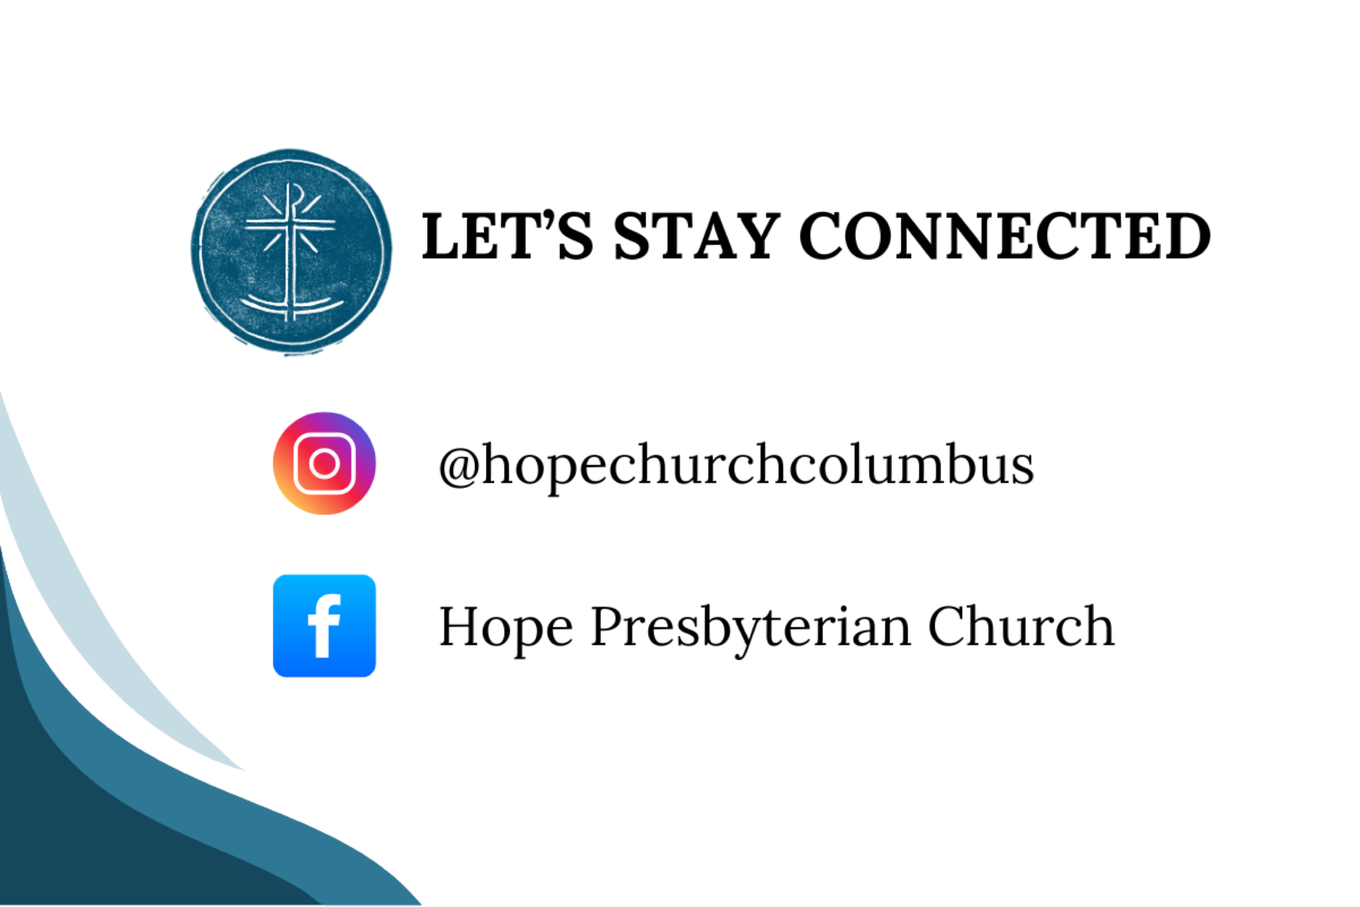

## PREPARATION FOR WORSHIP (Reflection before the Service)

Lent is a season of preparation and repentance during which we anticipate Good Friday and Easter. Just as we carefully prepare for big events in our personal lives, such as a wedding or commencement, Lent invites us to make our hearts ready for remembering Jesus’ passion and celebrating Jesus’ resurrection. (The Worship Sourcebook)

## CALL TO WORSHIP

Hebrews 12:2–3

### LEADER

Lord God, in this season of Lent, we look forward to our remembrance of Jesus’ death and our celebration of his resurrection. We pray that your Spirit will renew in us today our anticipation for these events and our awareness that Jesus’ death and resurrection are a sure source of hope and life. In the power of Jesus’ name we pray.

### ALL

Let us fix our eyes on Jesus, the author and perfecter of our faith, who for the joy set before him endured the cross, scorning its shame, and sat down at the right hand of God. Let us consider him who endured such opposition from sinful people, so that we will not grow weary and lose heart.



## DOXOLOGY

Lyrics: Thomas Ken, 1674

Praise God from whom all blessings flow;

Praise him all creatures here below;

Praise him above, ye heavenly host;

Praise Father, Son, and Holy Ghost.

Amen.

## Hope Church Columbus logo featuring a stamped chi-rho cross superimposed on an anchor.Prayer of Invocation

## HYMN

## Shame Into Praise

CCLI Song # 7121368

Will Duvall | © 2018 William Hill Publishing

Fear not

For the Lord God is with us

Fear not

And be still in His love

As the Lord of all creation

Rejoices with singing

Over us

By grace

Your sins are forgiven

By faith

In the Son of God alone

Called from darkness

Into light

To proclaim the works of Christ

Our cornerstone

Sing praise!

O daughter of Zion

Sing praise!

Our Redeemer King has come

Who is gathering the outcast

Calling home the strayed

Who is binding up the broken

And will change

Our shame into praise

So come

All you heavy laden

Come all

To the One who gives you rest

Call on Jesus and receive

All His mercy

For all your weariness

Sing praise!

O daughter of Zion

Sing praise!

Our Redeemer King has come

Who is gathering the outcast

Calling home the strayed

Who is binding up the broken

And will change

Our shame into praise

Fear not daughter of Zion

Fear not daughter of Zion

Fear not daughter of Zion

Fear not daughter of Zion

Sing praise!

O daughter of Zion

Sing praise!

Our Redeemer King has come

Who is gathering the outcast

Calling home the strayed

Who is binding up the broken

And raising the dead to life again

He is worthy

And mighty to save

Hallelujah!

King Jesus will change

Our shame into praise



## Prayer of Remembrance

Based on Heidelberg Catechism #46

### ALL

O God, we remember and we trust that you have become our loving Father through Christ’s life, death, and resurrection. You do not deny or refuse us as your children, but you invite us to come near. Thank you for listening to whatever is on our hearts. By your Spirit, awaken in us a childlike reverence and trust in Your loving character, O God. Amen.

## HYMN

### All My Ways Are Known To You

CCLI #7073327

© 2016 CityAlight Music (Jonny Robinson, Rich Thompson, Dustin Smith, and Michael Farren)

In days of peace and days of rest

In times of loss and loneliness

Though rich or poor, Your word is true

That all my ways are known to You

No trial has come beyond Your hand

No step I walk, beyond Your land

The path is dark outside my view

Still all my ways are known to You

And O what peace that I have found

Wherever I may be

For all my ways are known to You

Hallelujah, they are known to You

I do not fear the final night

For death will be the door to light

You take my hand and lead me through

And all my ways are known to You

And O what peace that I have found

Wherever I may be

For all my ways are known to You

Hallelujah, they are known to You

Open up my eyes so I may see

That You have made these ways for me

Open up my eyes so I may see

That You my God, will walk with me

Open up my eyes so I may see

That You have made these ways for me

Open up my eyes so I may see

That You my God, will walk with me

And O what peace that I have found

Wherever I may be

For all my ways are known to You

Hallelujah, they are known to You

Hallelujah, they are known to You



## CONFESSION OF SIN AND LAMENT

### LEADER

Lord, we are like sheep, and we get lost. We need a Savior, so we long for Jesus.

### ALL

Why, Lord, must evil seem to get its way? We confess our own sin; and yet the wicked are openly scornful— they mock your name and laugh at those they hurt. We know your providential love holds true: nothing can curse us endlessly with sorrow. So we cry out: Dear Lord, transform this damage somehow into good; display your glory, hidden by evil.



## HYMN

### Lord, From Sorrows Deep I Call

CCLI Song # 7127376 Matt Boswell | Matt Papa

Lord, from sorrows deep I call

When my hope is shaken

Torn and ruined from the fall

Hear my desperation

For so long I’ve pled and prayed:

God come to my rescue

Even so the thorn remains

Still my heart will praise You

Storms within my troubled soul

Questions without answers

On my faith these billows roll

God, be now my shelter

Why are you cast down, my soul?

Hope in Him who saves you

When the fires have all grown cold

Cause this heart to praise You

Oh my soul

Put your hope in God

My help my rock

I will praise Him

Sing, oh sing

Through the raging storm

You're still my God

My salvation

Should my life be torn from me

Every worldly pleasure

When all I possess is grief

God be then my treasure

Be my vision in the night

Be my hope and refuge

’Til my faith is turned to sight

Lord, my heart will praise You

Oh my soul

Put your hope in God

My help my rock

I will praise Him

Sing, oh sing

Through the raging storm

You're still my God

My salvation

Oh my soul

Put your hope in God

My help my rock

I will praise Him

Sing, oh sing

Through the raging storm

You're still my God

My salvation

You're still my God

My salvation

## GRACE ASSURANCE

Matthew 11:28–30

### LEADER

Jesus said: Come to me, all you that are weary and are carrying heavy burdens, and I will give you rest. Take my yoke upon you, and learn from me; for I am gentle and humble in heart, and you will find rest for your souls. For my yoke is easy, and my burden is light.



## HYMN

### Goodness of God

CCLI # 7117726 | Ed Cash and Jenn Johnson

(C) 2018 Alletrop Music (Admin. By Music Services, Inc.) - Remaining Portion Is Unaffiliated

I love You Lord

Oh Your mercy never fails me

All my days

I've been held in Your hands

From the moment that I wake up

Until I lay my head

I will sing

Of the goodness of God

All my life

You have been faithful

All my life

You have been so, so good

With every breath that I am able

I will sing

Of the goodness of God

I love Your voice

You have led me through the fire

In darkest nights

You are close like no other

I've known You as a father

I've known You as a friend

I have lived

In the goodness of God

All my life

You have been faithful

All my life

You have been so, so good

With every breath that I am able

I will sing

Of the goodness of God

Your goodness is running after

It’s running after me

Your goodness is running after

It’s running after me

With my life laid down

I'm surrendered now

I give You everything

Your goodness is running after

It's running after me

Your goodness is running after

It's running after me

Your goodness is running after

It's running after me

With my life laid down

I'm surrendered now

I give You everything

Your goodness is running after

It's running after me

All my life

You have been faithful

All my life

You have been so, so good

With every breath that I am able

I will sing of the goodness of God

I will sing of the goodness of God

## TITHES AND OFFERINGS



## HOPE HAPPENINGS AND ANNOUNCEMENTS

Student Sunday 
March 30, 2025 
10AM
Free Lunch

March 21, 2025 at COHATCH GATEWAY 6:30-8:00PM
“Why Does Virtue Still Matter in a Secular Age?” 
Reflections on Aristotle and Aquinas for the 21st Century
Dr. Ben Burkholder 
Carmen House Speaker Series 
Features a photograph of Dr. Ben Burkholder and a QR code leading to https://www.carmenhouse.org/speaker-series/why-does-virtue-still-matter-in-a-secular-age.

## PASSING THE PEACE

## SCRIPTURE READING

Luke 5:12–26

## MESSAGE



### Slide 1

“It is madness to wear ladies’ straw hats and velvet hats to church; we should all be wearing crash helmets. Ushers should issue life preservers and signal flares; they should lash us to our pews. For the sleeping god may wake someday and take offense, or the waking god may draw us out to where we can never return.” Annie Dillard

### Slide 2

“They were filled with awe and said, “‘We have seen remarkable things today’” (5:26).

### Slide 3

“They were filled with awe and said, “‘We have seen paradoxos things today’” (5:26).

### Slide 4

1/ Faith in Jesus is wilder than we think

### Slide 5

20 When Jesus saw their faith, he said, “Friend, your sins are forgiven.”

### Slide 6

12 While Jesus was in one of the towns, a man came along who was covered with leprosy. When he saw Jesus, he fell with his face to the ground and begged him, “Lord, if you are willing, you can make me clean.”

### Slide 7

17 One day Jesus was teaching, and Pharisees and teachers of the law were sitting there. They had come from every village of Galilee and from Judea and Jerusalem. And the power of the Lord was with Jesus to heal the sick. 18 Some men came carrying a paralyzed man on a mat and tried to take him into the house to lay him before Jesus. 19 When they could not find a way to do this because of the crowd, they went up on the roof and lowered him on his mat through the tiles into the middle of the crowd, right in front of Jesus. 20 When Jesus saw their faith, he said, “Friend, your sins are forgiven” (5:17–20).

### Slide 8

12 While Jesus was in one of the towns, a man came along who was covered with leprosy. When he saw Jesus, he fell with his face to the ground and begged him, “Lord, if you are willing, you can make me clean.”

### Slide 9

19 When they could not find a way to do this because of the crowd, they went up on the roof and lowered him on his mat through the tiles into the middle of the crowd, right in front of Jesus. 20 When Jesus saw their faith, he said, “Friend, your sins are forgiven” (Lk 5:17–20).

### Slide 10

2/ The faithfulness of Jesus is wilder than we think

### Slide 11

13 Jesus reached out his hand and touched the man. “I am willing,” he said. “Be clean!” And immediately the leprosy left him. 14 Then Jesus ordered him, “Don’t tell anyone, but go, show yourself to the priest and offer the sacrifices that Moses commanded for your cleansing, as a testimony to them.”

### Slide 12

20 When Jesus saw their faith, he said, “Friend, your sins are forgiven.” 21 The Pharisees and the teachers of the law began thinking to themselves, “Who is this fellow who speaks blasphemy? Who can forgive sins but God alone?”

### Slide 13

22 Jesus knew what they were thinking and asked, “Why are you thinking these things in your hearts? 23 Which is easier: to say, ‘Your sins are forgiven,’ or to say, ‘Get up and walk’? 24 But I want you to know that the Son of Man has authority on earth to forgive sins.” So he said to the paralyzed man, “I tell you, get up, take your mat and go home.” 25 Immediately he stood up in front of them, took what he had been lying on and went home praising God. 26 Everyone was amazed and gave praise to God. They were filled with awe and said, “‘We have seen remarkable things today’” (5:20–26).

### Slide 14

15 Yet the news about him spread all the more, so that crowds of people came to hear him and to be healed of their sicknesses. 16 But Jesus often withdrew to lonely places and prayed (Lk 5:13–16).

### Slide 15

“That a faith based on staggering mysteries—the Trinity, the Incarnation, the Cross and Resurrection, the imparting of the Spirit—should have become shorn of mystery, so plodding and prosaic, so mundane and managerial is a bitter irony.” Mark Buchanan

### Slide 16



## PROFESSION OF FAITH

The Apostle’s Creed

### ALL

I believe in God, the Father almighty,

creator of heaven and earth.

I believe in Jesus Christ, God's only Son, our Lord,

who was conceived by the Holy Spirit,

born of the Virgin Mary,

suffered under Pontius Pilate,

was crucified, died, and was buried;

he descended to the dead.

On the third day he rose again;

he ascended into heaven,

he is seated at the right hand of the Father,

and he will come to judge the living and the dead.

I believe in the Holy Spirit,

the holy catholic Church,

the communion of saints,

the forgiveness of sins,

the resurrection of the body,

and the life everlasting. Amen.

## THE LORD’S SUPPER

### 1 Corinthians 11:23–26

The Lord Jesus, on the night when he was betrayed took bread and when he had given thanks, he broke it and said, “This is my body which is broken for you. Do this in remembrance of me.” In the same way also he took the cup, after supper, saying, “This cup is the new covenant in my blood. Do this as often as you drink it, in remembrance of me."



## HYMN

### Come Ye Souls By Sin Afflicted

Joseph Swain

Come ye souls by sin afflicted

Bowed with fruitless, sorrow down

By the broken law convicted

Through the cross, behold the crown

Look to Jesus

Look to Jesus

Look to Jesus

Mercy flows through Him alone

Take His easy yoke and wear it

Love will make your obedience sweet

Christ will give you strength to bear it

While His grace shall guide your feet

Look to Jesus

Look to Jesus

Look to Jesus

And His grace shall guide your feet

Blessed are the eyes that see Him

Blest the ears that hear His voice

Blessed are the souls that trust Him

And in Him alone rejoice

Look to Jesus

Look to Jesus

Look to Jesus

And in Him alone rejoice

Sweet as home to pilgrims weary

Light to newly opened eyes

Like full springs in deserts dreary

Is the rest the cross supplies

Look to Jesus

Look to Jesus

Look to Jesus

And the rest the cross supplies



## BENEDICTION

(Matthew 4:4, 6, 11)

Do not live by bread alone, but by the will of God. May God give the angels charge over you; may their hands bear you up and keep you from falling. Amen.



## HOPE HAPPENINGS

### CARMEN HOUSE SPEAKER SERIES

March 21, 2025 at COHatch Gateway, 6:30–8:00 p.m.

Speaker Dr. Ben Burkholder “Why Does Virtue Still Matter in a Secular Age? Reflections on Aristotle and Aquinas for the 21st Century”

### OSU STUDENT SUNDAY

March 30, 2025

Cru’s worship band will help lead Hope in worship. We’ll hear how God has been at work in the lives of students. Free lunch after church for all OSU students.

### CRU VISION DINNER—APRIL 12, 2025

Hope is grateful that many students who join us on Sunday mornings have been deeply impacted by involvement in Cru. To hear more about what God is up to at Cru at OSU and to learn how you can help, save the date for their Vision Dinner. Contact Kendall for more information at [kendall.laflin@cru.org](mailto:kendall.laflin@cru.org)

### HELP HOPE SHOW THE WELCOME OF JESUS: TWO OPPORTUNITIES TO PROVIDE FOOD

Please consider helping contribute to our fellowship events by

providing food.

1. Student Sunday—March 30th

2. Easter Sunday Brunch—April 20th

## Digital Connect Card

We’re glad you’re here! Let’s stay connected; please fill out the form at the following link: <https://hopechurchcolumbus.churchcenter.com/people/forms/281549>.