

# Hope Presbyterian Church Accessible Worship Folder and Slide Deck Transcription

**May 4, 2025**

[www.hopechurchcolumbus.org](http://www.hopechurchcolumbus.org)

Pastor—Joe Haack—[joe@hopechurchcolumbus.org](mailto:joe@hopechurchcolumbus.org)

Youth Pastor—Wes Piehl—[wes@hopechurchcolumbus.org](mailto:wes@hopechurchcolumbus.org)

Deacons—[deacons@hopechurchcolumbus.org](mailto:deacons@hopechurchcolumbus.org)

Operations Manager—Nichole Redinger—[operations@hopechurchcolumbus.org](mailto:operations@hopechurchcolumbus.org)

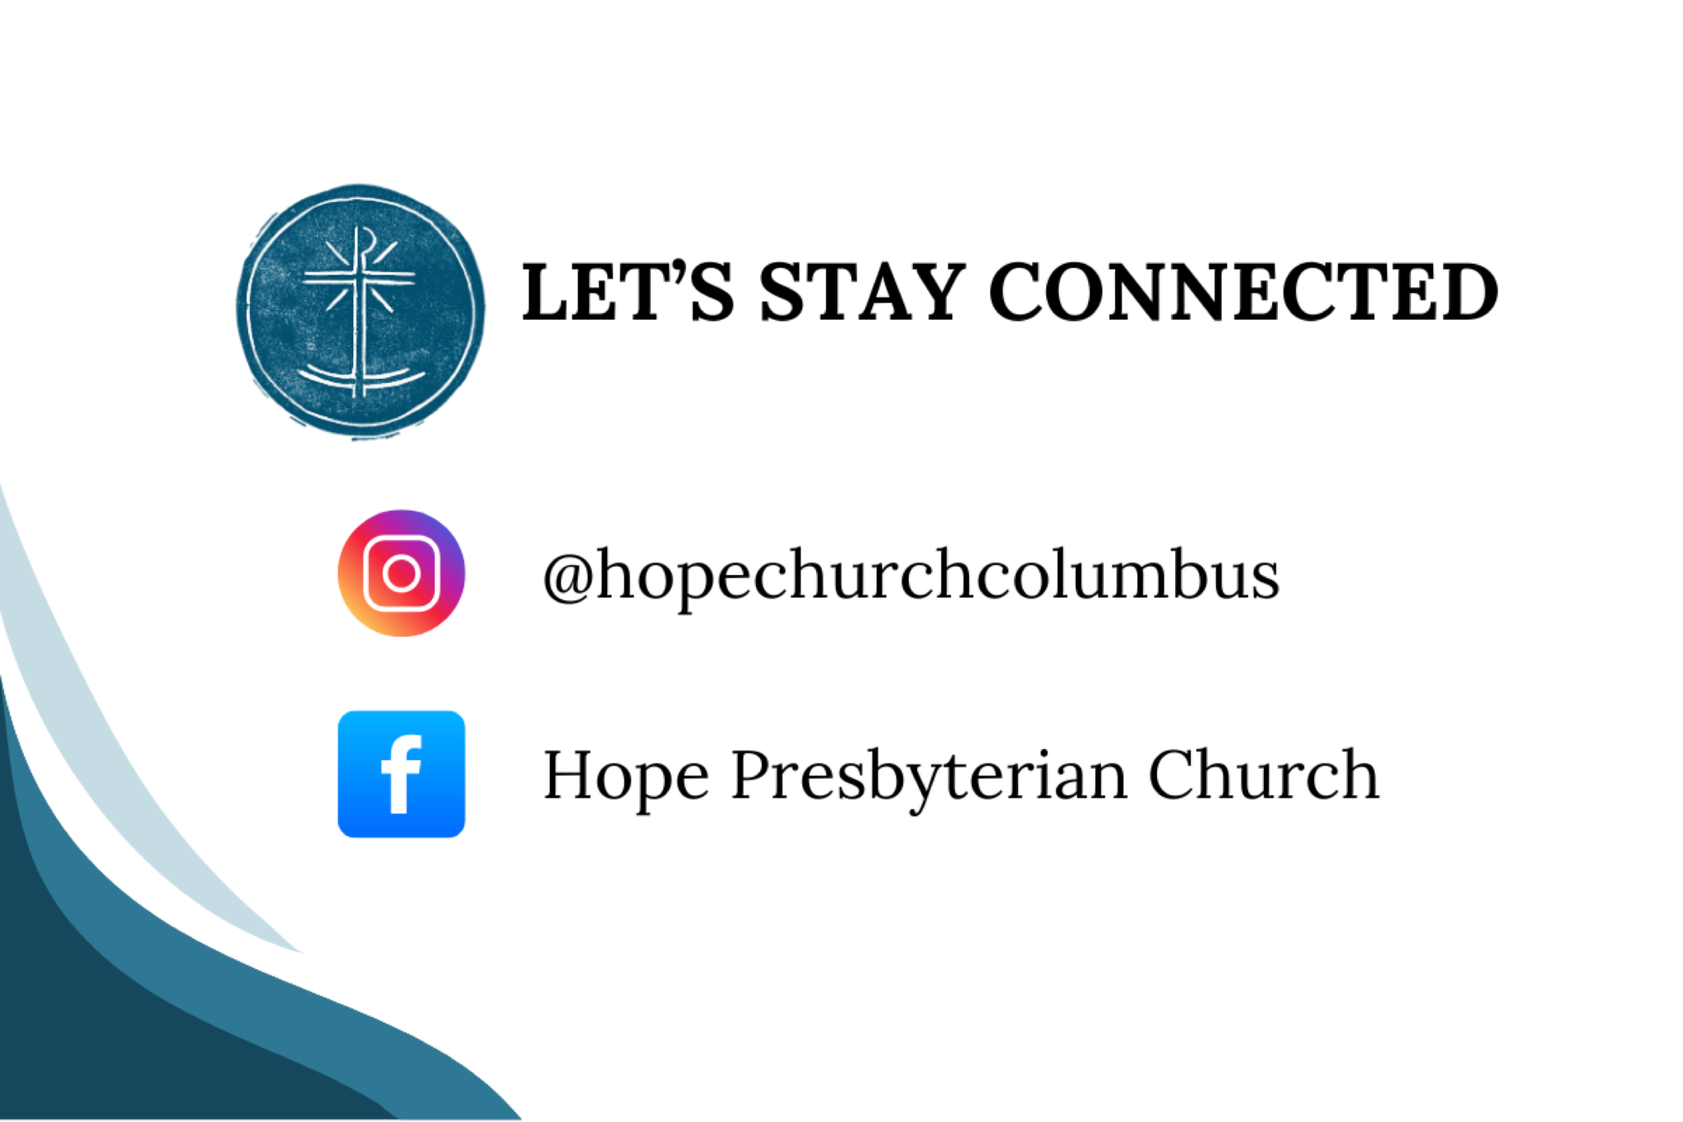

## CALL TO WORSHIP

Psalm 5:7

Because of your unfailing love, I can enter your house; I will worship at your Temple with deepest awe.



## DOXOLOGY

Lyrics: Thomas Ken, 1674

Praise God from whom all blessings flow;

Praise him all creatures here below;

Praise him above, ye heavenly host;

Praise Father, Son, and Holy Ghost.

Amen.



## HYMN

### O The Deep Deep Love of Jesus

Public Domain. Words: Samuel Trevor Francis. Music: Welsh melody (adapt. Thomas John Williams)

O the deep, deep love of Jesus

Vast, unmeasured, boundless, free!

Rolling as a mighty ocean

In its fullness over me!

Underneath me, all around me

Is the current of Thy love

Leading onward, leading homeward

To Thy glorious rest above

O the deep, deep love of Jesus,

Spread His praise from shore to shore!

How He loveth, ever loveth,

Changeth never, nevermore!

How He watches o’er His loved ones

Died to call them all His own

How for them He intercedeth

Watcheth o’er them from the throne

O the deep, deep love of Jesus,

Love of every love the best!

’Tis an ocean vast of blessing,

’Tis a haven sweet of rest!

O the deep, deep love of Jesus

’Tis a heaven of heavens to me

And it lifts me up to glory,

For it lifts me up to Thee!



## HYMN

### Great Things

CCLI #7111321 | Jonas Myrin and Phil Wickham Phil Wickham Music

Come, let us worship our King

Come, let us bow at His feet

He has done great things

See what our Savior has done

See how His love overcomes

He has done great things

He has done great things

Hero of Heaven

You conquered the grave

You free every captive

And break every chain

O God

You have done great things

We dance in Your freedom

Awake and alive

O Jesus, our Savior

Your name lifted high

O God

You have done great things

You've been faithful

Through every storm

You'll be faithful forevermore

You have done great things

And I know You will do it again

For Your promise is Yes and Amen

You will do great things

God You do great things

Hero of Heaven

You conquered the grave

You free every captive

And break every chain

O God

You have done great things

We dance in Your freedom

Awake and alive

O Jesus, our Savior

Your name lifted high

O God

You have done great things

Hallelujah

God above it all

Hallelujah

God unshakable

Hallelujah

You have done great things

Hallelujah

God above it all

Hallelujah

God unshakable

Hallelujah

You have done great things

Hero of Heaven

You conquered the grave

You free every captive

And break every chain

O God

You have done great things

We dance in Your freedom

Awake and alive

O Jesus, our Savior

Your name lifted high

O God

You have done great things

O God

You do great things



## CONFESSION OF SIN

Augustine; Jeremiah 17:9

### LEADER

Lord, you see us as we are, and know our inmost thoughts. We don’t deserve your gracious care. We don’t abide in you. We don’t trust your will. We don’t love one another well. Apart from you, we can do nothing. Lord, in your mercy, forgive us, heal us, and make us whole. Set us free from our sin, and restore unto us to the joy of your salvation Amen.



## HYMN

### How Deep The Father’s Love

CCLI Song # 1558110 Stuart Townend

How deep the Father’s love for us

How vast beyond all measure

That He should give His only son

To make a wretch His treasure

How great the pain of searing loss

The Father turns His face away

As wounds which mar the Chosen One

Bring many sons to glory

Behold the man upon a cross

My sin upon His shoulders

Ashamed I hear my mocking voice

Call out among the scoffers

It was my sin that held Him there

Until it was accomplished

His dying breath has brought me life

I know that it is finished

I will not boast in anything

No gifts, no power, no wisdom

But I will boast in Jesus Christ

His death and resurrection

Why should I gain from His reward?

I cannot give an answer

But this I know with all my heart

His wounds have paid my ransom



## GRACE ASSURANCE

Hebrews 4:14–16

### LEADER

So let us come boldly to the throne of our gracious God. There we will receive his mercy, and we will find grace to help us when we need it most.



## HYMN

### All Sufficient Merit

CCLI Song # 7212933 Bethany Barnard | Bryan Fowler | Shane Barnard

All sufficient merit,

shining like the sun

A fortune I inherit

by no work I have done

My righteousness I forfeit

at my Savior’s cross

Where all sufficient merit

did what I could not

In love He condescended,

eternal now in time

A life without a blemish

the Maker made to die

The law could never save us,

our lawlessness had won

Until the pure and spotless

lamb had finally come

It is done, it is finished

No more debt I owe

Paid in full

All sufficient merit now my own

I lay down my garments,

any empty boast

Good works now all corrupted

by the sinful host

I'm dressed in my Lord Jesus,

a crimson robe made white

No more fear of judgment

His righteousness is mine

It is done, it is finished

No more debt I owe

Paid in full

All sufficient merit now my own

It is done, it is finished

No more debt I owe

Paid in full

All sufficient merit now my own

All sufficient merit

firm in life and death

The joy of my salvation shall

be my final breath

When I stand accepted

before the throne of God

I’ll gaze upon my Jesus

and thank Him for the cross

Yes I’ll thank Him for the cross

It is done, it is finished

No more debt I owe

Paid in full

All sufficient merit now my own

It is done, it is finished

No more debt I owe

Paid in full

All sufficient merit now my own

## TITHES AND OFFERINGS



## HOPE HAPPENINGS AND ANNOUNCEMENTS

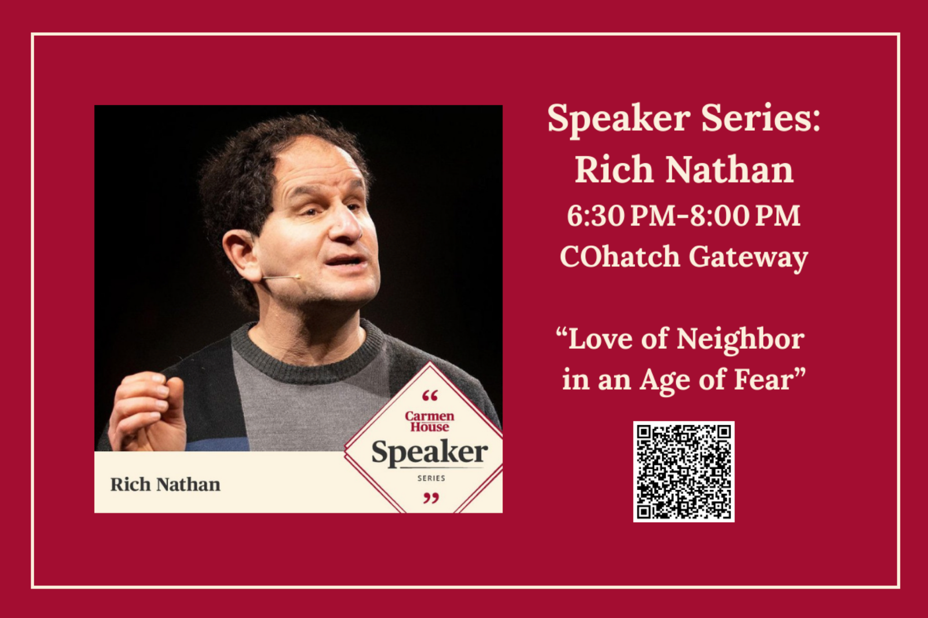

## PASSING THE PEACE

## SCRIPTURE READING

Luke 6:43–49

### LEADER:

The Word of the Lord

### ALL:

Thanks be to God

## MESSAGE

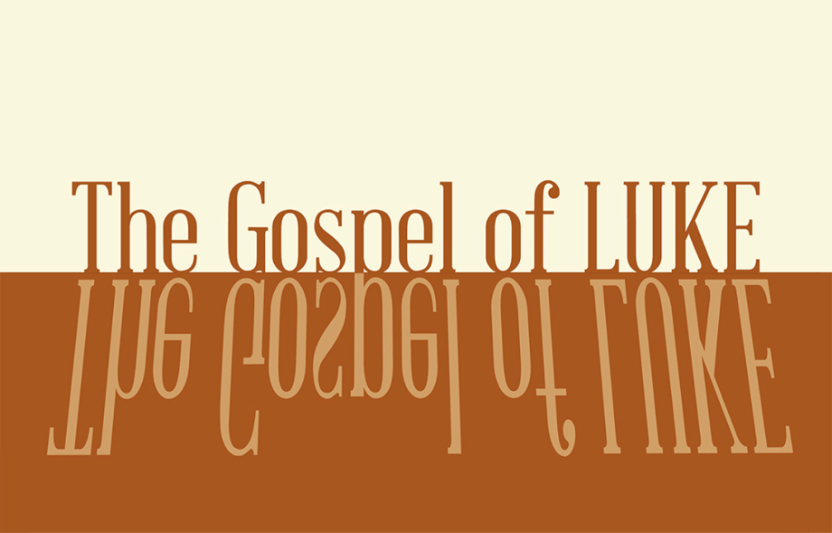

### Slide 1

“A disciple is a learner, a student, an apprentice – a practitioner… Disciples of Jesus are people who do not just profess certain views as their own but apply their growing understanding of life in the Kingdom of the Heavens to every aspect of their life on earth.”

Dallas Willard

### Slide 2

“Why do you call me, ‘Lord, Lord,’ and do not do what I say?” Luke 6:46

### Slide 3

inner ≠ outer

### Slide 4

“You are very entertaining to them, like someone who sings love songs with a beautiful voice or plays fine music on an instrument. They hear what you say, but they don’t act on it!” Ezekiel 33:32, NLT

### Slide 5

43 “No good tree bears bad fruit, nor does a bad tree bear good fruit. 44 Each tree is recognized by its own fruit. People do not pick figs from thornbushes, or grapes from

Briers. Luke 6:43-44

### Slide 6

inner = outer

### Slide 7

45 A good man brings good things out of the good stored up in his heart, and an evil man brings evil things out of the evil stored up in his heart. For the mouth speaks what the heart is full of. Luke 6:45

### Slide 8

Exploring Our Inner Life

### Slide 9

45 A good man brings good things out of the good stored up in his heart, and an evil man brings evil things out of the evil stored up in his heart. For the mouth speaks what the heart is full of. Luke 6:45

### Slide 10

47 As for everyone who comes to me and hears my words and puts them into practice, I will show you what they are like. 48 They are like a man building a house, who dug down deep and laid the foundation on rock. When a flood came, the torrent struck that house but could not shake it, because it was well built. 49 But the one who hears my words and does not put them into practice is like a man who built a house on the ground without a foundation. The moment the torrent struck that house, it collapsed and its destruction was complete.” Luke 6:47-49

### Slide 11

Assess Our Outer Life

### Slide 12

43 “No good tree bears bad fruit, nor does a bad tree bear good fruit. 44 Each tree is recognized by its own fruit. People do not pick figs from thornbushes, or grapes from briers. Luke 6:43-44



## PROFESSION OF FAITH

Our Father in heaven, hallowed be your name, your kingdom come, your will be done, on earth as in heaven. Give us today our daily bread. Forgive us our sins as we forgive those who sin against us. Lead us not into temptation but deliver us from evil. For the kingdom, the power, and the glory are yours now and forever. Amen.

## THE LORD’S SUPPER

### 1 Corinthians 11:23–26

The Lord Jesus, on the night when he was betrayed took bread and when he had given thanks, he broke it and said, “This is my body which is broken for you. Do this in remembrance of me.” In the same way also he took the cup, after supper, saying, “This cup is the new covenant in my blood. Do this as often as you drink it, in remembrance of me."



## HYMN

### Abide With Me

By: Henry Francis Lyte, William Henry Monk

Abide with me

Falls the eventide

The darkness deepens

Lord with me abide

When other helpers

Fail and comforts flee

Help of the helpless

Abide with me

Thou on my head

In early youth didst smile

And though rebellious

And perverse meanwhile

Thou hast not left me

Oft as I left Thee

On to the close Lord

Abide with me

I need Thy presence

Every passing hour

What but Thy grace

Can foil the tempter’s power?

Who, like Thyself

My guide and stay can be?

Through cloud and sunshine

Abide with me

I fear no foe

With Thee at hand to bless

Ills have no weight

Tears lose their bitterness

Where is thy sting death?

Where grave thy victory?

I triumph still

Abide with me

Hold Thou Thy cross

Before my closing eyes

Shine through the gloom

And point me to the skies

Heaven’s morning breaks

And earth’s vain shadows flee

In life, in death, Lord

Abide with me



## BENEDICTION

Romans 15:13

May the God of hope fill you with all joy and peace in believing, so that by the power of the Holy Spirit you may abound in hope.

## Digital Connect Card

We’re glad you’re here! Let’s stay connected; please fill out the form at the following link: <https://hopechurchcolumbus.churchcenter.com/people/forms/281549>.