

Hope Presbyterian Church Accessible Worship Folder and Slide Deck Transcription
November 24, 2024
www.hopechurchcolumbus.org
Pastor—Joe Haack—joe@hopechurchcolumbus.org
Youth Pastor—Wes Piehl—wes@hopechurchcolumbus.org
Deacons—deacons@hopechurchcolumbus.org
Operations Manager—Nichole Redinger—operations@hopechurchcolumbus.org


Prayer of Preparation

ALL
Lord, we want to hear your voice this morning. You are the perfect and good shepherd, and your sheep hear your voice. You know us, and we follow you.

Call to Worship

LEADER
Make a joyful noise to God, all the earth; sing the glory of his name; give to him glorious praise.

ALL
All the earth worships you; they sing praises to you, sing praises to your name.

DOXOLOGY
Lyrics: Thomas Ken, 1674
Praise God from whom all blessings flow;
Praise him all creatures here below;
Praise him above, ye heavenly host;
Praise Father, Son, and Holy Ghost.
Amen.

HYMNS

‘Tis So Sweet To Trust In Jesus
CCLI Song # 22609 Louisa M. R. Stead | William James Kirkpatrick © Words: Public Domain; Music: Public Domain
'Tis so sweet to trust in Jesus
Just to take Him at His word
Just to rest upon His promise
Just to know thus saith the Lord
Jesus Jesus how I trust Him
How I've proved Him o'er and o'er
Jesus Jesus precious Jesus
O for grace to trust Him more
O how sweet to trust in
Jesus Just to trust
His cleansing blood
Just in simple faith to plunge me
'Neath the healing cleansing flood
Jesus Jesus how I trust Him
How I've proved Him o'er and o'er
Jesus Jesus precious Jesus
O for grace to trust Him more
Yes 'tis sweet to trust in Jesus
Just from sin and self to cease
Just from Jesus simply taking
Life and rest and joy and peace
Jesus Jesus how I trust Him
How I've proved Him o'er and o'er
Jesus Jesus precious Jesus
O for grace to trust Him more
I'm so glad I learned to trust Thee
Precious Jesus Savior Friend
And I know that Thou art with me
Wilt be with me to the end
Jesus Jesus how I trust Him
How I've proved Him o'er and o'er
Jesus Jesus precious Jesus
O for grace to trust Him more

Reckless Love
CCLI Song # 7089641
Caleb Culver | Cory Asbury | Ran Jackson © 2017 Cory Asbury Publishing; Richmond Park Publishing; Watershed Worship Publishing; Bethel Music Publishing
Before I spoke a word
You were singing over me
You have been so, so good to me
Before I took a breath
You breathed Your life in me
You have been so, so kind to me
Oh the overwhelming
Never-ending
Reckless love of God
Oh it chases me down
Fights 'til I'm found
Leaves the ninety-nine
I couldn't earn it
I don't deserve it
Still You give Yourself away
Oh the overwhelming
Never-ending
Reckless love of God
When I was Your foe
Still Your love fought for me
You have been so, so good to me
When I felt no worth
You paid it all for me
You have been so, so kind to me
Oh the overwhelming
Never-ending
Reckless love of God
Oh it chases me down
Fights 'til I'm found
Leaves the ninety-nine
I couldn't earn it
I don't deserve it
Still You give Yourself away
Oh the overwhelming
Never-ending
Reckless love of God
There's no shadow You won't light up
Mountain You won't climb up
Coming after me
There's no wall You won't kick down
Lie You won't tear down
Coming after me
There's no shadow
You won't light up
Mountain You won't climb up
Coming after me
There's no wall
You won't kick down
Lie You won't tear down
Coming after me
Oh the overwhelming
Never-ending
Reckless love of God
Oh it chases me down
Fights 'til I'm found
Leaves the ninety-nine
I couldn't earn it
I don't deserve it
Still You give Yourself away
Oh the overwhelming
Never-ending
Reckless love of God

CONFESSION OF SIN
Isaiah 30:15

LEADER
In repentance and rest is your salvation, in quietness and trust is your strength, but you would have none of it.

HYMN

How Can I Keep From Singing?
CCLI Song # 2795377 Robert Lowry
My life flows on in endless song
Above earth's lamentation
I hear the real though far-off hymn
That hails a new creation
Through all the tumult and the strife
I hear the music ringing
It sounds and echoes in my soul
How can I keep from singing?
What though the joys and comforts die
The Lord my Savior liveth
What though the darkness gather 'round
Songs in the night He giveth
No storm can shake my inmost calm
While to that rock I'm clinging
Since Christ is Lord of Heaven and earth
How can I keep from singing?
I lift my eyes, the cloud grows thin
I see the blue above it
And day by day this pathway smooths
Since first I learned to love it
The peace of Christ makes fresh my heart
A fountain ever spring
All things are mine since I am His
How can I keep from singing?

Assurance of Pardon
Isaiah 30:18

LEADER
Yet the LORD longs to be gracious to you; therefore he will rise up to show you compassion. For the LORD is a God of justice. Blessed are all who wait for him!

HYMN

Hymn of Heaven
CCLI Song # 7089641 Caleb Culver | Cory Asbury | Ran Jackson © 2017 CoCCLI Song # 7168994 Bill Johnson | Brian Johnson | Chris Davenport | Phil Wickham
How I long to breathe the air of Heaven
Where pain is gone and mercy fills the streets
To look upon the One who bled to save me
And walk with Him for all eternity
There will be a day when all will bow before Him
There will be a day when death will be no more
Standing face to face with
He who died and rose again
Holy, holy is the Lord
And every prayer we prayed in desperation
The songs of faith we sang through doubt and fear
In the end, we'll see that it was worth it
When He returns to wipe away our tears
Oh, there will be a day when all will bow before Him
There will be a day when death will be no more
Standing face to face with He who died and rose again
Holy, holy is the Lord
And on that day, we join the resurrection
And stand beside the heroes of the faith
With one voice, a thousand generations
Sing, "Worthy is the Lamb who was slain"
So let it be today we shout the hymn of Heaven
With angels and the saints, we raise a mighty roar
Glory to our God who gave us life beyond the grave
Holy, holy is the Lord

TITHES AND OFFERINGS


HOPE HAPPENINGS AND ANNOUNCEMENTS
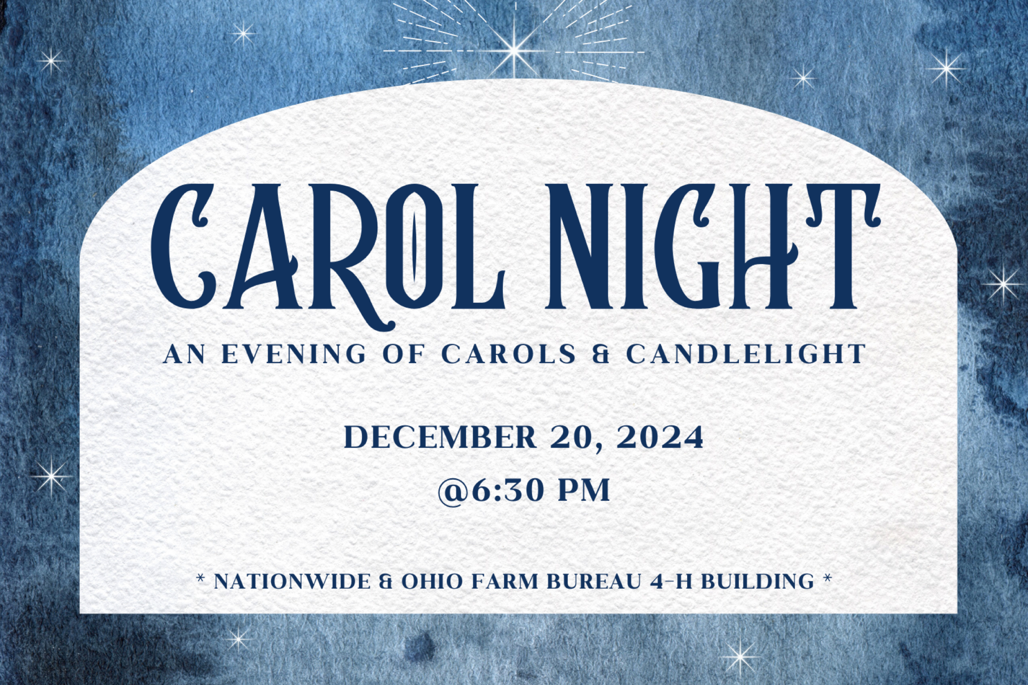



PASSING THE PEACE

SCRIPTURE READING
Psalm 44

MESSAGE

Slide 1


Slide 2
22 Yet for your sake we face death all day long; we are considered as sheep to be slaughtered.
23 Awake, Lord! Why do you sleep? Rouse yourself! Do not reject us forever.
24 Why do you hide your face
and forget our misery and oppression?
25 We are brought down to the dust; our bodies cling to the ground.
26 Rise up and help us;
rescue us because of your unfailing love. (Ps 44:23–26)

Slide 3
“37 A furious squall came up, and the waves broke over the boat, so that it was nearly swamped. 38 Jesus was in the stern, sleeping on a cushion. The disciples woke him and said to him, “Teacher, don’t you care if we drown?” (Mk 4:37–38)

Slide 4
God seems absent.

Slide 5
1/ God is present in his perceived absence

Slide 6
1/ God is present in his perceived absence
22 Yet for your sake we face death all day long; we are considered as sheep to be slaughtered. 23 Awake, Lord! Why do you sleep?
Rouse yourself! Do not reject us forever.
24 Why do you hide your face
and forget our misery and oppression?
25 We are brought down to the dust;
our bodies cling to the ground.
26 Rise up and help us;
rescue us because of your unfailing love. (Ps 44:23–26)

Slide 7
“...implies the revolutionary thought that suffering may be a battle-scar rather than a punishment; the price of loyalty in a world which is at war with God. If this is so, a reverse [i.e. defeat] as well as a victory may be a sign of fellowship with him, not of alienation.” (Derek Kidner)

Slide 8
1/ God is present in his perceived absence
22 Yet for your sake we face death all day long; we are considered as sheep to be slaughtered. 23 Awake, Lord! Why do you sleep?
Rouse yourself! Do not reject us forever.
24 Why do you hide your face
and forget our misery and oppression?
25 We are brought down to the dust;
our bodies cling to the ground.
26 Rise up and help us;
rescue us because of your unfailing love. (Ps 44:23–26)

Slide 9
2/ God is present in his gathered community

Slide 10
2/ God is present in his gathered community
4 There are different kinds of gifts, but the same Spirit distributes them. 5 There are different kinds of service, but the same Lord.
6 There are different kinds of working, but in all of them and in everyone it is the same God at work. 7 Now to each one the manifestation of the Spirit is given for the common good.
(1 Corinthians 12:4-7)

Slide 11
2/ God is present in his gathered community
22 But the fruit of the Spirit is love, joy, peace, forbearance, kindness, goodness, faithfulness, 23 gentleness and self-control. Against such things there is no law (Galatians 5:22–23).

Slide 12
God is present in his perceived absence.
God is present in his gathered people.

Slide 13

PROFESSION OF FAITH
My only comfort in life and in death is that I am not my own, but belong—body and soul, in life and in death—to my faithful Savior Jesus Christ. He has fully paid for all my sins with his precious blood, and has set me free from the tyranny of the devil. He also watches over me in such a way that not a hair can fall from my head without the will of my Father in heaven: in fact, all things must work together for my salvation. Because I belong to him, Christ, by his Holy Spirit, assures me of eternal life and makes me wholeheartedly willing and ready from now on to live for him.
—from Heidelberg Catechism, Q&A 1

THE LORD’S SUPPER

1 Corinthians 11:23–26
The Lord Jesus, on the night when he was betrayed took bread and when he had given thanks, he broke it and said, “This is my body which is broken for you. Do this in remembrance of me.” In the same way also he took the cup, after supper, saying, “This cup is the new covenant in my blood. Do this as often as you drink it, in remembrance of me."

HYMN

ALL MUST BE WELL
CCLI Song # 5617634
Mary Bowly Peters | Matthew S. Smith
Through the love of God our savior
All will be well
Free and changeless is His favor
All is well
Precious is the blood that healed us
Perfect is the grace that sealed us
Strong the hand stretched forth to shield us
All must be well
Though we pass through tribulation
All will be well
Ours is such a full salvation
All is well
Happy still in God confiding
Fruitful if in Christ abiding
Steadfast through the Spirit's guiding
All must be well
We expect a bright tomorrow
All will be well
Faith can sing through days of sorrow
All is well
On our Father's love relying
Jesus every need supplying
Yes in living or in dying
All must be well
On our Father's love relying
Jesus every need supplying
Yes in living or in dying
All must be well

BENEDICTION
based on Philippians 4:7

LEADER
The peace of God, which passes all understanding, keep your hearts and minds in the knowledge and love of God, and of God’s Son, Jesus Christ, our Lord; and the blessing of God Almighty, the Father, the Son, and the Holy Spirit, remain with you always.

HOPE HAPPENINGS

Women’s Christmas Party & Mug Swap
Saturday, December 7 at 10 a.m. Join us for a festive brunch and mug swap. Select a mug from your cupboard to exchange and return home with a new-to-you mug! Get creative or cozy, funny or fancy, classic, or weird!
At the Piehl Home 5364 Amy Lane, 43235. Text Michelle at 419–215–7848
RSVP at https://hopechurchcolumbus.churchcenter.com/registrations/events/2569217.

Carol Night
Friday, December 20 at 6:30 p.m. at Nationwide & Ohio Farm Bureau 4-H Center. Join us for Carol Night, an intimate Christmas Carol service filled with the timeless beauty of scripture and traditional Christmas carols. The evening will culminate in a special outdoor candlelit carol, creating a peaceful moment to celebrate the season. After the service, enjoy festive Christmas cookies and warm fellowship. There’s no need to dress up—just come as you are and bring your friends and family.
Please consider bringing christmas cookies or other treats to share as we
extend the welcome of Jesus to friends, family and newcomers that evening!

HOPE KIDS TEACHERS NEEDED
The Hope Kids team is in need of two Elementary teachers and one Preschool teacher. Teachers typically serve once a month. Please consider helping out in this way. Contact Wes for more information at wes@hopechurchcolumbus.org.

HOPE WOMEN'S RETREAT WEEKEND
Save the Date! April 4–6, 2025. More Information Coming Soon!

Digital Connect Card
We’re glad you’re here! Let’s stay connected; please fill out the form at the following link: https://hopechurchcolumbus.churchcenter.com/people/forms/281549.

