Hope Presbyterian Church
Accessible Worship Folder
June 23, 2024
www.hopechurchcolumbus.org
Pastor—Joe Haack—joe@hopechurchcolumbus.org
Youth Pastor—Wes Piehl—wes@hopechurchcolumbus.org
Deacons—deacons@hopechurchcolumbus.org
Operations Manager—Nichole Redinger—operations@hopechurchcolumbus.org

PREPARATION FOR WORSHIP

Reflection before the Service
May our worship today help us to offer our entire lives to you and unite us with your whole church throughout the world. We pray this in the name of Jesus Christ, who with the Father and the Spirit is one God, blessed forever. Amen.

CALL TO WORSHIP
From Exodus 15:26; Isaiah 6:10

LEADER
God invites us into his healing presence with these words: “I am the Lord, who heals you.”

ALL
Diseased, depressed, dysfunctional, defeated, we come hungering for health that only God can provide. God calls us to bring open eyes, hearing ears, and tender hearts turned toward him, the Great Physician. We bow before him in faith and expectancy!

DOXOLOGY
Praise God from whom all blessings flow;
Praise him all creatures here below;
Praise him above, ye heavenly host;
Praise Father, Son, and Holy Ghost.
Amen.

PRAYER OF INVOCATION

LEADER
God of grace, you have given us minds to know you, hearts to love you, and voices to sing your praise.

ALL
Fill us with your Spirit, that we may celebrate your glory and worship you in spirit and in truth through Jesus Christ, our Lord. Amen.

HYMNS

Holy, Holy, Holy

Verse
Holy, holy, holy! Lord God Almighty!
Early in the morning our song shall rise to Thee;

Verse
Holy, holy, holy, merciful and mighty!
God in three Persons, blessed Trinity!

Verse
Holy, holy, holy! All the saints adore Thee,
Casting down their golden crowns around the glassy sea;

Verse
Cherubim and seraphim falling down before Thee,
Who wert and art and evermore shall be.

Verse
Holy, holy, holy! Though the darkness hide Thee,
Though the eye of sinful man Thy glory may not see;

Verse
Only Thou art holy; there is none beside Thee,
Perfect in power, in love, and purity.

Verse
Holy, holy, holy! Lord God Almighty!
All Thy works shall praise Thy name in earth, and sky, and sea;

Verse
Holy, holy, holy; merciful and mighty!
God in three Persons, blessed Trinity!

Death Has Lost Its Sting

Verse
My God how many are my fears
How fast my foes increase
Conspiring my eternal death
They break my fleeting peace

Verse
The lying tempter would persuade
My heart to doubt Your aid
And all my swelling sins appear
Much greater than Your grace

Chorus
Arise oh Lord fulfill Your grace
While I Your glory sing
My God has broke the serpent's teeth
And death has lost His sting

Verse
But You my glory and my strength
Will on my tempter tread
Will silence all my threatening guilt
And raise my drooping head

Bridge
And though the hosts of death and hell
All armed against me stand
No more will terrors shake my soul
Secure within Your hand

CONFESSION OF SIN
From Psalm 66:16, 18–20, NRSV

LEADER
The psalmist testifies:

ALL
Come and hear, all you who fear God, and I will tell what he has done for me. If I had cherished iniquity in my heart, the Lord would not have listened. But truly God has listened; he has given heed to the words of my prayer. Blessed be God, because he has not rejected my prayer or removed his steadfast love from me. In the strength of this assurance, let us confess our sins to God.

HYMN

Amen, Amen

Verse
Let every creature rise and bring
their grateful praises to our King
Angels descend with songs again
and Earth repeats a loud Amen

Chorus
Amen, Amen
Amen, Amen
I found my life
I found my life in Him
Amen, Amen

Verse
Peace like a river from His throne
will flow to nations yet unknown
His word a light where all hope is dim and all tribes unite to cry “Amen”

Chorus
Amen, Amen
Amen, Amen
I found my life
I found my life in Him
Amen, Amen

Verse
And in this Child weʼll find our rest
and all the meek and lowly blessed
An infant tongue could sing the hymn of Hallelujah and Amen

Chorus
Amen, Amen
Amen, Amen
I found my life
I found my life in Him
Amen, Amen

GRACE ASSURANCE
From Romans 5:8–9, NIV

LEADER
God demonstrates his own love for us in this: While we were still sinners, Christ died for us. Since we have now been justified by his blood, how much more shall we be saved from God’s wrath through him!

HYMN

There is a Peace

VERSE
Come weary and tired worn out from life
Step out of the shadows and walk into light
Come sinner or saint slave-man or free
Bring blessings and offerings
Then you shall you see
Won't you bring blessings and offerings
Then you shall see

CHORUS
There is a peace to settle your soul
There is a peace that is calling you home

VERSE
You've been tempted and shaken tested and failed
You've been so far from Jesus and too close to hell
Your vision's been clouded by the world's delight
But I tell you you're not of this world
So stand up and fight
He said you're not of this world
So stand up and fight

TITHES AND OFFERINGS

ANNOUNCEMENTS
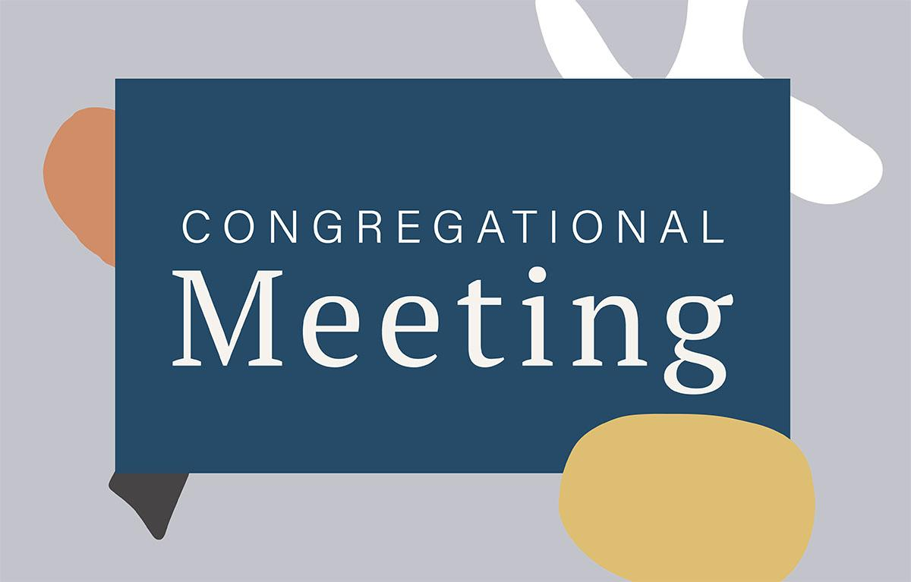
We will have a congregational meeting July 14th after the service.
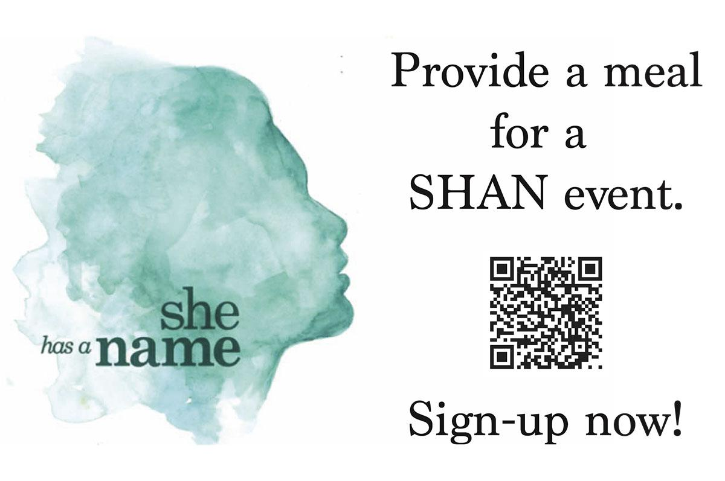

PASSING THE PEACE

SCRIPTURE READING
1 Peter 2:9–10

MESSAGE

Slide 1
Identity
Purpose
Belonging

Slide 2
“I am my own.”

Slide 3
“I am not my own, but belong to Christ

Slide 4
- Who am I?

Slide 5
1 Peter 2:9–10
But you are a chosen race, a royal priesthood, a holy nation, a people for his own possession, that you may proclaim the excellencies of him who called you out of darkness into his marvelous light. Once you were not a people, but now you are God’s people; once you had not received mercy, but now you have received mercy.

Slide 6
- What is my purpose?

Slide 7
1 Peter 2:9
But you are a chosen race, a royal priesthood, a holy nation, a people for his own possession, that you may proclaim the excellencies of him who called you out of darkness into his marvelous light.

Slide 8
- Do I belong?

Slide 9
1 Peter 2:9–10
But you are a chosen race, a royal priesthood, a holy nation, a people for his own possession, that you may proclaim the excellencies of him who called you out of darkness into his marvelous light. Once you were not a people, but now you are God’s people; once you had not received mercy, but now you have received mercy.

Slide 10
- Who am I?
- What is my purpose?
- Do I belong?

CONFESSION OF FAITH
Heidelberg Catechism #119

LEADER
What is the Lord's prayer?

ALL
Our Father in heaven, hallowed be your name, your kingdom come, your will be done on earth as it is in heaven. Give us today our daily bread. Forgive us our debts, as we also have forgiven our debtors. And lead us not into temptation, but deliver us from the evil one, for yours is the kingdom and the power and the glory forever. Amen.

THE LORD’S SUPPER

1 Corinthians 11:23-26
The Lord Jesus, on the night when he was betrayed took bread and when he had given thanks, he broke it and said, “This is my body which is broken for you. Do this in remembrance of me.” In the same way also he took the cup, after supper, saying, “This cup is the new covenant in my blood. Do this as often as you drink it, in remembrance of me."

HYMN

Before the Throne of God Alone

VERSE
Before the throne of God above
I have a strong, a perfect plea
A great High Priest whose name is Love
Who ever lives and pleads for me

CHORUS
My name is graven on His hands
My name is written on His heart
I know that while in heaven He stands
No tongue can bid me thence depart
No tongue can bid me thence depart

VERSE
When Satan tempts me to despair
And tells me of the guilt within
Upward I look and see Him there
Who made an end to all my sin

CHORUS
Because the sinless Savior died
My sinful soul is counted free
For God the Just is satisfied
To look on Him and pardon me
To look on Him and pardon me

VERSE
Behold Him there! The risen Lamb
My perfect, spotless righteousness
The great unchangeable I
The King of glory and of grace

CHORUS
One with Himself I cannot die
My soul is purchased with His blood
My life is hid with Christ on high
With Christ my Savior and my God
With Christ my Savior and my God

BENEDICTION
Go in peace as the reaffirmed church of Jesus Christ. We go to be his body in a broken world. May the grace of God and the love of Christ go with you. Amen.

HOPE HAPPENINGS

MEAL VOLUNTEERS NEEDED
Please consider signing up to provide a meal for our SHAN study group. Access the sign-up sheet with the Hope QR code.

UPCOMING EVENTS
September 13 through 15: Women's Adventure Weekend
November 1 through 3: Men's Adventure Weekend

Digital Connect Card
We’re glad you’re here! Let’s stay connected; please fill out the form at the following link: https://hopechurchcolumbus.churchcenter.com/people/forms/281549.

