

Hope Presbyterian Church Accessible Worship Folder and Slide Deck Transcription
February 16, 2025
www.hopechurchcolumbus.org
Pastor—Joe Haack—joe@hopechurchcolumbus.org
Youth Pastor—Wes Piehl—wes@hopechurchcolumbus.org
Deacons—deacons@hopechurchcolumbus.org
Operations Manager—Nichole Redinger—operations@hopechurchcolumbus.org


CALL TO WORSHIP
Psalm 46:1–3; 10

LEADER
God is our refuge and strength, an ever-present help in trouble. Therefore we will not fear, though the earth give way and the mountains fall into the heart of the sea, though its waters roar and foam and the mountains quake with their surging.

ALL
He says, “Be still, and know that I am God; I will be exalted among the nations, I will be exalted in the earth.”

DOXOLOGY
Lyrics: Thomas Ken, 1674
Praise God from whom all blessings flow;
Praise him all creatures here below;
Praise him above, ye heavenly host;
Praise Father, Son, and Holy Ghost.
Amen.

Prayer of Invocation

HYMNS

10,000 Reasons (Bless the Lord)
CCLI Song # 6016351 Jonas Myrin | Matt Redman
Bless the Lord
Oh my soul
Oh my soul
Worship His holy name
Sing like never before
Oh my soul
I'll worship Your holy name
The sun comes up
It's a new day dawning
It's time to sing Your song again
Whatever may pass
And whatever lies before me
Let me be singing
When the evening comes
Bless the Lord
Oh my soul
Oh my soul
Worship His holy name
Sing like never before
Oh my soul
I'll worship Your holy name
You're rich in love
And You're slow to anger
Your name is great
And Your heart is kind
For all Your goodness
I will keep on singing
Ten thousand reasons
For my heart to find
Bless the Lord
Oh my soul
Oh my soul
Worship His holy name
Sing like never before
Oh my soul
I'll worship Your holy name
And on that day
When my strength is failing
The end draws near
And my time has come
Still my soul will
Sing Your praise unending
Ten thousand years
And then forevermore
Bless the Lord
Oh my soul
Oh my soul
Worship His holy name
Sing like never before
Oh my soul
I'll worship Your holy name
Bless the Lord
Oh my soul
Oh my soul
Worship His holy name
Sing like never before
Oh my soul
I'll worship Your holy name

Blessed Be Your Name
CCLI Song # 3798438
Beth Redman | Matt Redman
Blessed be Your name
In the land that is plentiful
Where Your streams of abundance flow
Blessed be Your name
Blessed be Your name
When I'm found in the desert place
Though I walk through the wilderness
Blessed be Your name
Ev’ry blessing You pour out
I’ll Turn back to praise
When the darkness closes in Lord
Still I will say
Blessed be the name of the Lord
Blessed be Your name
Blessed be the name of the Lord
Blessed be Your glorious name
Blessed be Your name
When the sun's shining down on me
When the world's all as it should be
Blessed be Your name
Ev’ry blessing You pour out
I’ll Turn back to praise
When the darkness closes in Lord
Still I will say
Blessed be the name of the Lord
Blessed be Your name
Blessed be the name of the Lord
Blessed be Your glorious name
Blessed be Your name
On the road marked with suffering
Though there's pain in the offering
Blessed be Your name
You give and take away
You give and take away
My heart will choose to say
Lord blessed be Your name
Blessed be the name of the Lord
Blessed be Your name
Blessed be the name of the Lord
Blessed be Your glorious name
Blessed be the name of the Lord
Blessed be Your name
Blessed be the name of the Lord
Blessed be Your glorious name

CONFESSION OF SIN
Isaiah 55:6-7

LEADER
Seek the Lord while you can find him. Call on him now while he is near. Let the wicked change their ways and banish the very thought of doing wrong.

ALL
Let them turn to the Lord that he may have mercy on them. Yes, turn to our God, for he will forgive generously.

HYMN

How Deep the Father’s Love
CCLI Song # 1558110 | Stuart Townend
How deep the Father’s love for us
How vast beyond all measure
That He should give His only son
To make a wretch His treasure
How great the pain of searing loss
The Father turns His face away
As wounds which mar the Chosen One
Bring many sons to glory
Behold the man upon a cross
My sin upon His shoulders
Ashamed I hear my mocking voice
Call out among the scoffers
It was my sin that held Him there
Until it was accomplished
His dying breath has brought me life
I know that it is finished
I will not boast in anything
No gifts, no power, no wisdom
But I will boast in Jesus Christ
His death and resurrection
Why should I gain from His reward?
I cannot give an answer
But this I know with all my heart
His wounds have paid my ransom

GRACE ASSURANCE
Isaiah 53:5-6

LEADER
But he was pierced for our transgressions, he was crushed for our iniquities; the punishment that brought us peace was on him, and by his wounds we are healed.

ALL
We all, like sheep, have gone astray, each of us has turned to our own way; and the Lord has laid on him the iniquity of us all.

HYMN
On Jordan’s Stormy Banks
CCLI Song # 3251573
Christopher Miner | Samuel Stennett
On Jordan’s stormy banks I stand
And cast a wishful eye
To Canaan’s fair and happy land
Where my possessions lie
All o’er those wide extended plains
Shines one eternal day
There God the Son forever reigns
And scatters night away
I am bound (I am bound)
I am bound (I am bound)
I am bound for the promised land
I am bound (I am bound)
I am bound (I am bound)
I am bound for the promised land
No chilling winds nor poisonous breath
Can reach that healthful shore
Sickness sorrow pain and death
Are felt and feared no more
I am bound (I am bound)
I am bound (I am bound)
I am bound for the promised land
I am bound (I am bound)
I am bound (I am bound)
I am bound for the promised land
When shall I reach that happy place
And be forever blessed?
When shall I see my Father’s face
And in His bosom rest?
I am bound (I am bound)
I am bound (I am bound)
I am bound for the promised land
I am bound (I am bound)
I am bound (I am bound)
I am bound for the promised land

TITHES AND OFFERINGS


HOPE HAPPENINGS AND ANNOUNCEMENTS


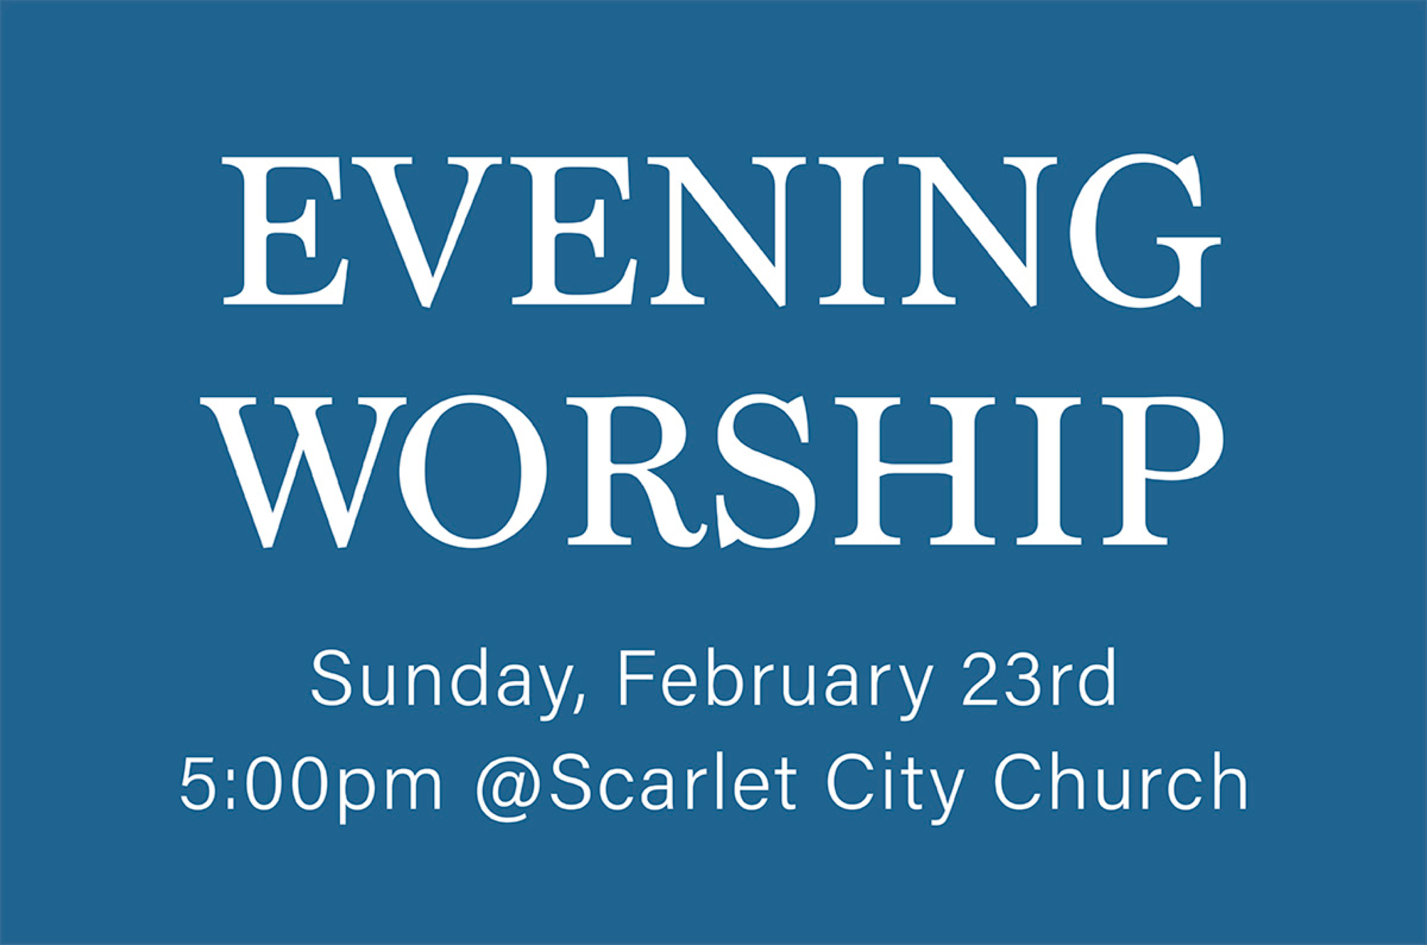

PASSING THE PEACE

SCRIPTURE READING
Luke 4:16–30

MESSAGE
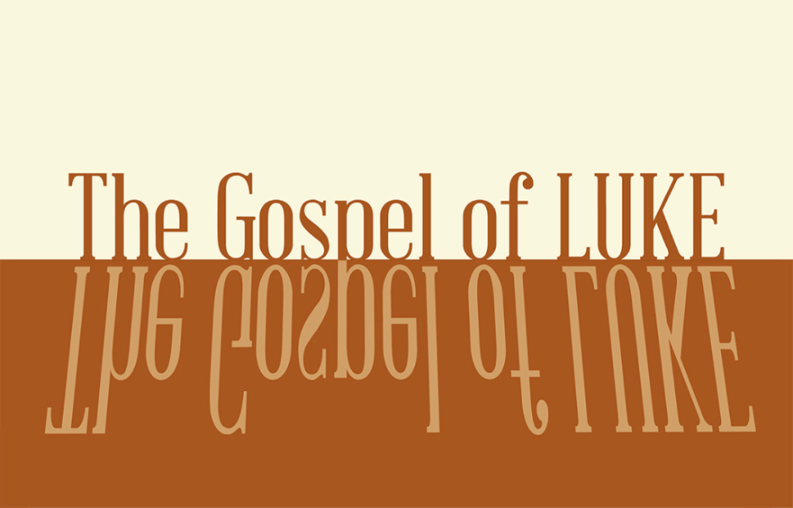

Slide 1
“This change of plans [God’s mercy instead of judgment] greatly upset Jonah, and he became very angry. 2 So he complained to the Lord about it: “Didn’t I say before I left home that you would do this, Lord? That is why I ran away to Tarshish! I knew that you are a merciful and compassionate God, slow to get angry and filled with unfailing love. You are eager to turn back from destroying people. 3 Just kill me now, Lord! I’d rather be dead than alive if what I predicted will not happen" (Jonah 3:10–4:3).

Slide 2
14 Jesus returned to Galilee in the power of the Spirit, and news about him spread through the whole countryside. 15 He was teaching in their synagogues, and everyone praised him. 16 He went to Nazareth, where he had been brought up, and on the Sabbath day he went into the synagogue, as was his custom. He stood up to read, 17 and the scroll of the prophet Isaiah was handed to him. Unrolling it, he found the place where it is written:

Slide 3
18 “The Spirit of the Lord is on me,
because he has anointed me
to proclaim good news to the poor.
He has sent me to proclaim freedom for the prisoners and recovery of sight for the blind,
to set the oppressed free,
19 to proclaim the year of the Lord’s favor” (Lk 4:18–19).

Slide 4
“Today this scripture is fulfilled in your hearing.”

Slide 5
1/ Elijah’s ministry to the desperate widow in Zarephath
2/ Elisha’s ministry to Naaman the Syrian with a skin disease

Slide 6
“Common to Elijah’s and Elisha’s stories was their mission to those despised by reason of their gender (woman), marital status (widowed), gentile origin (Sidonian and Syrian), and physical deformity (leper).” Diane Chen

Slide 7
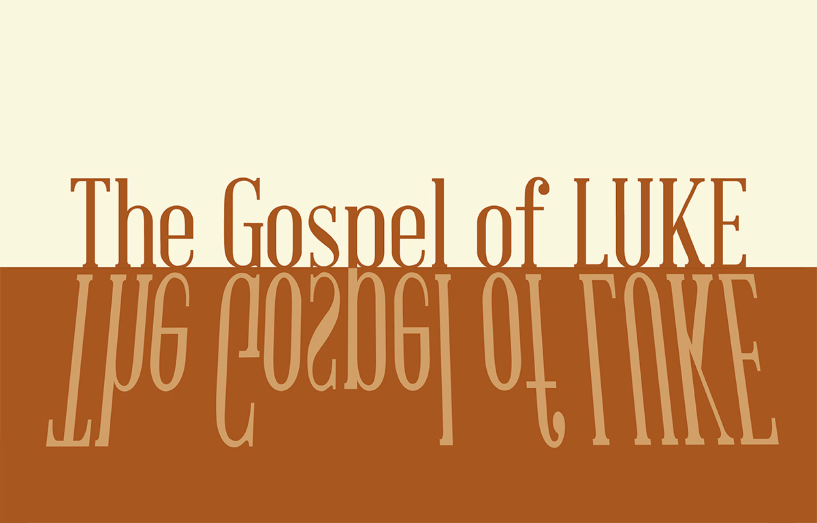

Slide 8
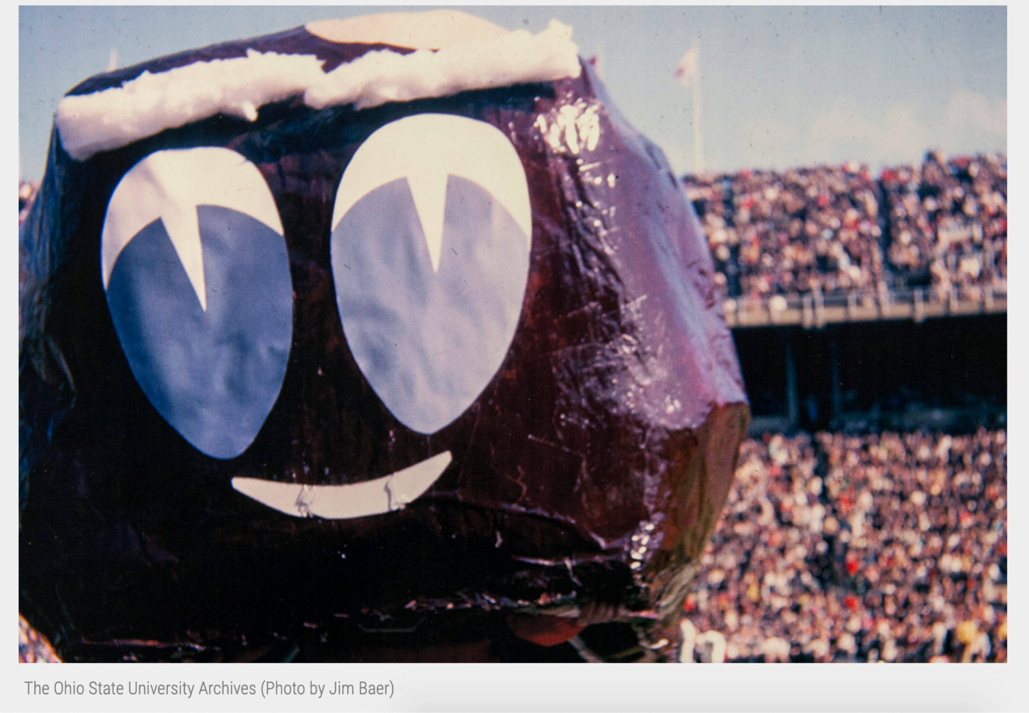Slide 9
1/ Jesus won’t let us define him (16-22)
2/ Jesus won’t let us confine him (23-30)

Slide 10
1/ Jesus won’t let us define him (16-22)

Slide 11
1/ Jesus won’t let us define him (16-22)
Spirit of the Lord is upon me,
For he has anointed me;
To preach good news to the poor he has sent me:
To proclaim for the captives release,
and to the blind sight;
To send forth the oppressed in release;
To proclaim the year of the Lord’s favor. ‘
(translation, Joel Green)

Slide 12
2/ Jesus won’t let us confine him (23-30)

Slide 13
2/ Jesus won’t let us confine him (23-30)
23 Jesus said to them, “Surely you will quote this proverb to me: ‘Physician, heal yourself!’ And you will tell me, ‘Do here in your hometown what we have heard that you did in Capernaum.’ ”

Slide 14
2/ Jesus won’t let us confine him (23-30)
“20 Then Jesus entered a house, and again a crowd gathered, so that he and his disciples were not even able to eat. 21 When his family heard about this, they went to take charge of him, for they said, “He is out of his mind” (Mk 3:20–21).

Slide 15
2/ Jesus won’t let us confine him (23-30)
28 All the people in the synagogue were furious when they heard this. 29 They got up, drove him out of the town, and took him to the brow of the hill on which the town was built, in order to throw him off the cliff. 30 But he walked right through the crowd and went on his way.

Slide 16
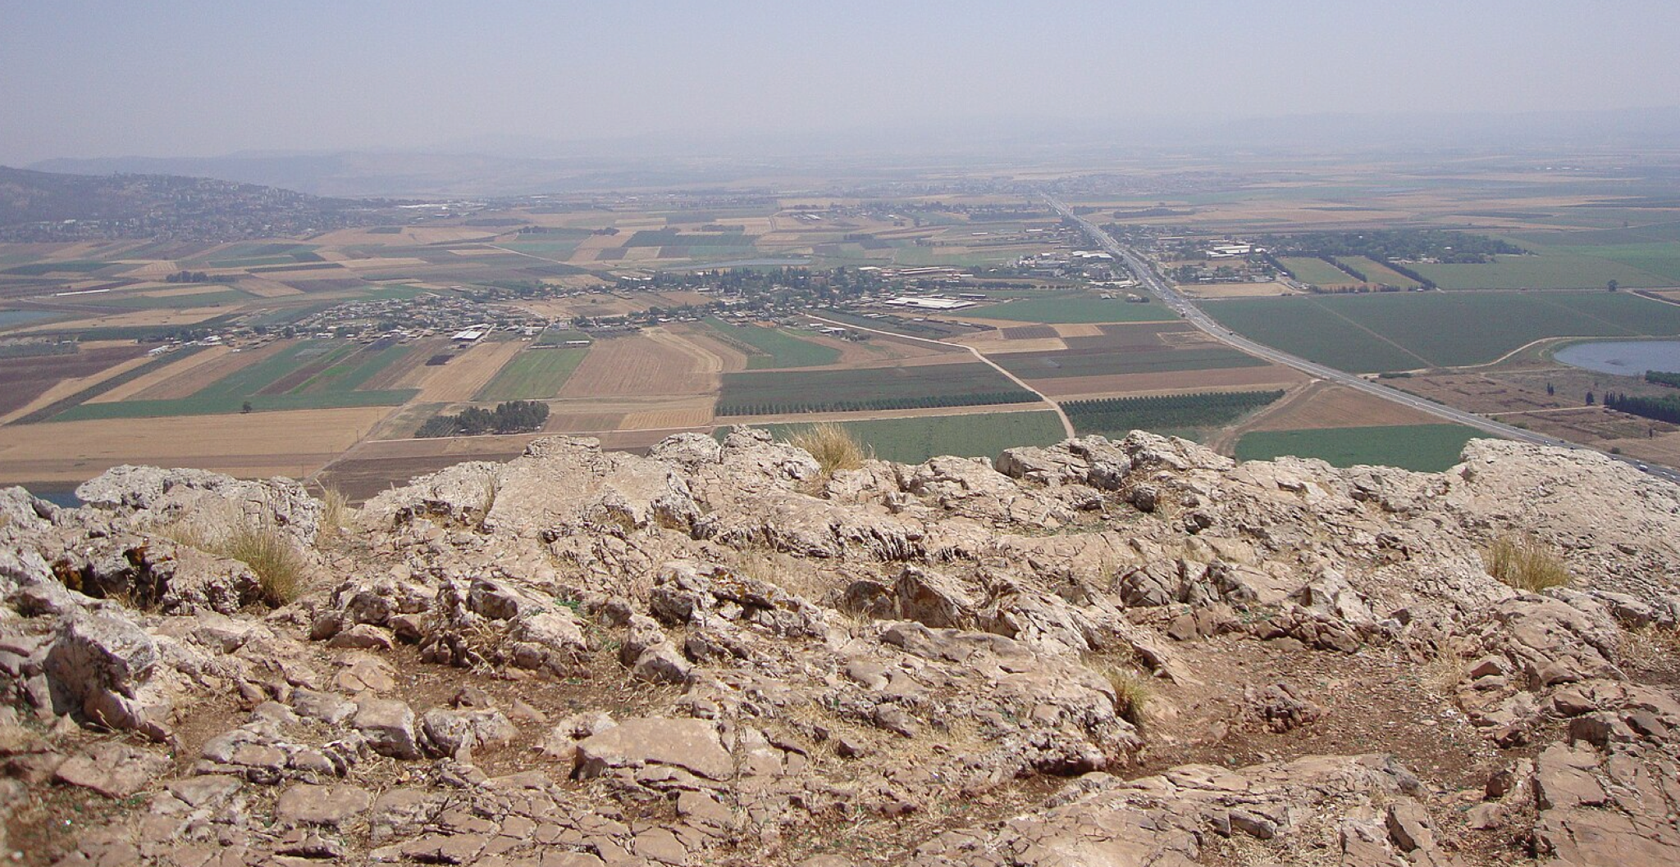

Slide 17

PROFESSION OF FAITH
The Lord’s Prayer
ALL
Our Father, who art in heaven,
Hallowed be thy Name.
Thy Kingdom come.
Thy will be done in earth,
As it is in heaven.
Give us this day our daily bread.
And forgive us our trespasses,
As we forgive those who trespass against us.
And lead us not into temptation,
But deliver us from evil.
For thine is the kingdom,
The power, and the glory,
For ever and ever.
Amen.

THE LORD’S SUPPER

1 Corinthians 11:23–26
The Lord Jesus, on the night when he was betrayed took bread and when he had given thanks, he broke it and said, “This is my body which is broken for you. Do this in remembrance of me.” In the same way also he took the cup, after supper, saying, “This cup is the new covenant in my blood. Do this as often as you drink it, in remembrance of me."

HYMN

Church’s One Foundation
CCLI Song # 55377
Samuel John Stone | Samuel Sebastian Wesley
The church's one foundation
Is Jesus Christ her Lord,
She is His new creation
By water and the Word.
From heaven He came and sought her
To be His holy bride;
With His own blood He bought her,
And for her life He died.
Elect from every nation,
Yet one over all the earth;
Her charter of salvation,
One Lord, one faith, one birth;
One holy Name she blesses,
Partakes one holy food,
And to one hope she presses,
With every grace endued.
Though with a scornful wonder
Men see her sore oppressed,
By schisms rent asunder,
By heresies distressed,
Yet saints their watch are keeping;
Their cry goes up, "How long?"
And soon the night of weeping
Shall be the morn of song.
The church shall never perish,
Her dear Lord to defend
To guide, sustain and cherish,
Is with her to the end
Though there be those that hate her,
And false sons in her pale
Against a foe or traitor,
She ever shall prevail
Mid toil and tribulation,
And tumult of her war,
She waits the consummation
Of peace forevermore;
'Til, with the vision glorious,
Her longing eyes are blessed,
And the great church victorious
Shall be the church at rest.
Yet she on earth hath union
With God the Three in One,
And mystic sweet communion
With those whose rest is won.
O happy ones and holy!
Lord, give us grace that we
Like them, the meek and lowly,
On high may dwell with Thee.

BENEDICTION
Philippians 4:7

The peace of God, which passes all understanding, keep your hearts and minds in the knowledge and love of God, and of God’s Son, Jesus Christ, our Lord; and the blessing of God Almighty, the Father, the Son, and the Holy Spirit, remain with you always.

HOPE HAPPENINGS

HOPE WOMEN'S RETREAT WEEKEND
April 4–6, 2025
Mohican Haven Lodge in Brickhaven, Ohio
Registration is now open!

EVENING WORSHIP—FEBRUARY 23rd at 5 p.m.
On Sunday, Feb, 23rd, we will not have access to the 4-H building and will instead be meeting for evening worship at Scarlet City Church (114 Morse Rd.)

PROVIDE A MEAL FOR SHAN BIBLE STUDIES
Please consider teaming up with a friend, neighbor, family, etc. to make a meal for 12 women who are part of the She Has a Name Thrivers Group. They meet and eat dinner together once a month. Please no pizza! We like to save that for emergencies. Healthier/balanced meals are appreciated. QR code link leads to the signup page.

CONGREGATIONAL MEETING
March 2, 2025: There will be a brief congregational meeting immediately
following the morning worship service.

ASH WEDNESDAY
March 5, 2025 @Scarlet City Church Hope is invited to join Scarlet City Church for one of their Ash Wednesday gatherings as we enter the Lenten season together. On March 5, choose from one at 7:30 AM and another at 6:30 PM. The evening service will have childcare provided.

CRU VISION DINNER- APRIL 12. 2025
Hope is grateful that many students who join us on Sunday mornings have been deeply impacted by involvement in Cru. To hear more about what God is up to at Cru at OSU and to learn how you can help, save the date for their Vision Dinner. Contact Kendall for more information at kendall.laflin@cru.org

Digital Connect Card
We’re glad you’re here! Let’s stay connected; please fill out the form at the following link: https://hopechurchcolumbus.churchcenter.com/people/forms/281549.

