

Hope Presbyterian Church Accessible Worship Folder and Slide Deck Transcription
February 9, 2025
www.hopechurchcolumbus.org
Pastor—Joe Haack—joe@hopechurchcolumbus.org
Youth Pastor—Wes Piehl—wes@hopechurchcolumbus.org
Deacons—deacons@hopechurchcolumbus.org
Operations Manager—Nichole Redinger—operations@hopechurchcolumbus.org


CALL TO WORSHIP

LEADER
A voice cries in the wilderness “Prepare the way of the Lord, make straight in the desert a highway for our God.”

ALL
Let us prepare to welcome God’s dramatic work in our midst, in our hearts, in our community, and in all of creation. Let us worship God.

DOXOLOGY
Lyrics: Thomas Ken, 1674
Praise God from whom all blessings flow;
Praise him all creatures here below;
Praise him above, ye heavenly host;
Praise Father, Son, and Holy Ghost.
Amen.

Prayer of Invocation

HYMNS

Satisfied
Clara T. Williams 1997 | 1875 Karl Digerness
All my life long I had panted
For a drink from some cool spring
That I hoped would quench the burning
Of the thirst I felt within
Hallelujah!
He has found me
The one my soul so long has craved
Jesus satisfies all my longings
Through His blood I now am saved
Feeding on the filth around me
Til my strength was almost gone
Longed my soul for something better
Only still to hunger on
Hallelujah!
He has found me
The one my soul so long has craved
Jesus satisfies all my longings
Through His blood I now am saved
Poor I was and sought for riches
Something that would satisfy
But the dust I gathered round me
Only mocked my soul’s sad cry
Hallelujah!
He has found me
The one my soul so long has craved
Jesus satisfies all my longings
Through His blood I now am saved
Well of water, ever springing
Bread of life so rich and free
Untold wealth that never faileth
My redeemer is to me
Hallelujah!
He has found me
The one my soul so long has craved
Jesus satisfies all my longings
Through His blood I now am saved
Hallelujah!
He has found me
The one my soul so long has craved
Jesus satisfies all my longings
Through His blood I now am saved

For a Thousand Tongues to Sing
CCLI Song # 5013881 | Words by Charles Wesley | David Crowder Music by Carl Gotthelf Glaser | Charles Wesley | David Crowder | Jack Parker
O for a thousand tongues to sing
My great Redeemer's praise
The glories of my God and King
The triumphs of His grace
My gracious Master and my God
Assist me to proclaim
To spread through all the earth abroad
The honors of Thy name
So come on and sing out
Let our anthem grow loud
There is one great love, Jesus
Jesus, the name that charms our fears
That bids our sorrows cease
'Tis music in the sinner's ears
'Tis life and health and peace
He breaks the power of canceled sin
He sets the prisoner free
His blood can make the foulest clean
His blood availed for me
So come on and sing out
Let our anthem grow loud
There is one great love
There is one great love, Jesus
He speaks, and listening to His voice
New life the dead receive
The mournful broken hearts rejoice
The humble poor believe
Glory to God and praise and love
Be ever, ever giv'n
By saints below and saints above
The church in earth and Heav'n
So come on and sing out
Let our anthem grow loud
There is one great love, Jesus

CONFESSION OF SIN

LEADER
From ages past no one has heard, no ear has perceived, no eye has seen any God besides you, who works for those who wait for him. We have all become like one who is unclean, and all our righteous deeds are like a filthy cloth. We all fade like a leaf, and our iniquities, like the wind, take us away from you.

ALL
Yet, you O Lord, are our Father; and you do not remember our iniquity forever. Restore us, we pray, through the coming of our Lord Jesus, in whom we place our hope and trust. Amen.

HYMN

He Leadeth Me
By William Batchelder Bradbury and Gilbert M. Martin © 1995 The Sacred Music Press CCLI Song # 442643 -- CCLI License # 20115471
He leadeth me: O blessed thought!
O words with heavenly comfort fraught!
Whate'er I do, where'er I be,
still 'tis God's hand that leadeth me.
Sometimes mid scenes of deepest gloom,
sometimes where Eden's flowers bloom,
by waters calm, o'er troubled sea,
still 'tis God's hand that leadeth me.
He leadeth me, he leadeth me;
by his own hand he leadeth me:
his faithful follower I would be,
for by his hand he leadeth me.
Lord, I would clasp thy hand in mine,
nor ever murmur nor repine;
content, whatever lot I see,
since 'tis my God that leadeth me.
He leadeth me, he leadeth me;
by his own hand he leadeth me:
his faithful follower I would be,
for by his hand he leadeth me.
And when my task on earth is done,
when, by thy grace, the victory's won,
e'en death's cold wave I will not flee,
since God through Jordan leadeth me.
He leadeth me, he leadeth me;
by his own hand he leadeth me:
his faithful follower I would be,
for by his hand he leadeth me.

GRACE ASSURANCE

LEADER
Take comfort in the assurance that even those things that are hidden from memory, or are too deep for our words, are not beyond God’s forgiving love.

ALL
God, who knows us completely, bestows pardon and peace. Thanks be to God!

HYMN

Christ Be All Around Me
CCLI Song # 7016414 David Leonard | Jack Mooring | Leeland Mooring | Leslie Jordan
As I rise
Strength of God
go before
lift me up
As I wake
Eyes of God
look upon
be my sight
As I wait
Heart of God
satisfy
and sustain
As I hear
Voice of God
lead me on
be my guide
be my guide
Above and below me
Before and behind me
In ev'ry eye that sees me
Christ be all around me
Above and below me
Before and behind me
In ev'ry eye that sees me
Christ be all around me yeah
As I go
Hand of God
my defense
by my side
As I rest
Breath of God
fall upon
bring me peace
bring me peace
Above and below me
Before and behind me
In ev'ry eye that sees me
Christ be all around me
Above and below me
Before and behind me
In ev'ry eye that sees me
Christ be all around me yeah
Your life Your death Your blood
Was shed for ev'ry moment ev'ry moment
Above and below me
Before and behind me
In ev'ry eye that sees me
Christ be all around me
Above and below me
Before and behind me
In ev'ry eye that sees me
Christ be all around me yeah

TITHES AND OFFERINGS


HOPE HAPPENINGS AND ANNOUNCEMENTS


PASSING THE PEACE

SCRIPTURE READING
Luke 4:1–15

MESSAGE
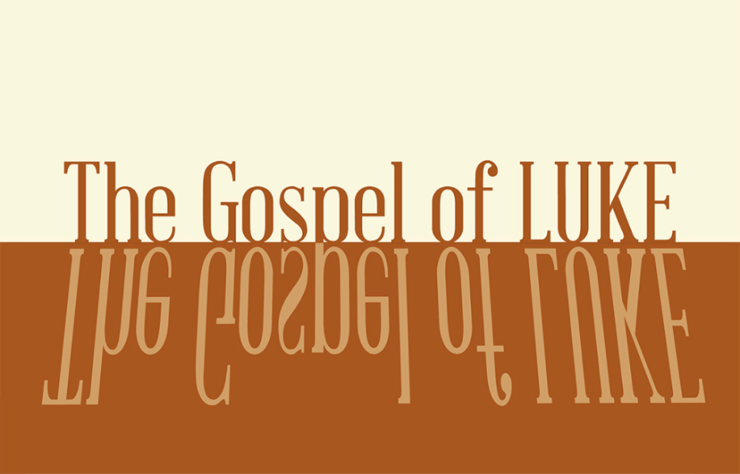

Slide 1


Slide 2

Slide 3
Jesus, full of the Holy Spirit, left the Jordan and was led by the Spirit into the wilderness, 2 where for forty days he was tempted by the devil. He ate nothing during those days, and at the end of them he was hungry.
Luke 4:1–2

Slide 4
“Jesus returned to Galilee in the power of the Spirit, and news about him spread through the whole countryside. 15 He was teaching in their synagogues, and everyone praised him.”
Luke 4:14-15

Slide 5
1/ The wilderness is not pointless
2/ The wilderness is not victorious

Slide 6
1/ The wilderness is not pointless

Slide 7
1/ The wilderness is not pointless
Jesus, full of the Holy Spirit, left the Jordan and was led by the Spirit into the wilderness, 2 where for forty days he was tempted by the devil. He ate nothing during those days, and at the end of them he was hungry.
Luke 4:1–2

Slide 8
1/ The wilderness is not pointless
4 Jesus answered, “It is written: ‘Man shall not live on bread alone.’”
8 Jesus answered, “It is written: ‘Worship the Lord your God and serve him only.’”
12 Jesus answered, “It is said: ‘Do not put the Lord your God to the test.’”

Slide 9


Slide 10
1/ The wilderness is not pointless

Slide 11
1/ The wilderness is not pointless
“For we do not have a high priest who is unable to empathize with our weaknesses, but we have one who has been tempted in every way, just as we are—yet he did not sin” (Hebrews 4:15).

Slide 12
1/ The wilderness is not pointless
“Tests in life are not bad; in fact, they can be divinely sent (James 1:2–4). The main issue is my response to a test. Do I respond in a way that looks to God to guide me through it? Do I trust him, or do I put him to the test? How do I respond to personal struggles in my life? Do I get angry? Do I seek to reassert my control (even when I know I cannot control events!)?” -D. Bock

Slide 13
2/ The wilderness is not victorious

Slide 14
2/ The wilderness is not victorious
“There’s a military strategy here. Satan is the prince of this world. He has usurped the authority, the dominion that God gave originally to Adam.... something is going to happen for the first time in human history. The man, Christ Jesus, the new Adam, is going to enter enemy-occupied territory—a garden that’s been turned into a wilderness by the enemy—and He’s going to face him down, withstand his fiercest, attacks and conquer him.” -Sinclair Ferguson

Slide 15
2/ The wilderness is not victorious
“When the devil had finished all this tempting, he left him until an opportune time” (13).

Slide 16


Slide 17
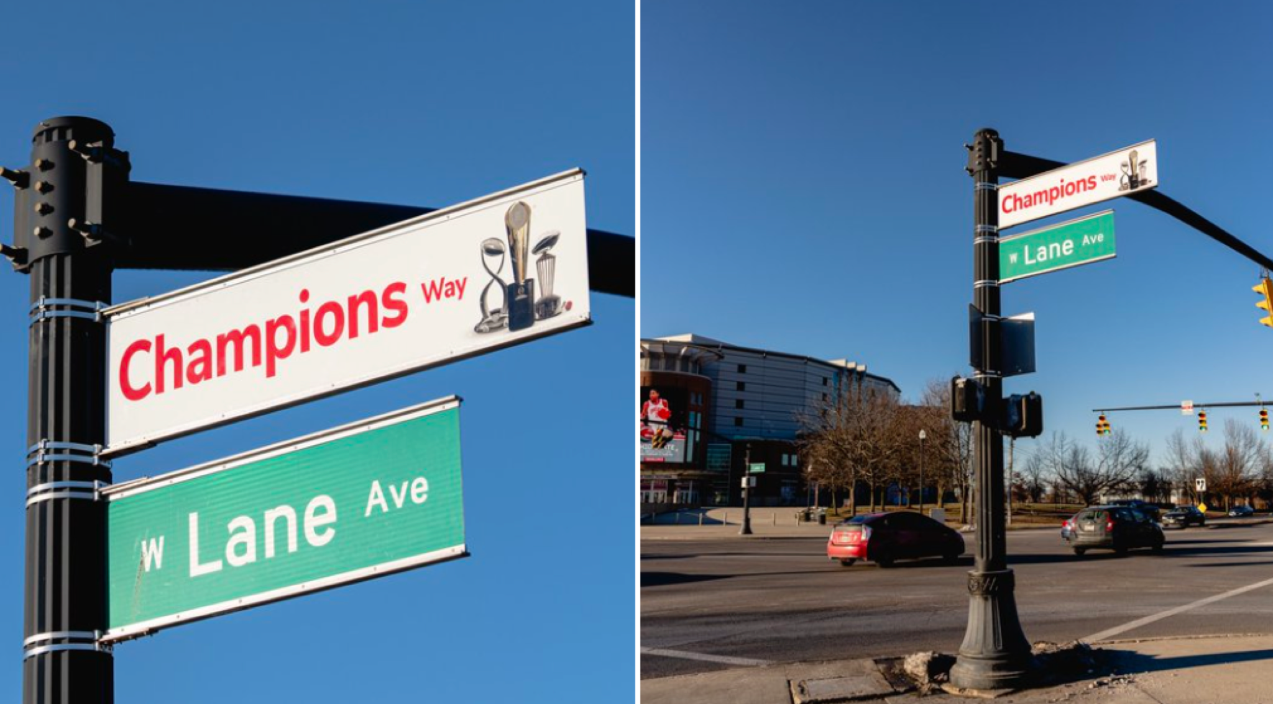

Slide 18
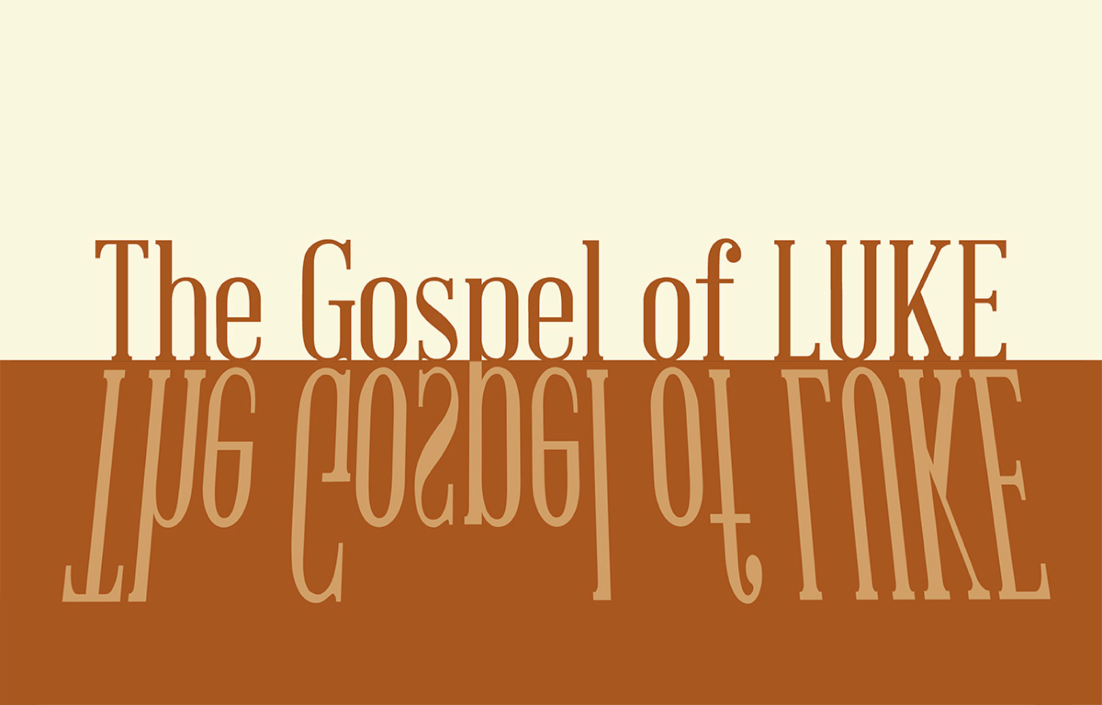

PROFESSION OF FAITH
The Lord’s Prayer
ALL
Our Father, who art in heaven,
Hallowed be thy Name.
Thy Kingdom come.
Thy will be done in earth,
As it is in heaven.
Give us this day our daily bread.
And forgive us our trespasses,
As we forgive those who trespass against us.
And lead us not into temptation,
But deliver us from evil.
For thine is the kingdom,
The power, and the glory,
For ever and ever.
Amen.

THE LORD’S SUPPER

1 Corinthians 11:23–26
The Lord Jesus, on the night when he was betrayed took bread and when he had given thanks, he broke it and said, “This is my body which is broken for you. Do this in remembrance of me.” In the same way also he took the cup, after supper, saying, “This cup is the new covenant in my blood. Do this as often as you drink it, in remembrance of me."

HYMN

This Is My Father’s World
© Words: Public Domain and Music: 1996 Vi Ray Publishing CCLI Song # 2923352 -- CCLI License # 20115471
This is my Father's world
And to my listening ears
All nature sings and round me rings
The music of the spheres
This is my Father's world
I rest me in the thought
Of rocks and trees of skies and seas
His hand the wonders wrought
This is my Father's world
O let me ne'er forget
That though the wrong seems oft so strong
God is the Ruler yet
This is my Father's world
Why should my heart be sad
The Lord is King let the heavens ring
God reigns let the Earth be glad
This is my Father's world
Though soiled by our sin
Creation groans for God alone
Can liberate us from within
This is my Father's world
And so He sent His son
By grace through faith our lives to save
And sanctify until He's done
This is my Father's world
And all will be made new
Our darkest days will pass away
And He will make His dwelling place
Our darkest days will pass away
And He will make His dwelling place

BENEDICTION
Let the beloved of the Lord rest secure in Him, let Him shield them all day long, let the one the Lord loves rest between His shoulders. That you might be steadfast, immovable and knowing that your toil in the Lord is not in vain, today and forevermore.

HOPE HAPPENINGS

GALENTINE’S DAY SOIREE
Thursday, February 13, 2025
7:30 p.m. at the Haack home
888 Timberman Rd. 43212
HOPE LADIES! Join us for an evening of fun & fellow- ship! This is a super casual event, perfect to bring a friend! Bring a treat, snack or drink to share if you’d like–or just show up! We're so excited just to hang out!

HOPE WOMEN'S RETREAT WEEKEND
April 4–6, 2025
Mohican Haven Lodge in Brickhaven, Ohio
Registration is now open!

EVENING WORSHIP—FEBRUARY 23rd at 5 p.m.
On Sunday, Feb, 23rd, we will not have access to the 4-H building and will instead be meeting for evening worship at Scarlet City Church (114 Morse Rd.)

PROVIDE A MEAL FOR SHAN BIBLE STUDIES
Please consider teaming up with a friend, neighbor, family, etc. to make a meal for 12 women who are part of the She Has a Name Thrivers Group. They meet and eat dinner together once a month. Please no pizza! We like to save that for emergencies. Healthier/balanced meals are appreciated. QR code link leads to the signup page.

SUBSCRIBE TO CARMEN HOUSE SUBSTACK
Get updates and offerings from Carmen House Christian Study
Center, and its director, Aaron Badenhop. QR code link leads to the signup page.

Digital Connect Card
We’re glad you’re here! Let’s stay connected; please fill out the form at the following link: https://hopechurchcolumbus.churchcenter.com/people/forms/281549.

