

Hope Presbyterian Church Accessible Worship Folder and Slide Deck Transcription
June 1, 2025
www.hopechurchcolumbus.org
Pastor—Joe Haack—joe@hopechurchcolumbus.org
Youth Pastor—Wes Piehl—wes@hopechurchcolumbus.org
Deacons—deacons@hopechurchcolumbus.org
Operations Manager—Nichole Redinger—operations@hopechurchcolumbus.org
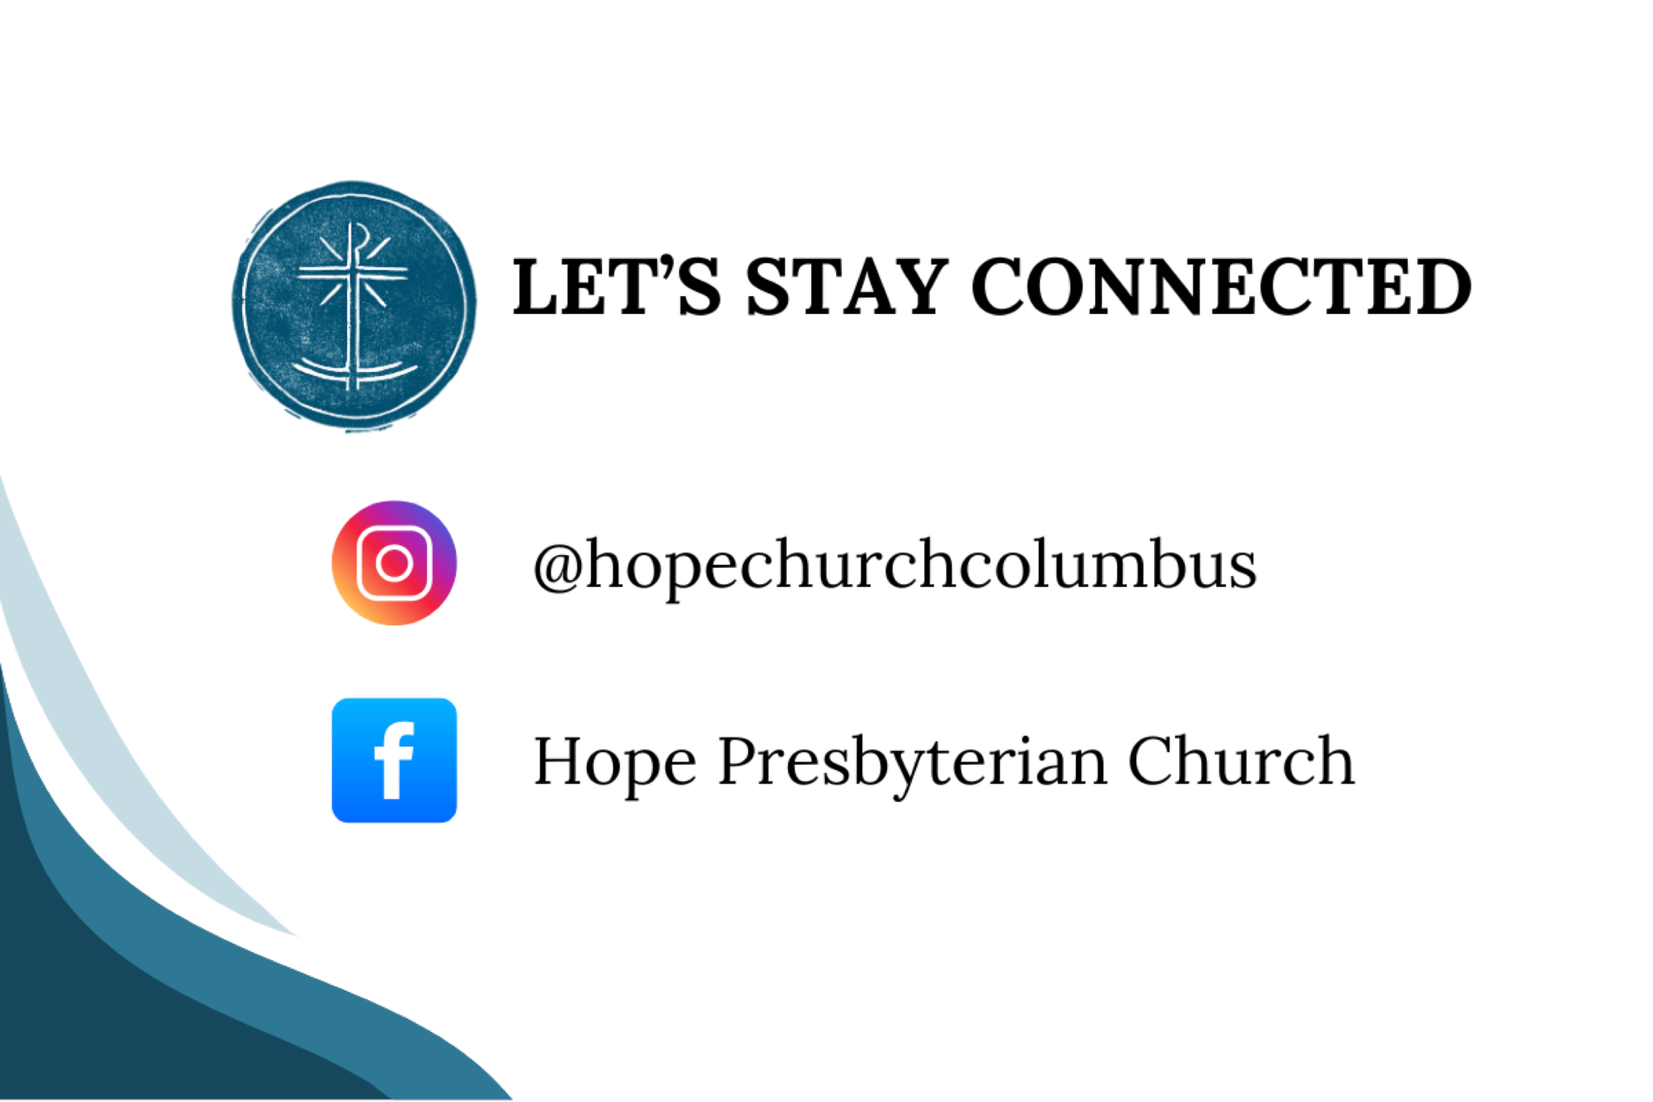

REFLECTION (Before the service)
We must not expect to see an immediate reward for all the good we do; nor must we always confine our efforts to places and persons which seem likely to yield us a recompense for our labors. The Egyptian casts his seed upon the waters of the Nile, where it might seem a sheer waste of corn. But in due time the flood subsides, the rice or other grain sinks into the fertile mud, and rapidly a harvest is produced. Let us today do good to the unthankful and the evil. Let us teach the careless and the obstinate. Unlikely waters may cover hopeful soil. Nowhere shall our labor be in vain in the LORD. - Spurgeon, Faith’s Checkbook

CALL TO WORSHIP
Acts 16:13-15 (NET)

LEADER
On the Sabbath day we went outside the city gate to the side of the river, where we thought there would be a place of prayer, and we sat down and began to speak to the women who had assembled there. A woman named Lydia, a dealer in purple cloth from the city of Thyatira, a God-fearing woman, listened to us. The Lord opened her heart to respond to what Paul was saying. After she and her household were baptized, she urged us, “If you consider me to be a believer in the Lord, come and stay in my house.” And she persuaded us.

ALL
Like Lydia, open our hearts to respond to your Word this morning, that we might display hospitality and persuasiveness of your love, in accordance with your mission. Amen.


DOXOLOGY
Lyrics: Thomas Ken, 1674
Praise God from whom all blessings flow;
Praise him all creatures here below;
Praise him above, ye heavenly host;
Praise Father, Son, and Holy Ghost.
Amen.

HYMN

Here is Love Vast as the Ocean
CCLI Song # 3287884 Matt Redman | Robert Lowry | William Rees
Here is love vast as the ocean
Loving kindness as the flood
When the Prince of Life, our ransom
Shed for us His precious blood
Who His love will not remember
Who can cease to sing His praise
He shall never be forgotten
Throughout Heaven’s everlasting days
On the mount of crucifixion
Fountains opened deep and wide
Through the floodgates of God’s mercy
Flowed the vast and gracious tide
Grace and love like mighty rivers
Poured incessant from above
Heaven’s peace and perfect justice
Kissed a guilty world in love
Let me all Thy love accepting
Love Thee ever all my days
Let me seek Thy kingdom only
And my life be to Thy praise
Thou alone shalt be my glory
Nothing in this world I see
Thou hast cleansed and sanctified me
Thou Thyself hast set me free
Thou alone shalt be my glory
Nothing in this world I see
Thou hast cleansed and sanctified me
Thou Thyself hast set me free
Thou Thyself hast set me free

PRAYER OF REMEMBRANCE
Ps. 17:7-8

ALL
Show me the wonders of your great love, you who save by your right hand those who take refuge in you from their foes. Keep me as the apple of your eye; hide me in the shadow of your wings.

HYMN

The Gospel
CCLI Song # 7004145 Brian Eichelberger | Cam Huxford
This is the word the gospel truth
In which we stand
The perfect life the saving death
Of just one man
Oh oh look what God has done
Oh oh through his son
Christ died for our sins
Met death in his grave
Then rose to life again
By this we are saved
By this we are saved
So Jesus' death has conquered death
And killed our sin
And Jesus' life has brought us life
We live in him
Oh oh look what God has done
Oh oh through his son
Christ died for our sins
Met death in his grave
Then rose to life again
By this we are saved
By this we are saved
This is good news the Father shows us grace
This is the truth the Spirit gives us faith
Jesus is King and by this we are saved
By this we are saved
By this we are saved
By this we are saved

CONFESSION OF SIN

ALL
Most merciful God, we confess that we are in bondage to sin and cannot free ourselves. We have sinned against you in thought, word, and deed, by what we have done and by what we have left undone. We have not loved you with our whole heart; we have not loved our neighbors as ourselves. For the sake of your Son, Jesus Christ, have mercy on us. Forgive us, renew us, and lead us, so that we may delight in your will and walk in your ways, to the glory of your holy name. Amen.

SILENT CONFESSION

HYMN

Lament
The Worship Initiative
My sins are before me,
Transgressions so great
Against You, and You only,
Have I turned away
I’ve worshiped creation,
I’ve chosen my pride
From You, and You only,
Have I tried to hide
Lord I confess my need
Your mercy washes me
My heart is uncovered, my soul is laid bare
To You, and You only, will I lift my head
Lord I confess my need
Your mercy washes me
The steadfast love of the Lord never ceases
His mercies will never end
He is my God, my portion forever
I find my hope in Him
Great is Thy faithfulness
Great is Thy faithfulness
Great is Thy faithfulness
Let the bones You have broken rejoice
In the silence I lift up my voice
Great is Thy faithfulness

ASSURANCE OF PARDON
John 10:7-11, ESV

LEADER
So Jesus again said to them, “Truly, truly, I say to you, I am the door of the sheep. All who came before me are thieves and robbers, but the sheep did not listen to them. I am the door. If anyone enters by me, he will be saved and will go in and out and find pasture. The thief comes only to steal and kill and destroy. I came that they may have life and have it abundantly. I am the good shepherd. The good shepherd lays down his life for the sheep."

HYMN

Goodness of God
CCLI # 7117726 Ed Cash and Jenn Johnson
I love You Lord
Oh Your mercy never fails me
All my days
I've been held in Your hands
From the moment that I wake up
Until I lay my head
I will sing
Of the goodness of God
All my life
You have been faithful
All my life
You have been so, so good
With every breath that I am able
I will sing
Of the goodness of God
I love Your voice
You have led me through the fire
In darkest nights
You are close like no other
I've known You as a father
I've known You as a friend
I have lived
In the goodness of God
All my life
You have been faithful
All my life
You have been so, so good
With every breath that I am able
I will sing
Of the goodness of God
Your goodness is running after
It’s running after me
Your goodness is running after
It’s running after me
With my life laid down
I'm surrendered now
I give You everything
Your goodness is running after
It's running after me
Your goodness is running after
It's running after me
Your goodness is running after
It's running after me
With my life laid down
I'm surrendered now
I give You everything
Your goodness is running after
It's running after me
All my life
You have been faithful
All my life
You have been so, so good
With every breath that I am able
I will sing of the goodness of God
I will sing of the goodness of God

TITHES AND OFFERINGS


HOPE HAPPENINGS AND ANNOUNCEMENTS





PASSING THE PEACE

SCRIPTURE READING
Luke 7:36-50

LEADER:
The Word of the Lord

ALL:
Thanks be to God

SERMON


Slide 1
“whoever has been forgiven little loves little” (7:47).

Slide 2
Simon does not hate Jesus.

Slide 3
Simon does not hate Jesus.
“When one of the Pharisees invited Jesus to have dinner with him, he went to the Pharisee’s house and reclined at the table” (36).

Slide 4
Simon does not hate Jesus.
A woman in that town who lived a sinful life learned that Jesus was eating at the Pharisee’s house, so she came there with an alabaster jar of perfume (37).

Slide 5


Slide 6


Slide 7
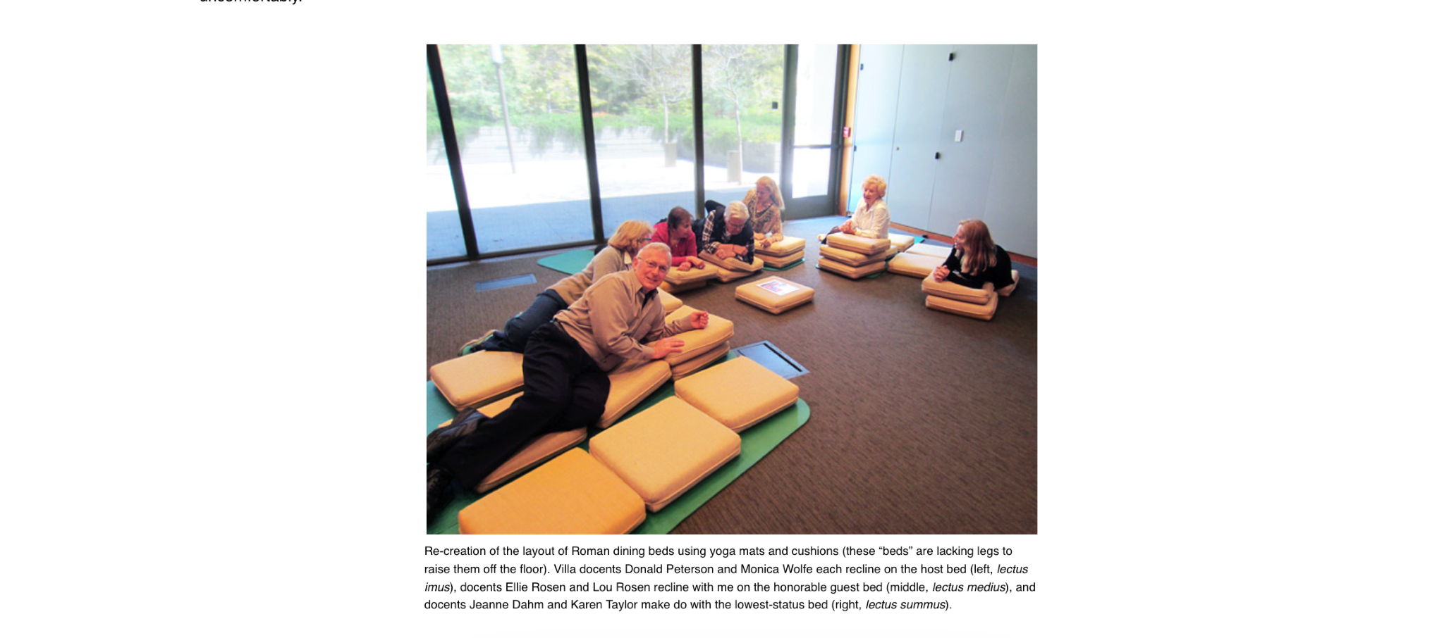

Slide 8
Simon does not hate Jesus.
38 As she stood behind him at his feet weeping, she began to wet his feet with her tears. Then she wiped them with her hair, kissed them and poured perfume on them. 39 When the Pharisee who had invited him saw this, he said to himself, “If this man were a prophet, he would know who is touching him and what kind of woman she is—that she is a sinner” (37–39).

Slide 9
Simon does not see Jesus.

Slide 10
Simon does not see Jesus.
When the Pharisee who had invited him saw this, he said to himself, “If this man were a prophet, he would know who is touching him and what kind of woman she is—that she is a sinner” (39).

Slide 11
Simon does not need Jesus.

Slide 12
Simon does not need Jesus.
40 Jesus answered him, “Simon, I have something to tell you.” “Tell me, teacher,” he said. 41 “Two people owed money to a certain moneylender. One owed him five hundred denarii, and the other fifty. 42 Neither of them had the money to pay him back, so he forgave the debts of both. Now which of them will love him more?” 43 Simon replied, “I suppose the one who had
the bigger debt forgiven.” “You have judged correctly,” Jesus said (Lk 7:40–43).

Slide 13
Simon does not need Jesus.
“In the end, self-righteousness may turn out to be the most impenetrable barrier between a person and God’s salvation. One does not have to be a Pharisee to possess a holier-than-thou
attitude. Simon’s lesson may well be ours” (Diane Chen).

Slide 14
1/ Experience authentic forgiveness from Jesus
2/ Express authentic gratitude to Jesus

Slide 15
1/ Experience authentic forgiveness from Jesus

Slide 16
1/ Experience authentic forgiveness from Jesus
40 Jesus answered him, “Simon, I have something to tell you.” “Tell me, teacher,” he said. 41 “Two people owed money to a certain moneylender. One owed him five hundred denarii, and the other fifty. 42 Neither of them had the money to pay him back, so he forgave the debts of both. Now which of them will love him more?” 43 Simon replied, “I suppose the one who had
the bigger debt forgiven.” “You have judged correctly,” Jesus said (Lk 7:40–43).

Slide 17
1/ Experience authentic forgiveness from Jesus
47 Therefore, I tell you, her many sins have been forgiven…—as her great love has shown. But whoever has been forgiven little loves little.” 48 Then Jesus said to her, “Your sins are forgiven.” 49 The other guests began to say among themselves, “Who is this who even forgives sins?” 50 Jesus said to the woman, “Your faith has saved you; go in peace.”

Slide 18
1/ Experience authentic forgiveness from Jesus
“…the stress is not that she is a sinner but the people in the city thinks that she is. Jesus has already forgiven her prior to this encounter, but the community fails to acknowledge it and continues to brand her as a sinner” (Diane Chen).

Slide 19
2/ Express authentic gratitude to Jesus

Slide 20
2/ Express authentic gratitude to Jesus
44 Then he turned toward the woman and said to Simon, “Do you see this woman? I came into your house. You did not give me any water for my feet, but she wet my feet with her tears and wiped them with her hair. 45 You did not give me a kiss, but this woman, from the time I entered, has not stopped kissing my feet. 46 You did not put oil on my head, but she has poured perfume on my feet.

Slide 21
2/ Express authentic gratitude to Jesus
44 Then he turned toward the woman and said to Simon, “Do you see this woman? I came into your house. You did not give me any water for my feet, but she wet my feet with her tears and wiped them with her hair. 45 You did not give me a kiss, but this woman, from the time I entered, has not stopped kissing my feet. 46 You did not put oil on my head, but she has poured perfume on my feet.
If you have communicant children who are participating in the Lord's Supper, you may pick them up from Hope Kids at this time.

CONFESSION OF FAITH
The Lord’s Prayer

ALL
Our Father in heaven,
hallowed be your name,
your kingdom come,
your will be done,
on earth as in heaven.
Give us today our daily bread.
Forgive us our sins
as we forgive those who sin against us.
Lead us not into temptation
but deliver us from evil.
For the kingdom, the power,
and the glory are yours
now and forever.
Amen.

THE LORD’S SUPPER

1 Corinthians 11:23–26
The Lord Jesus, on the night when he was betrayed took bread and when he had given thanks, he broke it and said, “This is my body which is broken for you. Do this in remembrance of me.” In the same way also he took the cup, after supper, saying, “This cup is the new covenant in my blood. Do this as often as you drink it, in remembrance of me."

HYMN

It Is Well
CCLI Song # 5875665 Ben Fielding | Horatio Gates Spafford | Philip Paul Bliss | Reuben Morgan
When peace, like a river,
Attendeth my way,
When sorrows like sea billows roll;
Whatever my lot,
Thou hast taught me to say,
“It is well, it is well with my soul”
It is well (it is well)
With my soul (with my soul)
It is well, it is well
With my soul
Though Satan should buffet,
Though trials should come,
Let this blessed assurance control,
That Christ has regarded
My helpless estate,
And hath shed His own blood
For my soul
It is well (it is well)
With my soul (with my soul)
It is well, it is well
With my soul
My sin, oh the bliss
of this glorious thought!
My sin, not in part but the whole,
Is nailed to the cross,
And I bear it no more,
Praise the Lord, praise the Lord,
O my soul!
It is well (it is well)
With my soul (with my soul)
It is well, it is well
With my soul
And Lord haste the day
When the faith shall be sight,
The clouds be rolled back as a scroll;
The trump shall resound,
And the Lord shall descend,
Even so, it is well
With my soul
It is well (it is well)
With my soul (with my soul)
It is well, it is well
With my soul

BENEDICTION
(based on a prayer of Augustine)
The Lord watches over those who wake, or watch, or weep today and he gives His angels charge over them. The Lord tends to sick ones, weary ones, suffering and dying ones. The Lord pities afflicted ones, and shields joyous ones, and all for His love’s sake. Amen.

HOPE HAPPENINGS

“WHO IS HOPE EPC?”
If you are interested in learning more about membership at Hope, use the QR code to the left to sign up for more information. QR code leads to https://hopechurchcolumbus.churchcenter.com/registrations/events/2941425

NEWCOMER’S BRUNCH JUNE 15, 2025

CONGREGATIONAL MEETING/VISION SURVEY
Please plan on staying after morning worship for a brief Congregational Meeting on June 22, 2025. At our last family meeting we invited you to join us in prayerfully envisioning what it would look like for Hope to live out our values in the next 5-10 years. As we approach our next congregational meeting on June 22nd, would you consider taking this survey by scanning the QR code?

JUBILEE SUNDAY
June 29, 2025
This will be a more scaled-back service and no childcare or Hope Kids activities will be available. There will be a designated self-serve nursery area for parents to utilize during the service, if needed. On Jubilee Sunday, the worship service is crafted with kids in mind, to celebrate our youngest members and honor our Hope Kids volunteers by giving them a week off from serving.

Digital Connect Card
We’re glad you’re here! Let’s stay connected; please fill out the form at the following link: https://hopechurchcolumbus.churchcenter.com/people/forms/281549.

