

# Hope Presbyterian Church Accessible Worship Folder and Slide Deck Transcription

**June 15, 2025**

[www.hopechurchcolumbus.org](http://www.hopechurchcolumbus.org)

Pastor—Joe Haack—[joe@hopechurchcolumbus.org](mailto:joe@hopechurchcolumbus.org)

Youth Pastor—Wes Piehl—[wes@hopechurchcolumbus.org](mailto:wes@hopechurchcolumbus.org)

Deacons—[deacons@hopechurchcolumbus.org](mailto:deacons@hopechurchcolumbus.org)

Operations Manager—Nichole Redinger—[operations@hopechurchcolumbus.org](mailto:operations@hopechurchcolumbus.org)

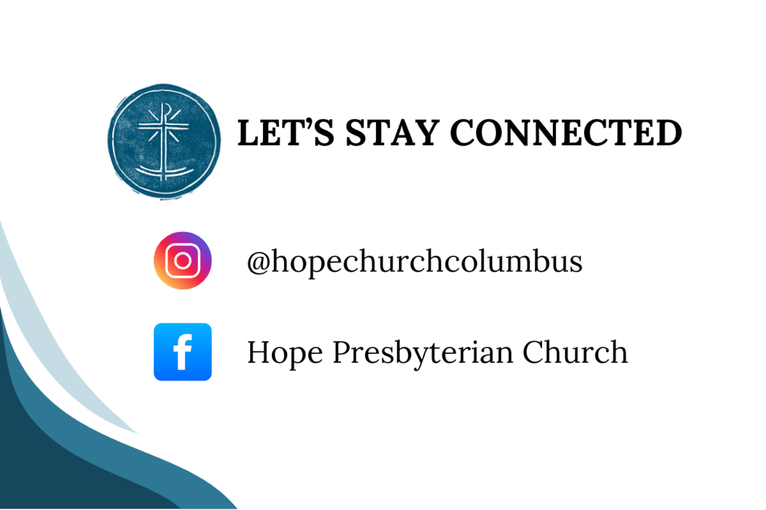

## REFLECTION

"Good works can hardly be done without suffering, yet the suffering of the saints is nourished by a great hope. For nothing earthly is promised, but rather eternal glory." - Cyril of Alexandria

## CALL TO WORSHIP

Prov. 8:1-4 (NIV)

### LEADER

Does not wisdom call out?

Does not understanding raise her voice?

At the highest point along the way,

where the paths meet, she takes her stand;

beside the gate leading into the city,

at the entrance, she cries aloud:

“To you, O people, I call out;

I raise my voice to all mankind.

### ALL

Glory to the Father, and to the Son, and to the Holy Spirit. As it was in the beginning, is now, and will be forever. Amen.



## DOXOLOGY

Lyrics: Thomas Ken, 1674

Praise God from whom all blessings flow;

Praise him all creatures here below;

Praise him above, ye heavenly host;

Praise Father, Son, and Holy Ghost.

Amen.



## HYMN

### A Day For Singing

CCLI Song # 7223272

Jess Ray Langdon | Jessie Early | Mitch Wong | Natalie Leonhardt

Mercy rising with the rising of the sun

Goodness rushing in and filling up my lungs

Your faithfulness is here and now

The evidence is all around

I bless Your name

I give You praise

Today is a day for singing

Awake my soul

Come on praise the Lord

Today is a day for singing

Oh my soul

Praise the Lord

Oh my soul

Today is a day for singing

A new song

Is welling up From deep inside of me

There's new life

Hallelujah I have been redeemed

I have been redeemed

I bless Your name

I give You praise

Today is a day for singing

Awake my soul

Come on praise the Lord

Today is a day for singing

Oh my soul

Praise the Lord

Oh my soul

Today is a day for singing

From the valley to the mountain

The desert to the fountain

Oh I will praise You

From the morning to the evening

As long as I am breathing

Today is a day for singing

From the valley to the mountain

The desert to the fountain

Oh I will praise You

From the morning to the evening

As long as I am breathing

Today is a day for singing

I bless Your name

I give You praise

Today is a day for singing

Awake my soul

Come on praise the Lord

Today is a day for singing

Oh my soul

Praise the Lord

Oh my soul

Today is a day for singing

I bless Your name

I give You praise

Today is a day for singing

Awake my soul

Come on praise the Lord

Today is a day for singing

Oh my soul

Praise the Lord

Oh my soul

Today is a day for singing



## PRAYER OF REMEMBRANCE

Based on Belgic Confession 12 & 14

### ALL

We believe, Father, that it seemed good to you

To create heaven and earth and all creatures

From nothing, but the Word

That is by the Son

You have given all creatures their being,

Their form and function,

To serve You, the creator.

You created human beings from the dust of the earth,

Formed in Your image and likeness

You made them very good

To steward Your creation.

Thank you that in spite of the fall,

We can know that we are not a mistake,

But were created for Your good purposes. Amen.

### Lord, I Need You

CCLI Song # 5925687

Christy Nockels | Daniel Carson | Jesse Reeves | Kristian Stanfill | Matt Mahe

Lord I come I confess

Bowing here I find my rest

And without You I fall apart

You're the one that guides my heart

Lord I need You oh I need You

Ev'ry hour I need You

My one defense my righteousness

Oh God how I need You

Where sin runs deep Your grace is more

Where grace is found is where You are

And where You are Lord I am free

Holiness is Christ in me

Where You are Lord I am free

Holiness is Christ in me

Lord I need You oh I need You

Ev'ry hour I need You

My one defense my righteousness

Oh God how I need You

So teach my song to rise to You

When temptation comes my way

And when I cannot stand I'll fall on You

Jesus You're my hope and stay

And when I cannot stand I'll fall on You

Jesus You're my hope and stay

Lord I need You oh I need You

Ev'ry hour I need You

My one defense my righteousness

Oh God how I need You

My one defense my righteousness

Oh God how I need You



## CONFESSION OF SIN

(based on Matt. 23:25-28 ESV)

### Leader

“Woe to you, scribes and Pharisees, hypocrites! For you clean the outside of the cup and the plate, but inside they are full of greed and self-indulgence. You blind Pharisee! First clean the inside of the cup and the plate, that the outside also may be clean. “Woe to you, scribes and Pharisees, hypocrites! For you are like whitewashed tombs, which outwardly appear beautiful, but within are full of dead people’s bones and all uncleanness. So you also outwardly appear righteous to others, but within you are full of hypocrisy and lawlessness.

### ALL

Merciful God, cleanse us from all greed and self-indulgence. If there be any blindness in us, heal us. Make us beautiful, not by mere outward appearance, but from the inside out. For the sake of Christ and the Kingdom we pray, Amen.



## HYMN

### Pass Me Not O Gentle Savior

CCLI #4760135 | William Howard Doane, Mary McDonald, and Fanny Jane Crosby

Pass me not, O gentle savior

Hear my humble cry

While on others Thou art calling

Do not pass me by

Savior, savior

Hear my humble cry

While on others Thou art calling

Do not pass me by

Let me at Thy throne of mercy

Find a sweet relief

Kneeling there in deep contrition

Help my unbelief

Savior, savior

Hear my humble cry

While on others Thou art calling

Do not pass me by

Trusting only in Thy merit

Would I seek Thy face

Heal my wounded, broken spirit

Save me by Thy grace

Savior, savior

Hear my humble cry

While on others Thou art calling

Do not pass me by

Thou the spring of all my comfort

More than life to me

Whom have I on Earth beside Thee?

Whom in Heav'n but Thee?

Savior, savior

Hear my humble cry

While on others Thou art calling

Do not pass me by



## ASSURANCE OF PARDON

1 Cor. 15:55-57 (NIV)

### LEADER

“Where, O death, is your victory?

Where, O death, is your sting?”

The sting of death is sin, and the power of sin is the law. But thanks be to God! He gives us the victory through our Lord Jesus Christ.



## HYMN

### All Sufficient Merit

CCLI Song # 7212933

Bethany Barnard | Bryan Fowler | Shane Barnard

All sufficient merit,

shining like the sun

A fortune I inherit

by no work I have done

My righteousness I forfeit

at my Savior’s cross

Where all sufficient merit

did what I could not

In love He condescended,

eternal now in time

A life without a blemish

the Maker made to die

The law could never save us,

our lawlessness had won

Until the pure and spotless

lamb had finally come

It is done, it is finished

No more debt I owe

Paid in full

All sufficient merit now my own

I lay down my garments,

any empty boast

Good works now all corrupted

by the sinful host

I'm dressed in my Lord Jesus,

a crimson robe made white

No more fear of judgment

His righteousness is mine

It is done, it is finished

No more debt I owe

Paid in full

All sufficient merit now my own

It is done, it is finished

No more debt I owe

Paid in full

All sufficient merit now my own

All sufficient merit

firm in life and death

The joy of my salvation shall

be my final breath

When I stand accepted

before the throne of God

I’ll gaze upon my Jesus

and thank Him for the cross

Yes I’ll thank Him for the cross

It is done, it is finished

No more debt I owe

Paid in full

All sufficient merit now my own

It is done, it is finished

No more debt I owe

Paid in full

All sufficient merit now my own

## TITHES AND OFFERINGS



## HOPE HAPPENINGS AND ANNOUNCEMENTS





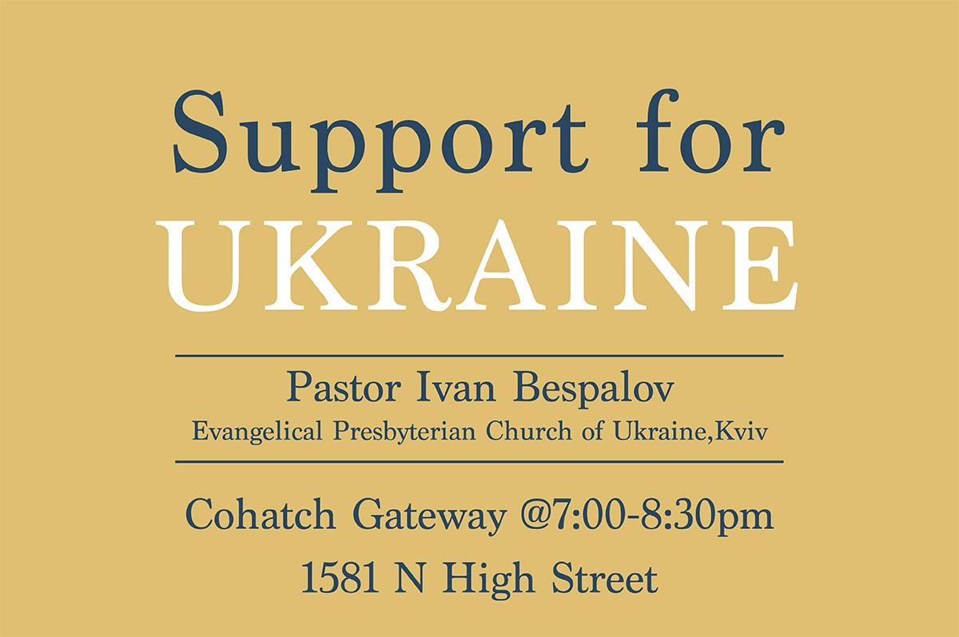



## PASSING THE PEACE

## SCRIPTURE READING

Luke 8:22-25

### LEADER:

The Word of the Lord

### ALL:

Thanks be to God

## MESSAGE

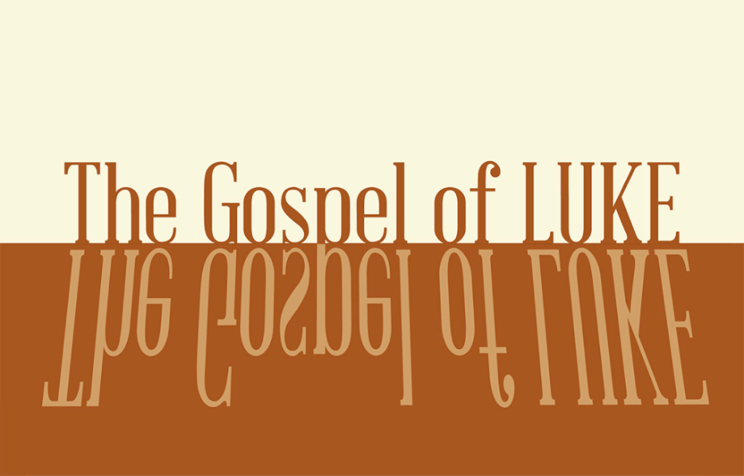

### Slide 1

“Where is your faith?” he asked his disciples (Lk 8:25).

### Slide 2

22 One day Jesus said to his disciples, “Let us go over to the other side of the lake.” So they got into a boat and set out. 23 As they sailed, he fell asleep. A squall came down on the lake, so that the boat was being swamped, and they were in great danger (Lk 8:22–23).

### Slide 3

23 As they sailed, he fell asleep… 24 The disciples went and woke him, saying, “Master, Master, we’re going to drown!” (Lk 8:24)

### Slide 4

Jesus is powerful (God above us)

### Slide 5

“In the beginning God created the heavens and the earth. 2 Now the earth was formless and empty, darkness was over the surface of the deep, and the Spirit of God was hovering over the waters.” (Ge 1:1–2).

### Slide 6

9 Awake, awake, arm of the LORD,

clothe yourself with strength!

Awake, as in days gone by,

as in generations of old.

Was it not you who cut Rahab to pieces,

who pierced that monster through?

10 Was it not you who dried up the sea,

the waters of the great deep,

who made a road in the depths of the sea

so that the redeemed might cross over? (Is 51:9–10).

### Slide 7

Who is like you, LORD God Almighty?

You, LORD, are mighty, and your faithfulness surrounds you.

You rule over the surging sea;

when its waves mount up, you still them. (Psalm 89:8-9)

### Slide 8

Jesus is powerful (God above us)

### Slide 9

Jesus is near (God with us)

### Slide 10

24 The disciples went and woke him, saying, “Master, Master, we’re going to drown!” (Lk 8:24)

### Slide 11

Jesus is loving (God for us)

### Slide 12

He got up and rebuked the wind and the raging waters; the storm subsided, and all was calm (24).

## The Gospel of Luke Sermon Series Slide

## CONFESSION OF FAITH

The Apostle’s Creed

### ALL

I believe in God, the Father almighty,

creator of heaven and earth.

I believe in Jesus Christ, his only Son, our Lord,

who was conceived by the Holy Spirit

and born of the virgin Mary.

He suffered under Pontius Pilate,

was crucified, died, and was buried;

he descended to hell.

The third day he rose again from the dead.

He ascended to heaven

and is seated at the right hand of God the Father almighty.

From there he will come to judge the living and the dead.

I believe in the Holy Spirit,

the holy catholic* church,

the communion of saints,

the forgiveness of sins

the resurrection of the body,

and the life everlasting. Amen.

## THE LORD’S SUPPER

### 1 Corinthians 11:23–26

The Lord Jesus, on the night when he was betrayed took bread and when he had given thanks, he broke it and said, “This is my body which is broken for you. Do this in remembrance of me.” In the same way also he took the cup, after supper, saying, “This cup is the new covenant in my blood. Do this as often as you drink it, in remembrance of me."



## HYMN

### Be Thou My Vision

CCLI Song # 7056332

Eleanor Henrietta Hull | Mary Elizabeth Byrne | Russell Mauldin

Be Thou my vision

O Lord of my heart

Naught be all else to me

Save that Thou art

Thou my best thought

By day or by night

Waking or sleeping

Thy presence my light

Be Thou my wisdom

And Thou my true word

I ever with Thee

And Thou with me, Lord

Thou my great Father

I Thy true son

Thou in me dwelling

And I with Thee one

Riches I heed not

Nor man’s empty praise

Thou mine inheritance

Now and always

Thou and Thou only

First in my heart

High King of Heaven

My treasure Thou art

High King of Heaven

My victory won

May I reach Heaven’s joys

O bright Heav’n’s sun

Heart of my own heart

Whate’er befall

Still be my vision

O ruler of all



## BENEDICTION

1 Cor. 15:58 (NIV)

Therefore, my dear brothers and sisters, stand firm. Let nothing move you. Always give yourselves fully to the work of the Lord, because you know that your labor in the Lord is not in vain.

## HOPE HAPPENINGS

### UPDATE FROM UKRAINE

This Sunday, June 15th Ivan Bespalov is an EPCU (Evangelical Presbyterian Church of Ukraine) pastor in Kviv, who has been granted a visa for the first time since the war. He and his wife are in the States in order to meet with as many churches as they can, so they can encourage engagement from the church in the US. If you are interested in hearing first hand how you can support your brothers and sisters in Ukraine, we have an opportunity Sunday evening to meet with Pastor Ivan. Students are especially invited! We have reserved a space at Cohatch Gateway (high street near South Campus) from 7:00-8:30 p.m. Food and refreshments will be provided.

### “WHO IS HOPE EPC?”

If you are interested in learning more about membership at Hope, use the QR code to the left to sign up for more Information. QR code leads to https://hopechurchcolumbus.churchcenter.com/registrations/events/2941425.

### CONGREGATIONAL MEETING/VISION SURVEY

Please plan on staying after morning worship for a brief Congregational Meeting on June 22, 2025. At our last family meeting we invited you to join us in prayerfully envisioning what it would look like for Hope to live out our values in the next 5-10 years. As we approach our next congregational meeting on June 22nd, would you consider taking this survey by scanning the QR code? QR Code leads to https://hopechurchcolumbus.churchcenter.com/people/forms/920195.

### WOMEN’S SUMMER PARTY

June 27, 2025 @ 7:30 p.m. Join the women of Hope for an evening of fellowship at the Redinger Home. Bring a snack, dessert or drink if you would like, or just show up! 2512 Swansea Rd, 43221

### JUBILEE SUNDAY

June 29, 2025 On Jubilee Sunday, the worship service is crafted with kids in mind, to celebrate our youngest members and honor our Hope Kids volunteers by giving them a week off from serving.

### VBS @ HOPE

Sunday, July 20th - More details coming soon!

## Digital Connect Card

We’re glad you’re here! Let’s stay connected; please fill out the form at the following link: <https://hopechurchcolumbus.churchcenter.com/people/forms/281549>.